AUTHOR INSTRUCTIONS (FINAL CAMERA-READY SUBMISSIONS)

This section contains instructions for authors for submitting camera-ready papers for publication in the proceedings of the 2025 28th Conference of the Oriental COCOSDA International Committee for the Co-ordination and Standardisation of Speech Databases and Assessment Techniques (O-COCOSDA).

Important Deadlines

1. Camera-ready paper due: 30 September 2025
2. Early Bird registration by: 1-6 October 2025
3. Regular registration by: 7-18 October 2025

In order for your paper to be included in the O-COCOSDA conference proceedings and IEEE Xplore® you need to complete the following steps:

- Step 1: Make improvements to your article according to the reviewers’ recommendations.
- Step 2: Format the final version of your article according to IEEE style
- Step 3: Generate a compatible PDF file for your article using the PDF eXpress service.
- Step 4: Complete and sign the Copyright form.
- Step 5: Submit the final version of your article.
- Step 6: Register for the conference.

It is mandatory to comply with all of these steps and submit the final version by September 30, 2025, to publish your article in IEEE Xplore. Registration must be completed by the indicated date.

Each of these steps is explained in detail below.

Step 2: Format the final version of your article according to IEEE style:

Your accepted paper will appear on IEEE Xplore® — the IEEE Digital Library — and it is important that your submitted PDF file meets the specification for IEEE Xplore®. Failing to submit an IEEE Xplore® compatible PDF file may result in the file not being included in the conference proceedings.

The following information is intended to guide you on formatting your final paper, ensuring your PDF file is IEEE Xplore® compliant.

Page limit

The page limit for regular (full) is six (6) pages. Please address the comments of the reviewers, make your figures large enough to be legible, and to comply with all formatting requirements. Please note that it is not possible to purchase extra pages.

Templates

Please format your final submission using the guidelines provided in the submission section of https://ococosda2025.id/cfp/index.html. The guidelines are implemented in the following:

- Papers may consist of up to six (6) pages of content, including references and appendices.
- All papers must be written in English and conform to the double-column format of IEEE Signal Processing Society conferences.
- The paper templates (word and latex) can be downloaded below:
O-COCOSDA 2025 (word)
O-COCOSDA 2025 (latex)
- All papers should include “Index Terms” following the Abstract.
- All papers should be camera-ready PDF files of up to six (6) pages in length. There must be no password protection on the PDF file, and all fonts must be embedded (for instruction to check the fonts, see Simplified Requirements for Creating PDF Files for IEEE Xplore®)
- At least one author of an accepted paper must be registered by the early registration deadline: 6 October 2025; otherwise, the paper will be withdrawn and not published in the proceedings.
- Each accepted paper must be presented by one of its authors in person at the conference.

Other common issues encountered in past submissions relate to the proper formatting of the title, authors, and affiliations. Please note:

- Use capital letters in the article title (main words with the first letter capitalized and minor words with lowercase).
- Author names should not be numbered; do not include any numbered sequence when specifying the article’s authors. Authors with different affiliations should not be grouped in the same column; they should be listed separately in different columns.
- Affiliations should include the organization name, city, country, email address, or ORCID.

Step 3: Generate a compatible PDF file for your article using the PDF eXpress service

In order to assure that all submitted PDF files are IEEE Xplore® compliant, your paper must pass both format checks in IEEE PDFXpress.

You must use IEEE PDF eXpress™ to generate or verify an IEEE Xplore® compliant PDF. We strongly recommend that all final submissions be created using the IEEE PDF eXpress™ service. The IEEE PDF eXpress™ service can convert your paper from a wide range of formats to IEEE Xplore®-compatible PDFs. The service is free of charge for O-COCOSDA 2025 authors and can be accessed using the following information:

Before Creating a PDF

Proofread your source document thoroughly to confirm that it will require no revision.

Then,

Go to the IEEE PDF eXpress™ Login Page https://ieee-pdf-express.org
First-time users should do the following:

1. Select the New Users - Click Here link.
2. Enter the following:
- 68185X for the Conference ID of O-COCOSDA 2025
- your email address
- a password
3. Continue to enter information as prompted.

An Online confirmation will be displayed, and an email confirmation will be sent verifying your account setup.

Previous users of PDF eXpress need to follow the above steps but should enter the same password that was used for previous conferences. Verify that your contact information is valid.

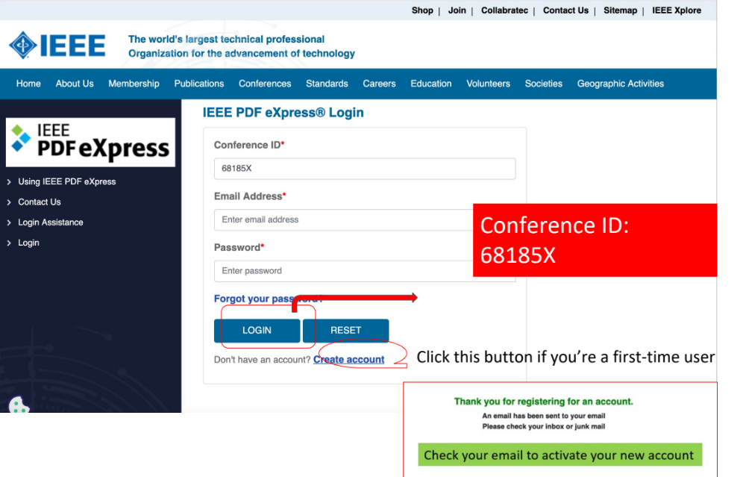

Now that you have a PDF eXpress account, for each article you want to generate, do the following:

REMINDER:
Be sure to check that the TITLE in the PDF file submitted to IEEE PDF eXpress agrees with the meta data (EasyChair) paper title and with copyright form, as otherwise the conference program will show the wrong paper title. The same goes for the author’s name & sequence & Abstract too.

1. Log in to the Dashboard and click the “Create New Title” button.

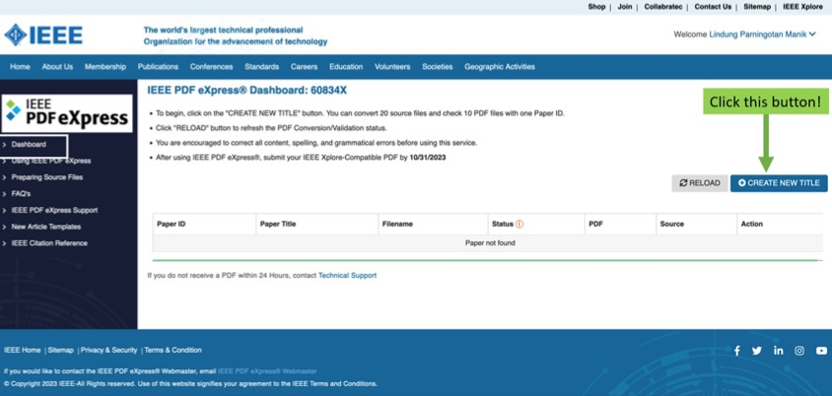

2. Enter a text that identifies your article (use the EasyChair title of your article), and upload your paper:

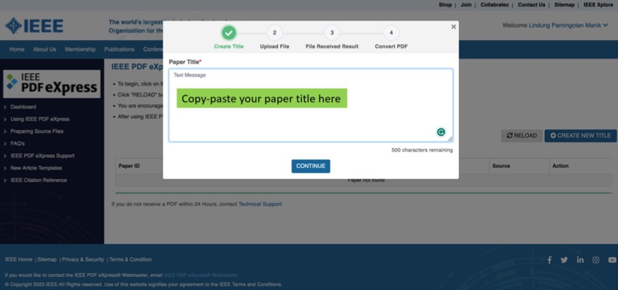

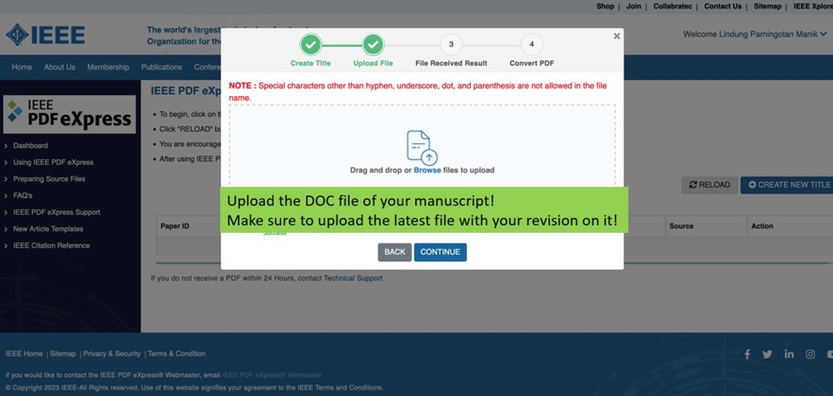

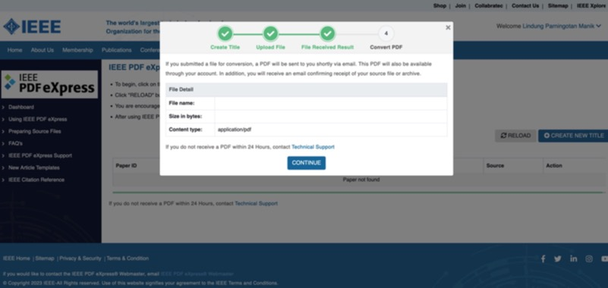

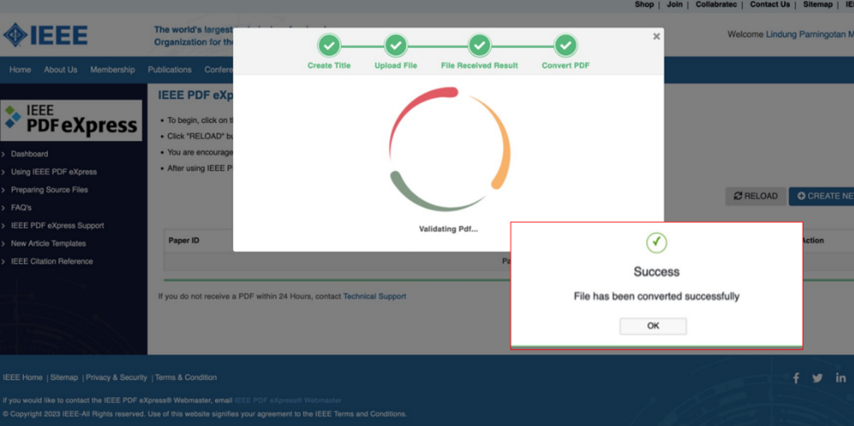

3. PDF eXpress will display a small table with summary information about the uploaded file. To convert or approve your article, review the icons on the right. The first converts from Word or LaTeX to PDF. The second icon allows you to validate a PDF. For example, if you have a DOC or DOCX file with your article, you need the conversion function (first icon), but if you have a PDF file generated on your own, you only need the verification function (second icon). The icon at the bottom (pointed by the green arrow below) allows you to download the PDF file that has passed the PDF eXpress checks (ensure the Status column shows “Pass” in the table).

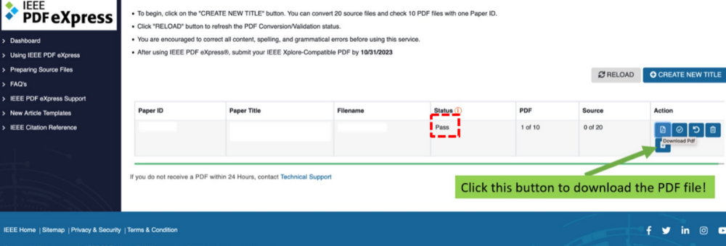

Contacting PDF eXpress Support

Access the Publications Support Center for IEEE PDF eXpress: https://supportcenter.ieee.org/app/answers/list/p/12

If you do not find an answer in the Find Answers tab, go to the
Ask A Question tab. Your question will be forwarded to IEEE PDF Support and answered within 3 business days.

Step 4: Complete and sign the Copyright form

The corresponding author of each accepted article must complete the copyright form by September 30, 2025, for their article to be indexed by IEEE Xplore. This time, the electronic system (IEEE Electronic Copyright Form – eCF) will be used.

When completing the form, it is important to check that the article title and authors match the final manuscript. Otherwise, the paper may be rejected once submitted to IEEE Xplore.

- You must log in to the conference’s EasyChair platform, but this time logging in as the “Proceedings author (IEEE Proceedings)” role.
- Then you must click the red “Sign Copyright Agreement” button, as shown in the figure.
- It is very important that the article title is the same in the copyright agreement, in the PDF of the article itself, and in the system information (EasyChair Paper Information).

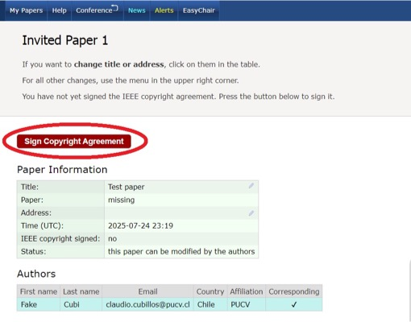

- You will be redirected to the ecopyright.ieee.org website, titled IEEE Publication Agreement, as shown in the figure below.

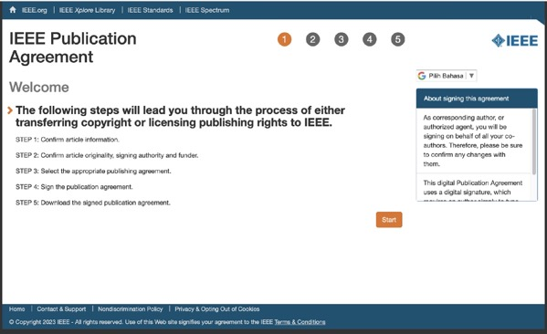

- Follow the five steps within the site and review your article’s title and author information, ensuring it is identical to the PDF version of the article.
- When you reach step 4, you will need to enter your name as your signature.

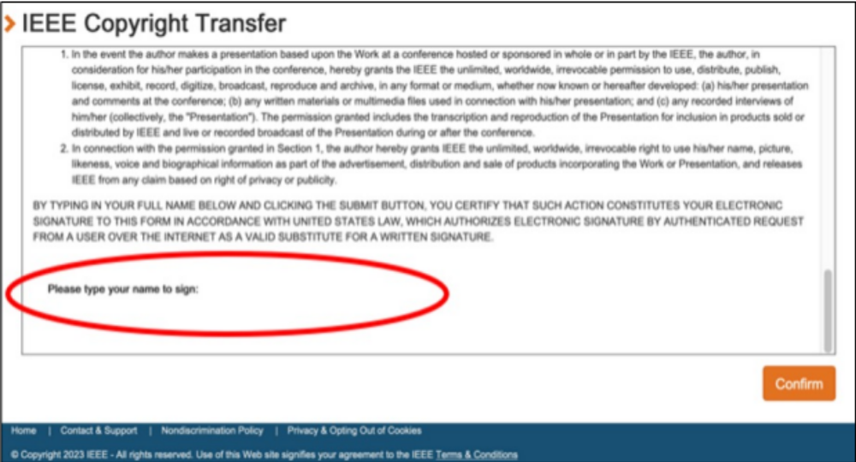

- In the fifth and final step, you will receive a confirmation email with a copy of the completed copyright form.

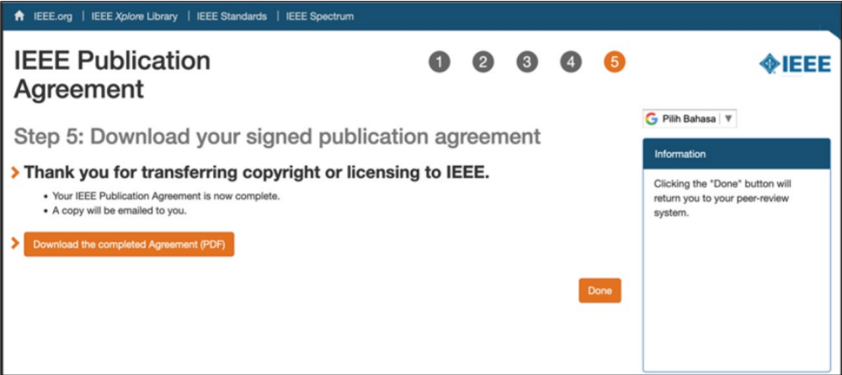

Step 5: Submit the final version of your article

The final version of your article must be submitted by September 30, 2025, for inclusion in the conference technical program (O-COCOSDA proceedings). To do so, you must:

- Log in to the conference’s EasyChair system, but this time as the “Proceedings author (IEEE Proceedings)” role, similar to the previous step.
- Then, in the upper right corner, select the “Upload new version” option and upload the article in PDF format, which you validated in step 3.

Before uploading the final version of your article, please check that you have not added page numbers and that your figures and tables are in high resolution. Also, verify that you have used IEEE style for bibliographic references.

Also, verify that you have formatted the final version of your article into an IEEE Xplore-compatible PDF file. For this reason, you must use PDF eXpress to generate or verify the PDF file of your article (see Step 3). IEEE Xplore reserves the right not to publish non-compliant articles or those that do not follow the format.

It is important to remember that al least one of the authors must present the article at the conference.

Step 6: Register for the conference
Every article must have a registration associated with it that covers its publication in the proceedings. For the registration process, please visit the Registration section on the Conference website https://ococosda2025.id/

