# **Fundamentals of Data Analysis – Topic 8**

## **Sex Bias in Graduate Admissions – notes**

* “Is society biased against gender or minorities?”
* Written as naive as possible. “Without a wider knowledge”
* Data on applications to UC Berkeley.
* ~13000 applications
* Bias: if the accepted applicants weren’t equal based on gender (roughly)
* Discrimination: decision making critea unnecessarily influences by the sex of the applicant.

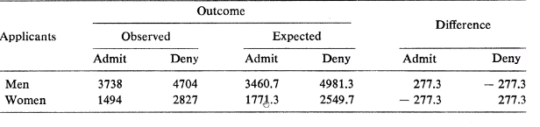

* Approach A: look at the numbers on campus.
* 44% of males admitted and 35% of females.
* Further investigation required.
* Assumptions:
  + No difference in capabilities of men vs women. (other scenarios where these could exist. I.e a third world country)
  + “Who’s apply for what is not important” (important later)
* With the above assumptions, we saw 277 more men and 277 less women. (about 138 more women should have been accepted.)
* Bias exists, must examine each of the 101 departments taking applicants.
  + Of the 101, 16 didnt get any women or accepted all applicants.
  + 4 departments biased against women
  + 6 departments biased against men (!)
* Above is rooted in the falsity of assumption two, we assumed bias existed with regard to applicant gender and decision to admit.
* Done so without giving attention to relationship between the sex of an applicant and the department which is sought.
  + Example: high proportion of women applied for english, vs very low proportion for mechanical engineering.
* Same analysis to be done on each individual department (85 of 101)
* Finds little bias in favour of men, finds evidence of bias in favour of women.
* Key piece of puzzle: not all departments are as easy to get into.
  + Women tend toward departments that are harder to enter/ have less places.
* Each department should be examined independently, when done so, no bias exists.
* Aggregate seems misleading, but further investigation and justification is needed.