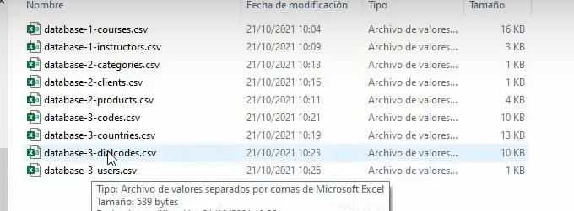

Instructors

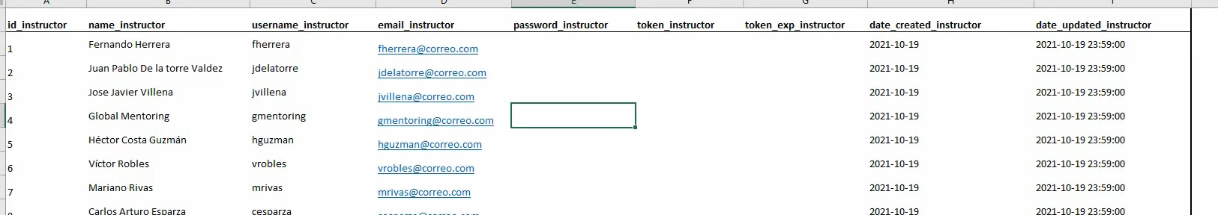

courses

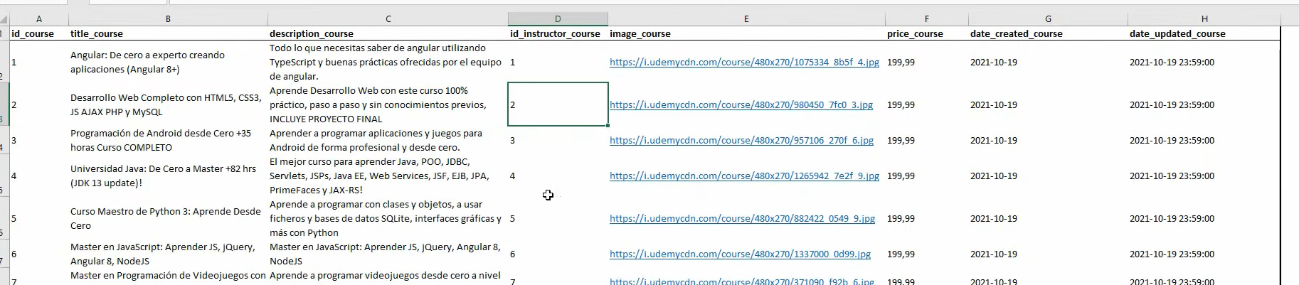

Products

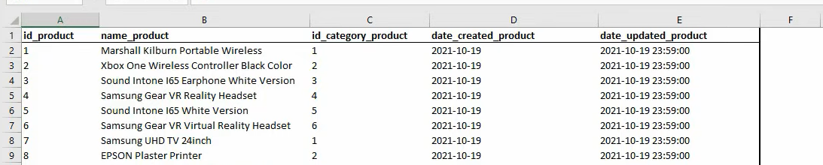

Category

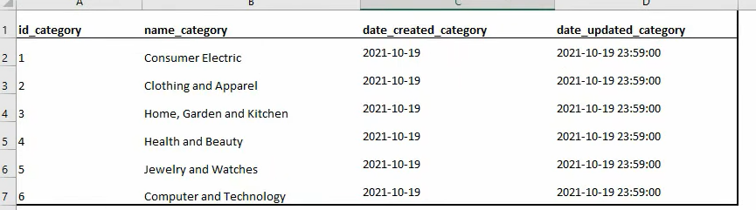

Clients

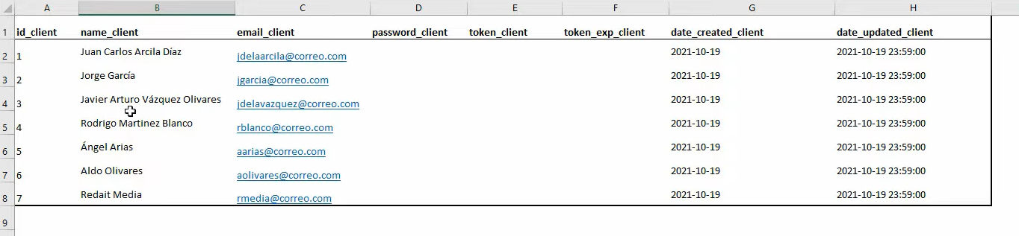

Countries

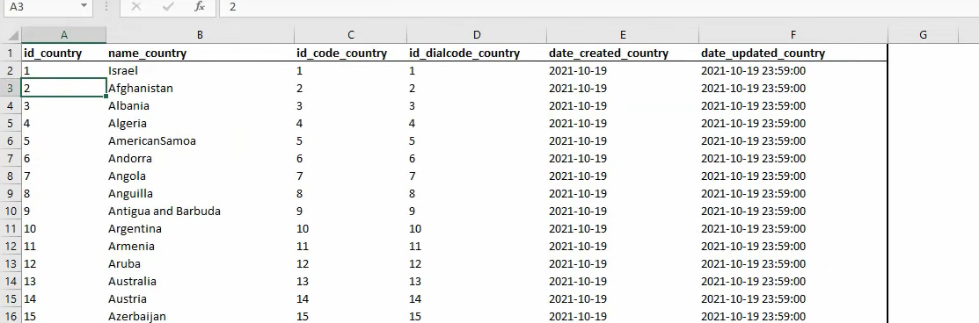

Codes

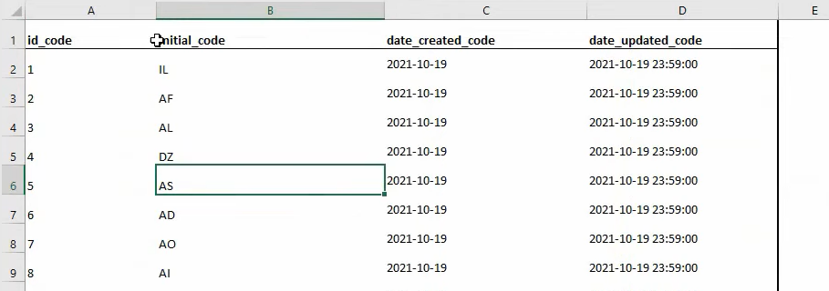

Users

