Assignment 2

Introduction
The aim of this report is to apply machine learning techniques to the Wisconsin Breast Cancer data set from the UCI Machine Learning Repository (Dua and Graff, 2019). The data was originally collected by Wolberg and Mangasarian (1990) and contains cytological measurements taken from breast tissue samples. The goal is straightforward: given these measurements, can we reliably predict whether a tumour is benign or malignant?
This is a worthwhile problem because getting the classification wrong has real consequences. A missed malignant case means delayed treatment, while a false alarm means unnecessary procedures and patient anxiety (American Cancer Society, 2024). The models need to be assessed not just on overall accuracy, but on how well they handle both types of errors.
To explore this, four different classifiers were built and compared in R: Logistic Regression, K-Nearest Neighbours (KNN), a Decision Tree, and Random Forest. The report covers the data and its preparation, explains why each method was chosen, walks through the R implementation, and then discusses the results.

Application Area and Data Used
Breast cancer diagnosis is one of the more common applications of classification in healthcare. The idea is not to replace doctors, but to give them a tool that can flag potentially malignant cases for closer inspection (Han, Kamber and Pei, 2012). In practice, this kind of model would sit alongside expert judgement rather than on its own.
The wisconsin.csv file has 699 patient records with nine predictor variables and a class label. The predictors are all scored on a 1 to 10 scale and cover things like clump thickness, cell size uniformity, cell shape, marginal adhesion, bare nuclei, bland chromatin, normal nucleoli, and mitoses. The class column is either "benign" or "malignant." There are sixteen missing values in the Bare.nuclei column, which works out to be about 2.3% of records.
Looking at the class split, there are 458 benign cases (65.5%) and 241 malignant (34.5%). This is a bit imbalanced but not drastically so. It does mean that a model could get decent accuracy just by predicting benign every time, which is why AUC was used as the main tuning metric instead of accuracy alone. AUC is less affected by class imbalance (Chawla et al., 2002).

Machine Learning Algorithms
Four models were chosen, each representing a different approach to classification. Logistic Regression works by fitting a linear equation to the log-odds of the outcome. It produces interpretable coefficients, and is commonly used in medical research for identifying risk factors (Kuhn and Johnson, 2013). It serves as a solid baseline here.
KNN takes a completely different approach. Instead of learning a function, it just looks at the most similar training examples and goes with the majority vote. The downside is that it relies heavily on distance calculations, so if the features are not on the same scale, it will not work well. This is why standardisation was applied before training (James et al., 2021).
The Decision Tree (CART, via the rpart package) splits the data into groups using a series of if-then rules. The big advantage is that you can look at the tree and understand the logic which matters in a medical setting. The drawback is that single trees tend to overfit (Han, Kamber and Pei, 2012). Random Forest addresses this by building many trees on random subsets of the data and features, then averaging their predictions. It usually gives better results than a single tree (Kuhn, 2008).
All four models were trained using repeated 10-fold cross-validation (3 repeats) in the caret package, with ROC as the optimisation metric. On the test set, they were evaluated using accuracy, kappa, sensitivity, specificity, F1-score, and AUC. Sensitivity got extra attention because missing a malignant case is the more dangerous mistake.

Pre-processing of Data
The data was loaded using read_csv() and checked for basic issues. The dimensions came back as expected (699 rows, 10 columns), all predictor values fell within the 1–10 range, and the only missing data was in Bare.nuclei. The Class column was converted to a factor with "benign" as the first level, which is how caret’s twoClassSummary function expects it when you want malignant treated as the positive class.
For the sixteen missing Bare.nuclei values, median imputation was used. The median is less sensitive to outliers than the mean and dropping those rows would have reduced the already modest sample size. After imputation, a quick check confirmed there were no remaining NAs.
The data was then split 70/30 into training and test sets using createDataPartition(), which does a stratified split, so both sets keep the same class proportions. This was verified in the output (both came out at about 65.5/34.5%). Standardisation was applied using preProcess() fitted on the training data only, then applied to both sets. Fitting it on the training set first is important so that information from the test set does not leak into the scaling parameters (James et al., 2021).
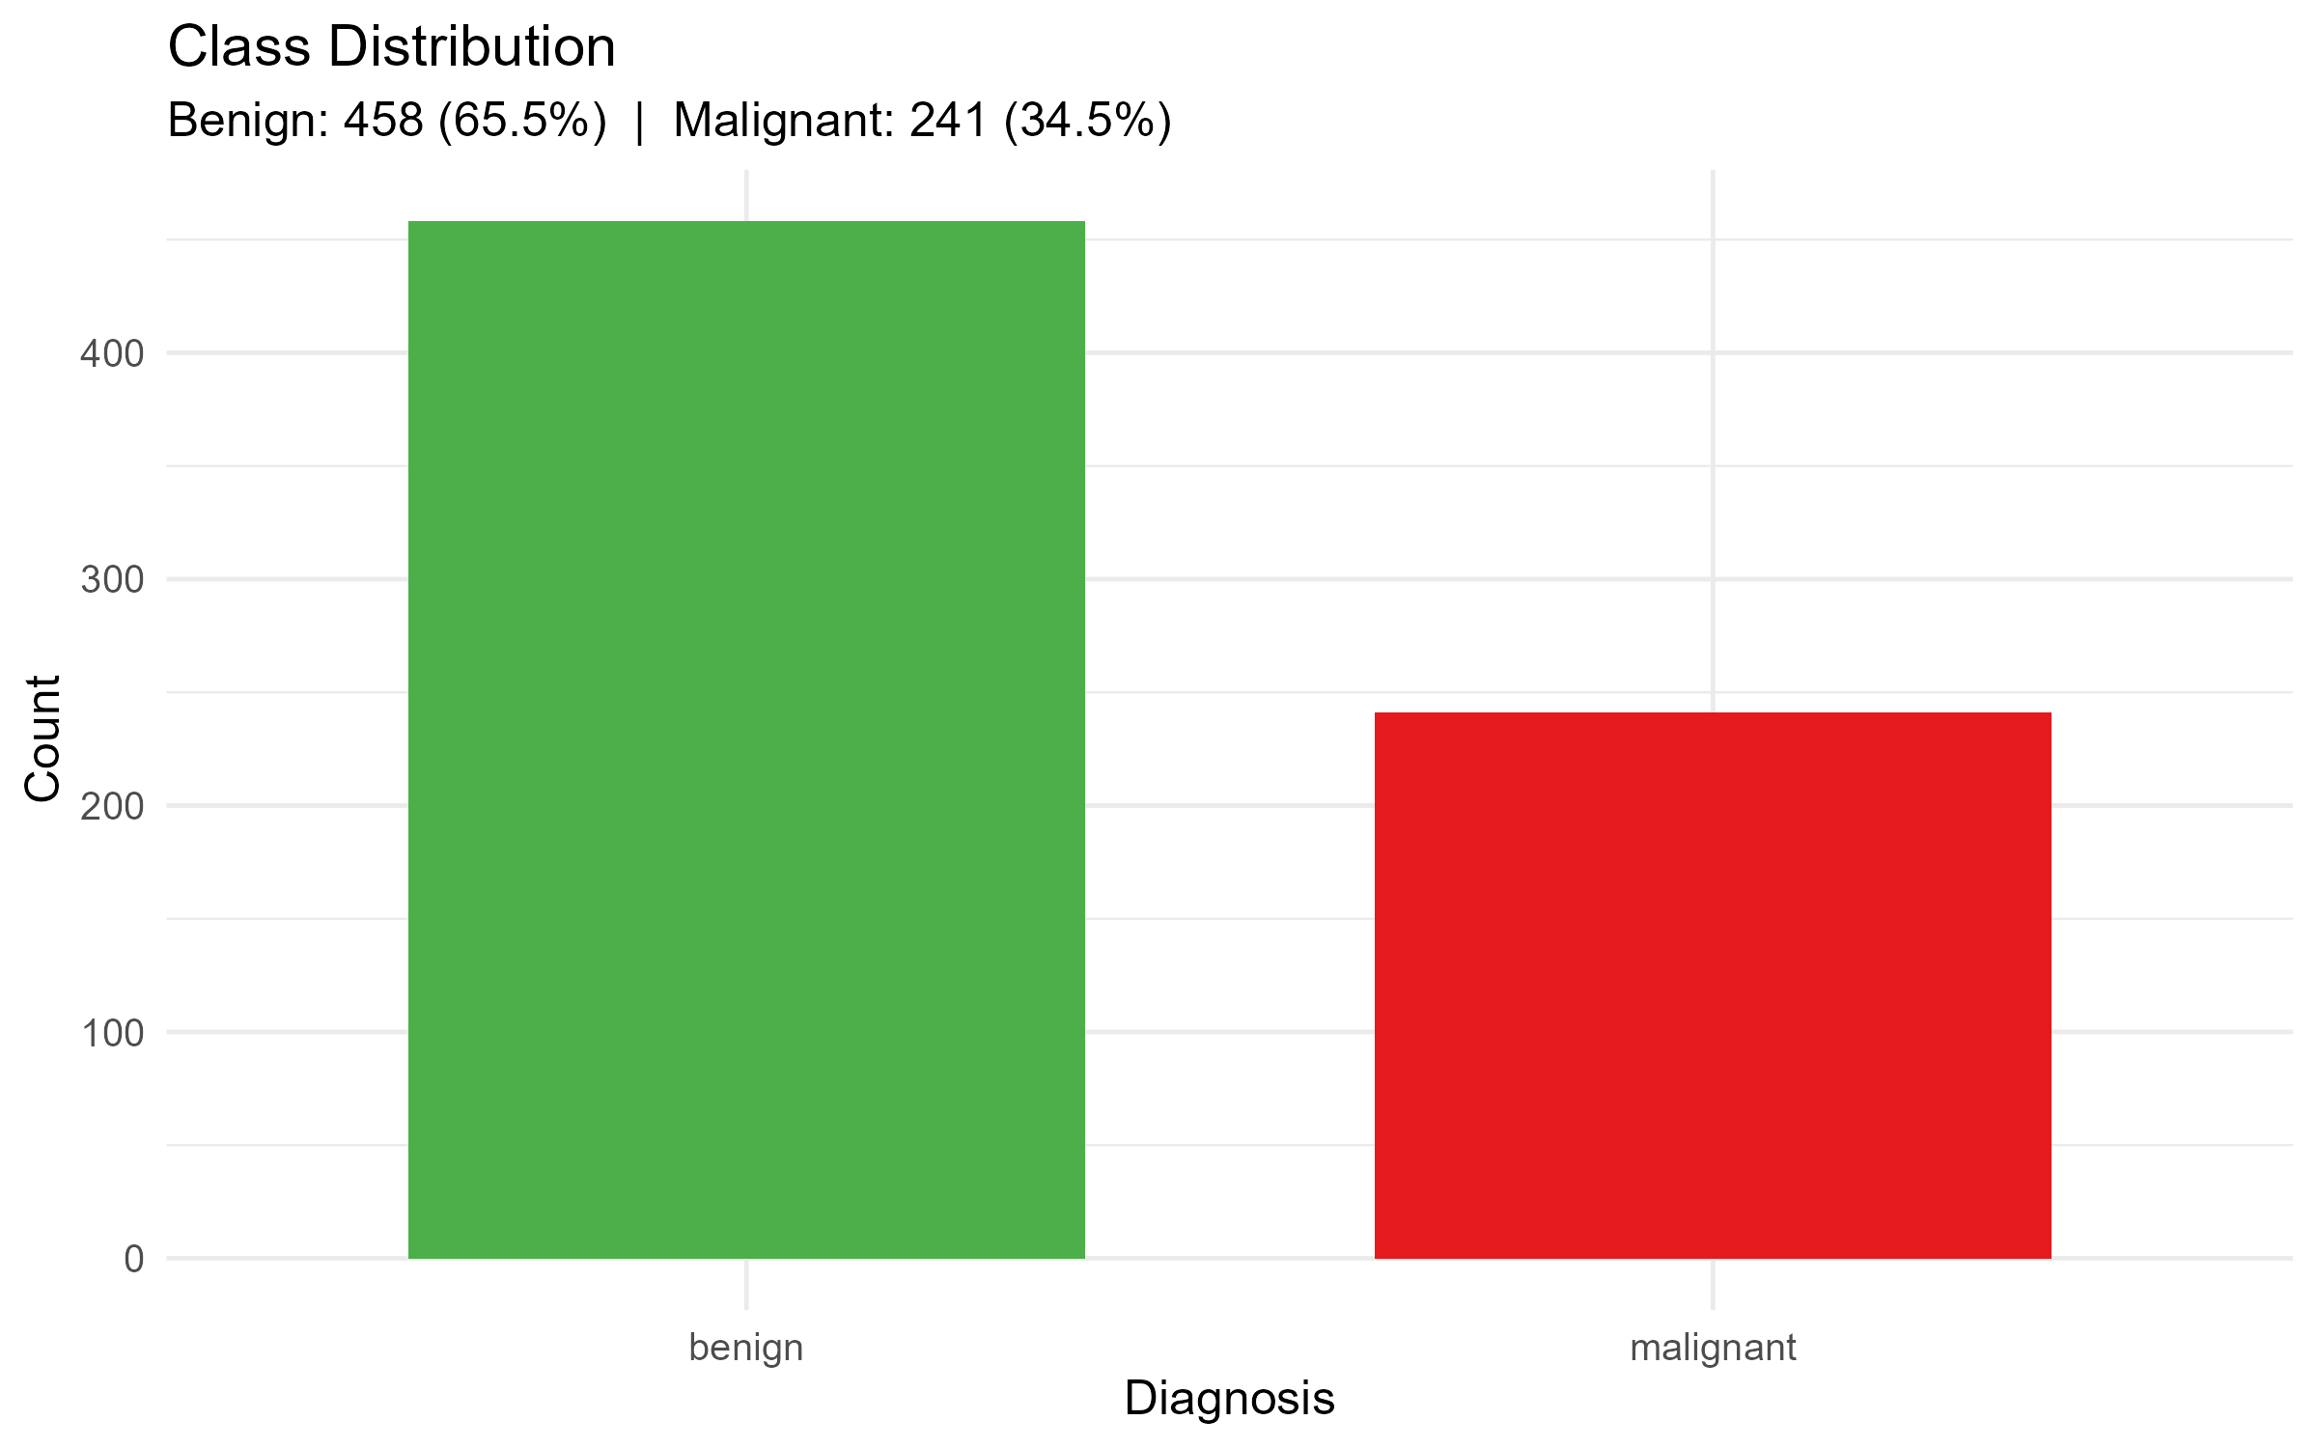
Figure 1: Class distribution – 65.5% benign, 34.5% malignant.

R Programming Content and Custom Function
This project was written in a single R script (wisconsin_analysis.R) that runs start to finish in RStudio. The script was broken into sections with comment headers for each stage: loading packages, reading data, preprocessing, EDA, splitting, training, evaluation, and saving outputs.
The main piece of original programming is the evaluate_model() function. It takes a trained caret model and the test data, generates predictions and class probabilities, builds a confusion matrix, computes a ROC curve, and bundles everything into a list. The list includes a data frame of metrics (accuracy, kappa, sensitivity, specificity, F1, AUC), the full confusion matrix object, and the ROC object for plotting later. This was useful because it meant each model could be scored with one line of code, and all four were guaranteed to be evaluated in the same way.
Model training used caret::train() with a shared trainControl setup so the comparison would be fair. KNN was tuned across 10 values of k (ended up picking k = 23), rpart across 10 complexity parameter values (cp = 0 worked best), and Random Forest across 5 values of mtry (settled on mtry = 2). Logistic Regression does not have hyperparameters to tune. Results were combined into a single table and saved as a CSV file for the report.
For exploration analysis, a few different visualisations were created: violin plots with boxplots overlaid for each predictor by class, a correlation heatmap showing which features are related to each other, and density plots for the six features that separated the classes best. These helped build intuition about the data before jumping into modelling.
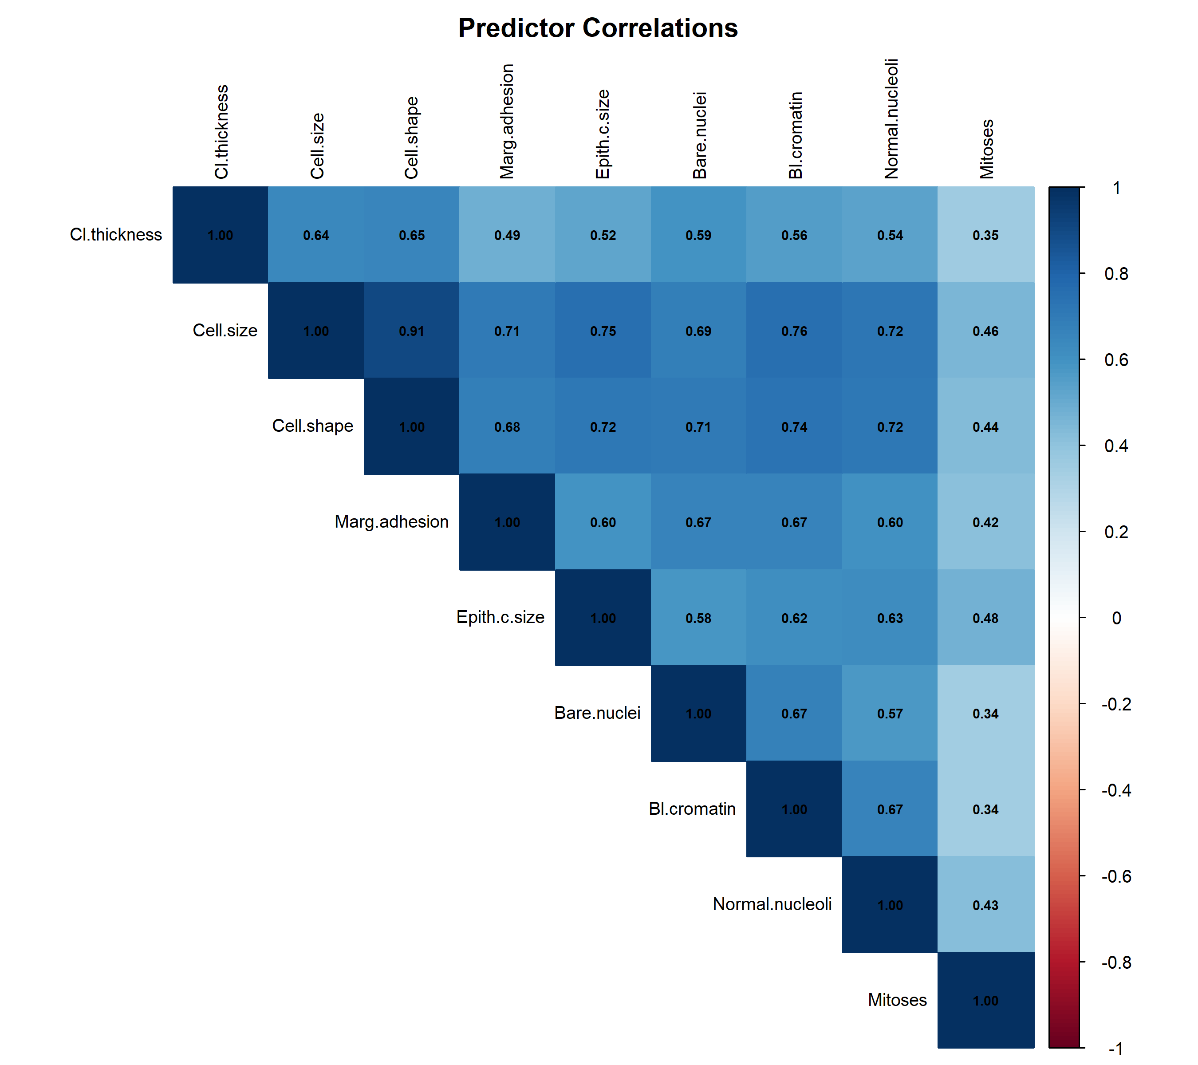
Figure 2: Correlation heatmap. Cell.size, Cell.shape, and Bare.nuclei are strongly correlated.
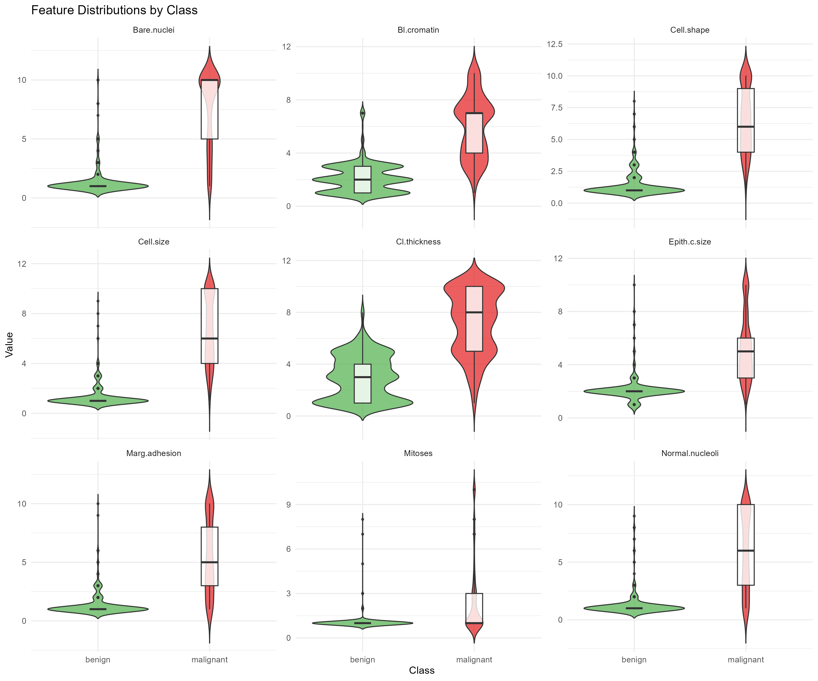
Figure 3: Violin plots showing feature distributions by class. Malignant cases tend to score higher across most predictors.

Display of Data and Results
Table 1 shows how each model performed on the test set. KNN came out on top with 98.6% accuracy and an AUC of 0.999, closely followed by Random Forest at 98.1%. Logistic Regression was not far behind either. The Decision Tree had the lowest accuracy at 96.2%, but interestingly it caught every single malignant case (sensitivity = 1.0). The trade-off was that it flagged eight benign cases as malignant.
Model | Accuracy | Kappa | Sensitivity | Specificity | F1 | AUC
KNN (k=23) | 0.986 | 0.968 | 0.986 | 0.985 | 0.979 | 0.999
Random Forest (mtry=2) | 0.981 | 0.958 | 0.972 | 0.985 | 0.972 | 0.997
Logistic Regression | 0.976 | 0.947 | 0.958 | 0.985 | 0.965 | 0.999
Decision Tree (cp=0) | 0.962 | 0.917 | 1.000 | 0.942 | 0.947 | 0.984
Table 1: Test-set performance for all four models.
The confusion matrices told a more nuanced story. KNN only missed one malignant case and had two false positives. Logistic Regression missed three, Random Forest missed two. In a clinical setting, which model you pick really depends on how much weight you give to each type of error. If the priority is never missing a malignant case, the Decision Tree looks appealing despite its lower accuracy.
The ROC curves for all four models were very close to the top-left corner, which is what you want to see. AUC values ranged from 0.984 (Decision Tree) to 0.999 (KNN and Logistic Regression). This suggests the cytological features in this dataset do a genuinely good job of separating the two classes.
Variable importance was looked at from two angles. Random Forest ranked Bare.nuclei, Cell.shape, and Cell.size as the top three. The logistic regression coefficients told a slightly different story, with Cl.thickness and Bl.cromatin also ranking highly. But both methods agreed that Bare.nuclei was the single most important predictor, which lines up with what you would expect from the medical literature on nuclear abnormalities.
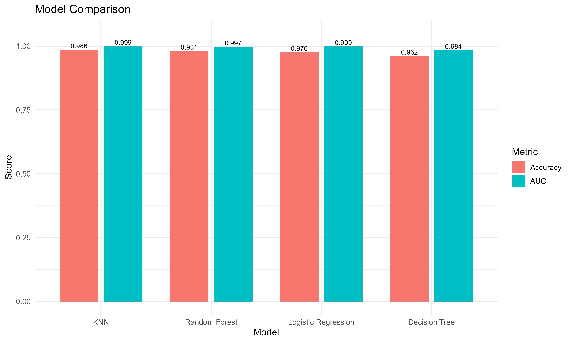
Figure 4: Accuracy and AUC comparison across models.
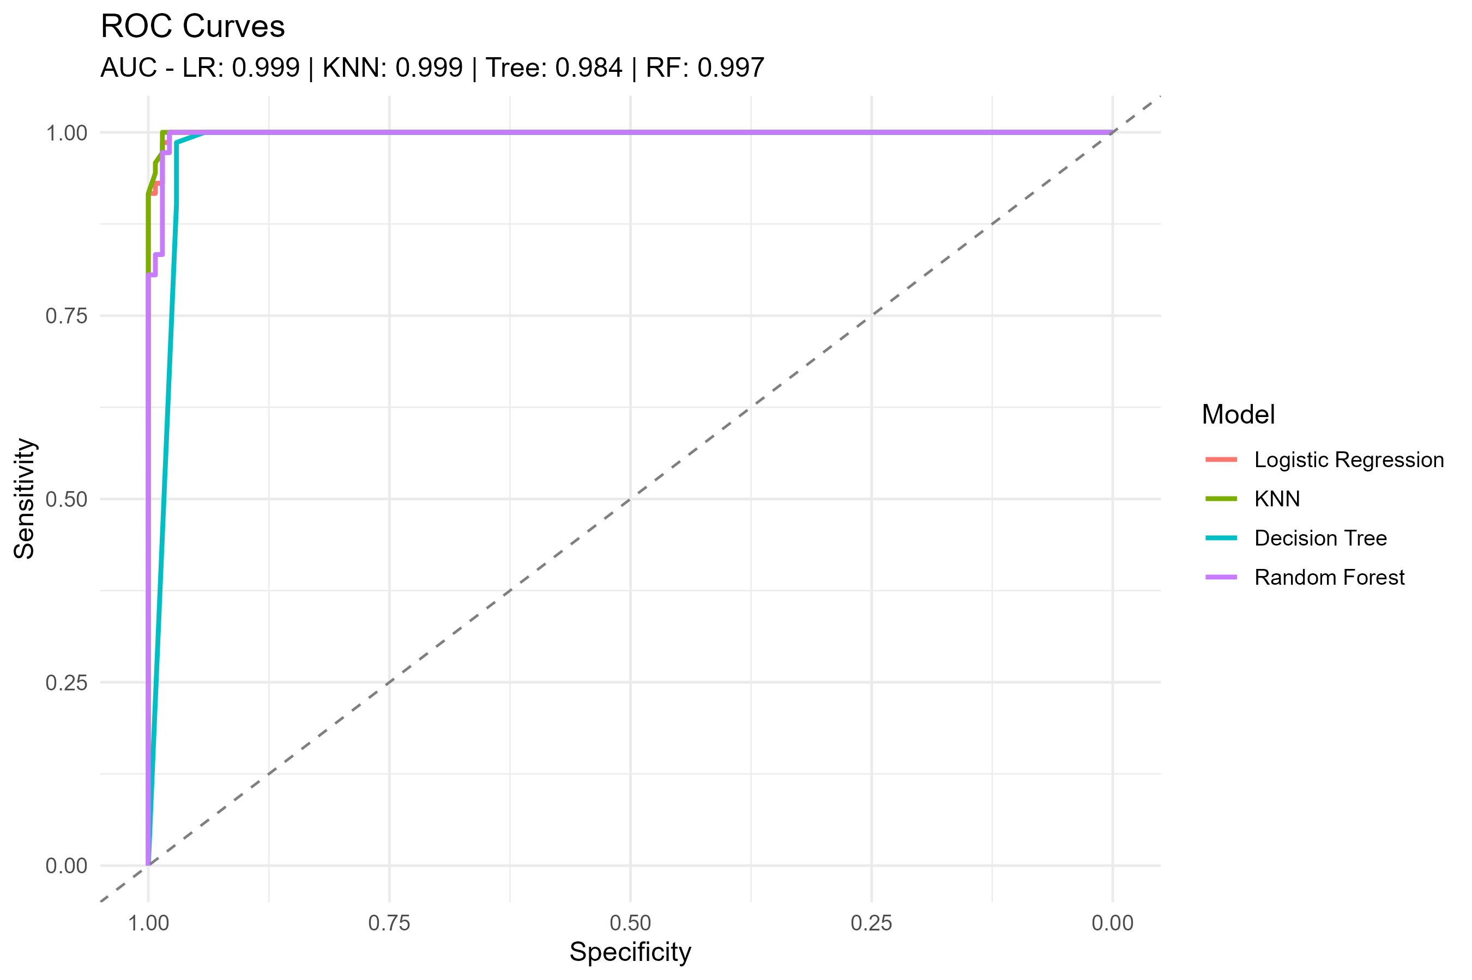
Figure 5: ROC curves. All models show strong discrimination.
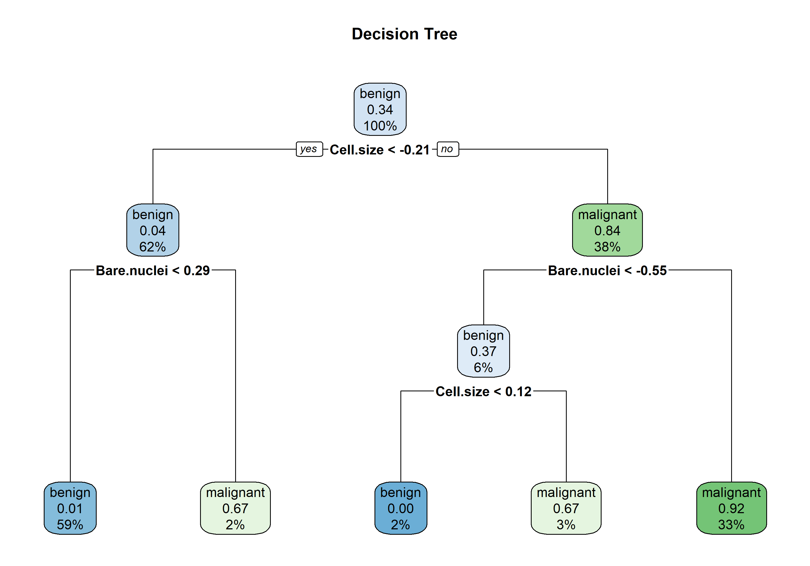
Figure 6: Decision tree structure – interpretable classification rules.
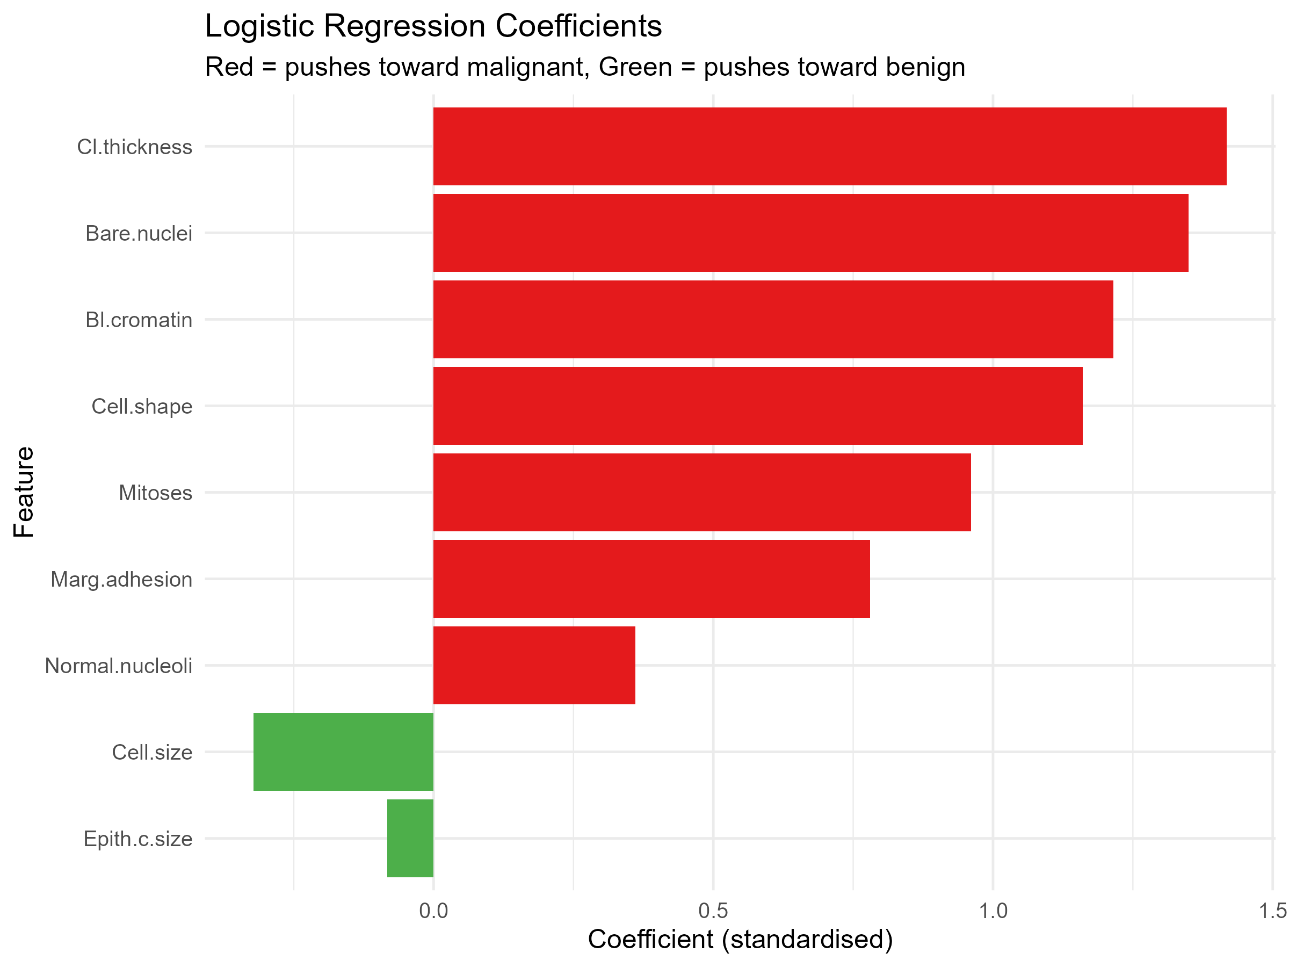
Figure 7: Logistic regression coefficients. Bare.nuclei and Cl.thickness have the largest effect.

Conclusions
Overall, the results show that all four models can classify this dataset with high accuracy, which is encouraging. KNN and Random Forest gave the best all-round performance, but the Decision Tree deserves credit for not missing a single malignant case. In a real screening scenario, which matters a lot.
Writing the evaluate_model() function turned out to be one of the more useful parts of the project. It made the code much cleaner and meant there was no risk of scoring one model differently from another. Feature importance from both Random Forest and logistic regression pointed to Bare.nuclei as the strongest predictor, which makes sense given what is known about nuclear irregularities in cancer cells.
There are some clear limitations. The dataset only has 699 records, and it is a well-known benchmark rather than real-world clinical data. Before using something like this in practice, you would need to validate it on a separate dataset. It would also be worth exploring cost-sensitive learning, where the model is explicitly told that missing a malignant case is worse than a false alarm. Other directions could include trying gradient boosting (XGBoost) or looking at whether the predicted probabilities are well calibrated.

Packages and Source Attribution
The following R packages were used: readr (data import), dplyr (data wrangling), ggplot2 (plotting), caret (model training and cross-validation), rpart and rpart.plot (decision trees), randomForest (ensemble method), pROC (ROC analysis), corrplot (correlation heatmap), and tidyr (reshaping data for plots).
All code in the accompanying R script is my own work. The general approach to using caret for model comparison follows patterns from the package documentation and Kuhn (2008). The Wisconsin data set was obtained from the UCI Machine Learning Repository (Dua and Graff, 2019). No third-party source code was used.

References
American Cancer Society (2024) Breast Cancer Facts & Figures. Available at: https://www.cancer.org/ (Accessed: 3 March 2026).
Chawla, N.V., Bowyer, K.W., Hall, L.O. and Kegelmeyer, W.P. (2002) ‘SMOTE: Synthetic Minority Over-sampling Technique’, Journal of Artificial Intelligence Research, 16, pp. 321–357.
Dua, D. and Graff, C. (2019) UCI Machine Learning Repository. Irvine, CA: University of California, School of Information and Computer Science. Available at: https://archive.ics.uci.edu/ (Accessed: 3 March 2026).
Han, J., Kamber, M. and Pei, J. (2012) Data Mining: Concepts and Techniques. 3rd edn. Waltham, MA: Morgan Kaufmann.
James, G., Witten, D., Hastie, T. and Tibshirani, R. (2021) An Introduction to Statistical Learning: with Applications in R. 2nd edn. New York: Springer.
Kuhn, M. (2008) ‘Building predictive models in R using the caret package’, Journal of Statistical Software, 28(5), pp. 1–26.
Kuhn, M. and Johnson, K. (2013) Applied Predictive Modeling. New York: Springer.
Robin, X. et al. (2011) ‘pROC: an open-source package for R and S+ to analyze and compare ROC curves’, BMC Bioinformatics, 12(77), pp. 1–8.
Wolberg, W.H. and Mangasarian, O.L. (1990) ‘Multisurface method of pattern separation for medical diagnosis applied to breast cytology’, Proceedings of the National Academy of Sciences, 87(23), pp. 9193–9196.

Appendix A: Full Source Code Listing
