Spesifikasi Desain Perangkat Lunak

untuk

Aplikasi *e-Filing* Pada PT Al-Amanah

Versi 1.0

Disiapkan oleh

Kelompok 4

Parera Jumano - 181022000012

Rachmat Rizal – 181022000003

Arif Rahman Andika - 181022000006

Januar Ilham - 182022000002

Danil Satria - 181022000011

20 April 2019

STMIK Eresha

Table of Contents

Table of Contents ii

Revision History iii

Approved By iii

1. Introduction 1

1.1 Purpose 1

1.2 System Overview 1

1.3 Design Map 1

1.4 Supporting Materials 1

1.5 Definitions and Acronyms 1

2. Design Considerations 1

2.1 Assumptions 1

2.2 Constraints 2

2.3 System Environment 2

2.4 Design Methodology 2

2.5 Risks and Volatile Areas 2

3. Architecture 2

3.1 Overview 2

3.2 Subsystem, Component, or Module 1 …N 2

3.3 Strategy 1…N 3

4. Database Schema 3

4.1 Tables, Fields and Relationships 3

4.1.1 Databases 3

4.1.2 New Tables 3

4.1.3 New Fields(s) 3

4.1.4 Fields Change(s) 3

4.1.5 All Other Changes 3

4.2 Data Migration 4

5. High Level Design 4

5.1 View / Model Element 1…N 4

6. Low Level Design 4

6.1 Module 1…N 4

7. User Interface Design 4

7.1 Application Controls 4

7.2 Screen 1… N 4

Appendix A: Project Timeline 5

Riwayat Revisi

|  |  |  |  |
| --- | --- | --- | --- |
| **Nama** | **Tanggal** | **Alasan Perubahan** | **Versi** |
| eFiling | 20-04-2019 |  | 1.0 |
|  |  |  |  |
|  |  |  |  |

Disetujui Oleh

|  |  |  |  |
| --- | --- | --- | --- |
| **Nama** | **Signature** | **Fungsi/Bagian** | **Tanggal** |
| Hermanto |  | Manager IT-Development |  |
|  |  |  |  |

# Pengantar

## Tujuan

Dokumen ini bertujuan untuk menjelaskan arsitektur perangkat lunak dan keputusan desain perangkat lunak untuk implementasi aplikasi e-Filing pada PT Al-Amanah. Audiens yang dituju dari dokumen ini adalah pengembang, perancang, dan penguji aplikasi e-Filing

## Gambaran Sistem

Aplikasi e-filing merupakan aplikasi dokumentasi surat-menyurat secara elektronik, yang merupakan bagian dari kegiatan surat-menyurat yang berjalan di PT Al Amanah.

## Peta Desain

## Definisi dan Akronim

# Pertimbangan Desain

## Asumsi-asumsi

## Kendala

## Lingkungan Sistem

Aplikasi e-Filing merupakan aplikasi berbasis web yang menggunakan server web Internet Information Server (IIS), dan di kembangkan dengan teknologi asp .net. Aplikasi e-Filing akan di bangun menggunakan bahasa VB.NET dan menggunakan database MySQL sebagai back end nya.

## Metodologi Desain

(Optional) - Summarize the approach that will be used to create and evolve the designs for this system. Cover any processes, conventions, policies, techniques or other issues which will guide design work.

## Risiko dan Area Volatile

# Arsitektur

The architecture provides the top level design view of a system and provides a basis for more detailed design work

Provide or reference a detailed description and diagrams of the architecture..

## Overview

This section provides a high level overview of the structural and functional decomposition of the system. Focus on how and why the system was decomposed in a particular way rather than on details of the particular components. Include information on the major responsibilities and roles the system (or portions) must play.

## Subsystem, Component, or Module 1 …N

You only need to provide this level of detail for elements which are custom for this design. Do not go into gory detail. Goal is to get 80% of the elements figured out ahead of time.

Describe an element (subsystem, component, module, etc.) from architecture in further detail. When appropriate, include information on how the element is further broken down and the interactions and relationships between these subcomponents.

## Strategy 1…N

Describe the strategy used or decision made. Include information on the alternatives considered and the reasons for their rejection.

# Class Diagram

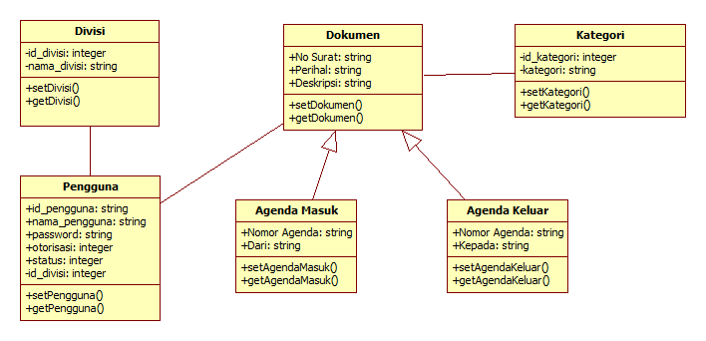

# Sequence Diagram

## Sequence Diagram Login

## Sequence Diagram Kelola Data Divisi

**5.2.1 Sequence Diagram Lihat Data Divisi**

**5.2.2 Sequence Diagram Tambah Data Divisi**

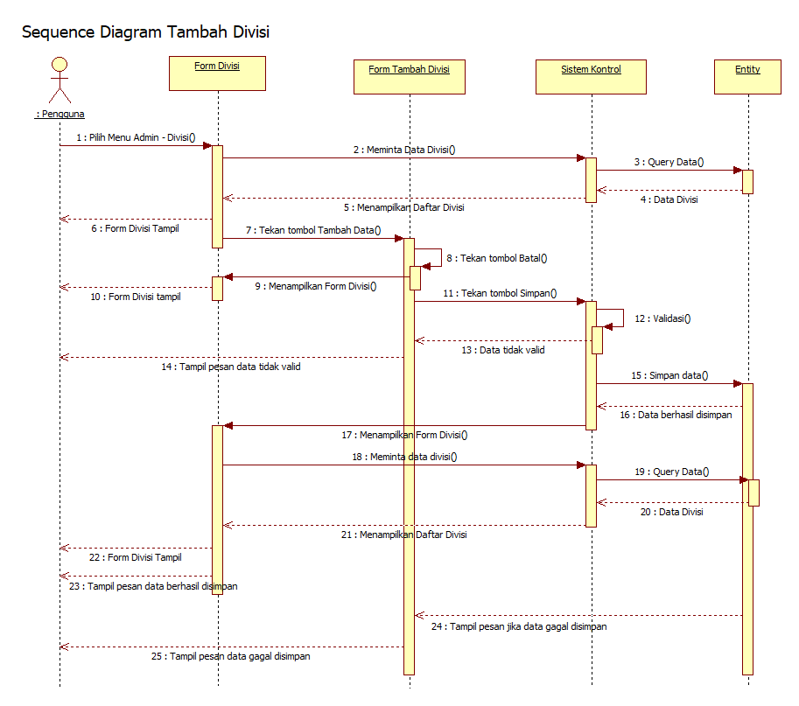

**5.2.2 Sequence Diagram Ubah Data Divisi**

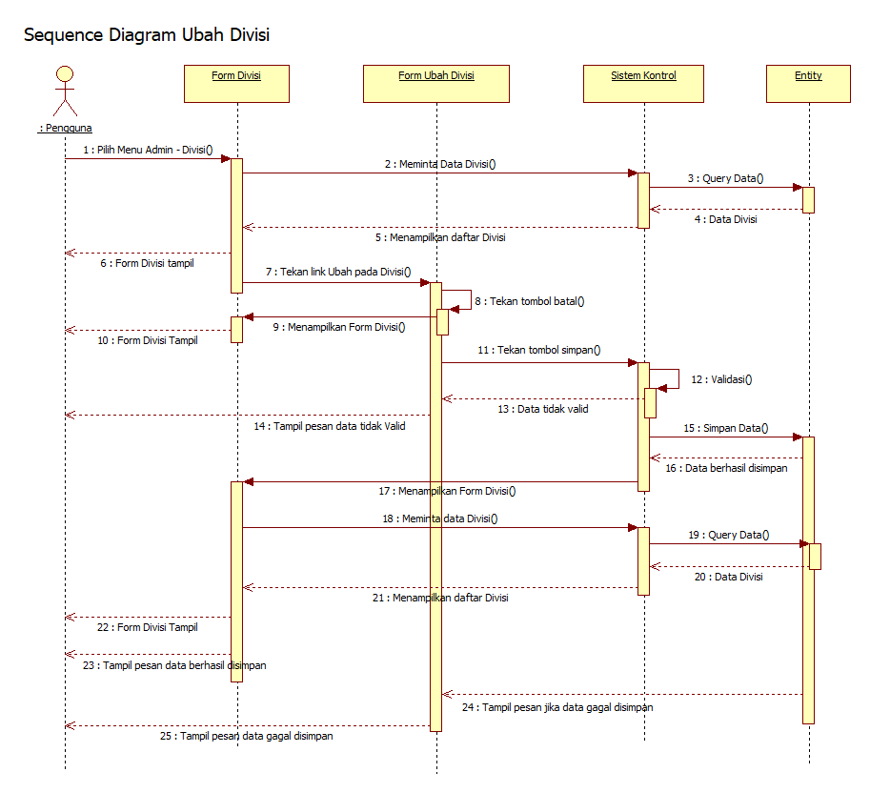

## Sequence Diagram Kelola Data Pengguna

### 5.3.1 Sequence Diagram Lihat Data Pengguna

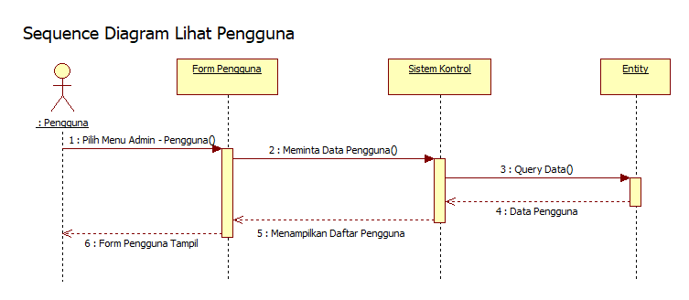

### 5.3.2 Sequence Diagram Tambah Data Pengguna

**5.3.3 Sequence Diagram Ubah Data Pengguna**

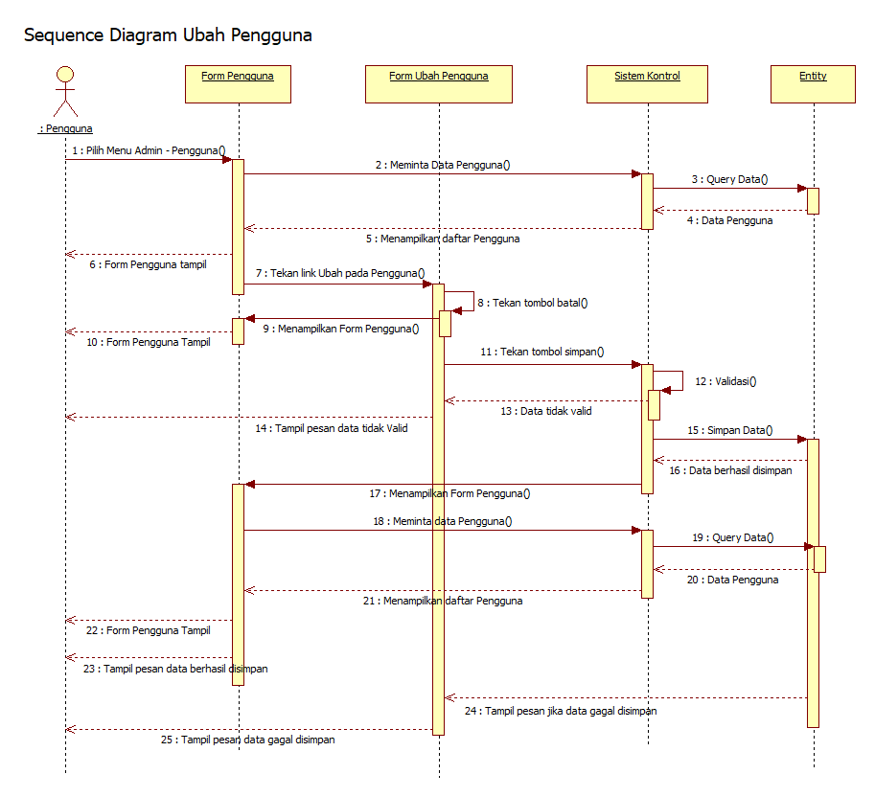

## Sequence Diagram Kelola Data Log

## Sequence Diagram Kelola Data Kategori

### Sequence Diagram Lihat Data Kategori

### Sequence Diagram Tambah Data Kategori

### Sequence Diagram Ubah Data Kategori

## Sequence Diagram Kelola Data Agenda Masuk

### Sequence Diagram Lihat/Cari Data Agenda Masuk

### Sequence Diagram Tambah Data Agenda Masuk

### Sequence Diagram Ubah Data Agenda Masuk

## Sequence Diagram Kelola Data Agenda Keluar

### Sequence Diagram Lihat/Cari Agenda Keluar

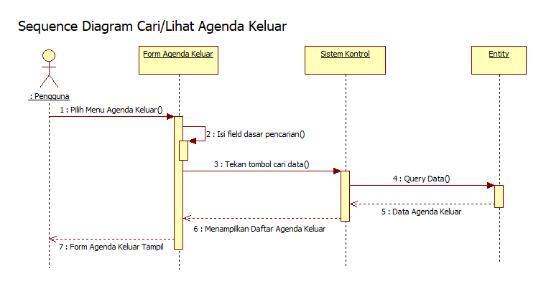

### Sequence Diagram Tambah Data Agenda Keluar

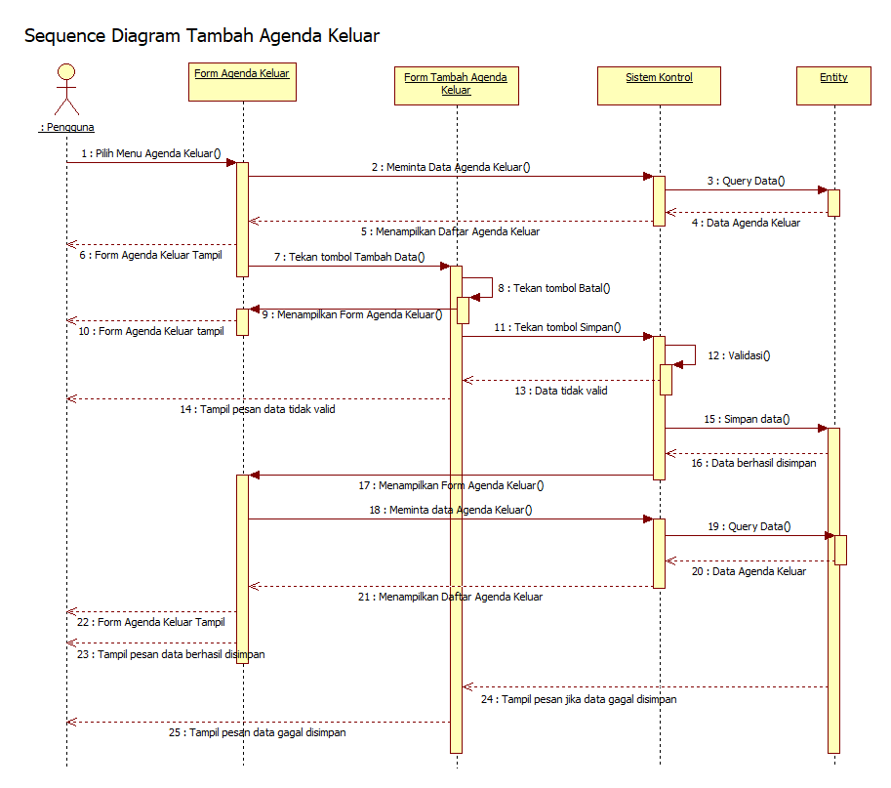

### Sequence Diagram Ubah Data Agenda Keluar

## Sequence Diagram Kelola Password

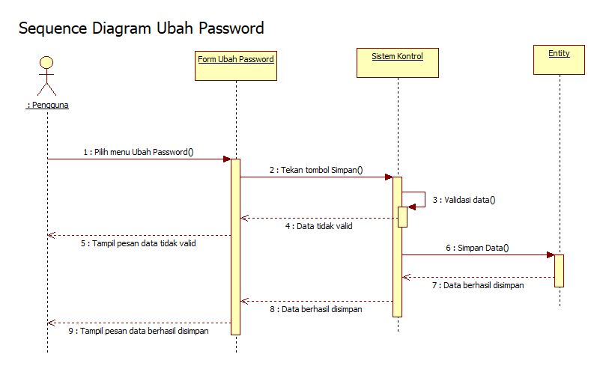

## Sequence Diagram Logout

# Database Schema

## Database Diagram

## Tables, Fields and Relationships

Provide a description of any new tables, fields and relationships that need to be created for the design.

### Databases

BPData production, BPDataPCMSTest for development and testing..

### New Tables

List any new tables that will be needed, for each one including table name, table description, and related tables.

### New Fields(s)

List any new tables that will be needed, for each one including table name, table description, and related tables.

|  |  |  |  |  |
| --- | --- | --- | --- | --- |
| **Table Name** | **Field Name** | **Data Type** | **Allow Nulls** | **Field Description** |
| BinderRequest | SellingRep | Varchar(50) |  | Get this field from BankPlan.ProposalRepCode  But use actual name (Roy Pinnell) |
| BinderRequest | SigningRep | Varchar(50) |  | Get this field from Bankplan.SigningRepCode  But use actual name (Roy Pinnell) |
| ProcessBP | ParentProcessID | Int | Yes | This will tie a subprocess to a process |
| BinderRequest | ProjectedWireDate | Date |  | The earliest Policy.ProposalWireDate of all included policies in the scenario. |
|  |  |  |  |  |
|  |  |  |  |  |

### Fields Change(s)

*For each field change (such as data types, required/not required, or renaming), please complete a row of the following table. (Insert additional rows as needed.)*

|  |  |  |
| --- | --- | --- |
| **Table Name** | **Field Name** | **What to change?** |
|  |  |  |
|  |  |  |
|  |  |  |
|  |  |  |

### All Other Changes

*If any other changes are requested (stored procedures, indexes, relationships, security settings, DTS packages, maintenance plans, etc), please describe what is needed here.*

## Data Migration

(Optional) - Provide a description of how existing data should be migrated to new tables and fields.

# High Level Design

## Binder Request Form

The notes tab should have fields displayed in the order Date|Author|Note.

Users will select a contact from a dropdown on the binder request form. If no binder contact exists for the current binder, the user will need to go to the Contacts module and add a binder contact.

Users will now have two places to click to save their binder requests. A new “Submit” button will be added to the binder request form.

Users will be able to delete binder requests as well. A new “Cancel” button will be added to the binder request form.

Automatic bank check-in will be removed. The user will be required to manually check in the bank before a binder request is submitted.

There will be three new fields on the binder request form. “Proposal Rep”, “Signing Rep”, and “Projected Wire Date” will be added to the form. Whenever a user selects email or fax as a delivery method, these fields must be set to ‘required’ in the Contacts area of the binder request form.

Account Manager will be added as a new delivery option for both the unsigned and signed delivery method.

## User Interface Modifications

Formatting modifications:

SUE –Will recheck the TRMs for Binder REQUEST.

Process modifications to the User Interface.

Make the task name subprocess reflect the delivery option name.

Null the task completion dates for each process at it’s creation . Teamplate will enter the completion date.

Automatically generate a note when binder request is created.

Add 30 day, 60 day, 90 day and 120 day tasklists for the user.at the menu level.

## Workflow sub-processes

Workflow subprocesses will be created for each individual binder in each binder request. The Teamplate Model that will be used to create the subprocess is called BinderPerCarrier.

Binder Extension subprocesses will be created each time an extension is needed for each binder. The Teamplate Model name used to create the subprocess is called BinderExtension.

# Low Level Design

This section provides low-level design descriptions that directly support construction of modules. Normally this section would be split into separate documents for different areas of the design.

## Binder Request Form

### Contact Changes

The format of the name in the drop down will be “firstname lastname”. Only ‘Binder Request’ contacts will be displayed. If more than one Binder Contact exists for this bank, initially all the Contact information will be filled in with the information from the Binder Contact that is listed as Primary in the contacts module. If no Binder Contact exists for this bank, then no Contact information will be filled in. The user will then need to go to the Contacts module to add a Binder Contact Type and Save the new Contact. NOTE: It is very important that the user remembers to “Save” the Binder Contact in the Contacts Module. Otherwise, the Binder Request Form will not be able to populate the Contact information.

Any time the user returns to the binder request node before the binder request has been saved, the system will refresh the contact name dropdown with the latest contact information for the bank.

Any Contact data that is entered on the binder request screen will be saved to the BinderRequest table and only valid for that binder. The Contact information saved with that Binder will not be saved to the account Contact’s information. If a user wishes to change the data for a contact, they must do that in the Contact module

### Submit Button

The submit button will only be enabled for those users that are in the BinderRequestCreate group. Once the user has entered all the information for the binder request, they will press “Submit” and it will submit the binder request. All fields marked in red will be validated before submission. The “Submit” button will work function like the ‘Save’ button on the toolbar.

### Cancel Button

The “Cancel” button will only be enabled for users who belong to the BinderRequestApprove group. This button will only be enabled and used one the binder request is passed the “Approved” task. The user will be prompted “Are you sure you would like to cancel this binder request”. The cancellation will delete all Teamplate processes associated with the binder request and moark the policy groups as “Not Taken”. There is currently a stored procedure called spRemoveProcess that deletes from the correct tables. This stored procedure should be used when removing a process. It will need to be modified to handle deleting the new subprocesses spawned from the main process.

?????? What do we want to do with the binder status (in regards to the binder process report of binder status)

### Automatic Bank Check-in

There will no longer be an automatic bank check-in when the binder request is submitted. Before a binder request is saved, the user must check in a bank. If the bank is not checked in, a message will be displayed indicating to the user that they must first check in the bank before creating a binder request. There is a column located in the bank table called checkout that can be used to determine if the bank is still checked out.

### Other Changes

This sub-section will group together some of the other small changes with the Binder Request form.

Whenever a user selects e-mail or fax as a delivery method, the e-mail or fax fields located in the Contact area will be required by the user to fill in before they are allowed to save. Change the labels to display in red so that the user knows this is required field.

The binder request form will have three new fields. These fields will be read only and will be populated by data stored in TOPS.

## Workflow sub-processes

Once the Binder Request has been approved, the Binder Request process will spawn off 1 to n child processes (BinderRequestPerCarrier). There will be one child process per carrier (or policy group). There could be more than one child process per carrier if the product or interest rate is different. The child processes will be connected to the main process via the ProcessBP table. Since each process is inserted into this table, we will add a parentprocessid column to the table. For each process that is inserted into the processBP table, the parentprocessid will be the process ID of the main process.

### Binder Extension

A Binder Extension Process will be created for a Binder if the “Submit Case to Carrier” step for that Binder has not been completed within 5 days of the Wire Expiration Date. A long running Windows Service will need to be created and run daily to find any Binders that need an extension. This service will need to check the due date of the “Submit Case to Carrier” task in Teamplate of each Binder and see if the current date is within the 5 days. If it is, the windows service will need to start the Binder Extension process. A row will need to be inserted into the ProcessBP table for the new process and the parentprocessid column filled in with the process id of the binder the extension was created for. The process type column in the ProcessBP table will be populated with the value “BinderExtension”.

The following query will find Binders that need to have a Binder Extension process created for them that currently do not:

SELECT ProcessID, DueDate FROM ProcessBP

INNER JOIN TeamPlate..Process TP ON ProcessBP.ProcessID = TP.ID

INNER JOIN TeamPlate..Task TPT ON TP.ID = TPT.PID

WHERE ProcessType = 'BinderRequest'

AND TP.Status <> 'Complete'

AND TPT.Name = 'Submit Case to Carriers'

AND TPT.DueDate <= dateAdd( day, 5, getdate())

AND ProcessID NOT IN ( SELECT parentProcessID from ProcessBP WHERE ProcessType = ‘BinderExtension’)

The processID from the query will be used to populate the parentprocessId column in the processBp table. When the Binder Extension process is created it calls the CreateProcessBp located in WorkFlowCommon. This function will need to get updated to handle another parameter called parentprocessID. This parameter will need to be passed in when the Binder Extension is created and when each individual Binder is created. When modifying this function, please keep in mind that the first phase of the Binder request calls this as well as the sub process Binder Delivery in Teamplate. These will need to be modified as well.

When the task tskSubmitCaseToCarrier in a Binder process is advanced and asked to complete, it will first need to check and make sure that there is no Binder Extension that was created for that Binder. The following SQL will find if there is a Binder Extension for that Binder:

SELECT ID FROM Teamplate..Process TP

WHERE Status <> ‘Complete’

AND ID IN ( SELECT ISNULL(ProcessID,0) as processID FROM ProcessBP

WHERE parentProcessID = xxxx

AND ProcessType = ‘BinderExtension’ )

Where xxxx is the processID of the Binder we are checking for. If the query returns an ID greater than 0, then we know that there is a Binder Extension process that still has not completed. If this is the case, the Binder will NOT be allowed to complete. This code will be called from a consumed web service on the execute event of the task tskSubmitCaseToCarrier of the Binder.

If the Binder Extension’s last task reaches it’s due date, then the Binder Extension needs to be reworked and start back at the beginning step.

# User Interface Design

This section provides user interface design descriptions that directly support construction of user interface screens.

## Application Controls

Detail the common behavior that all screens will have. Common look and feel details such as menus, popup menus, toolbars, status bar, title bars, drag and drop mouse behavior should be described here.

## Screen 1… N

Illustrate all major user interface screens and describe the behavior and state changes that the user will experience.

A screen transition diagram or table can optionally be created to illustrate the flow of control through the various screens.

### Workflow Reports

??? Are these the correct parameters for this report???

Add calendar control next to all dates.

Remove the Binder Status report and the Binder Extension Report from BPS..

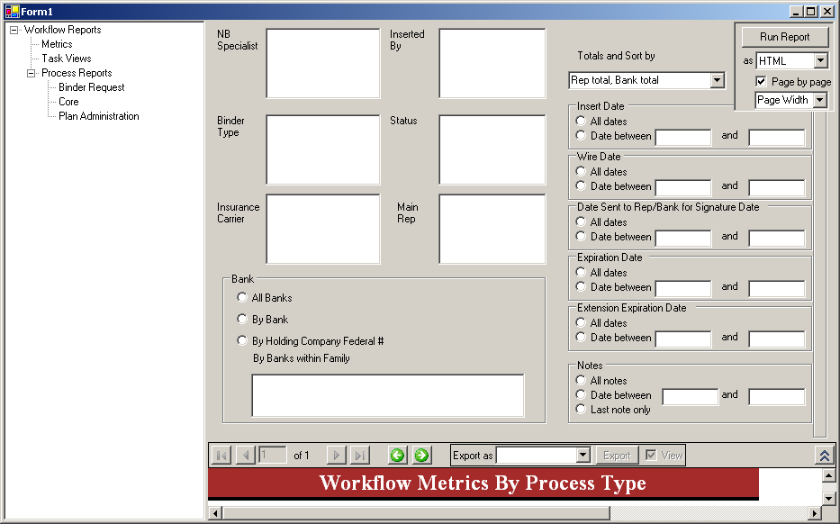

The following is a breakdown of the values in the above Workflow Reports screen:

|  |  |  |
| --- | --- | --- |
| **Label Name** | **Note** | **Source** |
| NB Specialist |  | SELECT UWUserID FROM PolicyGroup GROUP BY UWUserID ORDER BY PolicyGroup.UWUserID; |
| Inserted By | Change to be a dropdown containing the NB Cordinators (approve group).  Add to the BinderRequest table a new filed ‘NBCordinator’ | SELECT InsertBy FROM PolicyGroup GROUP BY InsertBy ORDER BY InsertBy;  Query active directory to return the NBCordinator group. |
| Binder Type |  | SELECT CodeToText.Code, CodeToText.Text FROM CodeToText WHERE (((CodeToText.TableDotField)='PolicyGroup.Type')) ORDER BY CodeToText.SortOrder; |
| Status | This will not be used. | SELECT PolicyStatus.Status, PolicyStatus.PolicyGroupApply FROM PolicyStatus WHERE (((PolicyStatus.PolicyGroupApply)<>0)) ORDER BY PolicyStatus.Status; |
| Insurance Carrier |  | SELECT InsCo.InsCo, InsCo.CompanyName FROM InsCo ORDER BY InsCo.InsCo, InsCo.CompanyName; |
| Main Rep | Will this be the ***selling*** or ***signing*** rep? | SELECT Rep.RepCode, [LName]+", " & [FName] AS Name, Rep.RepCode AS AcctgRepCode FROM Rep ORDER BY [LName]+", " & [FName]; |
|  |  |  |

Appendix A: Project Timeline

Reference the Microsoft project Binder Request Release 2 – Development..