**MARTIN OUMA CORNEL**

℅ Insteel Limited: P.O. Box 78161 – 00507 NAIROBI, Kenya.

**Mobile**: 0724755556 | **Email**: mrtncornel@gmail.com | **Web:** martin.superflygroup.com

13 November, 2017

**To**

The Human Resources Manager

And persons concerned with recruitment.

Dear Sir/Madam,

**REF: SEEKING ICT RELATED PLACEMENT (ENTRY LEVEL)**

I hope this finds you well. Allow me to humbly communicate my interest and aptness for relevant placement with your company. I seek to build my career in IT and computing.

I am a part-time student of MSc. Software Engineering continuing the research 2nd year holding a BSc. in Computer Science (Second class upper). I have skills and work experience in IT support, computer diagnosis and repair, databases, networks and coding (Java, Python, CMS and Websites). My communication skills, presentation, attention to details, team work, interpersonal and problem solving skills are commendable.

My past work experience was attained while working for IEBC, KEMRI and Daproim Africa. I am available and enthusiastic to start working with and for you as soon as needed. I hope to exercise the knowledge and skills I have and to gain more experience working with other staff of your company.

Your response will be a great honor. I hope to hear from you to set up an interview in which I would showcase my work, skills and personality. Find my CV attached to this letter.

Have all the best in your daily endeavors.

Yours faithfully,

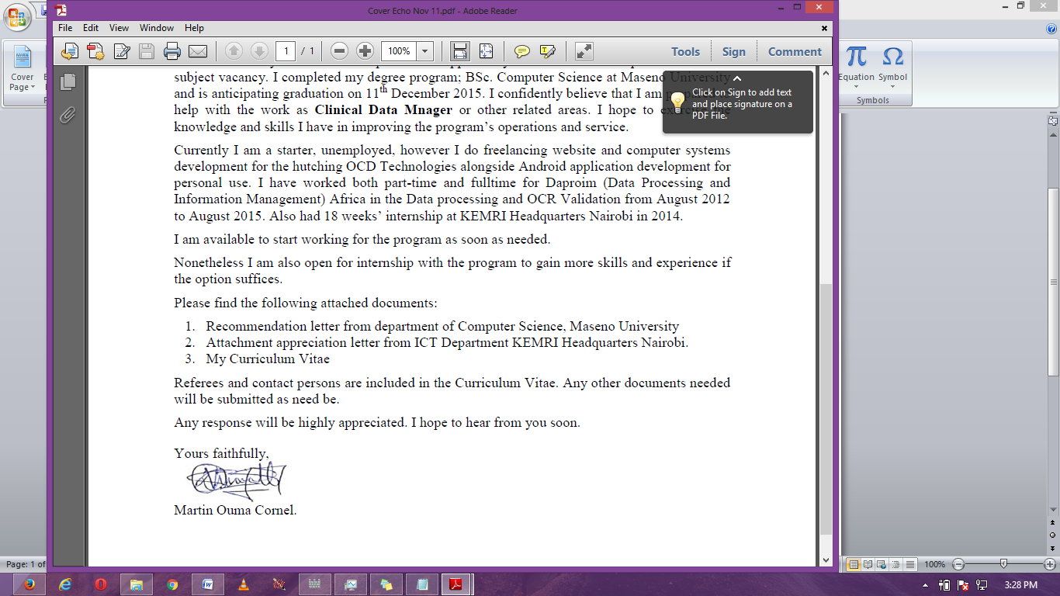

Martin O. Cornel.