1) Create account with telegram account
2) Visit https://telegram.me/botfather
3) start conversation with botfather
4) type /newbot
5) will be prompted to name bot
6) then enter username for bot (must end in ‘bot’ e.g. ‘DoorbellBot’ or ‘doorbell_bot’)
7) The bot will then create a token which will be needed later
8) There will also be a link starting with ‘t.me’ , click the link and press start conversation
9) go to the below address replacing <YourBOTToken> with the token generated earlier
https://api.telegram.org/bot<YourBOTToken>/getUpdates
10) look for where it says “chat”:{“id”: followed by a string of numbers
11) Save this for later; this is the Chat Id

Make sure that raspbian is installed and set up on the pi; more can be found out at:
https://www.raspberrypi.org/downloads/raspbian/
Make sure remote GPIO is enabled in the config by typing ‘sudo raspi-config’ in the terminal and going to interfacing options

12)on the pi type ‘pip install python-telegram-bot --upgrade’ and press enter
13)wait for download to finish
14) on the pi type: ‘sudo apt-get install fswebcam’ and press enter
15) Download the WebDoorbell.py file and open it, either through nano over ssh or through idle directly on the pi
16) replace where it says PASTE BOT TOKEN HERE with the token generated when the bot was created
17) go to lines 19 and 20; replace where it says PlaceChatIdHere with the Chat Id from earlier
18) save the file and turn off the pi

19) connect the pi to breadboard like below:
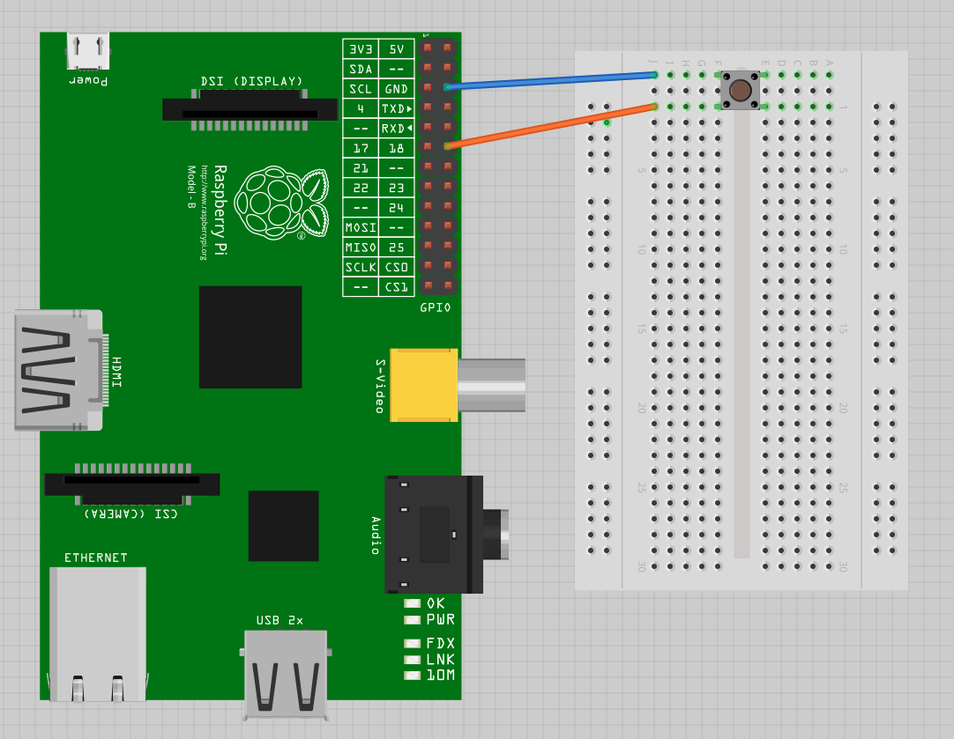

make sure that one of the pins is connected to ground and the other to GPIO pin 18, and make sure webcam is connected over USB.

20) Turn the pi back on and type ‘sudo python WebDoorbell.py’
21) When the button is pressed a message and photo should be sent to the telegram app
22) to run the program headless type ‘nohup sudo python WebDoorbell.py’ from a ssh client

