**Creating a Power Systems Virtual Server Instance  
  
Assumptions:**

1. Private network subnet already created for your Power Systems Virtual Server service. For more info [here](https://cloud.ibm.com/docs/power-iaas?topic=power-iaas-configuring-subnet).

2. RHEL 8.0+ image already imported. For more info [here](https://cloud.ibm.com/docs/power-iaas?topic=power-iaas-importing-boot-image).

**Procedure:**  
1. Click **Create instance** under Virtual server instances.

2. Fill in **Instance name** field under the **Virtual servers section**. Leave other options unchanged.

3. Click on **SSH key** section. Choose an existing SSH key from dropdown or click on **New SSH key** to create one to securely connect to your Power Systems Virtual Server.

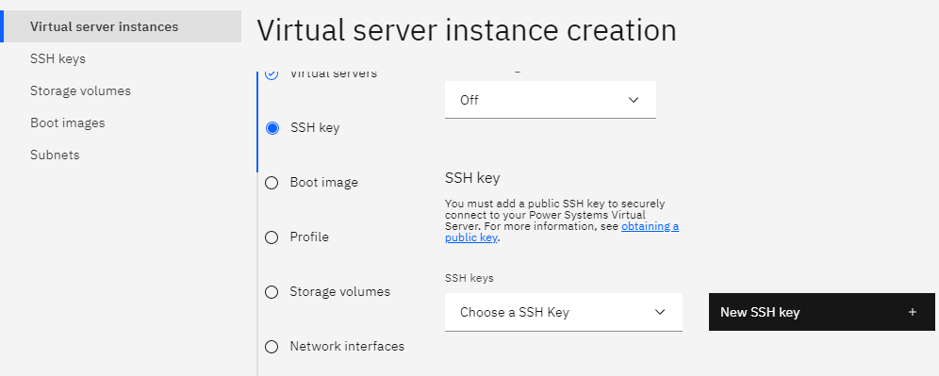

Fill in **Key name** field under **New SSH Key** section. Paste your **Public key** and click on **Add SSH key**

Select the newly created key under **SSH keys** dropdown

4. Click on **Boot image** section. Choose **Linux – Client supplied subscription** under **Operating system** dropdown and name of image which you have already imported under **Image dropdown.**

5. Click on **Profile** section. Choose your preferred **Machine type**. Increase **Core (CPUs)** (recommended - 1) and **Memory (GB)** (recommended - 8) as per your need. Leave other options unchanged.

6. Click on **Storage volumes** section. Click on **New storage volume**. Fill in **Name** field for volume. Select **Size** as per your need (recommended - 300). Leave other options unchanged. Click on **Create and attach**.

7. Click on **Network interfaces** section. Toggle **Public networks** button to “**On**” state. Click on **Attach existing** under Private networks. Select the private network you already created under **Existing networks** dropdown. Leave other options unchanged. Click on **Attach**.

8. Select **I agree to the Terms and conditions** checkbox under Summary tab and click on **Create instance**.

For more detailed info [here](https://cloud.ibm.com/docs/power-iaas?topic=power-iaas-creating-power-virtual-server).

Retrieving Power Systems Virtual Server Instance details  
  
Newly created Instance listed under **Virtual server instances** tab.  
  
  
Click on the name of newly created instance. Under Attached volumes section newly created additional volume will be listed.  
  
Under Network interfaces attached Public and Private networks will be listed.

