Data set loaded in Gretl

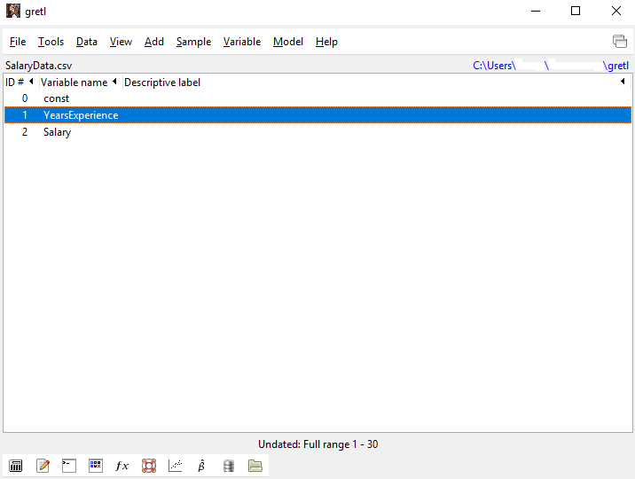

Summary of Data set

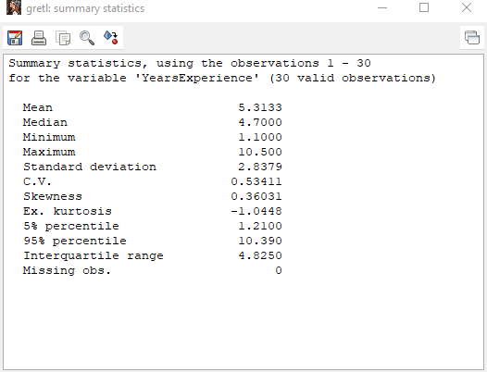

OLS Model

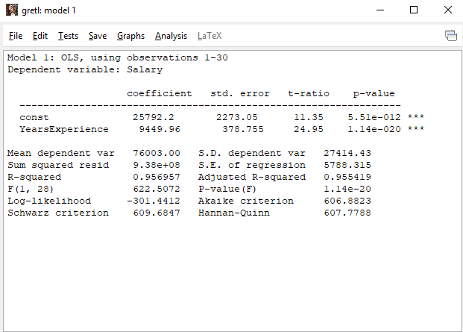

Graphical Regression Model

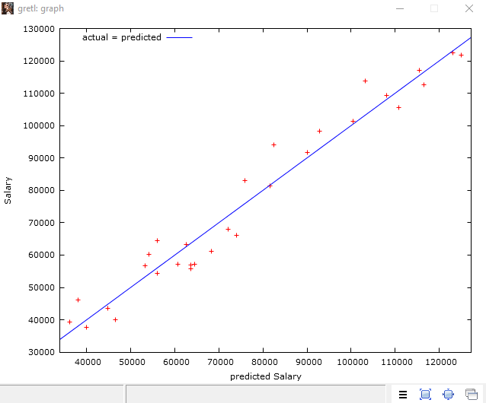

Forecasting

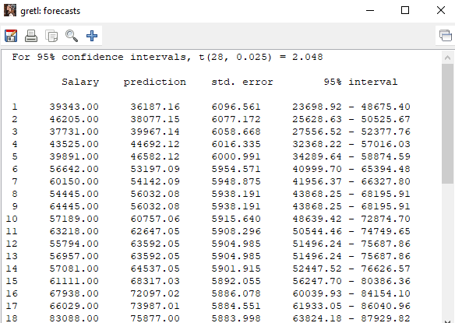

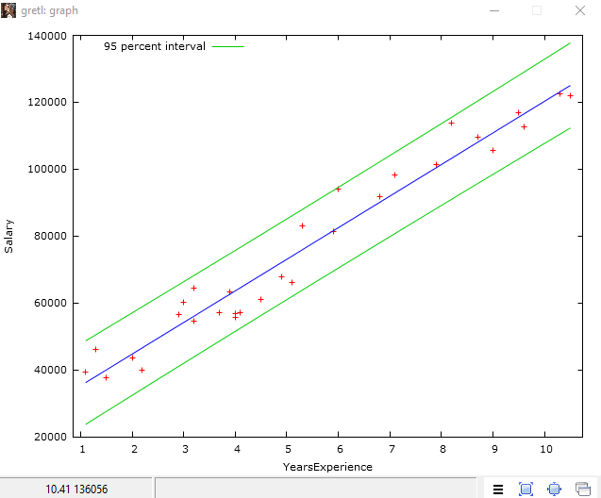

Multiple linear regression model using backward elimination

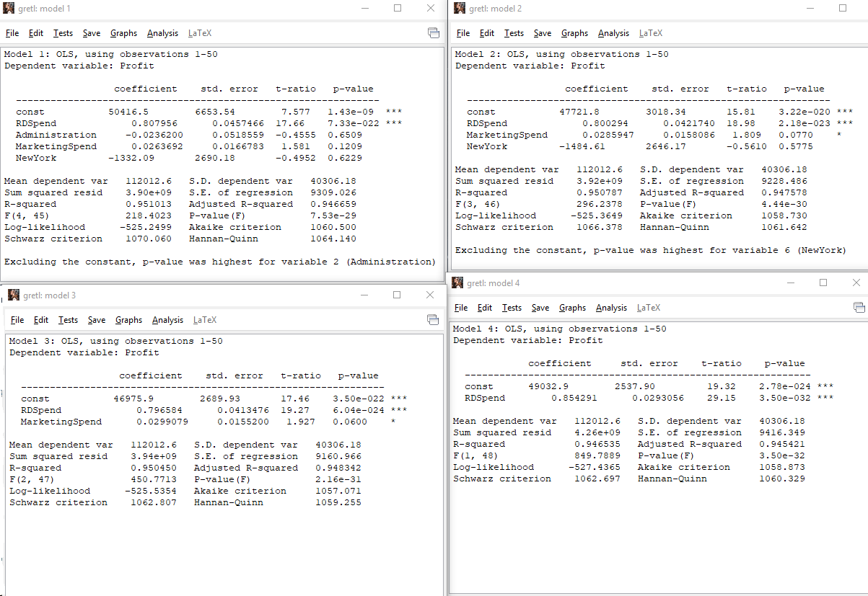

Best fitted model is model 3. From the above model 3, we can say that every $1 spent in R&D will give rise to 0.796 per unit increase in profit. It better to spend in R&D than Marketing because marketing coefficient is less then R&D.

Logistic Regression

Creating dummy variables

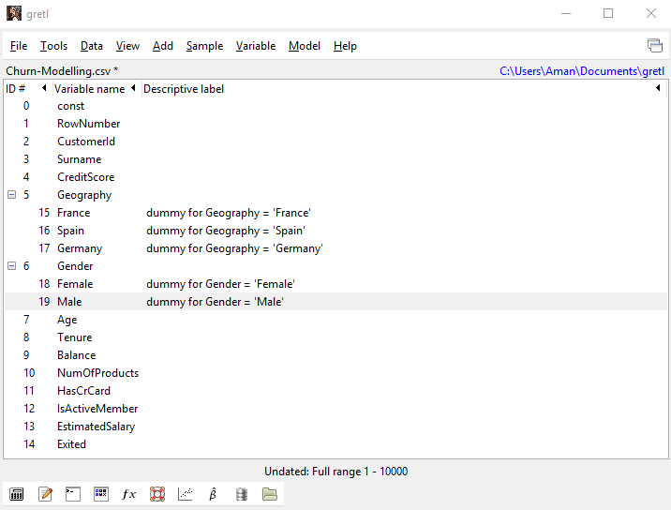

Running Logit test against data set

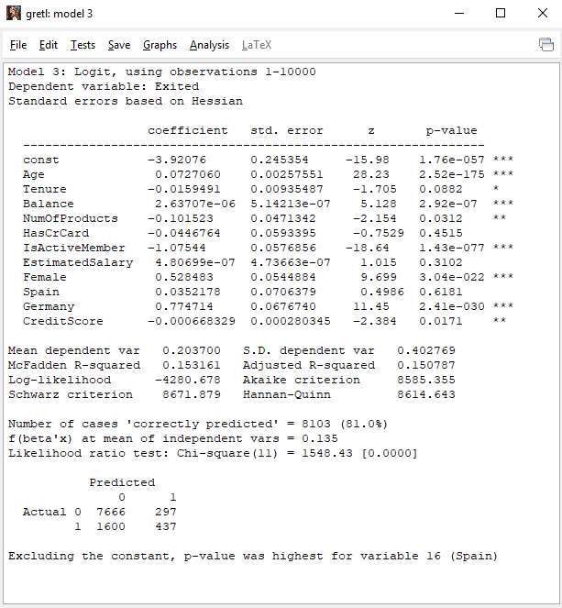

Step by step backward elimination

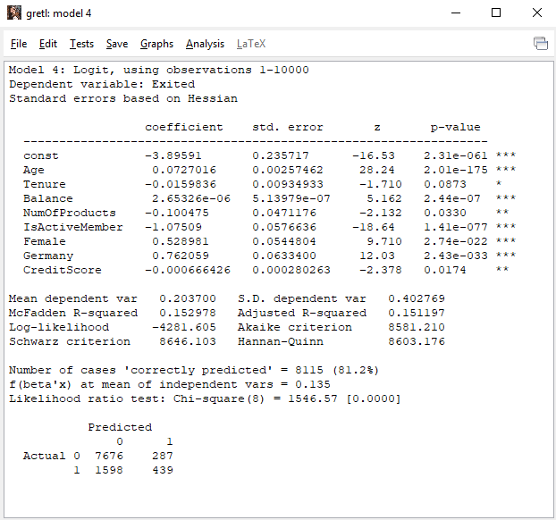

Creating Derived Variables

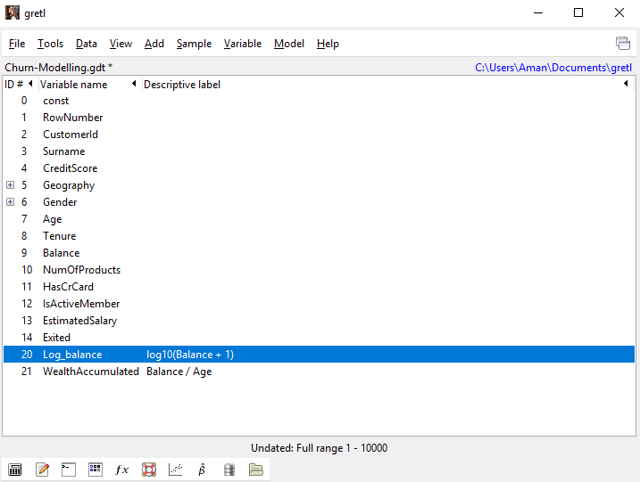

Run the Logit test again

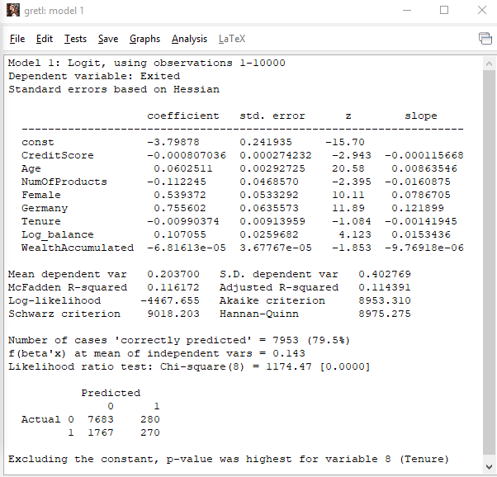

Multicollinearity



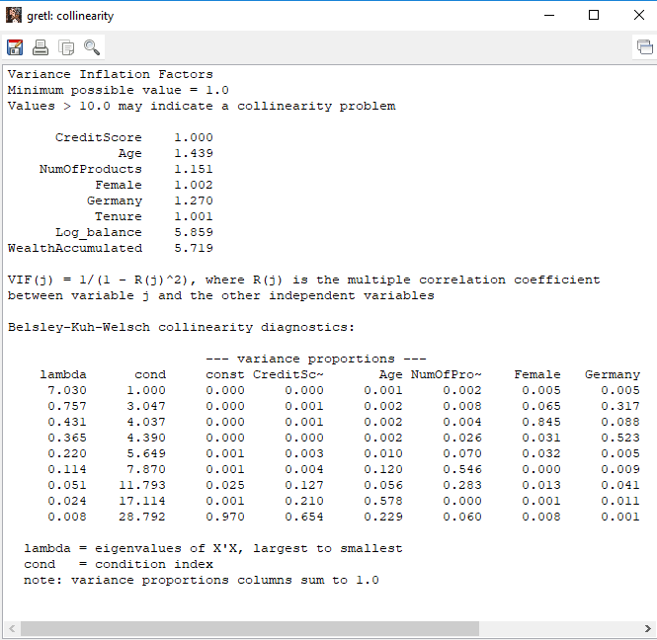

Log Balance and Wealth Accumulated values are less than 10 but they are related because WealthAccumulted=Balance/Age. So remove balance from the model.

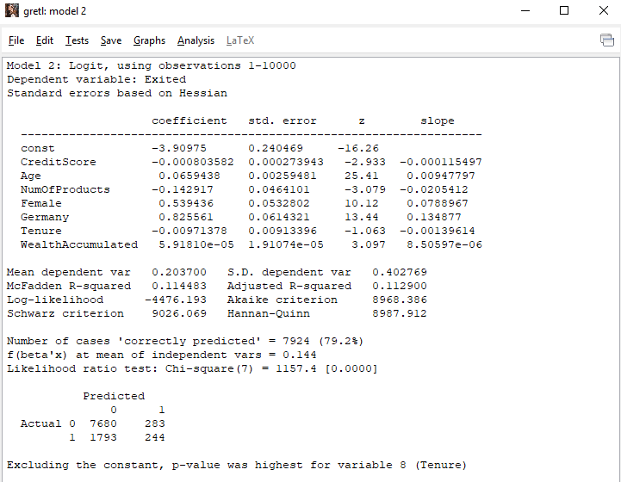

Now value of wealth changes from –ve to +ve.

Cumulative Accuracy Profile (CAP) Curve to check how best our model is performing using EXCEL

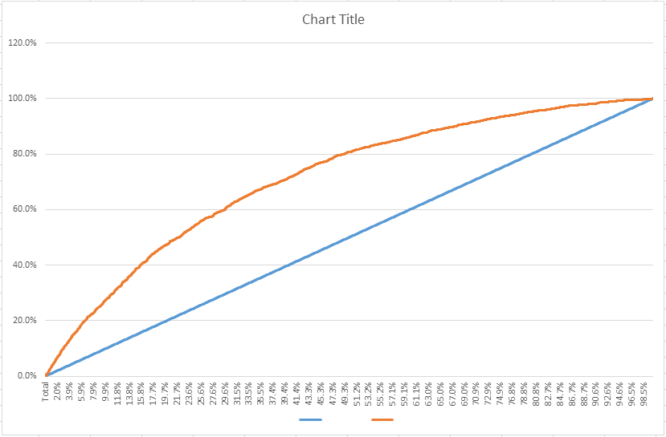

Calculating Odds in order to compare the coefficient with independent variables for logistic regression

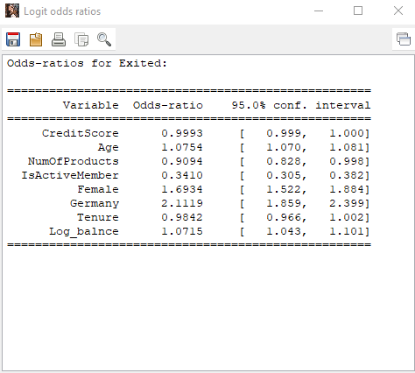

Final Findings in EXCEL

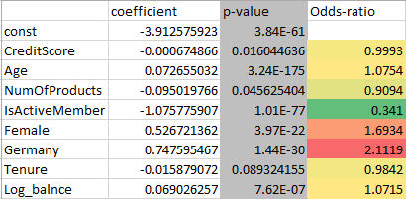

From the above table we can say that there is some problem with Females in Germany for leaving the bank. Either there is some other competitor who is pulling them or might be some other reason. ‘IsActiveMember’ is in green which means it is very less likely that active members of the bank would churn.