**32. Activating Start Mode**

Q1. What is the "Strict Mode" in JavaScript?

"Strict Mode" is a special mode that we can activate in JavaScript which makes it easier for us to write secure JavaScript code.

Q2.How to activate the JavaScript Code?

To activate the strict mode use the syntax "use strict";. It has to be the very first line of the script otherwise the strict mode will not activate.

Q3.What are the advantages of the strict mode?

1. It helps to write a secure code.

2. It makes it easier for the developers to avoid accidental errors. So basically it helps us to avoid bugs in our code.

3. It forbids us to do certain things.

4. It creates visible errors in the developer console, where in other situations JavaScript would just fail silently.

5. It introduces a short list of variable names that are reserved for features that might be added to the language a bit later.

**33. Functions**

Q1. What are Functions?

A piece of code that we can reuse over and over again in our code. It just like a variable but a function can hold one or more complete lines of code.

A function is just not only to reuse a piece of code but it can also receive data and return data back.

Q2. How functions are defined?

Defining the function: -



All the code that is within this code block inside curly braces is called the function buddy.

Q3. How to use the function?



This process here is basically using the function is called invoking the function, running the function or calling the function.

Q4. What are parameters in the function?

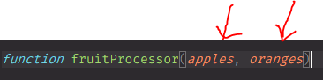

Parameters are like variables that are specific only to a certain function and they will get defined once we call the function.

The above two parameters will get defined once the function is called and they represent the input data of this function.

The parameters are like a placeholder in the function.

Q5. What are arguments of a function?

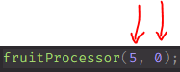

Apples will become 5 and oranges will become 0. These actual values here of the parameters are called the arguments.

The arguments is the actual values that we use to fill in that placeholder that is the parameter.

**34. Function Declarations vs. Expressions**

Q1. Give an example of Function Declaration.

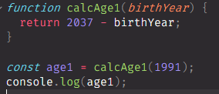

We can call a function declaration before we define it.

Q2. Give an example of Function Expressions.

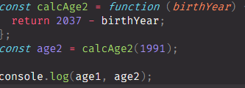

**35. Arrow Functions**

Q1. What is an “Arrow Function”?

It is actually a third type of function that was added to JavaScript in ES6. An Arrow Function is simply a special form of function expression that is shorter and therefore faster to write.

Q2. How to implement an Arrow Function?

When we have only one parameter: -



When we have multiple parameters: -

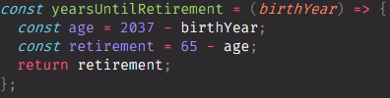

Q3. What are the advantages of an arrow function?

1. It is a lot easier and faster to write as we don’t need curly braces to define a code block.
2. The return happens implicitly and we don’t need to write the return keyword.

**36. Functions Calling other Functions**

Q1. Draw a data flow of functions calling other functions?

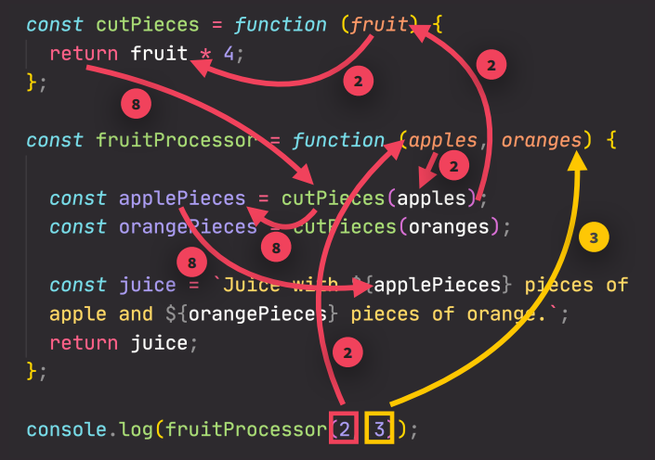

**37. Reviewing Functions**

**39. Introduction to Arrays**

Q1. What is an Array?

Array is like a big container into which we can throw variables and then later reference them. Array is not a primitive value, so we can actually always change it so we can mutate it even if it is defined as const but we can’t replace an entire array. Arrays can actually hold values of different types all at the same time.



Q2. How to declare an array?

Two ways to declare an array: -

1. 
2. 

Q3. How to count the length of an array?



Q4. How to replace an element with another element in the array?



**40. Basic Array Operations (Methods)**

Q1. What is push method?

The push method adds elements to the end of an array.



The push method returns the length of the array.

Q2. What is unshift method?

The unshift method adds the element in the beginning of the array.



The unshift method also returns the length of the array.

Q3. What is pop method?

The pop removes the last element of an array.



The pop method returns the removed element.

Q4. What is a shift method?

The shift method removes the first element of an array.



This method also returns the removed element.

Q5. What is indexOf method?

This returns the index of the given element in an array.



Q6. What is includes method?

This method instead of returning the index of the element will simply return true if the element is in the array and false if it’s not.



It checks strict equality, which means it doesn’t do type coercion.

**42. Introduction to Objects**

Q1. What are objects?

In objects, we actually define key value pairs.

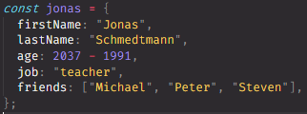

The above implementation is called the object literal syntax, because we are literally writing down the entire object content.

The key is basically the variable name.

Each of these keys is also called a property.

Q2. Why we use objects?

We use objects to essentially group together different variables that really belong together.

Q3. What is the big difference between the objects and arrays?

In objects, the order of these values doesn’t matter at all when we want to retrieve them.

In arrays, the order in which we specify the elements matters a lot. We can only access array elements using their order number.

This means that we should use arrays for more order data and objects for more unstructured data.

**43. Dot vs. Bracket Notation**

Q1. What are the two ways of getting a property from an object?

1. Dot Notation: -



This dot here is actually an operator which will go this object and then retrieve the property with the name that we specified here.

1. Bracket Notation: -



Here we need to specify a string with the property name with the key.

Q2. What is the big difference between the dot notation and bracket notation?

In the bracket notation we can actually put any expression that we’d like, so we don’t have to explicitly write the string here, but instead we can compute it from some operation because an operation is basically an expression, so something that produces a value.

Q3. How to add properties in an object using dot notation and bracket notation?



**44. Object Methods**

Q1. What a function is called if it is defined inside an object?

Any function that is attached to an object is called a method, but we can only use function expression only and declaration doesn’t work.

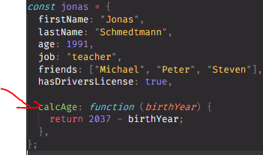

Q2. What is a this keyword?

The this keyword is basically equal to the object on which the method is called. Or in other words it is equal to the object calling the method.

**46. Iteration: The For Loop**

Q1. What are loops?

They basically allow us to automate repetitive tasks. Tasks that we perform over and over again.

**48. Looping Backwards and Loops in Loops**

**49. While Loop**

Q1. What is while loop?

It’s called the while loop because it will run while the condition is true. The while loop really not depend on any counter variable.