Project Report: Smart EV-Charging & Grid Optimizer
Table of Contents

Project Report: Smart EV-Charging & Grid Optimizer
Service Oriented Software course — Final exam, option 2 (design and implementation of a micro-SOA application)

1. Introduction, domain and objectives
The Smart EV-Charging & Grid Optimizer project implements a micro-SOA platform for optimizing electric vehicle charging in corporate or residential parking lots.
The domain problem is the following: in a parking lot equipped with multiple charging stations, the cost of energy varies significantly throughout the day, vehicles have different states of charge and battery capacities, and stations deliver different power levels. Deciding when and at what power to charge a vehicle therefore requires correlating three pieces of information that, in a real system, belong to three distinct information systems under the responsibility of three different actors:
Information | Real owner | Service in the project | Protocol
Hourly energy price | market operator / supplier | tariff-provider | REST
Vehicle telemetry (SoC, capacity) | vehicle manufacturer / fleet | vehicle-provider | REST
Station status and power | charging infrastructure operator | station-provider | SOAP
This heterogeneity is not a didactic artifice: it is precisely the reason the domain lends itself to a SOA. The station operator is typically a legacy industrial system with a rigid contract (hence the choice of SOAP/WSDL for station-provider), while the market and telemetry services are modern REST/JSON-contract services. The platform's added value lies in composing these heterogeneous sources behind a single, coherent interface for the client.
Alongside data correlation, the system treats a second dimension as an autonomous responsibility: economic evaluation. Knowing that a station delivers 150 kW and that the vehicle is at 20% is not enough to decide; one needs to know how much it costs to charge now and how much would be saved by waiting. In the project these two competencies are assigned to two distinct services — an orchestrator of technical constraints and an economic evaluator — that work in parallel and coordinate before responding. This is the system's central architectural choice, illustrated in sections 7.1 and 8.1.
Application objectives:
- Return to the user a charging recommendation that reconciles the technical constraints of the vehicle and the station with the economic convenience of drawing power from the grid.
- Quantify, through a long-running simulation, the economic savings obtainable by shifting charging from the peak time slot to the cheapest one of the day.
- Allow direct consultation of a station's status, without going through the prosumers' business logic.
Expected outputs. For objective (1) the system returns an aggregated JSON with the technical data, the economic evaluation, and a textual recommendation chosen among four possible ones. For objective (2) it returns a ticket and, on completion, the estimated savings in euros. For objective (3) it returns the SOAP envelope with the station's status and maximum power. Section 7 reports the concrete outputs, measured on the running system.

2. Mapping to the assignment requirements
# | Requirement | Implementation
1 | REST and SOAP services (Apache CXF, Jakarta, Spring) | 4 REST services (tariff, vehicle, charging-orchestrator, energy-prosumer) + 1 JAX-WS SOAP service on Apache CXF 4.0.4 (station-provider)
2 | ≥3 providers, ≥2 prosumers, ≥1 client; all client→service traffic via API Gateway | 3 providers, 2 prosumers, 1 Vue 3 web client; single entry point api-gateway on port 9000, with automatic routing disabled (see section 6.1)
3 | The client interacts with the prosumers; each prosumer with ≥2 providers | charging-orchestrator → 3 providers; energy-prosumer → 2 providers (see section 6.3)
4 | ≥1 asynchronous service (polling/callback) and ≥2 prosumers working in parallel and coordinating before responding to the client, all motivated by system logic | FLOW-02: fire-and-poll pattern with HTTP 202 + ticket (see section 7.2). FLOW-01: the two prosumers execute complementary tasks in parallel and synchronize on an allOf(...).join() barrier before responding (see section 7.1). Motivations in section 8
5 | ≥3 distinct client interactions with the prosumers | Three exercised by the web interface: GET /api/v1/optimize, POST /api/simulations/grid-savings, GET /api/simulations/status/{ticketId}. A fourth capability, GET /api/v1/energy/cost-estimate, is routed by the Gateway but in the current system is consumed by the Orchestrator, not by the client. In addition, FLOW-03 towards a provider (see section 7)
6 | Architectural diagram + sequence diagram for each scenario | Figure 1 (section 3), Figure 5 (section 5), Figures 2–4 and 6 (section 7)
7 | Clear textual description of the application, its objectives, its output | This document
8 | Commented code; OpenAPI/Swagger for all REST services | Verbose Javadoc on all classes and public methods; SpringDoc OpenAPI 2.5.0 on all four REST modules; SOAP contract defined by commented Jakarta annotations and WSDL generated by CXF (see section 10)
9 | README with setup steps | README.md at the root of the repository (see section 12)
10 | Spring Boot + Docker | Spring Boot 3.2.5, Java 17, parameterized multi-stage Dockerfile, docker-compose.yml with 8 services (see section 4)
11 | Maven as project management | Multi-module Maven reactor with a parent pom.xml (see section 4)
12 | (Optional) Maven archetype | Not implemented
13 | Multi-instance deployment and balanced interactions, with motivation | All four stateless services are replicable with --scale; client-side balancing via Eureka + Spring Cloud LoadBalancer, verified experimentally (see sections 5 and 9)

3. System architecture
The application follows the principles of a Service-Oriented Architecture implemented with microservices (Micro-SOA), organized into four logical layers plus one layer of supporting services.
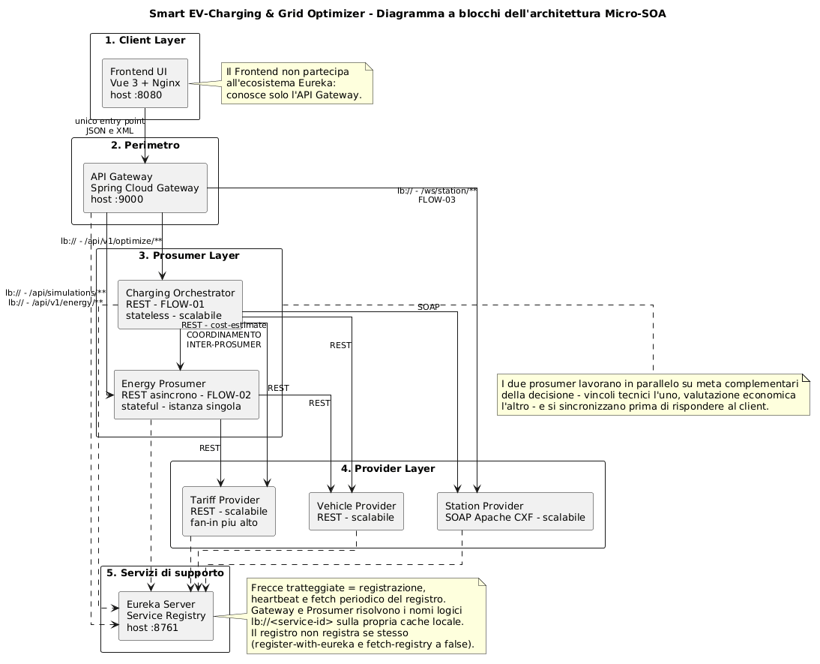
Figure 1 — Topology of the Micro-SOA architecture. Solid arrows represent business invocations, dashed arrows represent flows towards the Service Registry.
The architectural principle being respected is decoupling through layering: the client only knows the Gateway's address, and in the configuration of the Gateway, the prosumers, and the providers, the physical address of another component never appears — only its logical name. The Gateway routes towards the logical names of downstream services, the prosumers towards the logical names of the providers and — only in the Orchestrator → Energy Prosumer direction — towards the name of the other prosumer; the providers do not invoke any of them. Resolving a logical name into a physical address always happens at runtime, through the registry's local cache described in section 5: it is data that every component downloads and refreshes autonomously, never something written or kept in configuration. The only physical address present in the configuration of the entire system is that of the Service Registry.
The arc between the two prosumers is deliberately unidirectional, to avoid a circular dependency that would make it impossible to reason about startup order and failure propagation. The Orchestrator depends on the Energy Prosumer; never the other way around.
It is worth noting the asymmetry between the prosumer layer and the provider layer: the prosumers are the only components that own a RestTemplate annotated with @LoadBalanced, i.e. the only ones that perform active discovery. The providers register with the registry but never query it, because they consume nothing. It is exactly this asymmetry that distinguishes, on a technical level and not just nominally, a pure provider from a prosumer.

4. Project organization and build infrastructure
The project is structured as a monorepo with a multi-module Maven reactor.
- Centralized dependency management. A parent pom.xml sits at the project root, inherited by all seven child modules: it fixes the Java version and the versions of all shared dependencies, so no module needs to declare its own. The parent remains the single place to update a version — of the Spring stack or of a single library — instead of having to repeat it seven times.
- Unified base image. A single Dockerfile, parameterized via ARG MODULE_NAME, builds all seven backend services: the same file is invoked once per service, passing the module to compile each time. This avoids duplicating the same build logic seven times and concentrates any future update to the Java version or build strategy in one place. Compilation happens entirely inside the containers: the host machine needs no Java/Maven toolchain installed.
- Container orchestration. The deployment is described by docker-compose.yml (8 services on a dedicated bridge network). The startup sequence is constrained: the Service Registry starts first, and the other containers declare depends_on: eureka-server: condition: service_healthy. The HTTP healthcheck with start_period: 20s prevents services from attempting registration before the registry is listening.
- Frontend. frontend-ui has its own two-stage Dockerfile (Vite build with Node 20, static serving with Nginx) and is the only module outside the Maven reactor, consistent with its non-Java nature.
Ports exposed on the host. The port configuration directly reflects the scalability of each service, and is therefore itself an architectural choice (see section 9.2):
Service | Host port | Reason
frontend-ui | 8080 | fixed: it is the address the user opens
api-gateway | 9000 | fixed: it is the system's public address, hardcoded in the frontend
eureka-server | 8761 | fixed: it is the rendez-vous point for all other services
energy-prosumer | 8084 | fixed: stateful service, not replicable
tariff-provider | dynamic | stateless and replicable
vehicle-provider | dynamic | stateless and replicable
station-provider | dynamic | stateless and replicable
charging-orchestrator | dynamic | stateless and replicable
Direct exposure of internal services on the host serves exclusively to inspect Swagger UI and WSDL, but the application client never uses it.

5. Service Discovery and Client-Side Load Balancing
The pattern governing all intra-cluster communication is Dynamic Service Discovery combined with Client-Side Load Balancing. It is crucial to distinguish the three flows that involve eureka-server.
- Registration. At boot, every service performs a POST to the registry, communicating its logical service-id (the value of spring.application.name), hostname and port. The eureka-server Service Registry does not register itself and does not sync with peers: in this project it is a standalone node.
- Heartbeat. Every registered instance periodically renews its lease (default interval 30 s). Missing heartbeats lead to lease expiry after 90 s and subsequent eviction from the registry.
- Periodic fetch. Resolving a logical name into the corresponding physical address does not happen by querying Eureka at the moment of the HTTP call. Every client downloads the entire routing table in the background into a local cache and refreshes it periodically (default interval 30 s, delta-based).
Load balancing therefore happens entirely in the calling process, querying only the local cache: Spring Cloud LoadBalancer picks an instance among the known ones with a round robin policy. There is no centralized load balancer, and consequently no single point of failure on the request path.
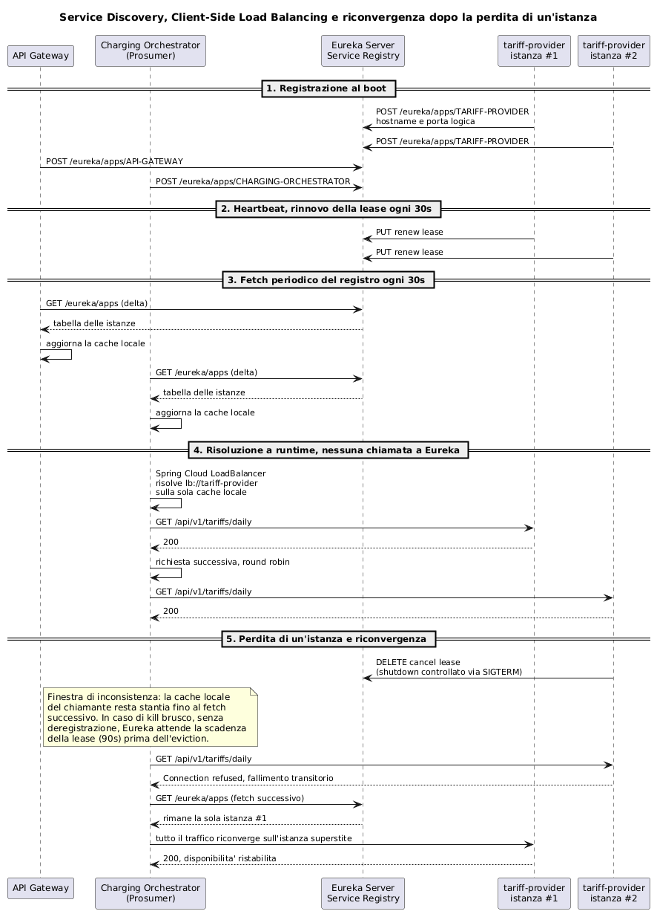
Figure 5 — The full discovery lifecycle: registration at boot, heartbeat, periodic fetch of the registry, runtime resolution against the local cache only, and reconvergence after the loss of an instance.
Inconsistency window. By construction, this architecture produces a natural asynchrony between the cluster's real state and the view held by callers. An instance's removal is not propagated instantly: the instance must first leave the registry, and clients must then refresh their cache on the next fetch cycle. The two scenarios behave very differently:
- Controlled shutdown (docker stop, SIGTERM signal): the Eureka client intercepts the shutdown and sends a cancel lease DELETE. The instance disappears from the registry immediately, and the remaining delay is just the callers' fetch interval (≤ 30 s), plus the Spring Cloud LoadBalancer cache TTL (35 s by default).
- Abrupt shutdown (docker kill, process crash): there is no deregistration. The registry must wait for the lease to expire (90 s) and for the eviction task's cycle, after which clients must still refresh their cache. In a realistically sized cluster, reconvergence would take a few minutes; in a small cluster like this one, however, the loss of even a single instance can push the overall renewal rate below the expected threshold and trigger Eureka's self-preservation — a safety mechanism that suspends automatic eviction so as not to risk removing healthy instances during a network partition. In that case the dead instance stays reported as UP indefinitely, until an external restart intervenes.
Both scenarios are reproducible with a minimal sequence of commands, run here on vehicle-provider scaled to two instances:
docker compose up -d --scale vehicle-provider=2
# wait ~40 s for both instances to register, then:
docker stop <victim-container> # scenario 1: controlled shutdown
# or
docker kill <victim-container> # scenario 2: abrupt shutdown
# meanwhile, repeatedly query FLOW-01:
curl "http://localhost:9000/api/v1/optimize?vehicleId=EV-001&stationId=STATION-FAST-01"
Running this sequence on the live system, the two scenarios behaved in qualitatively different ways, as expected. In the controlled shutdown, the first failure (HTTP 503) appeared 7 seconds after the stop, with alternating successes and failures — the effect of round robin alternating between the dead instance and the surviving one until the cache refreshes — settling down after 40 seconds, consistent with the theoretical bound of about 65 seconds (30 s fetch + 35 s LoadBalancer cache TTL). In the abrupt shutdown, failures instead continued past 170 seconds without spontaneously converging: the Eureka dashboard (http://localhost:8761) showed self-preservation active, with a renewal rate of 12 against an expected threshold of 15. This is a side effect, in a cluster with few instances, of a mechanism designed to protect larger clusters: losing a single service noticeably lowers the overall renewal rate, and Eureka prefers to suspend eviction rather than risk removing healthy instances during a suspected network partition. In this case reconvergence required an external intervention (restarting eureka-server) rather than happening spontaneously — a practical limitation worth keeping in mind in a small cluster like this one.
This distinction is the reason why, in a production system, discovery would be paired with a retry and a circuit breaker: in this project the conscious choice was not to introduce external resilience libraries (Resilience4j), to keep the focus on the SOA patterns covered in the course, limiting the implementation to explicit timeouts and a clean translation of errors (see section 11).

6. Classification and roles of the services

6.1 The infrastructure
- Eureka Server (:8761) — Passive Service Registry. It has no local cache, never initiates calls towards other services, and does not register on itself. It exposes the Netflix Eureka dashboard, useful during a demo to observe instances appearing and disappearing in real time.
- API Gateway (:9000) — Built with Spring Cloud Gateway, it is the system's only entry point and defines four explicit routes based on a path predicate:
Route | Predicate | Destination
charging-orchestrator | Path=/api/v1/optimize/** | lb://charging-orchestrator
energy-prosumer-route | Path=/api/simulations/** | lb://energy-prosumer
energy-cost-estimate-route | Path=/api/v1/energy/** | lb://energy-prosumer
station-provider-route | Path=/ws/station/** | lb://station-provider
- The lb:// prefix instructs the Gateway to resolve the service-id through its own local registry cache rather than through DNS. The Gateway also manages the CORS policy centrally, so that no individual microservice has to deal with it: this is one of the concrete advantages of the single entry point pattern.
- A minor but noteworthy choice: Spring Cloud Gateway's discovery locator is disabled. If enabled, the Gateway would create an additional route for every service registered on Eureka, on its own, at /<service-id>/** — bypassing the four routes declared above. Keeping it off means only those four routes remain reachable through the Gateway: this is immediately verifiable, since a request to http://localhost:9000/TARIFF-PROVIDER/api/v1/tariffs/daily returns HTTP 404.
- One last architecturally relevant aspect is that the Gateway is agnostic to the application protocol: it routes based only on the path and forwards the body unchanged, so the same instance that serves JSON to the prosumers forwards XML/SOAP to station-provider with no dedicated configuration (see section 7.3).
- Frontend UI (:8080) — Vue 3 Single Page Application built with Vite and served by Nginx. It does not participate in the Eureka ecosystem and knows no internal service: the only address it holds is that of the API Gateway. It exposes three panels, one per flow, plus a guide to the simulation parameters.

6.2 The Providers (pure suppliers)
These represent the data sources. They limit themselves to registering with the Service Registry and exposing a contract; none of them performs active discovery, because none of them consumes data from other internal services. They are stateless and idempotent: given the same parameters they always return the same result and keep no state between two invocations, which makes them natural candidates for horizontal replication (see section 9).
- tariff-provider (REST). Exposes GET /api/v1/tariffs/daily, which returns the day's 24 hourly slots. The logic differentiates between days: during the daytime slots — the thirteen hourly slots from 8:00 to 20:00 inclusive, i.e. up to 20:59 — the price is always 0.35 €/kWh; in the remaining eleven hours it is 0.28 €/kWh on weekdays and 0.15 €/kWh on weekends. This distinction is not arbitrary — it models the fact that industrial grid demand collapses on weekends, making a deep overnight discount available — and it serves the demonstration, since it is what makes different recommendation branches reachable. The optional simulateWeekend=true parameter forces weekend behavior regardless of the actual day: it is a demo-only parameter, letting both scenarios be shown on demand without waiting for a Saturday. The controller logs which instance served the request, making the balancing directly observable in a replicated configuration (see section 9.3).
- vehicle-provider (REST). Exposes GET /api/v1/vehicles/{vehicleId}/status, which returns battery capacity and state of charge. The fleet is simulated in memory with three profiles, chosen to make every branch of the recommendation logic reachable on demand:
Vehicle | Battery | SoC | Scenario demonstrated
EV-001 | 50 kWh | 60% | nominal case: deferring the charge is worth it
EV-002 | 50 kWh | 20% | critical case: technical urgency overrides cost
EV-003 | 50 kWh | 90% | nearly full: the absolute saving is too small to justify waiting
- Any other identifier falls back to the default profile. The comparison between EV-001 and EV-003 is the most instructive of the three: with the same tariff discount, the final recommendation flips. EV-001 needs 20 kWh and would save €4.00 by waiting — waiting is worth it. EV-003, nearly full, needs only 5 and would save just €0.35 — not worth it. Price alone is not enough to decide: it must be multiplied by the energy that vehicle actually needs, and this is exactly the calculation — tariffs and battery together — that only the Energy Prosumer can make (see section 7.1).
- station-provider (SOAP). The only service with a rigid contract. The contract originates from the Java code, not from a hand-written XML file: Apache CXF automatically generates the WSDL from the annotated interface, browsable at /ws/station?wsdl. It exposes a single operation, GetStationStatus, which returns the identifier, operational status, and maximum power of a station: the logic simulates the hardware by assigning 150 kW to stations whose identifier contains FAST, and 22 kW to all others.
The in-memory simulation of the domain logic does not undermine the architectural validity: what the project intends to demonstrate is the composition of heterogeneous services, and replacing the data source with a real database would be internal to the single provider and transparent to all other components — which is, after all, the advantage of encapsulation behind a service contract.

6.3 The Prosumers (consumers and producers)
These are the services that embody the application logic. Both have a RestTemplate annotated with @LoadBalanced (with explicit timeouts of 3 s to connect and 5 s to read) and a dedicated application thread pool.
The two prosumers are designed as complementary specialists: neither, on its own, holds everything needed to formulate the final recommendation.
- Charging Orchestrator — the technical-constraints evaluator (FLOW-01). Exposes GET /api/v1/optimize and queries three providers — vehicle-provider and tariff-provider over REST, station-provider over SOAP — to establish whether and how quickly the vehicle can be charged. Towards the client the interaction is synchronous, but the internal orchestration is strictly parallel: four integrations start simultaneously via CompletableFuture.supplyAsync(...), fed by an explicit executor (prosumerExecutor). The fourth is the call to the other prosumer. The service is stateless and therefore horizontally replicable with no special handling.
- Energy Prosumer — the economic evaluator (FLOW-02 and cost estimation). Queries two providers (tariff-provider and vehicle-provider) and performs two distinct tasks:
  - GET /api/v1/energy/cost-estimate — a synchronous, low-latency evaluation: how much energy is missing, how much it costs to buy it now, how much it would cost at the cheapest tariff, and what the saving would be. This is the contribution this prosumer brings to FLOW-01's parallel orchestration. The endpoint is deliberately synchronous because its primary consumer is another prosumer waiting for its outcome on a barrier: a ticket pattern here would introduce a second round of polling inside a request that, towards the end user, must remain synchronous.
  - POST /api/simulations/grid-savings and GET /api/simulations/status/{ticketId} — a non-blocking asynchronous polling pattern for the long-running simulation (see section 7.2).
- The simulation path is the system's only stateful one: it keeps ticket state in two in-memory ConcurrentHashMaps. As a result, the module is not horizontally scalable without external shared storage — with two instances, a client could send the POST to one instance and poll on the other, getting a 404. This is a known, consciously accepted limitation (see section 9.1). Note that the synchronous cost-estimation path, which lives in the same module, keeps nothing and would not suffer from this constraint: it is the ticket state, not the service as such, that prevents replication.
- Calls to the two providers are centralized in a single adapter (ProviderClient), shared between the two use cases: both need the same underlying data, and concentrating logical URLs and error handling in one place avoids duplication.

7. Interaction scenarios
The system implements three scenarios, all triggerable from the web interface. The outputs reported below were measured on the running system during daytime hours: since the immediate cost depends on the current hour's tariff, the euro amounts differ if the same requests are run during the night slot, when charging right away is already the most convenient choice.

7.1 FLOW-01 — Parallel orchestration and inter-prosumer coordination
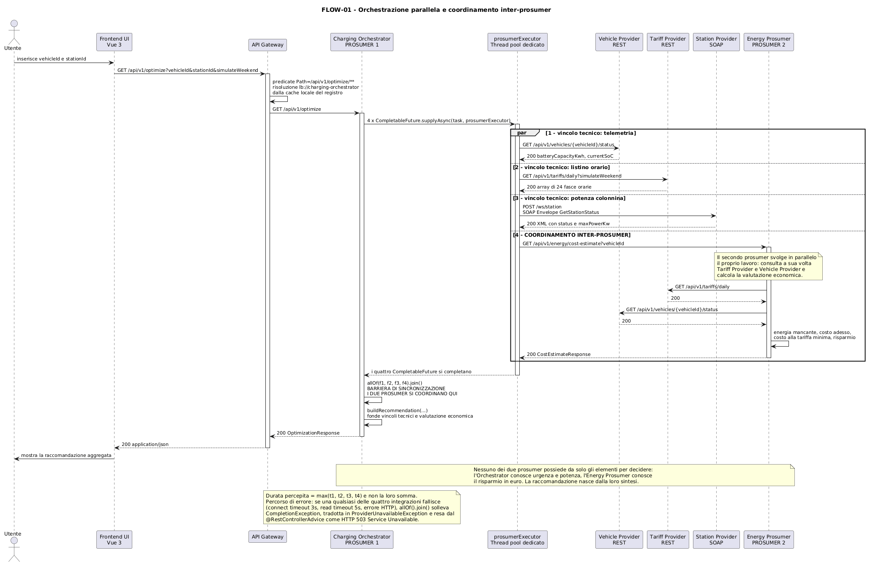
Figure 2 — The Charging Orchestrator launches four concurrent integrations: three towards the providers and one towards the Energy Prosumer, which in the meantime does its own work by consulting two providers in turn. The two prosumers synchronize on the allOf(...).join() barrier before the recommendation is built.
Description. The user selects a vehicle and a station. The Frontend sends a GET /api/v1/optimize to the Gateway, which recognizes the path predicate, resolves lb://charging-orchestrator against its local cache, and forwards the request. The orchestrator submits four tasks to its dedicated executor:
- the vehicle's telemetry, from vehicle-provider;
- the 24 hourly tariff slots, from tariff-provider;
- the station's status, from station-provider, building the SOAP envelope by hand;
- the economic evaluation, from energy-prosumer, which in parallel queries the two REST providers in turn.
Once the allOf(...).join() barrier is passed — the point where the two prosumers coordinate — the orchestrator merges the contributions into a single recommendation, evaluating four cascading conditions ordered by priority:
- technical urgency (SoC < 30% and power ≥ 50 kW): immediate charging overrides any cost consideration, but the other prosumer's economic contribution quantifies its price, making the trade-off transparent;
- already in the cheapest slot: waiting would bring no benefit;
- worthwhile deferral (savings ≥ €1.00): the cheapest tariff hour is suggested, with the savings quantified;
- otherwise, distributed charging: the saving does not offset the vehicle's unavailability.
Measured outputs.
EV-002 on STATION-FAST-01 on a weekday (branch 1, technical urgency) — the same case shown in Figure 6:
{
"vehicleId": "EV-002", "stationId": "STATION-FAST-01",
"batteryCapacity": 50.0, "currentSoC": 20.0, "maxPower": 150.0,
"energyNeededKwh": 40.0,
"estimatedCostNowEur": 14.0, "estimatedCostAtCheapestEur": 11.2,
"potentialSavingsEur": 2.8, "cheapestHour": 0,
"recommendation": "Ricarica immediata ad alta potenza consigliata: stato di carica critico. Costo stimato 14.00 EUR, rinunciando a un risparmio potenziale di 2.80 EUR"
}
EV-001 on STATION-SLOW-01 with the weekend tariff (branch 3, worthwhile deferral):
{
"vehicleId": "EV-001", "currentSoC": 60.0, "maxPower": 22.0,
"energyNeededKwh": 20.0,
"estimatedCostNowEur": 7.0, "estimatedCostAtCheapestEur": 3.0,
"potentialSavingsEur": 4.0, "cheapestHour": 0,
"recommendation": "Ricarica differita alle 00:00 consigliata: risparmio stimato di 4.00 EUR (3.00 EUR invece di 7.00 EUR)"
}
EV-003 on STATION-SLOW-01 on a weekday (branch 4, deferral not worthwhile):
{
"vehicleId": "EV-003", "currentSoC": 90.0, "maxPower": 22.0,
"energyNeededKwh": 5.0,
"estimatedCostNowEur": 1.75, "estimatedCostAtCheapestEur": 1.4,
"potentialSavingsEur": 0.35, "cheapestHour": 0,
"recommendation": "Ricarica distribuita nelle fasce a costo intermedio: differire farebbe risparmiare solo 0.35 EUR"
}
(The recommendation field is the literal text produced at runtime by the backend, in Italian, and is reported here unmodified as measured output.)
The comparison between the second and third case is the most instructive: the tariff differential is identical, only the energy need changes, and the recommendation flips. It is a decision that neither prosumer could have produced on its own.
Client-side presentation. Coordination between the two prosumers is entirely server-side: the Frontend obtains the technical data and the economic evaluation with a single call to the optimization endpoint, which returns one aggregated JSON. The interface does not simply dump that JSON: it visually separates the two contributions into two panels, so that the origin of each piece of data remains legible even to someone unfamiliar with the code.
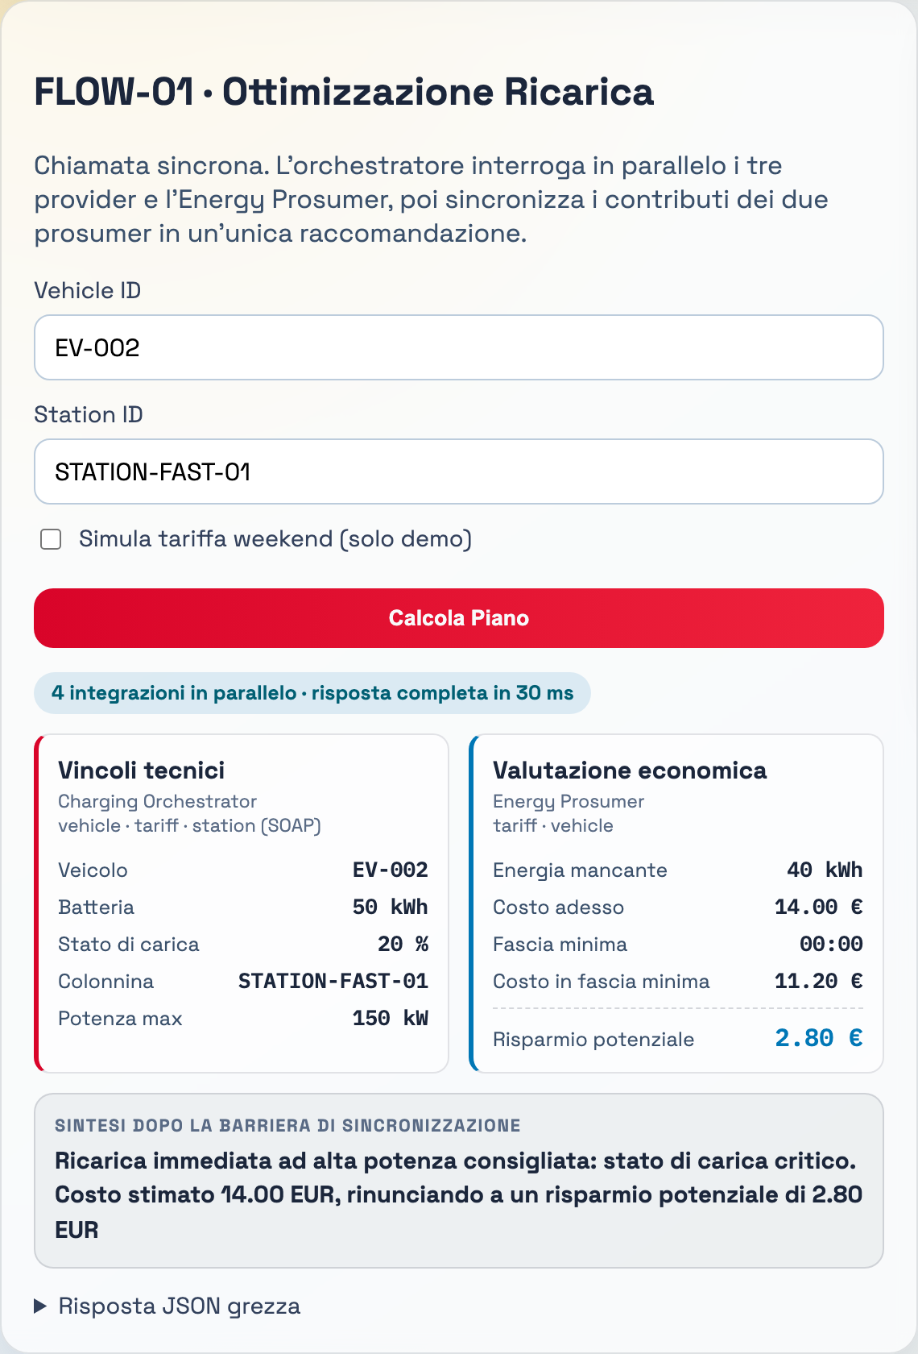
Figure 6 — The FLOW-01 panel after the computation. The technical constraints gathered by the Charging Orchestrator and the economic evaluation produced by the Energy Prosumer are shown separately, with colors matching those already associated with each service elsewhere in the interface; below, the recommendation as the synthesis reached after the synchronization barrier. The badge at the top reports the number of concurrent integrations and the total latency.
The badge deserves a note, since it is the only quantitative evidence of parallelism visible to the user: the full response arrives in a few tens of milliseconds despite requiring four network round trips, one of which is to a service that in turn queries two others. This is empirical confirmation that the perceived latency matches the slowest branch, not the sum of the branches.
Points of architectural interest. This scenario demonstrates two distinct properties. The first is aggregation of heterogeneous protocols: the client receives a clean JSON and has no way of knowing that one of the data points came from a SOAP service. The second is coordination between peers: the two prosumers are not in a simple hierarchical delegation relationship — they split the problem according to their competencies and recompose it at the barrier.

7.2 FLOW-02 — Asynchronous pattern with polling
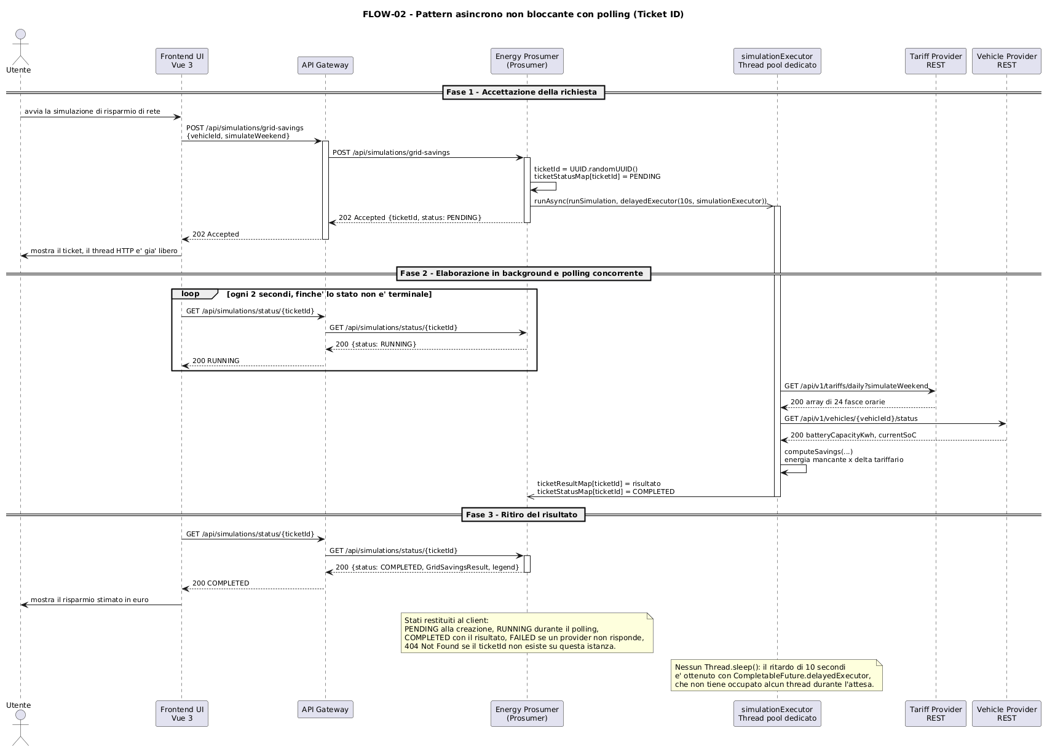
Figure 3 — The Energy Prosumer decouples receiving the request from actually processing it, issuing a ticket that the client uses to periodically query progress.
Purpose. This flow answers a planning question, different from FLOW-01's: not "where and how to charge right now," but "which time slot of the day is the most convenient one to charge in, and how much is it worth choosing it well." The comparison is between the worst case (peak tariff) and the best case (cheapest tariff) of the day, not between the current cost and the minimum one: it tells you how much the choice of timing can affect the cost, not how much you would save by giving up charging right this moment. It requires no station: it is a standalone economic simulation, useful for deciding when to schedule charging even before picking a charging point. The ticket/polling pattern fits this kind of computation naturally, since it does not need to be instantaneous to be useful and does not keep the client blocked while waiting. The result is purely informational: the completed ticket contains no recommendation at all, only the measured data (missing energy, peak tariff, cheapest tariff, best hour, savings between the two extremes); it is up to the reader to decide whether that saving justifies the wait. This is the opposite of FLOW-01, where it is the Orchestrator that decides on the client's behalf, comparing the saving against the MIN_WORTHWHILE_SAVINGS_EUR threshold and returning an already-resolved recommendation.
Description. The client sends a POST /api/simulations/grid-savings with the reference vehicle. The prosumer generates a ticketId, registers it as PENDING, schedules the processing, and responds with 202 Accepted, returning the ticket. The Frontend then starts polling every 2 seconds on GET /api/simulations/status/{ticketId}. In the background, the task queries the two providers, computes the energy missing to a full charge, and multiplies it by the differential between the peak tariff and the cheapest tariff, then publishes the result and moves the status to COMPLETED.
States returned to the client: PENDING in the initial 202 response; RUNNING while processing is under way; COMPLETED with the result and a legend for the fields; FAILED if one of the two providers does not respond correctly; 404 Not Found if the ticket does not exist. Internally the service only tracks PENDING, COMPLETED, and FAILED: the controller maps any non-terminal state to RUNNING, because from the client's point of view the distinction between "queued" and "running" is not actionable.
Measured output (EV-001, weekend tariff). The initial response is HTTP 202 with {"ticketId": "...", "status": "PENDING"}; polling returns RUNNING; on completion:
{
"ticketId": "fce43c2f-d38b-4177-a9ac-eb8f53a324b1",
"status": "COMPLETED",
"result": {
"vehicleId": "EV-001", "energyNeededKwh": 20.0,
"peakPricePerKwh": 0.35, "offPeakPricePerKwh": 0.15,
"cheapestHour": 0, "estimatedSavingsEur": 4.0
},
"legend": { "…": "concise description of each field" }
}
Point of architectural interest. The 10-second delay that makes polling observable is obtained with CompletableFuture.delayedExecutor(10, TimeUnit.SECONDS, simulationExecutor): delayedExecutor queues the task on a scheduler and consumes no thread until it is time to run it.

7.3 FLOW-03 — Hybrid REST/SOAP integration
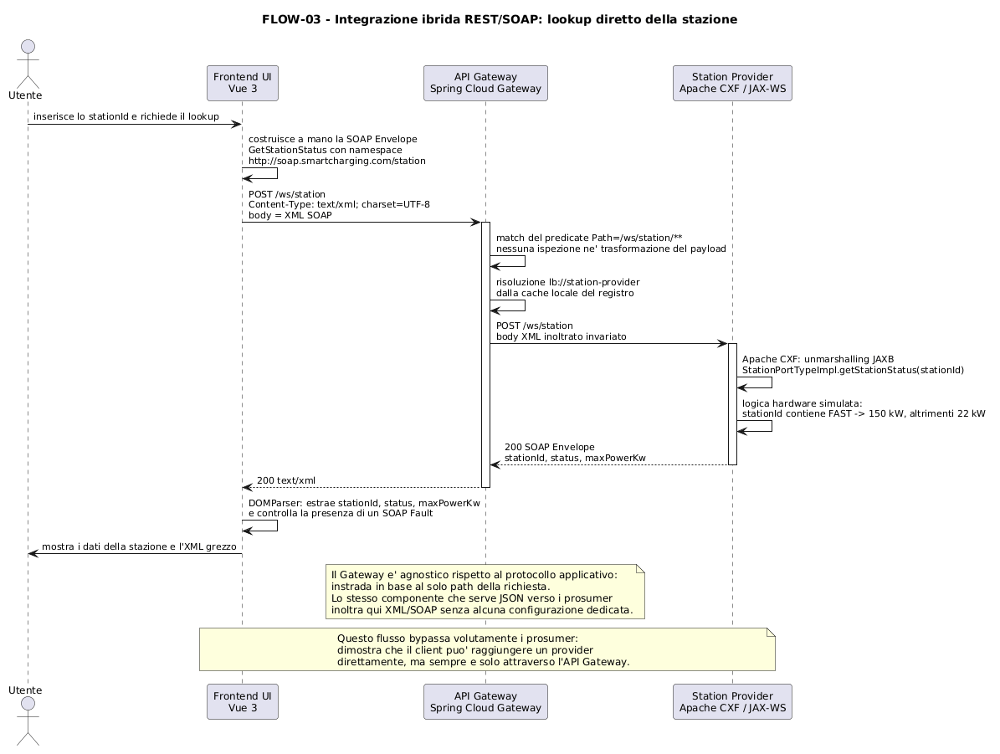
Figure 4 — Protocol-agnostic routing: the API Gateway forwards a raw SOAP/XML request directly to the Station Provider, with no awareness of the difference from the rest of the REST ecosystem.
Description. The Frontend manually builds a GetStationStatus SOAP envelope, sends it via POST to http://localhost:9000/ws/station with Content-Type: text/xml, and the Gateway forwards it unchanged to station-provider based solely on the path predicate. Apache CXF performs JAXB unmarshalling, invokes StationPortTypeImpl.getStationStatus(stationId), and returns the response envelope. The Frontend parses it client-side with DOMParser, extracts the values, checks for the presence of a faultstring, and displays both the extracted data and the raw XML.
Measured output:
<soap:Envelope xmlns:soap="http://schemas.xmlsoap.org/soap/envelope/">
<soap:Body>
<ns2:GetStationStatusResponse xmlns:ns2="http://soap.smartcharging.com/station">
<return>
<stationId>STATION-FAST-01</stationId>
<status>AVAILABLE</status>
<maxPowerKw>150.0</maxPowerKw>
</return>
</ns2:GetStationStatusResponse>
</soap:Body>
</soap:Envelope>
Point of architectural interest. This scenario demonstrates two things. The first is that the API Gateway operates at a purely transport-and-routing level of abstraction: it does not inspect or transform the payload, so it supports a legacy SOAP service with no additional configuration compared to the REST routes. The second is that the assignment's constraint «all client→service interactions must go through the API Gateway» is respected even when the client talks directly to a provider: the flow bypasses the prosumers, not the Gateway.

8. Motivation for asynchrony and parallelism
The assignment requires that the use of asynchrony be justified «not in general, but by considering the system's logic and interactions». The two justifications are distinct and concern different flows.

8.1 Why parallelism and coordination in FLOW-01
Why two prosumers and not one. The separation between technical constraints and economic evaluation reflects two competencies that, in the real domain, belong to different actors and change at different paces. Technical urgency logic depends on the physics of charging and on hardware characteristics; economic logic depends on pricing models and the operator's commercial policies, which can evolve autonomously and much more frequently. Assigning the two responsibilities to distinct services means the pricing policy can change without touching — or redeploying — the orchestrator.
Why in parallel. The four contributions needed for the recommendation are mutually independent: none needs another's result to be formulated. Running them sequentially would produce a latency of t₁ + t₂ + t₃ + t₄, while running them in parallel reduces it to max(t₁, …, t₄). Since this involves four network round trips to as many services — one of which is a SOAP call, typically the most expensive due to XML marshalling, while another is a prosumer that in turn queries two more — the difference is dominated by the longest branch, which without parallelism would add up together with all the others.
This matters for this application's specific logic because FLOW-01 is synchronous towards the user: the person is standing at the charging station waiting for the recommendation, and perceived latency is the primary quality criterion. Unlike FLOW-02, here it is not acceptable to return a ticket.
Why an explicit barrier. The recommendation is not composable piece by piece: it cannot start being formulated knowing only three contributions out of four, because each of the four cascading conditions draws on both the technical and the economic data. allOf(...).join() expresses exactly this semantic constraint — no decision before everyone has responded — and it is the point where coordination between the two prosumers materializes in code.
Why a dedicated executor. The tasks do not run on the default ForkJoinPool.commonPool(), but on an explicitly declared prosumerExecutor. The reason is that the orchestrator is simultaneously a server (towards the Gateway) and a client (towards four services): if I/O waits consumed Tomcat's HTTP threads, a slow downstream service would saturate the orchestrator's ability to accept new requests, turning a downstream degradation into an upstream outage. By separating the two pools, the HTTP thread stays occupied only for the duration of the orchestration and never for the wait on individual services.

8.2 Why asynchrony with polling in FLOW-02
The grid-savings simulation has a different nature: it is a batch, non-interactive computation, whose result does not drive an immediate action by the user. In a realistic version of the domain, the computation would traverse the historical tariff slots and charging profiles of an entire fleet over a horizon of weeks — an operation on the order of minutes, not milliseconds.
Keeping an HTTP connection open for that entire duration would be unsustainable for at least three reasons internal to this system:
- Intermediate timeouts. The request passes through the Gateway, which has its own response timeouts: a long computation would be cut off by the infrastructure before completing, and the client would receive an error even though the computation was perfectly under way.
- Thread occupation along the entire chain. A long synchronous request keeps a thread busy in the Gateway and one in the prosumer for its entire duration. A few dozen concurrent simulations would exhaust the Gateway's pool, making FLOW-01 and FLOW-03 unavailable too — i.e. a batch load would degrade the interactive flows. The risk is concrete precisely because the same module also serves the synchronous cost estimate that FLOW-01 needs: without the decoupling, heavy simulations would slow down the interactive recommendations.
- Temporal coupling. With the synchronous pattern, a client disconnecting means the work done is lost. With the ticket, the computation proceeds independently and the result remains retrievable even after a page reload.
The choice of polling over a callback is in turn motivated by the nature of the client: being a browser application, it has no reachable HTTP endpoint the prosumer could notify on completion. A callback would have required WebSocket or Server-Sent Events, technologies not covered in the course and disproportionate for a wait on the order of a few seconds.

9. Motivation and verification of scalability

9.1 Why scale, and what
The need to scale is not uniform across the system, but follows from the call topology visible in Figure 1. Counting incoming edges, it emerges that tariff-provider and vehicle-provider are the components with the highest fan-in in the entire architecture: both are queried by both prosumers and are involved in every business flow, unlike station-provider, reached over SOAP only by the Orchestrator.
Inter-prosumer coordination makes this imbalance measurable: a single FLOW-01 request generates two reads of both the tariff list and the vehicle telemetry, one from the Orchestrator and one from the Energy Prosumer. The measurement reported in section 9.3, conducted on tariff-provider, confirms this — ten optimization requests produced twenty reads; the same ratio holds identically for vehicle-provider, queried by the same two callers in the same way. In a corporate parking lot with dozens of stations, where requests concentrate around the start of the workday, tariff-provider and vehicle-provider are therefore the first components to be expected to saturate, both carrying double the load of station-provider.
Added to this is an availability consideration: if tariff-provider or vehicle-provider ran as a single instance, its outage would make FLOW-01 and FLOW-02 unavailable at the same time — that is, all business logic. By replicating them, the loss of one instance degrades capacity but not availability.
tariff-provider lends itself perfectly to replication because it is stateless, idempotent, and purely deterministic in its logic: two instances respond identically to the same request. The same considerations hold for vehicle-provider, station-provider, and charging-orchestrator, all configured for scale-out.
They do not hold for energy-prosumer, which keeps tickets in memory: replicating it would require externalizing the state (Redis, or a shared database) or introducing sticky sessions in the Gateway. The choice to leave it as a single instance is deliberate, and it also serves to highlight, by contrast, which property — the absence of local state — actually enables horizontal scalability. It is significant that the constraint stems only from the tickets and not from the service as a whole: the synchronous cost estimate, hosted in the same module, is perfectly replicable, and in an evolution of the system separating the two paths into distinct modules would be the natural first step.

9.2 Technical readiness
For docker compose up --scale <service>=N to work, a service can declare neither a fixed container_name (container names are unique) nor a fixed host port (host ports are unique). For this reason the four stateless services declare only the container port in docker-compose.yml, letting Docker assign a free host port to each replica. This constraint has no impact on internal communications, which happen on the bridge network via container ports resolved through Eureka; a replica's actual host port can be retrieved with docker compose port <service> <container-port>.
Only the components that need to be reachable at a known address stay on a fixed port — the registry, the Gateway, and the frontend — plus energy-prosumer, for the structural reason already discussed.

9.3 Verification experiment
A controlled experiment was conducted on the running system.
1. Startup in replicated configuration.
docker compose up -d --scale tariff-provider=2 --scale vehicle-provider=2 \
--scale station-provider=2 --scale charging-orchestrator=2
Querying the registry yields the expected instances, with the four stateless services doubled and the others at a single instance:
API-GATEWAY 1 instance
CHARGING-ORCHESTRATOR 2 instances
ENERGY-PROSUMER 1 instance
STATION-PROVIDER 2 instances
TARIFF-PROVIDER 2 instances
VEHICLE-PROVIDER 2 instances
2. Balancing verification. Ten consecutive FLOW-01 invocations, all completed with HTTP 200, produced a total of twenty reads of the tariff list, distributed by Spring Cloud LoadBalancer's round robin across the two replicas in an 11-to-9 ratio:
final-test-tariff-provider-1: 11 requests
final-test-tariff-provider-2: 9 requests
The result confirms two things at once. The first is that client-side balancing works with no centralized load balancer at all. The second, less obvious one, is empirical confirmation of the fan-in analysis in section 9.1: the ratio of two reads per request is the signature of inter-prosumer coordination, with both prosumers independently consulting the tariff list. The deviation from an exact 10–10 split is expected: round-robin counters are local to each caller, and there are three callers (two Orchestrator replicas plus the Energy Prosumer), each with its own independent state.
3. Reconvergence verification. Stopping one replica gracefully (docker stop), the system goes through a brief window of transient failures — the callers' local cache still contains the vanished instance — after which the Gateway and Orchestrator automatically reconverge onto the surviving instance, with no manual intervention: the measurement reported in section 5 records the first failure 7 seconds after the stop and stabilization at 40. An abrupt shutdown (docker kill) instead behaves in a qualitatively different way, as discussed in the same section: in a small cluster like this one it can trigger Eureka's self-preservation and require external intervention to reconverge.
The experiment confirms the property it set out to demonstrate: the system's topology adapts at runtime with no address ever needing to be reconfigured, because no component knows one.

10. Interface documentation
REST services. Each of the four REST modules exposes its own interactive OpenAPI/Swagger documentation: every endpoint, parameter, and DTO field is described with a name, type, and example, browsable without reading the code at /swagger-ui.html (raw specification at /v3/api-docs). Since the replicable services use dynamic host ports, the address is obtained with docker compose port <service> <container-port>; the exception is energy-prosumer, reliably reachable at http://localhost:8084/swagger-ui.html.
SOAP service. The contract of station-provider is defined code-first: the service's Java interface is written, and Apache CXF automatically derives the WSDL from it, published at /ws/station?wsdl. This guarantees that the published contract always stays aligned with the implementation, because it is generated from it rather than maintained by hand in parallel.
Source code. All classes and all public methods are documented with verbose Javadoc that spells out the architectural rationale — the why of a choice, not just the what — as required by the assignment. The application.yml files and docker-compose.yml carry comments on non-obvious configuration choices, in particular on disabling the discovery locator and on forgoing container_name for the replicable services.

11. Error handling and resilience
The system adopts a two-level approach, deliberately minimal and free of external resilience libraries.
Explicit timeouts. Both prosumers configure their RestTemplate with a connect timeout of 3 seconds and a read timeout of 5 seconds. Without them, a reachable but stuck service would keep an application pool thread occupied indefinitely, propagating the block upstream until the pool is exhausted.
Error translation. Both prosumers translate the failure of a downstream dependency into an HTTP 503 Service Unavailable with a clean JSON body, via a @RestControllerAdvice. In the Orchestrator, if one of the four parallel integrations fails, allOf(...).join() raises a CompletionException, which is rewrapped into a domain ProviderUnavailableException. In the Energy Prosumer, the ProviderClient adapter converts RestClientExceptions into the same domain exception.
The symmetry between the two handlers is not cosmetic: when the Orchestrator invokes the other prosumer's cost estimate during parallel coordination, it receives a 503, not a 500, and can therefore treat that prosumer exactly like it treats the other participants in the orchestration, with no special cases in the code.
Ticket termination in FLOW-02. The background task catches the exception and marks the ticket as FAILED. This handling is essential, not cosmetic: the CompletableFuture returned by runAsync is never observed by anyone, so without the catch the exception would simply be lost, the ticket would remain forever in a non-terminal state, and the client would keep polling indefinitely with no visible error. The Frontend recognizes FAILED, stops polling, and shows an explicit message.
Non-existent tickets. A status request for an unknown ticketId returns 404 Not Found rather than a fake status, correctly distinguishing "does not exist" from "not ready yet".

12. Deployment and reproducibility
The entire system starts with a single command from the root of the repository:
docker compose up -d --build
No installation of Java, Maven, or Node.js is required on the host machine: every service is compiled inside its own container via a multi-stage build. Once startup completes, the interface is reachable at http://localhost:8080 and the registry dashboard at http://localhost:8761. Up to about thirty seconds should be allowed for all services to register and for callers to refresh their local cache.
To start in a replicated configuration:
docker compose up -d --build --scale tariff-provider=2 --scale charging-orchestrator=2
docker compose logs -f tariff-provider # to observe the balancing
The README.md file at the root of the repository documents the prerequisites, installation steps, the complete port table, the API documentation addresses, the demo data, and the verification procedures for all flows, both from the web interface and from the command line.

13. Conclusions
The project delivers a complete, working micro-SOA platform, in which eight containerized components collaborate without any of them knowing another's physical address. The main architectural choices — an API Gateway as the single entry point with an explicit route whitelist, dynamic discovery with client-side balancing, parallel orchestration with a synchronization barrier, coordination between specialist prosumers, temporal decoupling through polling, and transparent integration of a legacy SOAP service into a REST ecosystem — were adopted in response to concrete needs of the application logic, not as exercises in style.
Inter-prosumer coordination, in particular, is not a requirement satisfied merely formally but a modeling choice: separating technical constraints from economic evaluation reflects two competencies that in the real domain belong to different actors and evolve at different paces, and the comparison between the EV-001 and EV-003 profiles concretely shows that the final recommendation cannot be derived from either contribution taken in isolation.
The known limitations are as instructive as the solutions: the stateful nature of the simulation path is what prevents replicating energy-prosumer, and shows by contrast why the absence of local state is the real precondition for horizontal scalability; the discovery's inconsistency window, observed experimentally, shows that eliminating the centralized load balancer is paid for in eventual consistency. In an evolution of the system, the natural next steps would be externalizing ticket state to shared storage — or separating the synchronous path into its own, replicable module — and introducing retry and circuit breaker logic on the intra-cluster call path.

