Team AYIC

* Samir Ouahhabi
* David Stewart
* Paul Jones

presents …

The Trivia Maze of DEATH

**GitHub screen capture**

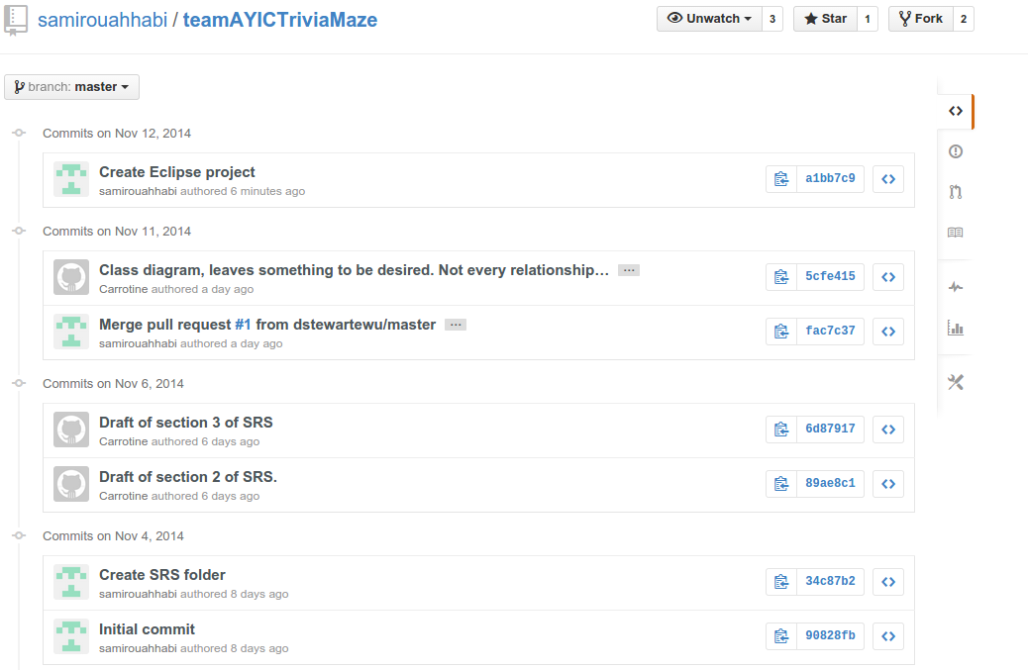

**Pivotal tracker screen capture**

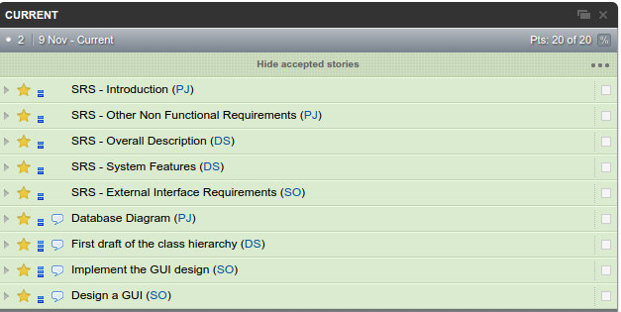

**Code demo**

