Data Structure and Algorithm Assignment 2

List:
- Reverse a list in Python

Code:

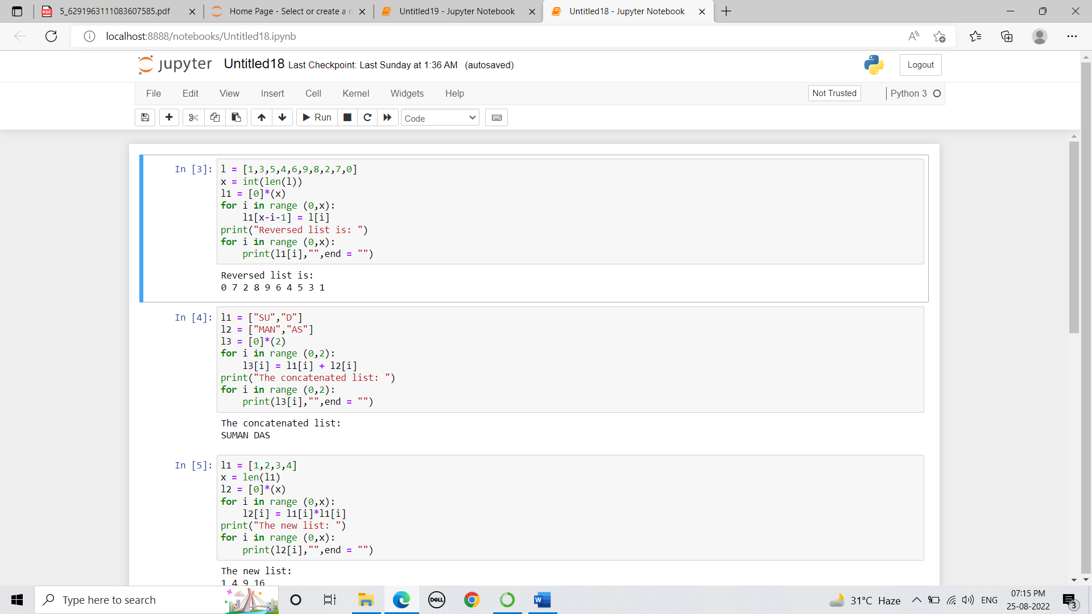
Output:

- Concatenate two lists index-wise.

Code:

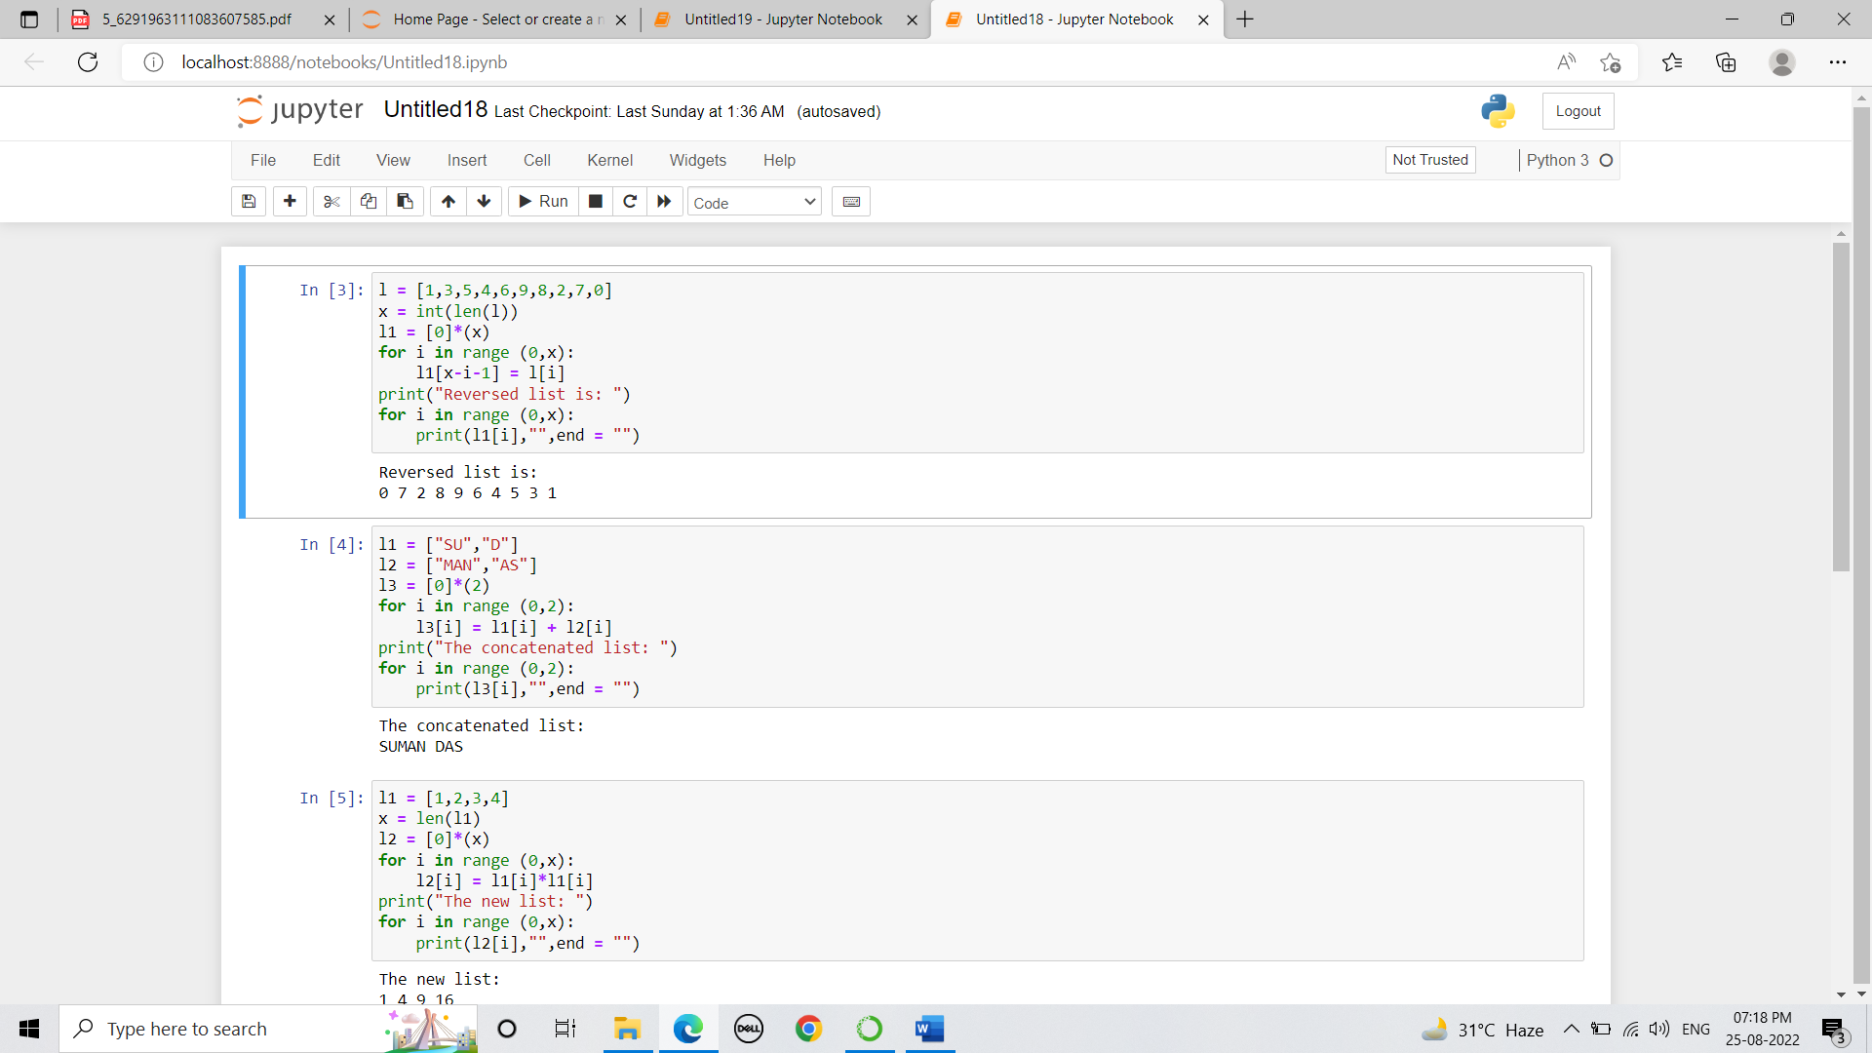

Output:

- Turn every item of a list into its square:

Code:

Output:

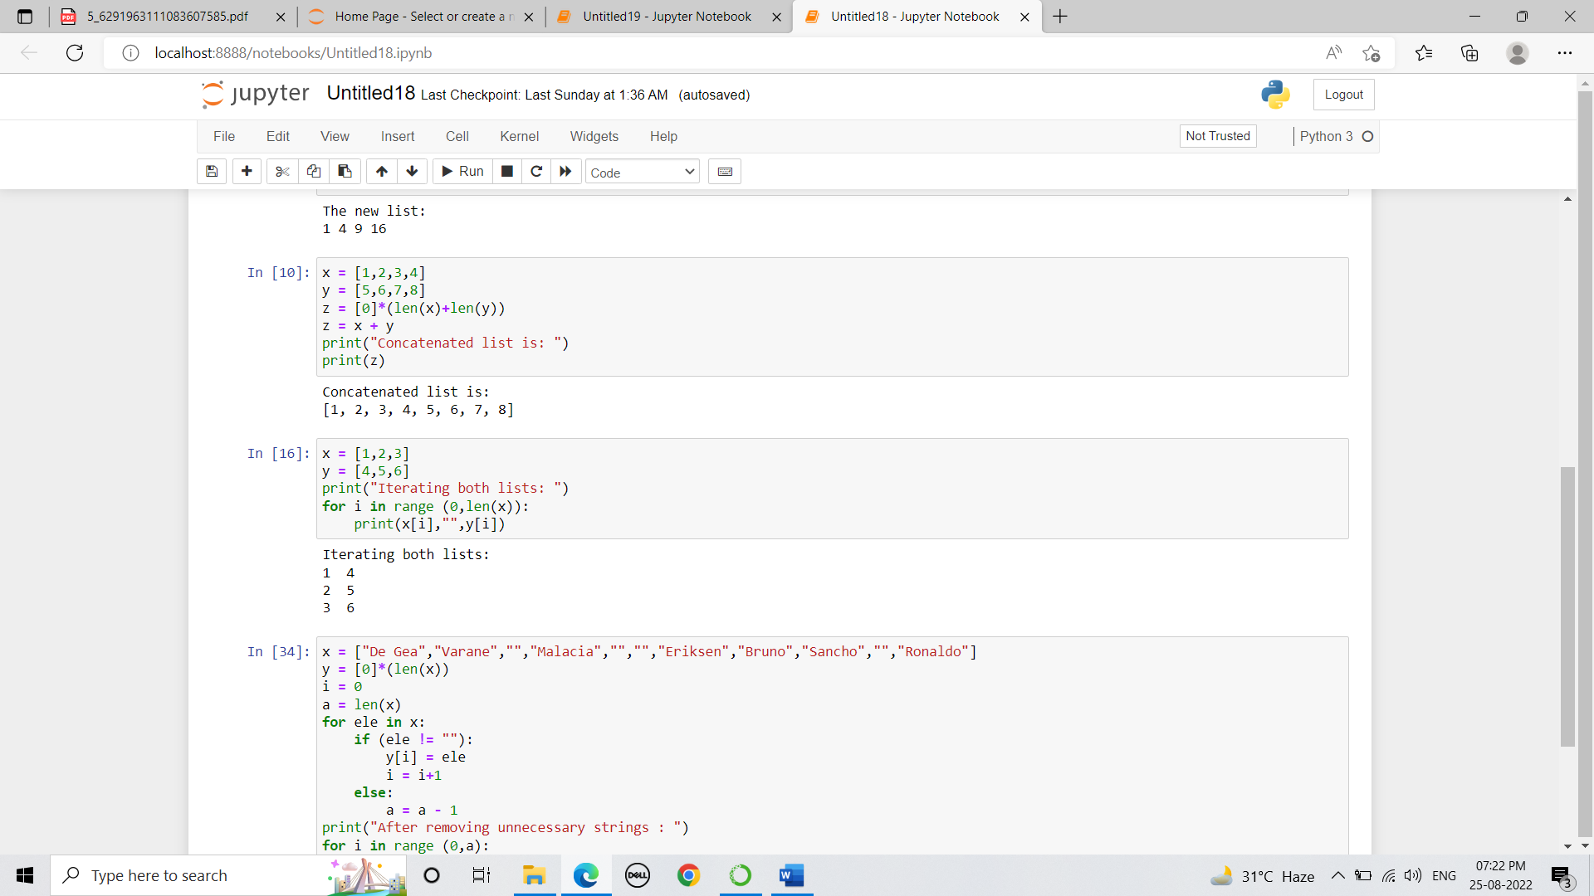

- Concatenate two lists in the following order.

Code:

Output:

- Iterate both lists simultaneously.

Code:

Output:

- Remove empty strings from the list of the strings
Code:

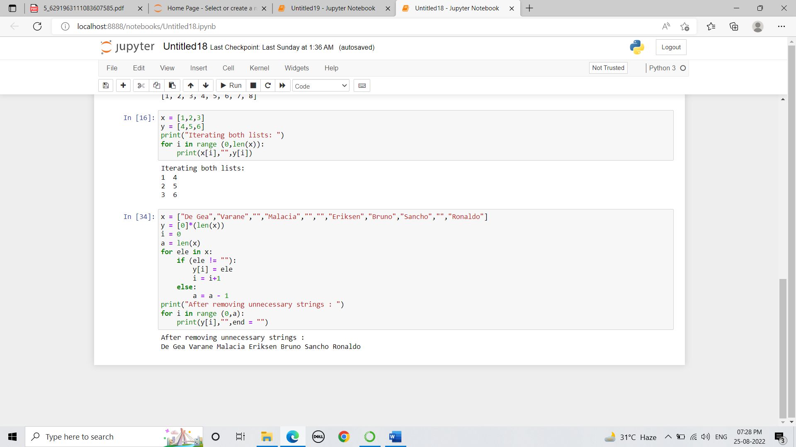

Output:

- Add new item to list after a specified item.

Code:

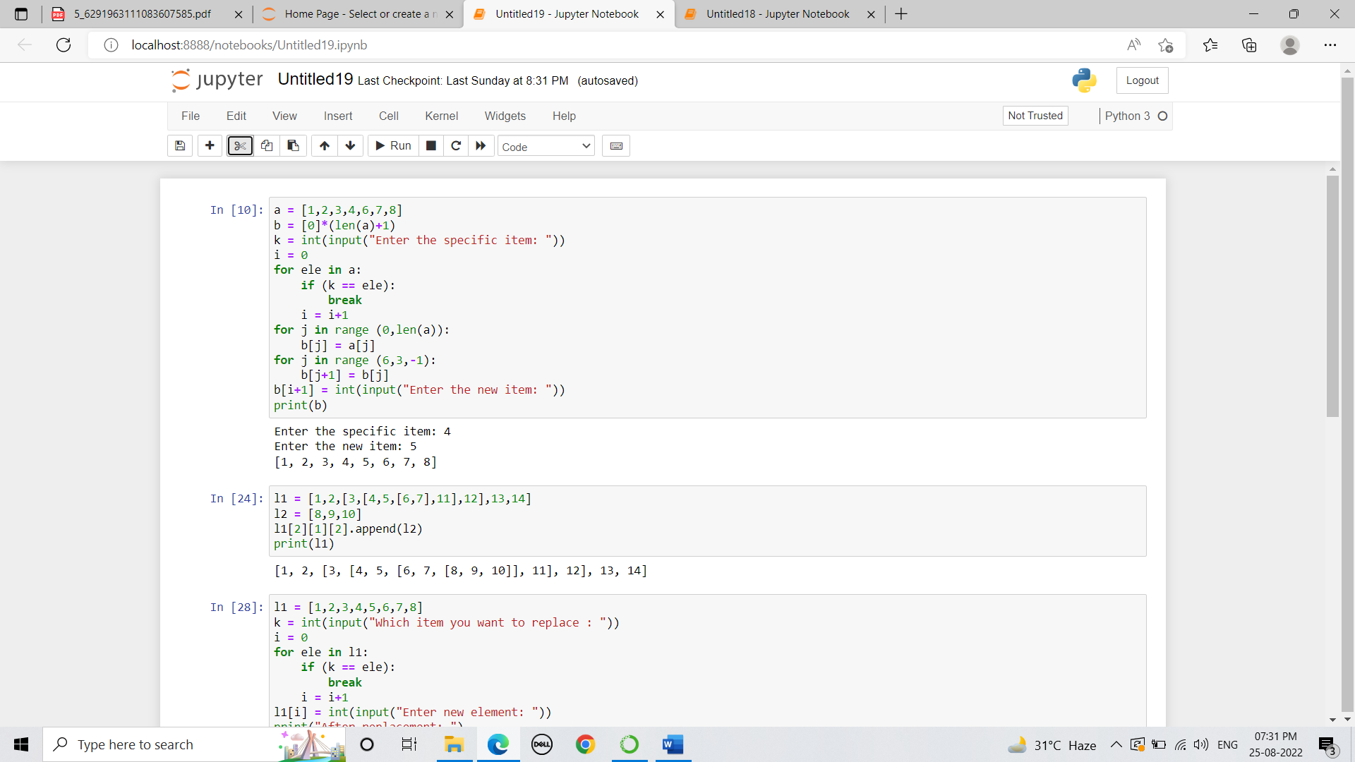

Output:

- Extend nested list by adding the sublist

Code:

Output:

- Replace list’s item with new value if found

Code:

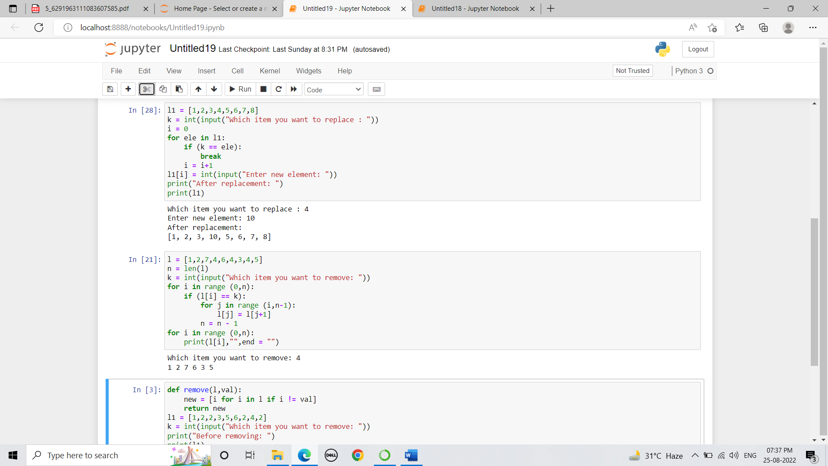

Output:

- Remove all occurrences of a specific item from a list

Code:

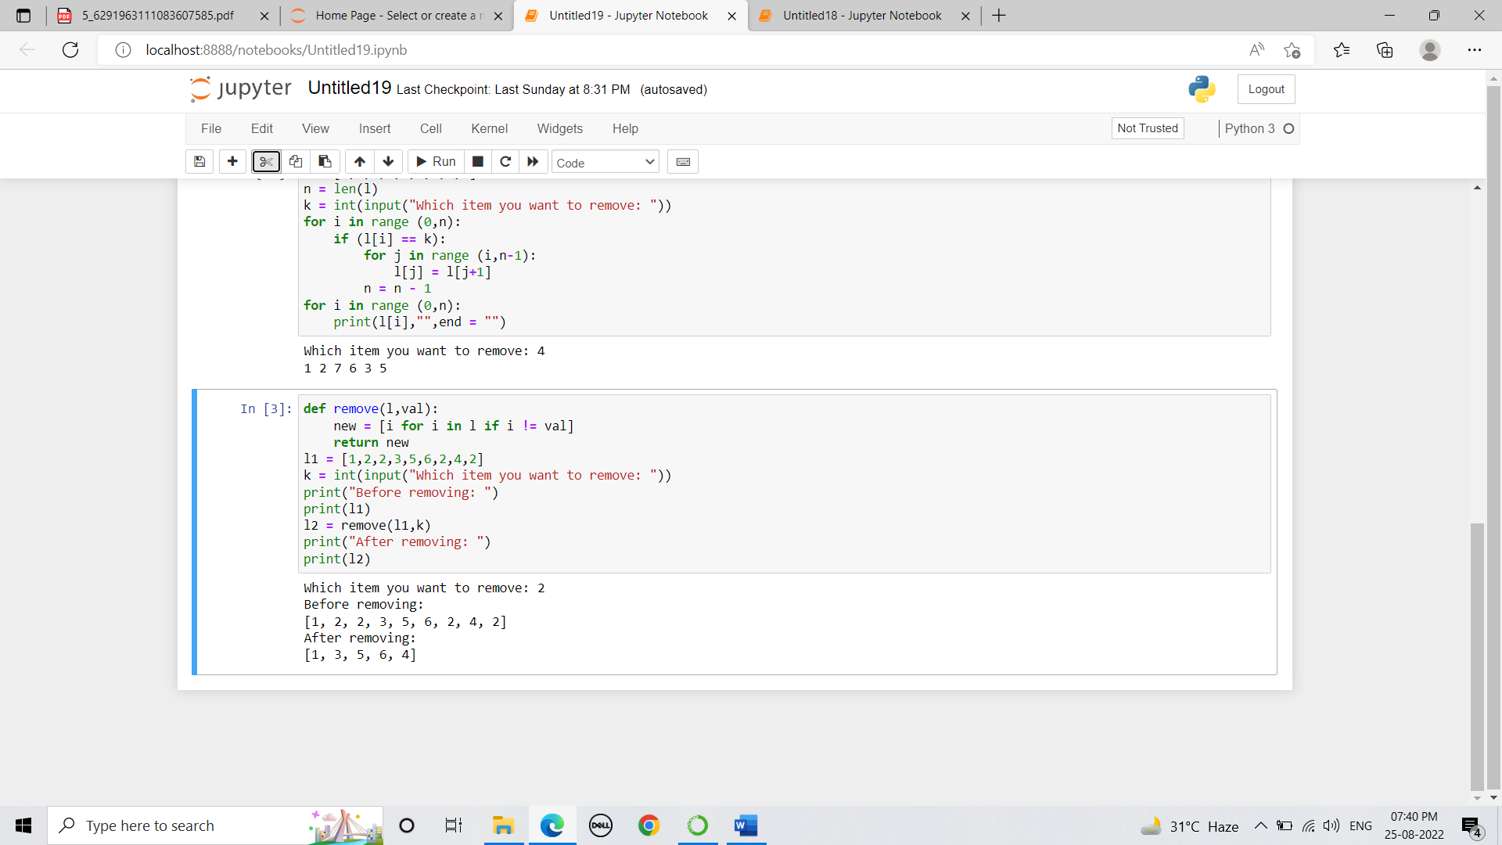

Output:

Tuples:
- Reverse the tuple

Code:

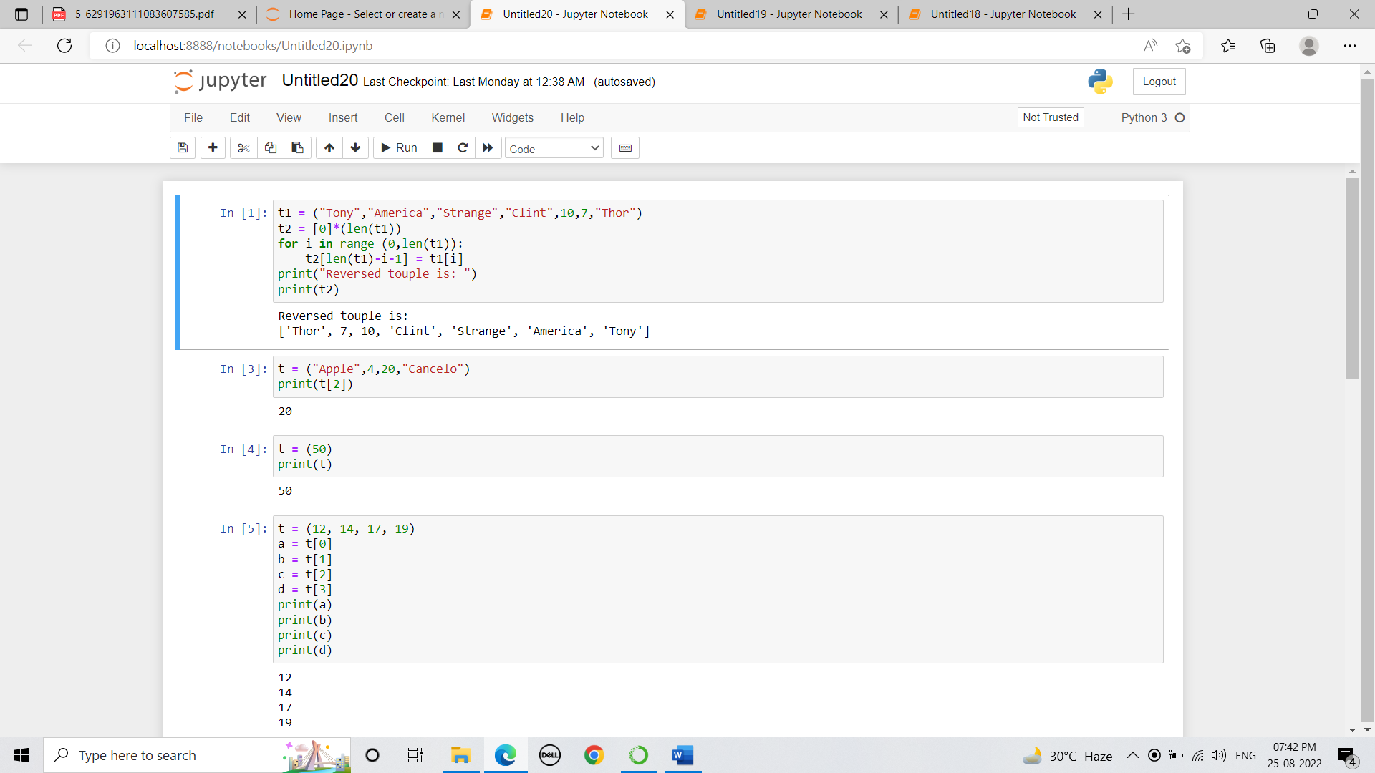

Output:

- Access value 20 from the tuple.

Code:

Output:

- Create a tuple with single item 10

Code:

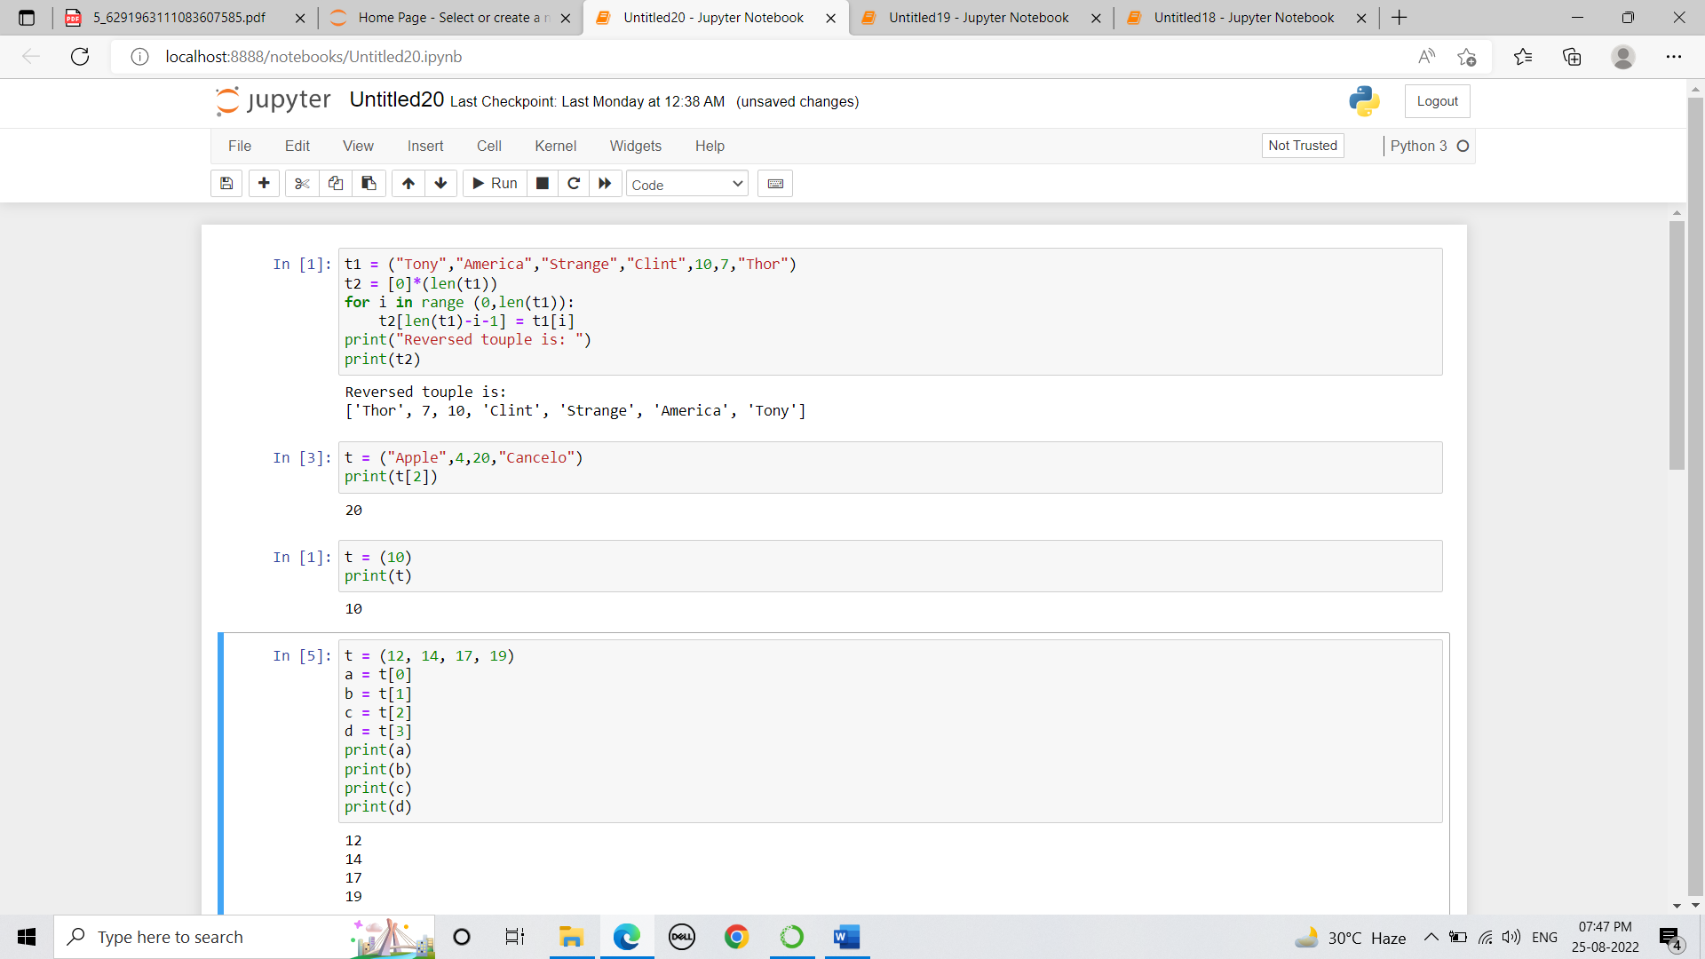

Output:

- Unpack the tuple into 4 variables

Code:

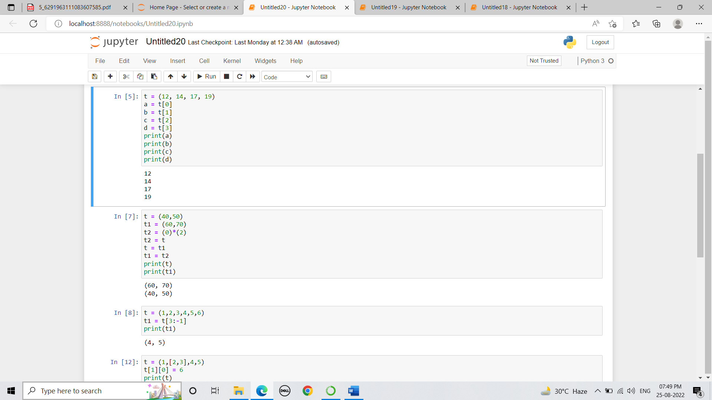

Output:

- Swap two tuples in python

Code:

Output:

- Copy Specific elements from one tuple into a new tuple

Code:

Output:

- Modify the tuple

Code:

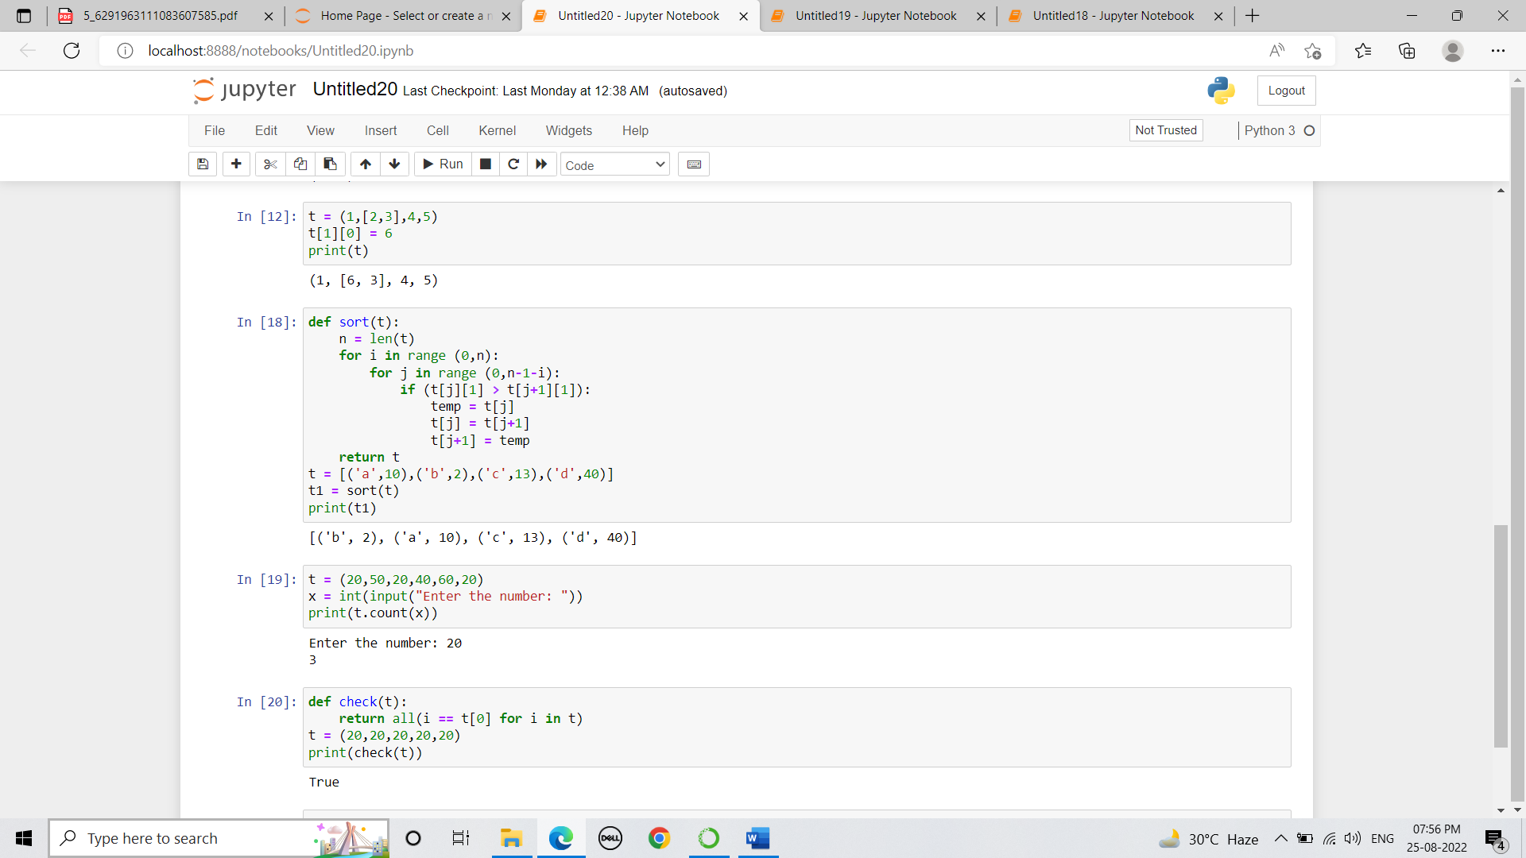

Output:

- Sort a tuple of tuples by 2nd item

Code:

Output:

- Count the number of occurrences of item ‘x’ from a tuple

Code:

Output:

- Check if all items in the tuple are the same:

Code:

Output:

Set:
- Add a list of elements to a set

Code:

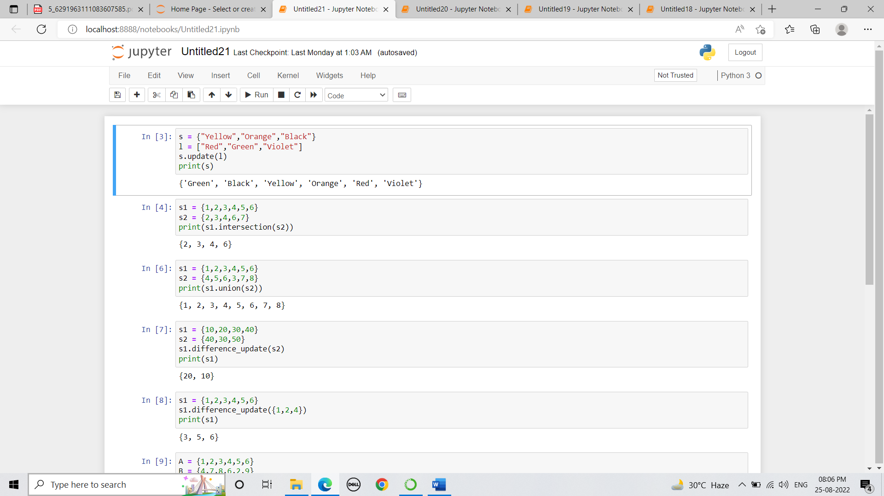

Output:

- Return a new set of identical items from two sets

Code:

Output:

- Get only unique items from two sets

Code:

Output:

- Update the first set with items that don’t exist in the second.

Code:
Output:

- Remove items from the set at once

Code:

Output:

- Return a set of elements present in Set A and B, but not both

Code:

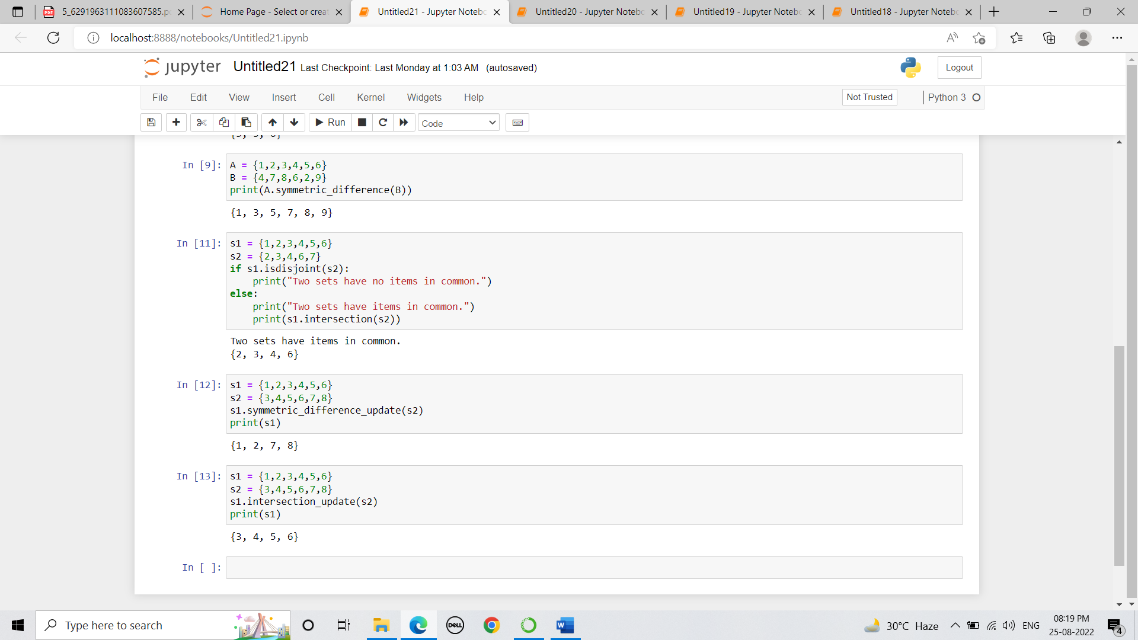

Output:

- Check if two sets have any elements in common. If yes, display the common elements

Code:

Output:

- Update set1 by adding items from set2, except common items
Code:

Output:
- Remove items from set1 that are not common to both set1 and set2

Code:

Output:

Dictionary:
- Convert two lists into a dictionary

Code:

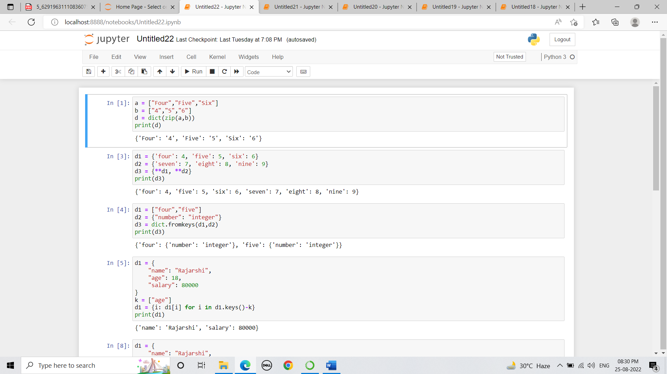

Output:

- Merge two Python dictionaries into one

Code:

Output:
- Initialize dictionary with default value
Code:

Output:

- Create a dictionary by extracting the keys from a given dictionary

Code:

Outputs:

- Delete a list of keys from a dictionary

Code:

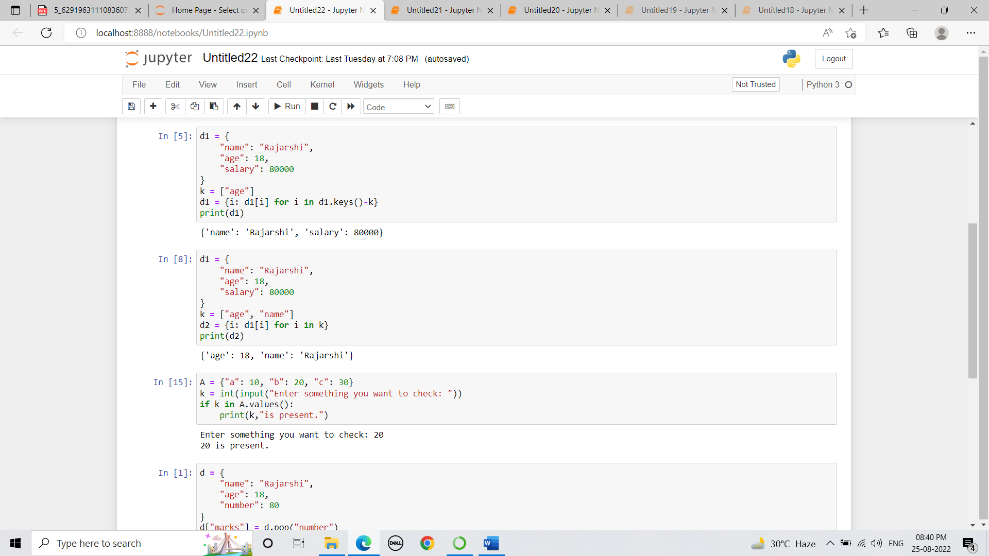

Output:

- Check if a value exists in a dictionary

Code:

Output:

- Rename key of a dictionary

Code:

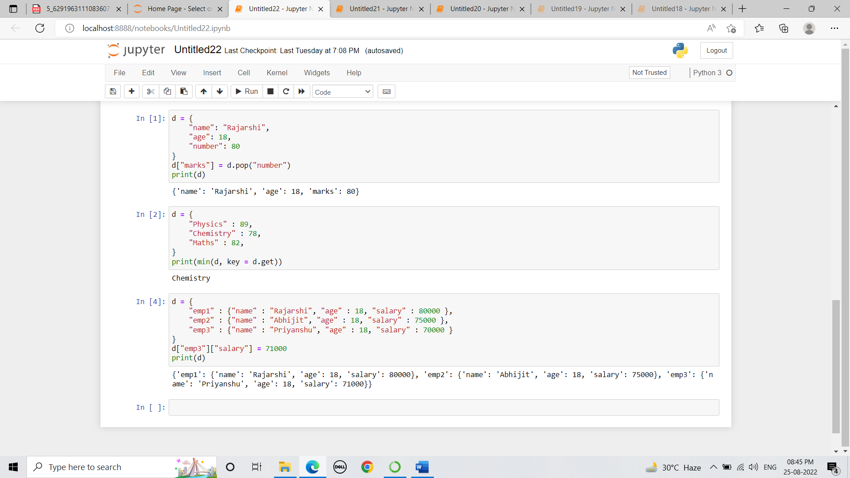

Output:

- Get the key of a minimum value from the following dictionary

Code:

Output:

- Change the value of a key in a nested dictionary

Code:

Output:

