1. ryanair.com

Bug report
1. Title: Redirect to a Spanish gift card page
2. Environment : - google chrome
- https://www.ryanair.com/ro/ro

3. Summary:
When the ,,buy now" button is pressed on the ,,Elemente esenţiale pentru călătorie" tab it redirect me to a Spanish page that couldn't be translated.

4. Steps:
1. Open Chrome browser
2. Access the ryanair.com
3. Go down to ,,Elemente esenţiale pentru călătorie"
4. Hold on ,,25,99 euros gift card"
5. Click Buy now

5.
Actual results
The gift card page is in Spanish and couldn't be translated
Expected
The gift card page to be in Romanian or to be translated

6. evidence
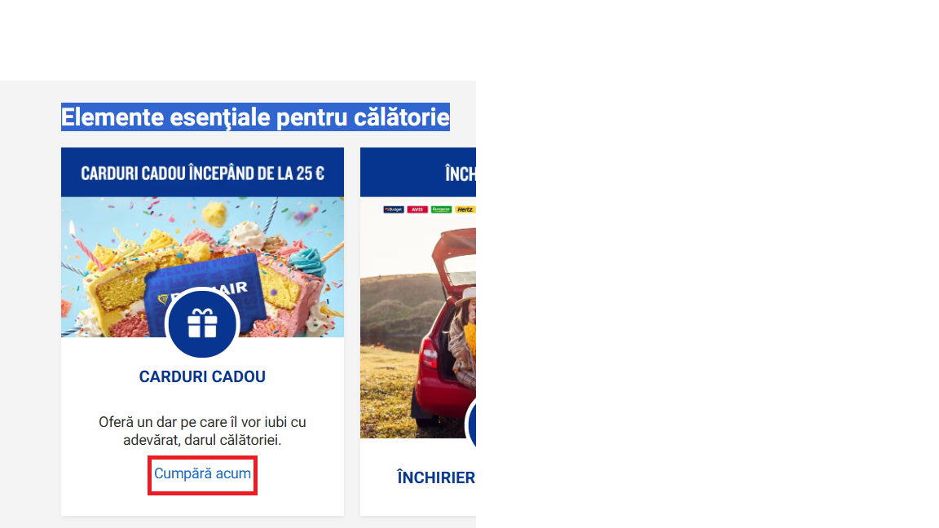
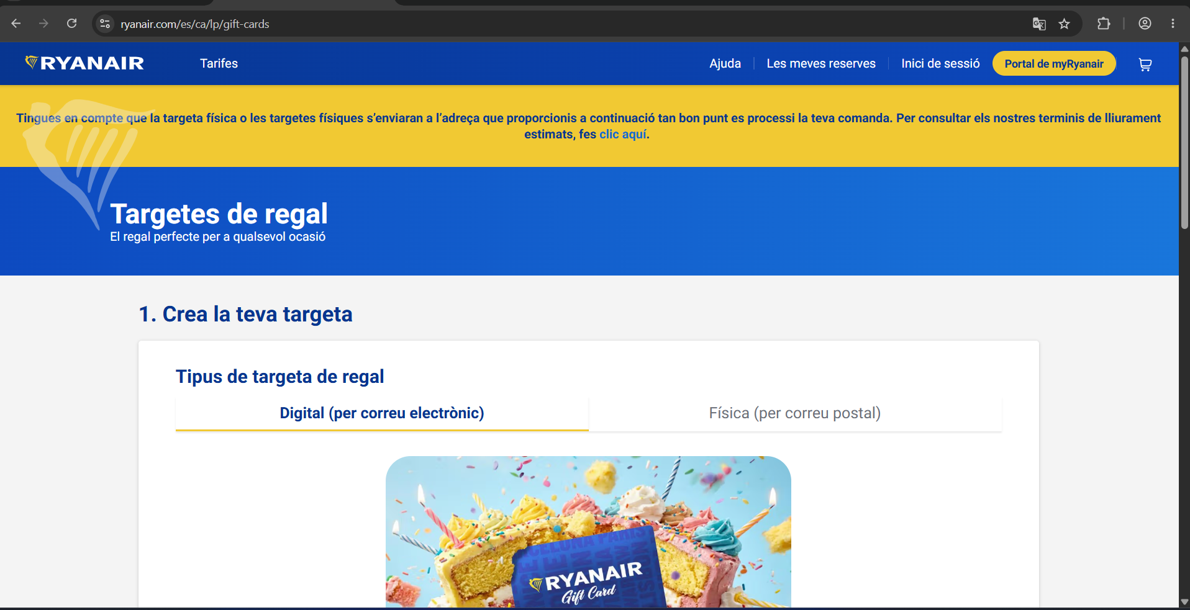

Test case
1. Id: 60543
2. Purpose : Verify if a client can make 2 reservation on the exact same period
3. Test data:
user credentials
4. Preconditions:
User is logged in.
2 flight on the exact same period approximately the same hours from the same airport but to different destinations
5. Steps
1. Open the ryanair.com
2. Log In
3. Book a flight
4. Book another flight from the same airport but to a different destination
6. Expected results:
1. Site opens
2. Log in works
3. Book flight works
4. The flight to be confirmed and actually exist
5. To receive a message or email that says if you are sure you want the flight because you have another flight on the same day

– developer suggestion a button book a flight for someone else
Am folosit Exploratory testing in gasirea bug ului si as putea spune State Transition Testing pentru ca am urmat starea in care a ajuns pagina de la pagina de flightbooking in romana la cea in spaniola
Bug report
1.Title: Premium subscription: Flexi Plus 20kg baggage
2. Environment : - google chrome
- https://www.ryanair.com/ro/ro
3. Summary:
The 20 kg baggage option is available for the Plus and Flexi Plus fares, but it cannot be added to the Premium subscription only after selecting the seats.
4.Steps:
1. Open Chrome browser
2. Access the ryanair.com
3. Book a flight on any destination
4. Go to select rate option
5. Chose Flexi Plus
6. You can’t select the 20 kg baggage option on the first page
5.
Actual results
The 20 kg baggage option is not checked on the first page when the flight is booked
Expected
The Premium option should show all included options from the first page.
6. Evidence
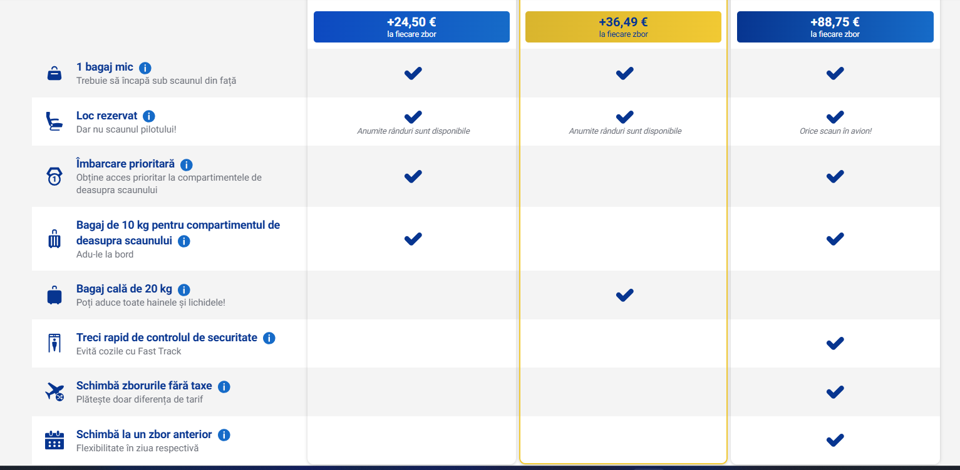

Test case
1. Id: 6544
2. Purpose: Verify baggage allowance for a Premium member traveling with a baby
3. Test data:
User premium credentials
4. Preconditions
- User is logged in and has an active Premium membership.
- User is traveling with an infant aged between 8 days and 23 months.
- The infant is traveling on the adult’s lap.
Steps:
- Log in with an account that has an active Premium membership.
- Create a booking for an adult traveling with a baby.
- Proceed to the baggage selection.
- Check the baggage allowance for both the Premium member and the infant.
Expected Result:
- The Premium member receives the baggage allowance included with the Premium membership.
- The infant is eligible for one free baby bag up to 5 kg, with maximum dimensions of 45 × 35 × 20 cm.
- The free infant bag is provided in addition to the baggage allowance included with the Premium membership.
- No additional fee is charged for the infant’s baby bag.

Am folosit Decision Test Table pentru ca am verificat daca sunt respectate 2 optiuni pe care site-ul mi le pune la dispozitie din punct de Vedere la userului

Bug
1. Title: Baggage price is not updated after changing the selected baggage weight
2. Environment : - google chrome
- https://www.ryanair.com/ro/ro
3. Summry:
When the user selects a 10 kg baggage option and then changes it to 20 kg, the baggage price remains the same as for the 10 kg option.
4.Steps:
1. Open Chrome browser
2. Access the ryanair.com
3. Book a flight on any destination
4. Select the 10 kg baggage option
5.Change the baggage option from 10 kg to 20 kg.
6.Check the baggage price and the total booking price.
5.
Actual results
The system continues to display the price for the 10 kg baggage.
Expected
The price should be updated according to the newly selected 20 kg baggage option.

6 Evidence
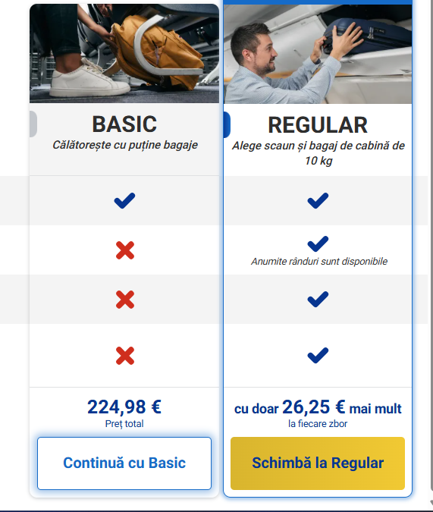

Test Case
ID: 6545
Purpose : Verify that the baggage price is correctly updated when changing the baggage weight.
Test data :
User credentials
Preconditions
User is logged in.
A flight with available baggage options is available.
Both 10 kg and 20 kg baggage options are available.
Steps
1. Open the ryanair.com
2. Log In
3. Book a flight
4. Select the 10 kg baggage option.
5. Change the baggage option from 10 kg to 20 kg.
6. Verify the displayed baggage price.
7. Verify the total booking price.

Expected Result:
The 20 kg baggage option is selected successfully.
The baggage price is updated according to the 20 kg option.
The total booking price is recalculated correctly.

