University Polytechnica of Bucharest

Faculty of Automatic Control and Computer Science

2018

Microcontroller Subsystem

Software Design

**SW_uC_Design**

DRAFT

**Author:**

**TEODORESCU OCTAV-IULIAN**

Table of Contents

I. Document purpose 3

II. The software of the uC subsystem 3

III. Software requirements 3

IV. References 5

V. Document History 5

VI. Other 5

1. Document purpose

This document contains a high level view of the uC subsystem, aswell as the explanations behind design decisions. The view is conveyed through various types of UML diagrams.

1. Diagrams

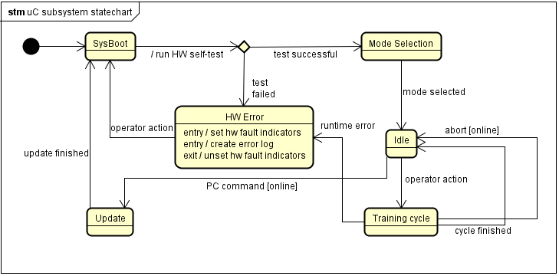

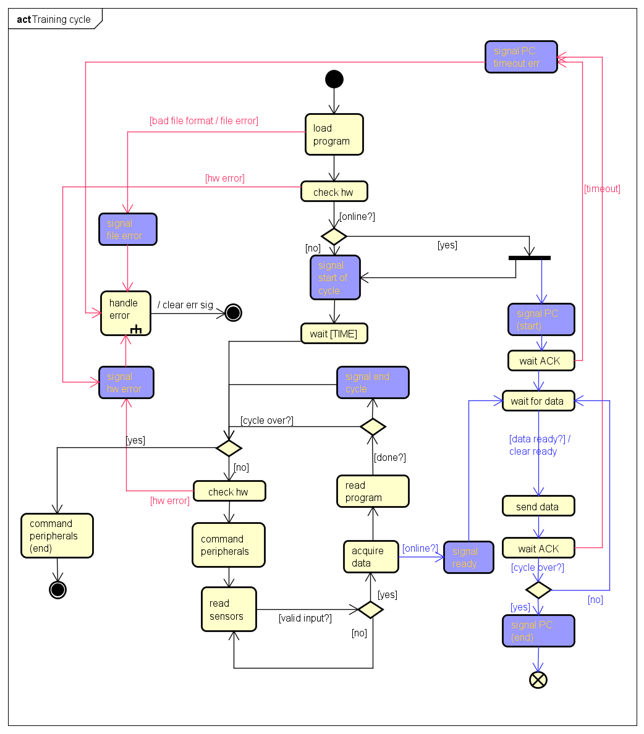

1. Document History

|  |  |  |
| --- | --- | --- |
| **Date** | **Status/Version** | **Comments** |
| 12/10/2017 | Awaiting Approval/DRAFT |  |

1. Other

*Abbreviations:* HW – hardware, SW – software, uC - microcontroller