FedCORE: Finite-Sample Selective-Risk Certification under Credal Client-Mixture Uncertainty
Sanghoon Kim*
Department of Industrial and Management Engineering, Korea University,
145 Anam-ro, Seongbuk-gu, Seoul 02841, Republic of Korea
*Corresponding author. E-mail address: dawonksh@korea.ac.kr

Abstract
Federated classifiers can appear reliable on average yet become unsafe when future traffic shifts toward a difficult client. This study asks which predictions from a fixed federated open-set classifier may be automated when the client mixture is uncertain. Client-dependent acceptance changes the mixture among automated predictions, so the relevant selective risk is a ratio whose numerator and denominator both depend on traffic. FedCORE represents traffic uncertainty by a credal set and sampling uncertainty by finite-sample client audits. Using audit size, accepted count, and accepted-error count, it returns a deploy-or-refuse decision without retraining. We establish a fixed-pooling reducibility boundary, an exact full-simplex certificate, a positive-denominator program for strict credal polytopes, and familywise-valid selection among proposal-frozen rules. In target-matched replay over 443 proposal-feasible empirical-reservoir conditions, the minimum observed coverage was 0.953 and none fell below 0.95. With the full-simplex target, predictors, selector families, budgets, and counts held fixed, the Holm intersection-union procedure certified 177 of 450 conditions with mean effective certified acceptance of 8.34%, whereas valid fixed-prior betting certified 81 with 3.97%. In Office-Home, changing the protected target from the full simplex to an independently formed traffic-informed credal set increased certifications from 74 to 92 of 100 and mean effective certified acceptance from 9.6% to 19.3%. This was target sensitivity, not a same-target method comparison. A 30-model PACS rerun and pre-specified VLCS and DomainNet fixed-frame evaluations failed primary utility or transfer gates. The results distinguish validity of a credal deployment decision from utility of the predictor and evidence budget.
Keywords: Credal sets; Federated learning; Open-set recognition; Selective risk; Finite-sample certification; Imprecise probability

1. Introduction
Federated learning trained one model from decentralized client data [1]. Open-set recognition allowed the deployed system to encounter classes that were absent from training [2]. Selective classification added a practical escape route: the system accepted a prediction only when its score was sufficiently reliable and deferred the remainder [3]. The unresolved deployment question was harder. If future traffic shifted toward a difficult client, could the accepted predictions of a frozen model still be certified with a small distributed clean audit?
The purpose of this study was to determine which predictions from a fixed federated open-set classifier could be automated when future client traffic was uncertain. A declared credal set represented the client mixtures requiring protection. The study examined two hypotheses. First, target-matched stratified certification could control accepted selective risk over the declared mixture set. Second, full-simplex family procedures that avoided client-count division would retain more certified utility than a valid conservative family-and-stratum allocation when the predictor, selector family, target, confidence budget, and audit counts were held fixed. A separately sealed PACS rerun then examined whether nontrivial certified utility persisted under fresh training randomness on the same hashed empirical frame.
A simple analogy is quality control across several factories. A pooled defect rate can look safe while one factory remains unsafe, and the conclusion can reverse when orders shift toward that factory. FedCORE therefore keeps client strata visible, certifies the worst admissible traffic mixture, and refuses deployment when too few accepted audit examples support the requested risk. This distinction is necessary because fixed heterogeneous quotas produce Poisson-binomial rather than homogeneous binomial error counts [4]. Confidence intervals for their mean require a separate construction [5]. The pooled calculation is therefore used only to diagnose a contract mismatch and not as a competing certificate for the full-simplex target.
The study made four contributions:
• The study identified the deployment target as the accepted-error ratio after client-dependent acceptance had reweighted the traffic mixture. A representation result established when this robust target can and cannot be reduced to one fixed pooled mixture, with exact singleton and full-simplex reductions.
• FedCORE provided fixed-size finite-sample deploy-or-refuse procedures for the full simplex and strict credal polytopes. Under full-simplex protection, a fixed selector's risk tail was not divided by the number of clients. An explicit positive-acceptance condition prevented certification when the audit supported no usable predictions.
• The framework permitted familywise-valid choice among rules frozen using proposal data. It kept epistemic uncertainty about future traffic separate from sampling uncertainty in client audits, and combined them only when evaluating the robust accepted-error ratio.
• The experiments separated target-matched validity from same-target utility. At a risk target of 0.20, the Holm intersection-union procedure certified 177 of 450 conditions, compared with 81 under valid fixed-prior betting and 130 under the client-divided conservative allocation. The PACS, VLCS, and DomainNet studies retained complete denominators and adverse primary outcomes, identifying risk-gate, evidence-budget, and transfer boundaries rather than broad procedure superiority.
The empirical study first tested the certificate under its stated sampling contract. It then diagnosed audit-target mismatch and compared valid full-simplex procedures under the same predictors, candidate families, targets, confidence budgets, and realized counts. Later analyses varied the risk target and credal set, and examined natural-domain and biomedical applications. A separately sealed post-incident PACS rerun tested fresh training randomness on the same hashed frame, while pre-specified VLCS and DomainNet evaluations tested transfer to source-distinct fixed empirical frames. Every registered cell and adverse result remained in the denominator.

2. Related Work

2.1 Selective decisions and finite-sample risk control
Selective classification concerns an accept-or-defer point prediction [6]. Risk-controlling prediction sets concern a set-valued output [7]. Conformal risk control bounds an expected monotone loss [8]. Reject-option certification imposes a different decision constraint [9]. Bounded abstention provides another formulation [10]. Learn then Test handles accepted point-prediction error through testing of frozen candidates [11]. Yu and Liu jointly certify selective risk, acceptance, and utility for adaptive finite-grid selection in a centralized setting [12]. FedCORE addresses a different object: client-dependent acceptance reweights the deployment mixture, so finite-sample audit uncertainty must be propagated across a credal set rather than through one pooled ratio.
Betting-based mean inference supplies one component of the certification procedures [13]. Coin-betting optimality provides a related foundation [14]. Intersection-union testing and Holm correction complete the inference used here. Full-simplex H is the existing LTT-IUT-Holm composition, not a new test. Strict-mixture RATIO optimizes a confidence-set ratio, while direct betting tests weighted risk contrasts. The comparisons isolate utility under matched evidence and declared protection, not priority for these components.
Search guided by eventual risk verification is also established [15]. Multi-distribution conformal prediction (MDCP) learns conformity scores for efficient multi-distribution prediction sets [16], whereas our output is an accepted point prediction. Classical reject-option analysis characterizes conditional-risk threshold selection [17]. These connections make a new objective or learned selector insufficient evidence of an independent methodological contribution.
Adaptive evidence use is established in active risk-controlling prediction sets [18], adaptive Learn then Test [19], risk-limiting audit design [20], and stratified audit procedures [21]. These methods address sequential evidence acquisition under their own sampling contracts. FedCORE instead studies a fixed-size, count-based certificate for a predeclared credal deployment target.
Private anytime selective-risk certification has also been developed for federated retrieval-augmented generation under differential privacy and a total-variation mixture-transfer contract [22]. FedCORE instead studies accepted point predictions from frozen visual classifiers under a predeclared credal set of client mixtures. Its certificate is fixed-size and count-based, and it claims neither differential privacy nor transport beyond the audited target.

2.2 Credal client mixtures and distributed calibration
Federated conformal methods address distributed coverage [23]. One-shot communication is treated in a separate construction [24]. Other methods handle label shift [25]. Prototype-based calibration provides another route [26]. Group-conditional coverage has also been studied [27]. A further formulation treats joint shift [28]. Multi-distribution max-p aggregation protects prediction-set coverage [16]. Site-conditional calibration addresses institutional segmentation risk [29].
Federated conformal methods primarily addressed distributed coverage under their own distributional contracts. FedCORE instead targeted error among accepted point predictions when both traffic and acceptance varied by client. Acceptance changed the client weights among automated predictions from the deployment weights to weights proportional to each deployment weight multiplied by that client’s acceptance rate. A pooled audit could therefore answer a different question, and a worst-group prediction-set coverage guarantee did not directly bound this accepted-error ratio. FedCORE kept client strata visible, propagated their finite-sample audit bounds over a declared credal set, and refused certification when positive acceptance was not supported.

2.3 Federated open-set deployment and closest comparators
FedPD modifies the upstream predictor [30]. FedOSS provides another federated open-set training method [31]. FOOGD also changes the learned predictor [32]. Agnostic federated learning addresses client mixtures [33]. Non-IID federated training has been reviewed separately [34]. Outlier exposure improves recognition quality [35]. Joint error and out-of-distribution detection addresses the same broader goal [36]. We freeze predictors and compare their deployment certificates. Archived exports are named by the implementations actually verified, rather than assumed full reproductions of these upstream methods.
FedCORE’s methodological contribution is the finite-sample decision obtained when accepted risk is conditioned jointly on an imprecise client mixture and candidate-specific client acceptance. Exact binomial limits, multiple-testing corrections, regular extension, and linear-fractional optimization are established components. Proposition 1 shows why a non-singleton credal target cannot generally be replaced by one pooled mixture fixed independently of the client-risk profile. Theorem 1 converts full-simplex protection into an exact fixed-worst-client decision without a client-count division. Theorem 2 propagates simultaneous audit uncertainty through a strict credal polytope while enforcing a positive acceptance denominator. The family results then preserve validity when the deployed rule is selected from a proposal-frozen family. Table 1 identifies which part of this construction is inherited and which target-specific step is supplied by FedCORE.
FedCORE denotes the deployment target, evidence contract, and fail-closed decision rule rather than one uniquely privileged confidence procedure. The primary analyses use full-simplex Holm-IUT for a proposal-frozen family and the strict-polytope ratio program for a fixed selector. H, S, and B are confidence-allocation variants. BETTING-H and SCALE-H are matched inferential comparators evaluated under the same target and realized audit counts; they are not additional training methods.
Table 1. Theorem-linked novelty map. Established statistical components are separated from the target-specific steps supplied by FedCORE.
Established component | Standard object | Target-specific gap | FedCORE result | Validity scope
Federated conformal calibration | Distributed prediction-set coverage | Error among accepted point predictions | Proposition 1 and Equation (1) | Different protected object
Exact binomial inference | Fixed-stratum sampling bounds | Accepted-mixture risk over uncertain traffic | Theorem 1 | Fixed selector; full simplex
Credal regular extension | Conditional lower and upper expectation | Finite-sample audit uncertainty and deploy-or-refuse gate | Theorem 2 | Strict credal polytope; positive denominator
Holm and intersection-union testing | Familywise testing | Proposal-frozen client-dependent selectors | Theorem 6 | Full-simplex finite family
Linear-fractional optimization | Ratio optimization | Simultaneous endpoints with denominator failure | Theorem 2 | Strict-polytope robust program
Target-specific synthesis | Credal accepted-error ratio | Traffic and audit uncertainty are coupled in the ratio | Theorems 1, 2, and 6 | Proposal-frozen selector or finite family
The matrix locates the target-level gap. Proposition 1 below formalizes the fixed-pooling reducibility boundary. FedCORE does not claim novelty for exact binomial limits, Holm correction, or linear-fractional optimization in isolation.

3. Deployment Decisions under Client-Mixture Uncertainty
Figure 1 specifies the fixed-size deployment decision. The predictor, candidate rules, protection set, and sampling design are frozen before certification. Each client contributes only its audit size, accepted count, and accepted-error count. The server returns a certificate only when the applicable risk decision and a positive acceptance lower bound both pass.
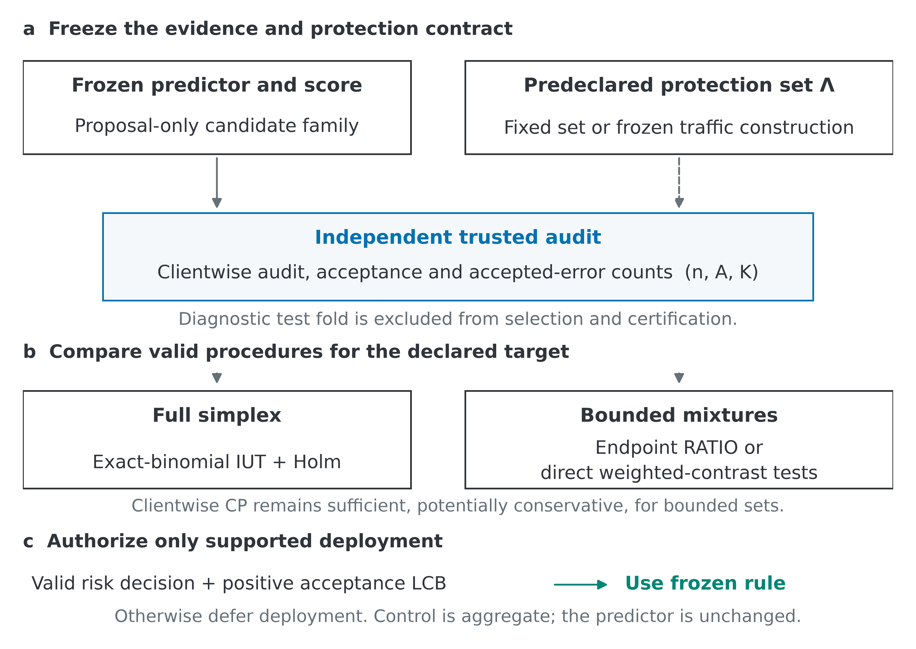
Figure 1. Count-based deployment under a predeclared protection set. Panels show (a) frozen evidence, (b) alternative valid procedures, and (c) the common deployment gate. IUT denotes intersection–union testing, CP Clopper–Pearson, and LCB a lower confidence bound. Arrows describe logical dependencies, not performance guarantees.
Clients and traffic mixture. There are $J$ clients with distributions $P_{j}$ over inputs and open-set labels. Define the full simplex as $Δ_{J-1}:=\{λ∈R^{J}:λ≥0,1^{⊤}λ=1\}$. The deployment weights satisfy $λ∈Λ⊆Δ_{J-1}$, and the resulting population is $Q_{λ}:=\sum_{j=1}^{J}{λ_{j}}P_{j}$. The full simplex permits any traffic allocation. A strict bounded-mixture set retains only allocations supported by information declared before certification.
Open-set decision. A score ranks the frozen classifier’s known-class predictions for acceptance or deferral. Independent trusted counts test this rule under Λ. A refused deployment sends every input to fallback; a certified deployment automatically uses only predictions accepted by the unchanged rule.
The target α limits errors among accepted point predictions [37]. Equation (1) excludes deferred inputs and accounts for both traffic and client acceptance. It is an aggregate selective-risk guarantee, not a correctness guarantee for every accepted prediction.
$R_{sel}(λ)={Pr}_{(X,Y)∼Q_{λ}}(\hat{y}(X)≠Y∣A(X)=1)=\frac{\sum_{j=1}^{J}{λ_{j}}m_{j}}{\sum_{j=1}^{J}{λ_{j}}a_{j}}$ (1)
For client $j$, define $a_{j}:={Pr}_{P_{j}}(A(X)=1)$, $m_{j}:={Pr}_{P_{j}}(A(X)=1,\hat{y}(X)≠Y)$, and $r_{j}:=\frac{m_{j}}{a_{j}}\text{if}a_{j}>0$. When $a_{j}=0$, we set $r_{j}:=0$ only as a null-acceptance convention. The deployment acceptance rate is $C(λ):=\sum_{j=1}^{J}{λ_{j}}a_{j}$, and selective risk is considered on $Λ_{+}(a):=\{λ∈Λ:λ^{⊤}a>0\}$. Numerical branches report a risk upper confidence bound and an acceptance lower confidence bound. The fixed-$α$ Holm intersection-union testing branch instead reports a familywise-valid decision and adjusted p-value. Deployment is refused when positive acceptance is not certified.
Acceptance reweights traffic. If equally visited clients accept 90% and 10% of inputs with accepted risks 0.02 and 0.20, their accepted-input shares are 0.90 and 0.10. Equation (1) gives risk 0.038 rather than the unweighted 0.11. This is an illustrative calculation, not an empirical result.
A nonempty closed convex $Λ⊆Δ^{J−1}$ is a credal set over client traffic weights. It induces the deployment-distribution set $𝒫_{Λ}:=\{Q_{λ}:λ∈Λ\}=\{∑_{j=1}^{J}λ_{j}P_{j}:λ∈Λ\}$. Maximizing conditional error over mixtures with positive acceptance has a regular-extension interpretation [38]. Thus, $Λ$ represents epistemic uncertainty about traffic weights, whereas $𝒫_{Λ}$ contains the corresponding deployment distributions. The statistical procedure still requires its own finite-sample argument.
The credal set represents epistemic uncertainty about future client traffic, whereas the binomial endpoints quantify sampling uncertainty in the client audits. FedCORE keeps these sources separate. The audit first produces finite-sample bounds for accepted errors and acceptance within each stratum. For a strict credal polytope, regular extension then propagates those simultaneous bounds over the declared deployment mixtures while excluding mixtures whose acceptance denominator is not supported as positive. The resulting decision therefore changes when either the traffic set or the audit evidence changes, but it does not treat uncertainty about traffic as additional labeled evidence.
Proposition 1 (fixed-pooling reducibility boundary). Fix a selector with $a_{j}>0$ for every client and a nonempty closed credal set $Λ⊆Δ^{J−1}$. A traffic vector $q∈Δ^{J−1}$, which may depend on the acceptance vector and on $Λ$ but is fixed independently of the unknown client-risk profile $r$, represents the robust accepted-error target in Equation (1) for every $r∈{\left[0 , 1\right]}^{J}$ if and only if $Λ=\{q\}$. Thus a singleton contract reduces to its matched-mixture risk, whereas full-simplex protection reduces exactly to $\max_{j:a_{j}>0}r_{j}$ rather than to a fixed pooled average. If some $a_{j}=0$, the characterization applies to the induced accepted-client weights; an empty positive-denominator domain fails closed.
Proof. Define $w_{j}(λ,a)=\frac{λ_{j}a_{j}}{λ^{⊤}a}$. For positive $a$, $w(λ,a)$ is a probability vector, and the map from $λ$ to $w$ is injective because, for each client, $λ_{j}=\frac{{w_{j}}/{a_{j}}}{\sum_{k=1}^{J}{(}w_{k}/a_{k})}$. Suppose a fixed $q$ represented the robust target for every $r$. If some admitted $λ$ induced a different accepted-client weight, then $S=\{j:w_{j}(λ,a)>w_{j}(q,a)\}$ would be nonempty. Choosing $r=1_{S}$ would make the robust supremum strictly exceed the pooled risk under $q$, a contradiction. Hence every admitted mixture equals $q$, and the converse is immediate. Full-simplex vertices give the stated maximum. Estimand reduction does not itself justify pooled Clopper–Pearson inference: Theorem 3 additionally requires matched i.i.d. client sampling, whereas fixed heterogeneous quotas generally yield Poisson-binomial errors. Enlarging $Λ$ cannot decrease the supremum.
Throughout, confidence coverage means containment of the target by a bound; acceptance means the mass of inputs used automatically. These quantities are not interchangeable.
Errors include falsely accepted unknowns and misclassified known inputs. Audits therefore need trusted labeled unknown support. When diagnostic labels are available, these components may be reported descriptively, but no componentwise risk guarantee is implied.
Trusted audit data. Each client has nonoverlapping clean proposal, certification, and diagnostic test folds. For client $j$, write the certification observations as $Z_{ji}=(X_{ji},Y_{ji})$, for $i=1,…,n_{j}$. For the primary fixed-size procedures, audit sizes, sampling rules, candidates, and tie rules are fixed before certification, with no sequential stopping. Fresh draws target a declared population, while with-replacement draws from a frozen reservoir target only that empirical reservoir.
$A_{j}:=\sum_{i=1}^{n_{j}}{1\{A(X_{ji})=1\}},K_{j}:=\sum_{i=1}^{n_{j}}{1\{A(X_{ji})=1,\hat{y}(X_{ji})≠Y_{ji}\}}$ (2)
For fresh sampling, $A_{j}∼Bin(n_{j},a_{j})$ and, conditional on the frozen selector, $K_{j}∣A_{j}∼Bin(A_{j},r_{j})$. The same laws hold conditionally for independent with-replacement reservoir draws. The held-out evaluation fold remains diagnostic.
Independent with-replacement indices are i.i.d. conditional on the reservoir. Audit size counts draws, not unique source records or newly acquired labels; its guarantee covers that empirical target only.
The present study uses fixed-size audit evidence. Proposal data freeze the candidate rule or candidate family, certification data support the deployment decision, and diagnostic test data are not used to select or certify a rule.
Trusted correctness information is necessary: identical inputs, scores, and predictions can conceal different accepted errors. Unlabeled outputs alone cannot establish distribution-free clean-risk control.
Proposal data select the largest-acceptance threshold satisfying empirical risk ≤ γα for each frozen score and buffer γ. Certification is independent; a smaller buffer does not itself guarantee passage.
Five conditions delimit the audit. A1 fixes independent within-stratum sampling, quotas, and stopping; A2 freezes the model, candidates, ties, groups, and mixture construction before certification; A3 requires trusted labels and relevant unknown support; A4 requires the audited client conditionals to match the target, with reservoir-only interpretation when applicable; A5 requires mixture membership or a separately budgeted traffic confidence set. Validity under these conditions does not ensure nonzero certified acceptance.

4. Finite-Sample Certification under Credal Mixtures
Theorem 1 and the family procedures use exact conditional binomial testing under full-simplex protection. Theorem 2 uses simultaneous endpoints for strict mixture sets; Section 4.7 also supplies direct weighted-contrast tests. Each procedure must respect its own endpoint, family, acceptance, and traffic budgets. The statements below specify valid implementations of established statistical constructions.
The count floor in Section 4.5 is a necessary full-simplex evidence threshold, not a sufficient input-budget prescription. Pooling in Section 4.4 needs a separate sampling contract and is not an Algorithm 1 branch.

4.1 Clopper–Pearson primitives
The risk target α limits accepted error; δ limits certificate failure. Exact one-sided Clopper–Pearson limits [39] include zero-error and empty-sample cases.
For $K∼Bin(n,p)$, the one-sided upper Clopper–Pearson limit [39] with tail probability $ε$ is shown in Equation (3). Here, $BetaInv(u;a,b)$ denotes the $u$-quantile of a beta distribution with shape parameters $a$ and $b$:
$U^{+}\left(K,n;ε\right):=\left\{\begin{matrix}\text{BetaInv}\left(1-ε;K+1,n-K\right) & \text{if }K<n \\ 1 & \text{if }K=n\end{matrix}\right.$ (3)
The corresponding lower limit, used to bound acceptance probabilities, is:
$L^{-}\left(K,n;ε\right):=\left\{\begin{matrix}\text{BetaInv}\left(ε;K,n-K+1\right) & \text{if }K>0 \\ 0 & \text{if }K=0\end{matrix}\right.$ (4)
Under the binomial sampling law, these limits satisfy $Pr(p≤U^{+}(K,n;ε))≥1-ε$ and $Pr(p≥L^{-}(K,n;ε))≥1-ε$ for every $p∈[0,1]$. Thus, they provide exact finite-sample coverage for the stated binomial model.

4.2 Full-simplex certification from exact conditional tests
With unrestricted traffic, the largest true client risk determines the target. Bounding that fixed population maximum requires neither simultaneous client risk intervals nor division by the client count. It still requires accepted observations.
For each client, conditional on the accepted count and the frozen selector, $K_{j}∣A_{j}∼Bin(A_{j},r_{j})$. Define the risk bound on the accepted subsample as follows:
${\overline{r}}_{j}:=\left\{\begin{matrix}U^{+}\left(K_{j},A_{j};δ_{r}\right) & \text{if }A_{j}>0 \\ 1 & \text{if }A_{j}=0\end{matrix}\right.$ (5)
The two zero-acceptance cases differ. If the population rate $a_{j}=0$, conditional risk is defined only by convention. If the observed count $A_{j}=0$, the population risk may still lie anywhere in $[0,1]$. Therefore, Equation (5) correctly returns one.
Lemma 1 (acceptance-reweighted decomposition). Define $Δ_{J-1}^{+}(a):=\{λ∈Δ_{J-1}:λ^{⊤}a>0\}$. For every $λ∈Δ_{J-1}^{+}(a)$, Equation (6) holds.
$R_{sel}(λ)=\sum_{j=1}^{J}{w_{j}}(λ)r_{j},w_{j}(λ):=\frac{λ_{j}a_{j}}{\sum_{l=1}^{J}{λ_{l}}a_{l}},w(λ)∈Δ_{J-1}$ (6)
Proof. Because $m_{j}=a_{j}r_{j}$, including under the null-acceptance convention, substituting this identity into Equation (1) gives Equation (6). For $λ∈Δ_{J-1}^{+}(a)$, every weight is nonnegative and the weights sum to one. Hence, $R_{sel}(λ)≤\max_{j:a_{j}>0}r_{j}$, with equality at a simplex vertex attaining the maximum.
Theorem 1 (exact full-simplex worst-client certificate). Assume A1–A3, including a deterministic audit size and no sequential stopping. A future deployment-population interpretation additionally requires A4. Suppose $Δ_{J-1}^{+}(a)≠∅$. Define ${\overline{U}}_{Δ}:=\max_{1≤j≤J}{\overline{r}}_{j}$, where Equation (5) supplies each client bound. Then:
$Pr(\sup_{λ∈Δ_{J-1}^{+}(a)}R_{sel}(λ)≤{\overline{U}}_{Δ})≥1-δ_{r}$ (7)
Proof. Condition on the proposal-side information that fixes the complete pipeline and selector. For any fixed client $j$, Equation (5) covers automatically when $A_{j}=0$. When $A_{j}=t>0$, conditional Clopper–Pearson coverage is at least $1-δ_{r}$. Averaging over the random accepted count therefore gives $Pr(r_{j}≤{\overline{r}}_{j})≥1-δ_{r}$. Let $j^{⋆}∈{arg max}_{j:a_{j}>0}r_{j}$ be chosen by a deterministic population tie rule. This index is fixed independently of the certification outcomes. On the event $r_{j^{⋆}}≤{\overline{r}}_{j^{⋆}}$, Lemma 1 yields, for every admissible mixture, $R_{sel}(λ)≤r_{j^{⋆}}≤{\overline{r}}_{j^{⋆}}≤{\overline{U}}_{Δ}$. Thus, Equation (7) follows without a clientwise union bound. If the positive-acceptance domain is empty, selective risk is undefined and deployment is refused.

4.3 Certification under a restricted credal set
A justified traffic restriction reduces the mixtures that require protection. Theorem 2 optimizes over both those mixtures and compatible acceptance endpoints. An empty positive-acceptance domain refuses deployment.
Equation (8) bounds risk, Corollary 1 ensures positive acceptance, and Corollary 2 budgets estimated traffic. Unlike the full-simplex maximum argument, the strict-mixture construction uses simultaneous client endpoints.
Theorem 2 (strict bounded-mixture robust certificate). Let $∅≠Λ⊊Δ_{J-1}$ be predeclared, compact, and fixed under A2. Assume A1–A3. A deployment-population interpretation additionally requires A4–A5. Set $ε_{r}:=\frac{δ_{r}}{3J}$. For every client, define ${\overline{r}}_{j}:=U^{+}(K_{j},A_{j};ε_{r})$ when $A_{j}>0$ and ${\overline{r}}_{j}:=1$ when $A_{j}=0$. In addition, set ${\underline{a}}_{j}^{(r)}:=L^{-}(A_{j},n_{j};ε_{r}),{\overline{a}}_{j}^{(r)}:=U^{+}(A_{j},n_{j};ε_{r})$, $A^{(r)}:=\prod_{j=1}^{J}{[{\underline{a}}_{j}^{(r)},{\overline{a}}_{j}^{(r)}]}$, and $D_{Λ}^{(r)}:=\{(λ,\tilde{a})∈Λ×A^{(r)}:λ^{⊤}\tilde{a}>0\}$. Define the robust risk bound by Equation (8).
${\overline{U}}_{Λ}:=\sup_{(λ,\tilde{a})∈D_{Λ}^{(r)}}\frac{\sum_{j=1}^{J}{λ_{j}}{\tilde{a}}_{j}{\overline{r}}_{j}}{\sum_{j=1}^{J}{λ_{j}}{\tilde{a}}_{j}}$ (8)
The vector $\tilde{a}$ is an optimization variable, not the unknown true acceptance vector. If $D_{Λ}^{(r)}=∅$, set ${\overline{U}}_{Λ}:=+∞$ and refuse deployment. Otherwise, with $Λ_{+}(a):=\{λ∈Λ:λ^{⊤}a>0\}$, Theorem 2 guarantees $Pr\{∀λ∈Λ_{+}(a):R_{sel}(λ)≤{\overline{U}}_{Λ}\}≥1-δ_{r}$.
The risk-side acceptance limits use the same $\frac{δ_{r}}{3J}$ tail allocation as the risk limits. The bounded optimizer can depend on every endpoint. Therefore, the $J$ risk bounds and both sets of $J$ acceptance bounds must hold together. Acceptance uses the separate allocation in Corollary 1.
Proof. Let $E_{r}$ be the event on which $r_{j}≤{\overline{r}}_{j},{\underline{a}}_{j}^{(r)}≤a_{j}≤{\overline{a}}_{j}^{(r)}$ for all $j=1,…,J$. Each of the $3J$ endpoint failures has probability at most $ε_{r}$. Therefore, the union bound gives $Pr(E_{r})≥1-δ_{r}$. On this event, $a∈A^{(r)}$. Therefore, for every $λ∈Λ_{+}(a)$, the feasible pair $(λ,a)$ has positive denominator and satisfies $R_{sel}(λ)≤\frac{\sum_{j=1}^{J}{λ_{j}}a_{j}{\overline{r}}_{j}}{\sum_{j=1}^{J}{λ_{j}}a_{j}}≤{\overline{U}}_{Λ}$. The claim holds simultaneously over the declared mixture set.
For a fixed traffic vector, the objective is linear-fractional in acceptance. Introduce $q_{j}:=λ_{j}{\tilde{a}}_{j}$. The interval restriction is then equivalent to ${\underline{a}}_{j}^{(r)}λ_{j}≤q_{j}≤{\overline{a}}_{j}^{(r)}λ_{j}$. Charnes–Cooper normalization converts the resulting linear-fractional problem into a linear program.
Computational form. For the polyhedral set $Λ=\{λ∈R^{J}:λ≥0,1^{⊤}λ=1,Bλ≤b\}$, where $B∈R^{L×J},b∈R^{L}$, Equation (8) is equivalent to the program below [40]. A numerical certificate requires an exact optimum or a verified conservative upper bound, such as a dual-feasible upper bound. An empty domain, unsupported status, failed residual check, or unverified rounding returns ${\overline{U}}_{Λ}=+∞$. Risk coefficients and feasible-set approximations must be rounded outward in the conservative direction.
With $τ:=\frac{1}{\sum_{j=1}^{J}{q_{j}}},x_{j}:=τq_{j},y_{j}:=τλ_{j}$, the program becomes the linear program below.
maximize | $${\overline{r}}^{⊤}x$$
subject to | $$1^{⊤}x=1$$
 | $${\underline{a}}_{j}^{(r)}y_{j}≤x_{j}≤{\overline{a}}_{j}^{(r)}y_{j},j=1,…,J$$
 | $$1^{⊤}y=τ,By≤bτ$$
 | $$x≥0,y≥0,τ≥1$$
Since acceptance endpoints lie in [0, 1] and 1ᵀx = 1, τ ≥ 1. Recover λ = y/τ and q = x/τ. For yj > 0, set the acceptance variable aj = xj/yj; for yj = 0, the interval constraints force xj = 0 and any admissible aj suffices. Thus zero-weight coordinates preserve the inverse mapping.
Choose Λ independently of certification outcomes. The full simplex is appropriate without defensible traffic restrictions. Narrowing Λ changes the protected population; Sections 7.2 and 7.4 do not extend guarantees outside the declared set.
A risk pass authorizes deployment only with the positive acceptance supported by Corollary 1. This operational requirement supports a nonzero automatic-use fraction throughout the declared set. Regular extension can remain informative even when some admissible mixtures have zero acceptance [38]; the deployment gate is therefore stronger than the condition needed to form the conditional envelope.
Corollary 1 (acceptance-rate lower bounds). Under A1–A2, split the budget as $δ_{r}+δ_{c}≤δ$ and run the appropriate risk branch at $δ_{r}$. Full-simplex and strict bounded-mixture acceptance use different within-branch allocations.
${\underline{a}}_{j}^{(c)}:=L^{-}(A_{j},n_{j};δ_{c}),{\underline{C}}_{Δ}:=\min_{1≤j≤J}{\underline{a}}_{j}^{(c)}$ (9a)
Let $j_{c}^{⋆}$ be the fixed true minimum-acceptance client. Failure of $\min_{j}{\underline{a}}_{j}^{(c)}$ to cover $\min_{j}a_{j}$ implies failure of the marginal lower bound for $j_{c}^{⋆}$. Hence $C(λ)≥{\underline{C}}_{Δ}$ for every full-simplex mixture with probability at least $1-δ_{c}$, without a client-count penalty.
${\underline{a}}_{j}^{(c)}:=L^{-}(A_{j},n_{j};\frac{δ_{c}}{J}),{\underline{C}}_{Λ}:=\inf_{λ∈Λ}\sum_{j=1}^{J}{λ_{j}}{\underline{a}}_{j}^{(c)}$ (9b)
For a strict bounded-mixture set, all acceptance lower endpoints are simultaneous by a $J$-term union bound. Combining the applicable risk and acceptance branches gives joint confidence at least $1-(δ_{r}+δ_{c})$. For fixed groups, replace $J$ by $G$ only inside strict bounded-mixture allocations. The full-simplex tails remain $δ_{r}$ and $δ_{c}$.
Corollary 2 (traffic-estimated mixture set). Let $T$ be a traffic fold independent of the proposal and certification data, and let $\hat{Λ}\left(T\right)$ satisfy $Pr\left\{λ^{*}∈\hat{Λ}\left(T\right)\right\}≥1-δ_{λ}$ for the protected traffic vector. Conditional on the traffic fold, apply the applicable fixed-selector certificate or the simple-simultaneous family certificate of Theorem 5 with risk and acceptance budgets $δ_{r}$ and $δ_{c}$. For the fixed-selector statement in Equation (9c), assume that the protected traffic vector has strictly positive true acceptance. For a family, apply each risk statement only on that member's positive-acceptance domain.
$Pr\left\{R_{sel}\left(λ^{*}\right)≤{\overline{U}}_{\hat{Λ}\left(T\right)}∧C\left(λ^{*}\right)≥{\underline{C}}_{\hat{Λ}\left(T\right)}\right\}≥1-δ_{λ}-δ_{r}-δ_{c}.$ (9c)
Proof and scope. The traffic-set event fails with probability at most $δ_{λ}$. Conditional on the traffic fold, the risk and acceptance events fail with probability at most $δ_{r}+δ_{c}$. A union bound gives Equation (9c). The traffic fold and its construction must be fixed before certification. An empty confidence set, an empty positive-denominator domain, or a nonpositive acceptance lower bound refuses deployment. On the joint event, a deployed family member has positive true acceptance because its acceptance lower bound is positive. If true acceptance is zero, no conditional-risk statement is made for that member and target.
Before certification, intersect the independently estimated mixture set with the probability simplex and lock the result. Invalid or empty constructions refuse deployment; the reference Holm-IUT branch requires the full simplex.
Fixed-group reduction. Let the predeclared groups partition the clients, with fixed within-group weights $π_{j|g}$. Define $P_{g}=\sum_{j∈g}{π_{j|g}}P_{j}$ for a population target and $\hat{P_{g}}=\sum_{j∈g}{π_{j|g}}\hat{P_{j}}$ for a frozen-reservoir target. If each group audit observation first draws $j∼Categorical(π_{·|g})$ and then draws from that client's declared target, the group counts obey the same conditional binomial laws as one stratum, with $a_{g}=\sum_{j∈g}{π_{j|g}}a_{j}$ and $m_{g}=\sum_{j∈g}{π_{j|g}}m_{j}$. The stratum-level results therefore apply after replacing $j$ and $J$ by $g$ and $G$. This reduction protects mixtures over the declared group distributions, not arbitrary within-group reweighting.

4.4 Valid and invalid pooling regimes
Theorem 3 permits exact pooling only under i.i.d. sampling from a fixed known mixture. Proposition 1 shows that this estimand reduction is available uniformly over client-risk profiles only for a singleton credal set. Theorem 3 additionally requires its matched sampling law; it does not cover general heterogeneous quotas or outcome-selected mixtures and is not an Algorithm 1 branch.
Theorem 3 (known-mixture i.i.d. pooled certificate). Assume A1–A3. Fix a deterministic audit size $N$, a complete selector, and $λ∈Δ_{J-1}$ independently of certification. For $i=1,…,N$, independently draw $J_{i}∼Categorical(λ)$ and then $(X_{i},Y_{i})∣J_{i}=j∼P_{j}$. Set $I_{i}:=1\{A(X_{i})=1\},E_{i}:=1\{\hat{y}(X_{i})≠Y_{i}\}$, $A_{pool}:=\sum_{i=1}^{N}{I_{i}},K_{pool}:=\sum_{i=1}^{N}{I_{i}}E_{i}$, $a_{λ}:=\sum_{j=1}^{J}{λ_{j}}a_{j},m_{λ}:=\sum_{j=1}^{J}{λ_{j}}m_{j}$, and assume $a_{λ}>0$. Then $A_{pool}∼Bin(N,a_{λ})$ and, for every $a=1,…,N$, $K_{pool}∣\{A_{pool}=a\}∼Bin(a,R_{sel}(λ))$. Set ${\overline{U}}_{pool}:=1$ if $A_{pool}=0$, and otherwise set ${\overline{U}}_{pool}:=U^{+}(K_{pool},A_{pool};δ_{r})$. In addition, set ${\underline{C}}_{pool}:=L^{-}(A_{pool},N;δ_{c})$. Then $Pr\{R_{sel}(λ)≤{\overline{U}}_{pool},a_{λ}≥{\underline{C}}_{pool}\}≥1-(δ_{r}+δ_{c})$.
Proof and scope. The accepted-error, accepted-correct, and deferred counts form a multinomial vector under the stated i.i.d. mixture design. For one observation, $Pr(I_{i}=1)=a_{λ}$ and $Pr(I_{i}=1,E_{i}=1)=m_{λ}$. Hence, accepted observations have error probability $\frac{m_{λ}}{a_{λ}}=R_{sel}(λ)$. Independent multinomial thinning gives the stated laws for $A_{pool}$ and $K_{pool}∣\{A_{pool}=a\}$. Conditional Clopper–Pearson coverage holds for every $a≥1$. The convention at $A_{pool}=0$ and the law of total probability give unconditional risk coverage. The binomial law for $A_{pool}$ gives the acceptance bound, and a union bound gives the joint statement. For a frozen-reservoir target, replace $P_{j}$ by its fixed empirical distribution ${\hat{P}}_{j}$ . A future-population reading additionally requires A4 and matched audit and deployment mixtures.
Fixed-quota pooling. Conditional on client accepted counts, pooled errors are generally Poisson-binomial; equal client risks give the binomial special case. Conditioning only on the total accepted count does not establish a binomial law for the deployment target. Nor does equality of an estimand under a singleton mixture establish the matched i.i.d. sampling law required by Theorem 3. The target-mismatch experiment therefore uses pooling only as a non-certifying mechanism diagnostic (Section 6.2).
Section 4.4.1 derives a conditional pooled-mean corollary from Hoeffding [4]. It then gives a counterexample without the required side condition. This limitation is consistent with confidence intervals for average success probabilities [5]. The condition involves the unknown mean and cannot be verified from observed counts alone. The stratified guarantees and Theorem 3 do not depend on it.

4.4.1 Conditional pooled mean and limits
This analysis establishes a sufficient-condition corollary for the legacy pooled-mean question. It follows from Hoeffding’s interval comparison [4] and is not a new testing principle. Its target and assumptions differ from the deployment guarantee of the known-mixture i.i.d. Theorem 3. General one-sided Clopper–Pearson robustness for heterogeneous Bernoulli means is false [5].
Condition on the full vector A of J client accepted counts from a selector fixed independently of the audit errors. Assume independent client audits and Kⱼ given A distributed as Bin(Aⱼ, rⱼ), where each Aⱼ is a nonnegative integer and each rⱼ ∈ [0, 1] is the true accepted-error probability of client j. Write N = Σⱼ Aⱼ ≥ 1, S = Σⱼ Kⱼ, r̄ = (Σⱼ Aⱼrⱼ)/N, and μ = Nr̄. All probabilities below are conditional on this A. The scalar S is a sum of N independent Bernoulli trials and has mean μ. Let Q(k) = Pr{Bin(N, r̄) ≤ k}, with Q(−1) = 0.
Corollary L (conditional sufficient condition). For 0 < ε < 1, let U(k) = U⁺(k, N; ε) be the closed one-sided Clopper–Pearson upper endpoint, with U(N) = 1. If ε ≤ Q(⌊μ⌋), then Pr{r̄ ≤ U(S) | A} ≥ 1 − ε.
Proof. When r̄ = 0 or 1, every trial is deterministic and the assertion follows directly. Suppose 0 < r̄ < 1. For k < N, the binomial cumulative distribution function is strictly decreasing in its probability parameter, and its value at U(k) is ε. Consequently r̄ > U(k) is equivalent to Q(k) < ε. For k = N both statements are false. Strict inequality is essential because equality at the upper endpoint is covered.
Define b = min{k ∈ {0, …, N}: Q(k) ≥ ε}; this set is nonempty because Q(N) = 1. Monotonicity of Q gives {r̄ > U(S)} = {S ≤ b − 1}. If b = 0, this event is empty. Otherwise the side condition implies b ≤ ⌊μ⌋ ≤ μ, while minimality gives Q(b − 1) < ε.
Hoeffding’s Theorem 5 [4] compares the probability of an integer interval containing the common mean. Applied to [b, N], whose endpoints satisfy 0 ≤ b ≤ μ ≤ N, it gives Pr{S ≥ b | A} ≥ Pr{Bin(N, r̄) ≥ b}. Taking complements therefore yields the following chain.
$Pr\{r̄ > U(S) | A\} = Pr\{S ≤ b − 1 | A\} ≤ Q(b − 1) < ε.$
This proves the corollary, including equality in its side condition. The relevant lower-tail cutoff is b − 1; replacing it by b without checking the interval condition would invalidate the argument.
The corollary concerns an audit-allocation target. Its r̄ weights client risks by the realized accepted counts, whereas deployment risk weights them proportionally to λⱼaⱼ. Fixed client audit quotas do not establish equality of those weights. Averaging conditional coverage is legitimate only when the assumptions and side condition hold for every accepted-count vector with positive probability, and it still covers the corresponding allocation-dependent mean. If N = 0, no pooled selective-risk target is inferred and deployment is refused.
The side condition contains the unknown r̄; replacing it by S/N does not verify it. Finite numerical checks at specified probabilities establish only those cases and cannot remove the assumption or supply an observable runtime check.
A direct counterexample shows why the qualification matters. With two Bernoulli probabilities 1 and 0.9496 and ε = 0.05, the mean is 0.9748 but U(1) = √0.95 ≈ 0.974679. The interval misses its mean whenever S = 1, an event of probability 0.0504; actual coverage is 0.9496 rather than 0.95. The side condition fails because Q(1) = 1 − 0.9748² = 0.04976496 < 0.05. This agrees with the established nonrobustness of unrestricted one-sided CP intervals [5].
This conditional pooled-mean result neither changes H/S/B decisions nor protects arbitrary reweighting. Under reservoir sampling its target remains the empirical reservoir mean.

4.5 Evidence needed for certification
Only accepted audit observations inform the conditional error rate. At $α=0.20,δ_{r}=0.05$, one fixed selector needs at least 14 error-free accepted observations in every client that can determine the worst case. Fourteen is therefore a practical starting point for audit planning, not a complete deployment guarantee. Rejection means that collecting 14 accepted observations can require more than 14 labeled audit inputs.
Theorem 4 (exact zero-error count threshold). Let $0<α,δ_{r}<1$ and suppose $K_{j}=0$ for every stratum. Under the full-simplex certificate, ${\overline{U}}_{Δ}≤α$ if and only if $\min_{j}A_{j}≥A_{min}(α,δ_{r})$, where:
$A_{min}(α,δ_{r}):=$⌈$\frac{log(\frac{1}{δ_{r}})}{-log(1-α)}$⌉ (10)
For a strict bounded-mixture program, Equation (10) is only a reference scale because that branch uses simultaneous risk and acceptance endpoints.
Proof. For $A_{j}>0$, $U^{+}(0,A_{j};δ_{r})=1-{δ_{r}}^{\frac{1}{A_{j}}}$. This is at most $α$ exactly when $A_{j}≥\frac{log(\frac{1}{δ_{r}})}{-log(1-α)}$. The maximum stratum bound is at most $α$ if and only if this condition holds for every stratum. Integer rounding gives Equation (10).
At tail 0.05, zero-error floors are 59, 29, and 14 accepted observations for risk targets 0.05, 0.10, and 0.20. Attaining 59 acceptances with 95% planning probability requires 1,437–137 inputs per client as assumed acceptance rises from 0.05 to 0.50. Certification uses realized counts.
At α = 0.20, J = 5, and M = 12, client, family, and combined confidence divisions raise the floor from 14 to 21, 25, and 32. At J = 50, client and combined floors become 31 and 43; the fixed-selector floor without client division remains 14.
One or two errors raise these counts to 22 and 30 at α = 0.20, and to 93 and 124 at α = 0.05. The thresholds do not predict the outcomes of a future audit.

4.6 Finite selector-family certification
Candidate freezing. Proposal data fix the complete family, order, ties, grouping, and selection rule. Infeasible templates remain reject-all placeholders. Shared audits induce permitted candidate dependence; certification cannot replace members. Write S = J for client strata and S = G for fixed groups.
Family correction remains necessary after client division is avoided. Simple allocation covers all endpoints used by each candidate; Holm corrects selector-level full-simplex IUT p-values.
Theorem 5 (simple simultaneous family certificate). Assume A1–A3 for every member of a proposal-frozen family of size $M$, including fixed audit sizes, no sequential stopping, and complete-family freezing. A future deployment-population interpretation additionally requires A4 and, for a strict bounded-mixture branch, A5. Allocate $\frac{δ_{r}}{M}$ and $\frac{δ_{c}}{M}$ to each member. Within a full-simplex member, use these complete member-level tails for every stratum, with no additional division by $S$. Within a strict bounded-mixture member, allocate $\frac{δ_{r}}{3SM}$ to each risk-side endpoint and $\frac{δ_{c}}{SM}$ to each acceptance endpoint. Then all memberwise risk and acceptance statements hold jointly with probability at least $1-(δ_{r}+δ_{c})$. Hence, certification may select among the passing members through the predeclared familywise-valid rule. Proof. Apply Theorem 1 or Theorem 2 and Corollary 1 to each member at budgets $\frac{δ_{r}}{M}$ and $\frac{δ_{c}}{M}$, and then take a union bound over the $M$ frozen members. Dependence among members is immaterial.
Theorem 6 (Holm family certificate with intersection-union tests). An intersection-union test (IUT) rejects a selector's unsafe null only when every stratum-level null is rejected. Assume A1–A3 for every member m = 1, …, M of a proposal-frozen full-simplex family, including deterministic audit sizes, no sequential stopping, and complete-family freezing. A future deployment-population interpretation additionally requires A4. For stratum s, define pₘₛ = 1 when Aₘₛ = 0. Otherwise let pₘₛ = Pr{B ≤ Kₘₛ}, where B ∼ Bin(Aₘₛ, α). Set pₘ = maxₛ pₘₛ and apply Holm's step-down procedure at level $δ_{r}$ to the M selector-level p-values [41]. Define Cₘ = minₛ L⁻(Aₘₛ, nₛ; $δ_{c}$/M). Then, with probability at least 1 − $δ_{r}$ − $δ_{c}$, every Holm-rejected member has full-simplex accepted risk below α, and every Cₘ simultaneously lower-bounds that member's worst-client acceptance rate. Any member selected from the Holm-rejected set by the predeclared rule and satisfying Cₘ > 0 is therefore valid for deployment.
Proof. Condition on the proposal-side information. Given Aₘₛ = a, the lower-tail binomial p-value computed at α is super-uniform under Hₘₛ: rₘₛ ≥ α because the binomial lower tail is nonincreasing in the success probability. The value pₘₛ = 1 is conservative when a = 0. Averaging over Aₘₛ gives unconditional validity. The selector-level unsafe null is the union over strata. If it is true, some stratum s₀ has a true null, and {pₘ ≤ u} is contained in {pₘₛ₀ ≤ u}. Therefore, pₘ = maxₛ pₘₛ is a valid intersection–union p-value. Holm therefore controls the probability of certifying any unsafe selector by $δ_{r}$ under arbitrary dependence. Corollary 1 at tail $δ_{c}$/M and a union bound over the M frozen members give simultaneous validity of all Cₘ with probability at least 1 − $δ_{c}$. A final union bound proves the joint statement. Reporting scope. Theorem 6 yields a fixed-α decision and adjusted p-value, not a numerical risk upper confidence bound. The reference implementation exposes strict bounded mixtures for one fixed selector and full-simplex simple-simultaneous and Holm intersection-union procedures for finite families.

4.7 Decision protocol and count interface
Algorithm 1 fixes the information flow and failure rules. It distinguishes numerical risk bounds from fixed-α Holm decisions, and records the target and sampling law with every output.
Algorithm 1. Fed-CORE certification
Require: fixed federated open-set model, selected checkpoint, preprocessing and label mapping, oriented score definitions, trusted clean proposal and certification folds, predeclared candidate templates $Q$, buffer grid $Γ$, proposal-only rule $E_{prop}$, deterministic audit sizes, draw laws, no sequential stopping, and deterministic tie rules
Risk target $α$. Predeclared budgets satisfy $δ_{r}+δ_{c}≤δ$. Mode ∈ {single selector, finite family}. Family procedure ∈ {simple simultaneous, Holm/IUT}. Holm/IUT is restricted to a full-simplex fixed-$α$ risk decision and reports no numerical risk upper confidence bound unless explicitly inverted
Declared mixture set $Λ$. Optional fixed groups with predeclared within-group weights $π_{·∣g}$ satisfying $π_{j∣g}≥0,\sum_{j∈g}{π_{j∣g}}=1$, and $π_{j∣g}=0\text{for}j∉g$. target_population ∈ {deployment population, frozen empirical reservoir}
Optional traffic-estimated branch. an independent fixed-size identity-only traffic fold T that uses no correctness labels. The simultaneous mixture box Λ̂(T) at tail $δ_{λ}$ frozen before certification. $δ_{λ}$ + $δ_{r}$ + $δ_{c}$ ≤ δ. An empty confidence set, an empty positive-denominator domain, or a failed solver verification fails closed
Let $S=J$ for client strata and $S=G$ for fixed groups, and let $Λ_{S}$ denote the operative mixture set. When the traffic-estimated branch is inactive, this is the declared set. Otherwise, it is the intersection of the declared set, the traffic-fold confidence set, and the S-stratum probability simplex, formed before any certification outcome is accessed. An empty set returns cannot certify. Single mode freezes exactly one selector after applying $E_{prop}$ and also indexes that sole selector by $m=1$. Family mode freezes the complete predeclared $Q×Γ$ family $F=\{A_{m}:m=1,…,M\}$, including deterministic reject-all placeholders for threshold-infeasible templates, hashes, ordering, and certification-time tie rule. All members use the same stratum system.
if mode = finite family and family procedure = Holm/IUT and $Λ_{S}$ is not the full simplex then return configuration-infeasible
1. Propose (proposal folds only, with the certification fold untouched)
Let $Q$ index every predeclared score or candidate template in either mode
for each $(c,γ)∈Q×Γ$ do
if some threshold satisfies ${\hat{R}}_{prop,c}(t)≤γα$ then freeze $t_{cγ}$ as the largest-proposal-acceptance qualifying threshold
else mark $(c,γ)$ threshold-infeasible and freeze a deterministic reject-all selector. Record proposal acceptance, empirical risk, feasibility, and any $E_{prop}$ statistics using proposal data only. end if
end for
single mode: apply the predeclared $E_{prop}$ rule and freeze exactly one proposal-defined selector. If $E_{prop}$ returns none, report proposal-infeasible and stop before accessing certification counts
family mode: freeze the complete $M$-member family, feasibility flags, hashes, deterministic order, and tie rule without using certification outcomes to add, remove, or reorder members
2. Count (strata in parallel, with fixed-size counts and audit accounting only)
for each declared stratum s in parallel do
if s is a fixed group g, draw from the predeclared group target defined by the fixed-group reduction. end if
if target_population is deployment population then draw exactly the predeclared $n_{s}$ independent observations from the declared stratum target
else draw exactly the predeclared $n_{s}$ independent with-replacement indices from the frozen empirical stratum target and label the result empirical-reservoir conditional. end if
compute and retain $(A_{s},K_{s},n_{s})$ in single mode or $(A_{ms},K_{ms},n_{s})$ for every frozen m in family mode, together with the predeclared reservoir uniqueness accounting for audit provenance
release only the count triples and approved nonsensitive metadata, while treating every released count as potentially sensitive
end for
3. Certify and decide
Certify at the server for the one fixed selector or every proposal-frozen family member
if mode = finite family and family procedure = Holm/IUT then
for every member $m$ compute ${pass}_{m}^{(r)}$ from the full-simplex Section 4.6 Holm intersection-union test and its adjusted p-value. Set ${\underline{C}}_{m}←\min_{s}L^{-}(A_{ms},n_{s};\frac{δ_{c}}{M})$. Do not assign a numerical risk upper confidence bound
else
set $(β_{r},β_{c})←(δ_{r},δ_{c})$ in single mode or $(β_{r},β_{c})←(\frac{δ_{r}}{M},\frac{δ_{c}}{M})$ in simple simultaneous family mode
for each applicable member m do
if $Λ_{S}$ is the full simplex then, for every $s$, set ${\overline{r}}_{ms}←1$ when $A_{ms}=0$ and otherwise set ${\overline{r}}_{ms}←U^{+}(K_{ms},A_{ms};β_{r})$. Set ${\overline{U}}_{m}←\max_{s}{\overline{r}}_{ms},{\underline{a}}_{ms}^{(c)}←L^{-}(A_{ms},n_{s};β_{c}),{\underline{C}}_{m}←\min_{s}{\underline{a}}_{ms}^{(c)}$
else set $ε_{r}←\frac{β_{r}}{3S}$. For every s set ${\overline{r}}_{ms}←1$ when $A_{ms}=0$ and otherwise ${\overline{r}}_{ms}←U^{+}(K_{ms},A_{ms};ε_{r})$. Set $[{\underline{a}}_{ms}^{(r)},{\overline{a}}_{ms}^{(r)}]←[L^{-},U^{+}](A_{ms},n_{s};ε_{r})$. Solve Equation (8) for a verified conservative ${\overline{U}}_{m}$. Set ${\underline{a}}_{ms}^{(c)}←L^{-}(A_{ms},n_{s};\frac{β_{c}}{S})$ and obtain a verified lower bound ${\underline{C}}_{m}≤\inf_{λ∈Λ_{S}}\sum_{s}{λ_{s}}{\underline{a}}_{ms}^{(c)}$. On an empty domain, unknown status, nonconvergence, or failed verification set ${\overline{U}}_{m}←+∞,{\underline{C}}_{m}←0$
end if. ${pass}_{m}^{(r)}←1\{{\overline{U}}_{m}≤α\}$. end for
end if
Decide: let $E$ contain exactly the members with ${pass}_{m}^{(r)}=1$, ${\underline{C}}_{m}>0$, and every applicable A1–A5, target, validity, and open-set relevance gate satisfied
if single mode and $E=\{1\}$ then deploy $A_{1}$. Else if family mode and $E≠∅$ then select $m^{⋆}∈E$ using the predeclared familywise-valid rule of Section 4.6 and deploy $A_{m^{⋆}}$
else report cannot certify, separating target or validity, relevance, accepted-count, and empirical-risk reasons. end if
report a numerical risk upper confidence bound only for the single or simple-simultaneous branch. For Holm/IUT, report the pass or fail decision, adjusted p-value, and acceptance lower confidence bound
Archive the declared target, family, audit design, confidence allocation, count triples, selected member, decision, and verified solver record.

4.7.1 Fixed-time betting under heterogeneous audit quotas
For a rule fixed independently of certification outcomes, this argument establishes fixed-time risk testing under heterogeneous independent sampling. Condition on G, comprising the frozen predictor, independent proposal fold, candidate family, independently formed traffic polytope, and positive audit quotas nⱼ. For client j, let aⱼ be acceptance probability and mⱼ be accepted-error probability, with 0 ≤ mⱼ ≤ aⱼ ≤ 1. Each independent audit observation has Yⱼᵢ = 0 on refusal, −α on a correct acceptance, and 1−α on an erroneous acceptance, where 0 < α < 1. Consequently, E[Yⱼᵢ | G] = mⱼ−αaⱼ.
For a traffic vertex v, define wⱼ = vⱼ/nⱼ, w* = maxⱼ wⱼ, and Dᵥ = Σⱼvⱼ(mⱼ−αaⱼ). The vertex null is Dᵥ ≥ 0. For a fixed stake s from {0.01, 0.02, 0.05, 0.1, 0.2, 0.4, 0.6, 0.8}, set tₛ = s/[(1−α)w*]. With accepted counts Aⱼ and error counts Kⱼ, the product is Eₛ(v) = ∏ⱼ[1−tₛwⱼ(1−α)]ᴷⱼ[1+tₛwⱼα]ᴬⱼ⁻ᴷⱼ. Its error factors are at least 1−s > 0, its correct-acceptance factors are at least one, and refusals contribute one.
Conditional independence gives E[Eₛ(v) | G] = ∏ⱼ[1−tₛwⱼ(mⱼ−αaⱼ)]ⁿⱼ. Every expected factor is positive. Applying 1+x ≤ exp(x) to each factor yields E[Eₛ(v) | G] ≤ exp[−tₛΣⱼnⱼwⱼ(mⱼ−αaⱼ)] = exp(−tₛDᵥ) ≤ 1 under the vertex null. This fixed-time argument allows different client probabilities and does not treat pooled counts as binomial. Individual factors may have expectation above one, so the argument does not establish a supermartingale or optional-stopping guarantee.
Proposal selection estimates future log wealth using unconditional client category rates qᴱⱼ = Kₚᵣₒₚ,ⱼ/nₚᵣₒₚ,ⱼ and qᶜⱼ = (Aₚᵣₒₚ,ⱼ−Kₚᵣₒₚ,ⱼ)/nₚᵣₒₚ,ⱼ. It maximizes Σⱼnⱼ{qᴱⱼ log[1−tₛwⱼ(1−α)] + qᶜⱼ log[1+tₛwⱼα]}, breaking ties toward smaller stakes. Empty proposal strata trigger the frozen uniform-prior fallback. These choices are fixed conditional on G. Therefore the selected component E* remains valid, as does Eᴾ = (Eᴸ+E*)/2, where Eᴸ is the uniform mixture of eight components, by linearity of conditional expectation.
For each vertex, pᵥ = min(1, 1/Eᴾ(v)) is superuniform under its null by Markov’s inequality. Robust unsafety is the union of the vertex nulls, so p = maxᵥpᵥ is valid: rejecting every vertex necessarily rejects any one true vertex null. All vertex nulls need not hold simultaneously. Holm correction over the M = 12 frozen candidate p-values controls family-wise risk error at δᵣ = 0.04 under arbitrary candidate dependence. Indeed, rejecting a true null requires the smallest true-null p-value to be at most δᵣ/m₀, where m₀ counts true nulls; a union bound completes the argument.
The replay preserves the common simultaneous CP acceptance bounds, positive-acceptance requirement, and traffic box. Combining risk error 0.04, acceptance error 0.04, and traffic-set error 0.02 gives joint error at most 0.10 by a union bound; risk and acceptance events need not be independent. The interpretation remains conditional on the fixed empirical reservoirs and stipulated independent sampling, without transport to unseen source populations.
Nonnegativity implies E* ≤ 8Eᴸ and hence Eᴸ/2 ≤ Eᴾ ≤ 4.5Eᴸ. After clipping and taking maxima over vertices, pᴸ/4.5 ≤ pᴾ ≤ min(1, 2pᴸ). These bounds establish neither uniform acceptance improvement nor certification-driven stake adaptation. Exact multinomial enumeration checks verify finite implementation properties of this argument; they are not empirical performance results, Monte Carlo evidence, or a substitute for its uniform proof.

4.7.2 Protection sensitivity and a corrected two-test combination
Let u be the uniform client mixture and Δ the full simplex. For 0 ≤ t ≤ 1, fix Λₜ = (1−t)u + tΔ. Robust testing requires only its vertices (1−t)u + teⱼ. This family is an external protection choice, not an estimate of traffic. With simultaneous acceptance lower endpoints ℓⱼ, the common objective is Cₜ = (1−t)meanⱼ(ℓⱼ) + t minⱼ(ℓⱼ). A full-simplex CP–IUT p-value is also valid for Λₜ because its safety condition is sufficient. Combining that p-value with a valid betting p-value gives pᶜ = min{1, 2 min(pᶜᴾ, pᴮ)}: for any 0 < x < 1, the union bound gives Pr(pᶜ ≤ x) ≤ x under the common unsafe null. Apply one Holm correction across candidates after this combination, not a union of separately selected pass sets.
The full-simplex endpoint supplies a known control on the comparison. Conditional on A accepted observations in one client, each fixed-stake betting factor product has expectation one at risk α and decreases with the error count K; the same holds for a fixed nonnegative prior mixture E(K). If B ∼ Bin(A, α), then E(B) ≥ E(K) whenever B ≤ K, so 1 = E[E(B)] ≥ E(K)Pr(B ≤ K). Thus the exact binomial lower-tail p-value is at most min{1, 1/E(K)}. When A = 0, both p-values are one. Taking client maxima and applying the same Holm rule preserves this order. With common acceptance bounds and candidate eligibility, CP cannot lose to the evaluated betting priors at t = 1. This inherited relationship is an implementation control, not a new optimality theorem for all valid procedures.
A subsequent exploratory check replaced inverse-e Holm by established arithmetic-e closed testing [42], retaining the same raw betting evidence. For each candidate, the minimum of its vertex e-values remains an e-value for the robust null: at least one vertex null is true, and the minimum is bounded above by its e-value. For every nonempty subset of the 12 candidates, we test the intersection null using their arithmetic mean e-value at threshold 1/δᵣ; a candidate passes only if every subset containing it passes. A false rejection requires rejection of the intersection of all true nulls, which has probability at most δᵣ by Markov's inequality. The original proposal eligibility, common acceptance lower bounds and tie rules remain fixed. We retain raw e-values below one, make no independence assumption across candidates, and attribute this stronger family procedure to existing work.

4.8 Scope and operational interpretation
Validity for a frozen selector follows from its audit contract, not its training method. Predictor and score quality affect the acceptance that can be certified.
All primary comparisons use the same realized count tensor for the procedures being compared. This pairing isolates the effect of the certification rule without changing the predictor, candidate family, target, or audit evidence.
The certificate requires stratum-level audit sizes, accepted counts, and accepted-error counts rather than record-level observations. These totals are compatible with a secure-aggregation layer. Whether a particular cryptographic protocol reveals them under an acceptable threat model is implementation-specific and is not established here. This study provides no cryptographic or formal privacy guarantee.

5. Experimental Design and Evidence Contracts
The experiments first assess whether the certificate covers its stated target under the declared sampling contract. They then diagnose audit-target mismatch and compare valid full-simplex confidence allocations under the same predictor, candidate family, target, and realized evidence. Later analyses vary the risk target, credal set, and available audit evidence. The allocation experiment is treated last because it evaluates evidence acquisition rather than certificate validity.
The replay comprises 150 conditions each for CIFAR-10 and CIFAR-100, with ten class splits × five training repetitions × three Dirichlet concentrations; 50 per Office-Home adaptation arm, with ten splits × five repetitions in each of two arms; and 50 PathMNIST conditions, with five unknown-class triples × five repetitions × two concentrations.
Class identities and disjoint roles were frozen in manifests. After identity-only traffic reservation, official CIFAR test records split 0.40/0.30/0.30 into proposal, certification, and diagnostic roles, giving 514 certification records per client. PathMNIST likewise separates training and testing with image-record-level disjointness.
Office-Home splits known-class records 0.60/0.40 into training and deployment pools; unknown classes never enter training. Deployment records split 0.20/0.40/0.15/0.25 into proposal, certification, traffic, and evaluation roles. All 450 cells had zero source-ID intersections among audit roles.
Primary audits sample each frozen client reservoir with replacement, using as many draws as unique reservoir records. All 12 selectors, six risk targets, and three confidence procedures share index vectors. Diagnostic/evaluation records enter neither proposal selection nor primary certification.
The 2,150 strata contain 1,229,400 draws and 778,702 unique indices (36.66% duplication). Utility uses this single prespecified realization; later conditional bound-validity resampling adds no source-level evidence.
Table 2 covers CIFAR-10 and CIFAR-100 predictors and their audit contracts [44]. It also includes the four Office-Home domains [45]. Those arms use ConvNeXt-Tiny [46]. The biomedical arm uses PathMNIST from MedMNIST v2 [47]. FedAvg denotes sample-count-weighted federated averaging, and WRN denotes WideResNet.
Effective certified acceptance (ECA) averages selected acceptance lower bounds across all attempted conditions and assigns refusals zero. Conditional certified acceptance averages the same lower bound only over certified conditions. These quantities distinguish broad deployment utility from coverage among successful certificates.
Statistical units differ across analyses. The 450 conditions form a fixed reporting roster rather than 450 independent draws from a model or deployment population. Within a condition, procedures are paired transformations of the same realized count tensor. The PACS rerun uses 30 newly trained checkpoints arranged as two architectures, five class splits, and three nominal seeds.
Unless stated otherwise, the experiments used the full-simplex target with $α=0.20,δ_{r}=0.05,δ_{c}=0.05$. Each primary cell froze $M=12$ candidates formed from three scores and the four proposal buffers $Γ=\{0.3,0.5,0.7,1.0\}$. Every candidate was defined from proposal data before certification outcomes were inspected. Familywise acceptance used the family-simultaneous $\frac{δ_{c}}{M}$ allocation. The two tails provided at least 0.90 joint confidence. The value $α=0.20$ was a benchmark operating point, not a clinical tolerance.
Primary confidence holds per cell and fixed risk target, not simultaneously across six targets or 450 conditions. The reported sweep is therefore a fixed roster of separately certified decisions rather than one joint confidence statement over every displayed condition.
Display precision is retained where it affects interpretation, and counts are exact. Unless a Figure explicitly uses a 0–1 axis, effective certified acceptance and conditional acceptance are reported as percentages, and contrasts are reported in percentage points.
AI-assisted analysis and visualization. During manuscript preparation in 2026, OpenAI ChatGPT, OpenAI Codex, and Anthropic Claude assisted with analysis-code drafting and data visualization. Exact service versions were not preserved in the working archive. The author executed, inspected, and validated all code against versioned inputs and archived outputs. No AI tool generated or altered the underlying observations or primary research images.
Training and checkpoints. The CIFAR predictor used a WideResNet-28-10 backbone [48]. It used the Placeholders for Open-Set Recognition (PROSER) dummy-class objective [49]. Training used weighted federated averaging for 50 rounds (two local epochs, batch size 128, stochastic gradient descent, learning rate 0.01, momentum 0.9, weight decay $5×{10}^{-4}$), with every nonempty client participating under sample-count aggregation. The PROSER mixup term had weight 0.01 with a Beta(1, 1) coefficient.
CIFAR and PathMNIST use training-split channel normalization without augmentation. PathMNIST uses ResNeXt-29 (8×64 d) [50], cross-entropy, and 25 rounds under the same schedule. CIFAR’s ten splits and PathMNIST’s five unknown triples each use seeds 0–4; the final global round is fixed before audit.
Both Office-Home arms initialize ImageNet-1 K-pretrained ConvNeXt-Tiny and use all four domains in 30 sample-weighted federated rounds with crop-flip augmentation. Full adaptation updates encoder/head using AdamW at 10⁻⁴; frozen-linear adaptation updates only the known-class head at 10⁻³. Each round uses one local epoch, batch size 32, weight decay 0.05, and warmup/cosine decay. The final round is fixed independently of audit outcomes.
Scores and proposal rules. Every score was oriented so that larger values favored acceptance. Let $K=\{1,…,K\}$ be the known-class index set. Let $p^{all}(x)=softmax([z_{1}(x),…,z_{K}(x),z_{d}(x)])$ denote the softmax over the known and PROSER dummy logits, and let $p^{known}(x)=softmax([z_{1}(x),…,z_{K}(x)])$ denote the softmax over known-class logits only. The native CIFAR score followed the PROSER dummy-logit construction [49]. It was $s_{PROSER}(x)=\max_{k∈K}p_{k}^{all}(x)-p_{d}^{all}(x)$. The native Office-Home and PathMNIST score was $s_{MSP}(x)=\max_{k∈K}p_{k}^{known}(x)$. Maximum softmax probability is a standard out-of-distribution detection baseline [51].
The first shared score was the positive log-partition score$s_{LSE}(x)=log(\sum_{k∈K}{exp}(z_{k}(x)))$ at temperature one. It equals the negative of the conventional energy score at this temperature [52]. The other shared score was the probability margin $s_{margin}(x)=p_{(1)}^{known}(x)-p_{(2)}^{known}(x)$, where parenthesized indices denote the two largest known-class probabilities. CIFAR computed both shared scores from known-class logits, and pairing three scores with four buffers produced $M=12$ selectors.
For each score and γ, proposal data supply unique thresholds from 300 score quantiles. Among thresholds accepting at least one observation with proposal risk ≤ γα, retain maximum acceptance, breaking ties toward the smaller threshold; otherwise retain reject-all.
Certification selects the passing frozen candidate with greatest acceptance lower bound. Holm ties use smaller γ, the theorem-facing score name (native slot msp), then candidate index. Proposal, certification, and diagnostic roles remain disjoint.
Table 2. Predictor and audit settings for 450 fixed conditions. Comparisons share predictors and realized evidence within each condition.
Dataset / conditions | Clients; known/unknown classes | Predictor; FedAvg rounds | Reservoir records/client
CIFAR-10  N = 150; d = 0.1, 0.5, 5 | 5 synthetic Dirichlet; 6/4 | WRN-28-10 + PROSER; 50 | 514
CIFAR-100  N = 150; d = 0.1, 0.5, 5 | 5 synthetic Dirichlet; 60/40 | WRN-28-10 + PROSER; 50 | 514
Office-Home  N = 100; 50 per arm | 4 observed domains; 45/20 | ImageNet-1K ConvNeXt-Tiny; 30; full / frozen-linear adaptation | 510–1,047
PathMNIST  N = 50; d = 0.5, 5 | 5 synthetic Dirichlet; 6/3 | ResNeXt-29 (8 × 64d); 25 | 399–430
Note. $d$ is the Dirichlet concentration. Smaller $d$ denotes stronger synthetic class-distribution heterogeneity. $N_{cert}:=\sum_{j=1}^{J}{n_{j}}$ is the total certification-fold size. Reported ranges cover all frozen cells. $n_{j}$ is the certification-fold size for client $j$. In the predeclared primary analysis, each client audit size is a draw count that equals the number of unique records in that frozen client reservoir. Because the draw uses replacement, the audit size is not a count of distinct source records.
Within a condition, procedures share the checkpoint, preprocessing, proposal information, candidates, audit evidence, target, and total confidence budget. They differ only in the explicitly compared inferential construction or allocation. No extra tuning or backbone advantage is assigned to a procedure.
Across datasets, tasks, backbones, and reservoirs differ. Their certification fractions therefore do not rank architectures or isolate causal dataset effects. Publication comparisons use matched within-condition contrasts.
The separate PACS study tested whether certified utility persisted under fresh training randomness on a fixed natural-domain frame. It was prospectively sealed after earlier PACS outcomes were known. It therefore qualifies as a post-incident fresh-seed rerun, not an untouched-dataset confirmation, an independent source-population replication, or evidence of population transport. PACS provides four domain clients corresponding to art painting, cartoon, photo, and sketch. It contains seven object classes [53]. Five frozen open-set class splits, three nominal training seeds, and two ImageNet-1K-initialized architectures, ResNet18 and ConvNeXt-Tiny, produced 30 newly trained final-round checkpoints. The exact hashed frame and train, proposal, and audit identities were fixed before this run.
For each PACS model, the primary contract used full-simplex protection over the four clients, a risk target of 0.20, risk and acceptance tails of 0.05 each, 12 proposal-frozen selectors, and 512 audit draws, with 128 draws per client. H, S, and B used the same realized count tensor. ECA averaged over all 30 models and assigned zero to refusals. The predeclared absolute H gate required at least six certifications, representation from both architectures and at least three class splits, and mean ECA of at least 5%. The client-division gain gate required mean S-minus-B ECA of at least one percentage point, a nonnegative mean within each architecture, and at least one strictly positive cell in each architecture. Every adverse cell remained in the denominator.
External fixed-frame evaluation contracts. Two additional evaluations tested whether certified utility transferred beyond the principal empirical frames while retaining every registered outcome. The VLCS protocol was frozen locally before training and prediction on a 10,720-image frame with four domain clients [54]. The DomainNet protocol was sealed before image download, decoding, and prediction [55]. It evaluated all 30 frozen PACS predictors on 12,027 images from six official domains restricted to six PACS classes. Exact decoded-image overlap was zero between VLCS and the checked PACS, Office-Home, and ISIC frames. Exact image-identity overlap was zero between DomainNet and PACS. These evaluations concern transfer between fixed empirical frames rather than transport to an unseen population.
PACS training-reproduction package. The public release contains the exact source commit and runtime manifest, the immutable scientific container image, registered configuration and fold manifests, input hashes, terminal logs, and all 30 final checkpoints. Licensed source images and pretrained archives are not redistributed. Their acquisition locations, expected sizes, and hashes are provided instead. The package records one complete PACS training-and-certification campaign; a clean-machine rerun remains a user-executed verification rather than evidence reported in this study.

6. Certificate Validity and Target Alignment

6.1 Target-Matched Finite-Sample Validity
The first empirical objective is to assess empirical coverage of the fixed-selector FedCORE bound under its stated target-matched contract. The 443 proposal-feasible conditions define the positive-acceptance validity denominator. The seven reject-all placeholders remain in the 450-condition utility denominator. This replay does not test transport to an unseen population.
The simulation target joins source-deduplicated certification and diagnostic records. Proposal data freeze one feasible selector in each of 443 conditions, and each condition receives 1,000 independent with-replacement audits at its original client certification sizes. Figure 2 compares FedCORE with a valid conservative clientwise Bonferroni reference that protects the same worst-client target. It additionally displays a fixed-quota pooled calculation only as a target-mismatch diagnostic. The pooled curve is not evidence of superiority over a valid competing certificate. Seven proposal-infeasible reject-all placeholders remain only in the 450-condition utility roster.
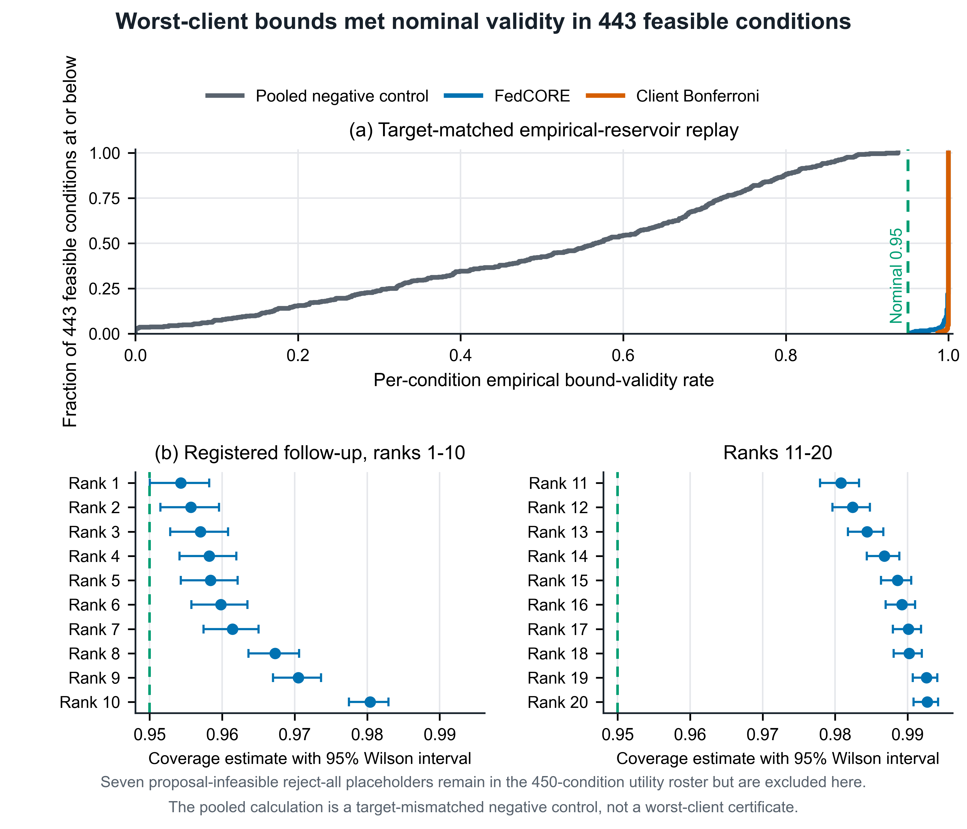
Figure 2. Target-matched fixed-selector coverage of worst-client risk on 443 proposal-feasible empirical conditions. Panel (a) compares FedCORE with a valid conservative clientwise Bonferroni reference and also displays a target-mismatched pooled mechanism diagnostic. Panel (b) shows the registered 10,000-resample follow-up for the 20 initially least favorable FedCORE conditions. Bars are pointwise 95% Wilson intervals, and reference lines mark nominal 0.95 coverage. The pooled curve is not a valid comparator for the protected worst-client target. Seven proposal-infeasible reject-all placeholders remain in the 450-condition utility roster but are excluded from this positive-acceptance validity denominator.
Among the 443 proposal-feasible conditions, the minimum observed FedCORE coverage was 0.953, and no estimate fell below 0.95. Its fifth percentile and median were 0.994 and 1.000. The corresponding minimum, fifth percentile, and median for the valid clientwise Bonferroni reference were 0.987, 1.000, and 1.000. A registered 10,000-resample follow-up over the 20 initially least favorable FedCORE conditions produced a minimum of 0.9543. The target-mismatched pooled diagnostic had a minimum of zero and a median of 0.566, but this result diagnoses target collapse rather than ranking FedCORE against a valid same-target procedure. All results remain conditional on the empirical reservoirs. The seven reject-all placeholders remain only in the 450-condition utility roster.

6.2 Mechanism Diagnostic under Audit-Target Mismatch
Figure 3 addresses a mechanism question rather than a method-ranking question. It examines what happens when the population represented by the audit differs from the deployment target protected by the reported bound.
Panel (a) uses five clients, 2,000 trials, 300 observations per client, and δ = 0.10. Four clients have acceptance/risk 0.70/0.02; the difficult client has 0.50/0.30. Nested binomial draws generate accepted counts/errors. Its weight ranges 0.20–1.00 by 0.10, with remaining mass equally split; bounded weights lie in [0.15, 0.40]. Blue squares show the bounded-mixture certificate: filled squares and a solid line lie in the shaded declared box; open squares and a dotted line lie outside it. Dark triangles show the full-simplex reference, and orange circles the non-certifying fixed-quota pooled control, distinct from Theorem 3’s i.i.d. regime.
Panels (b–c) use 3,000 multinomial audits of 200 observations with known/easy-unknown/hard-unknown masses 0.70/0.15/0.15, acceptance 0.75/0.10/0.50, and accepted-error probabilities 0.03/1.00/1.00. Panel (b) varies unknown prevalence 0.10–0.50; (c) fixes it at 0.30 and varies hard-unknown share. Blue squares and orange circles evaluate the audit and deployment populations using the same bound; vertical dotted lines mark matched prevalence 0.30 in (b) and hard-unknown share 0.50 in (c). All simulations use master seed 20260823, with shared draws at matched points. Error bars in (a) and orange bands in (b–c) are the saved pointwise 95% Clopper–Pearson intervals; audit-population curves in (b–c) show point estimates only.
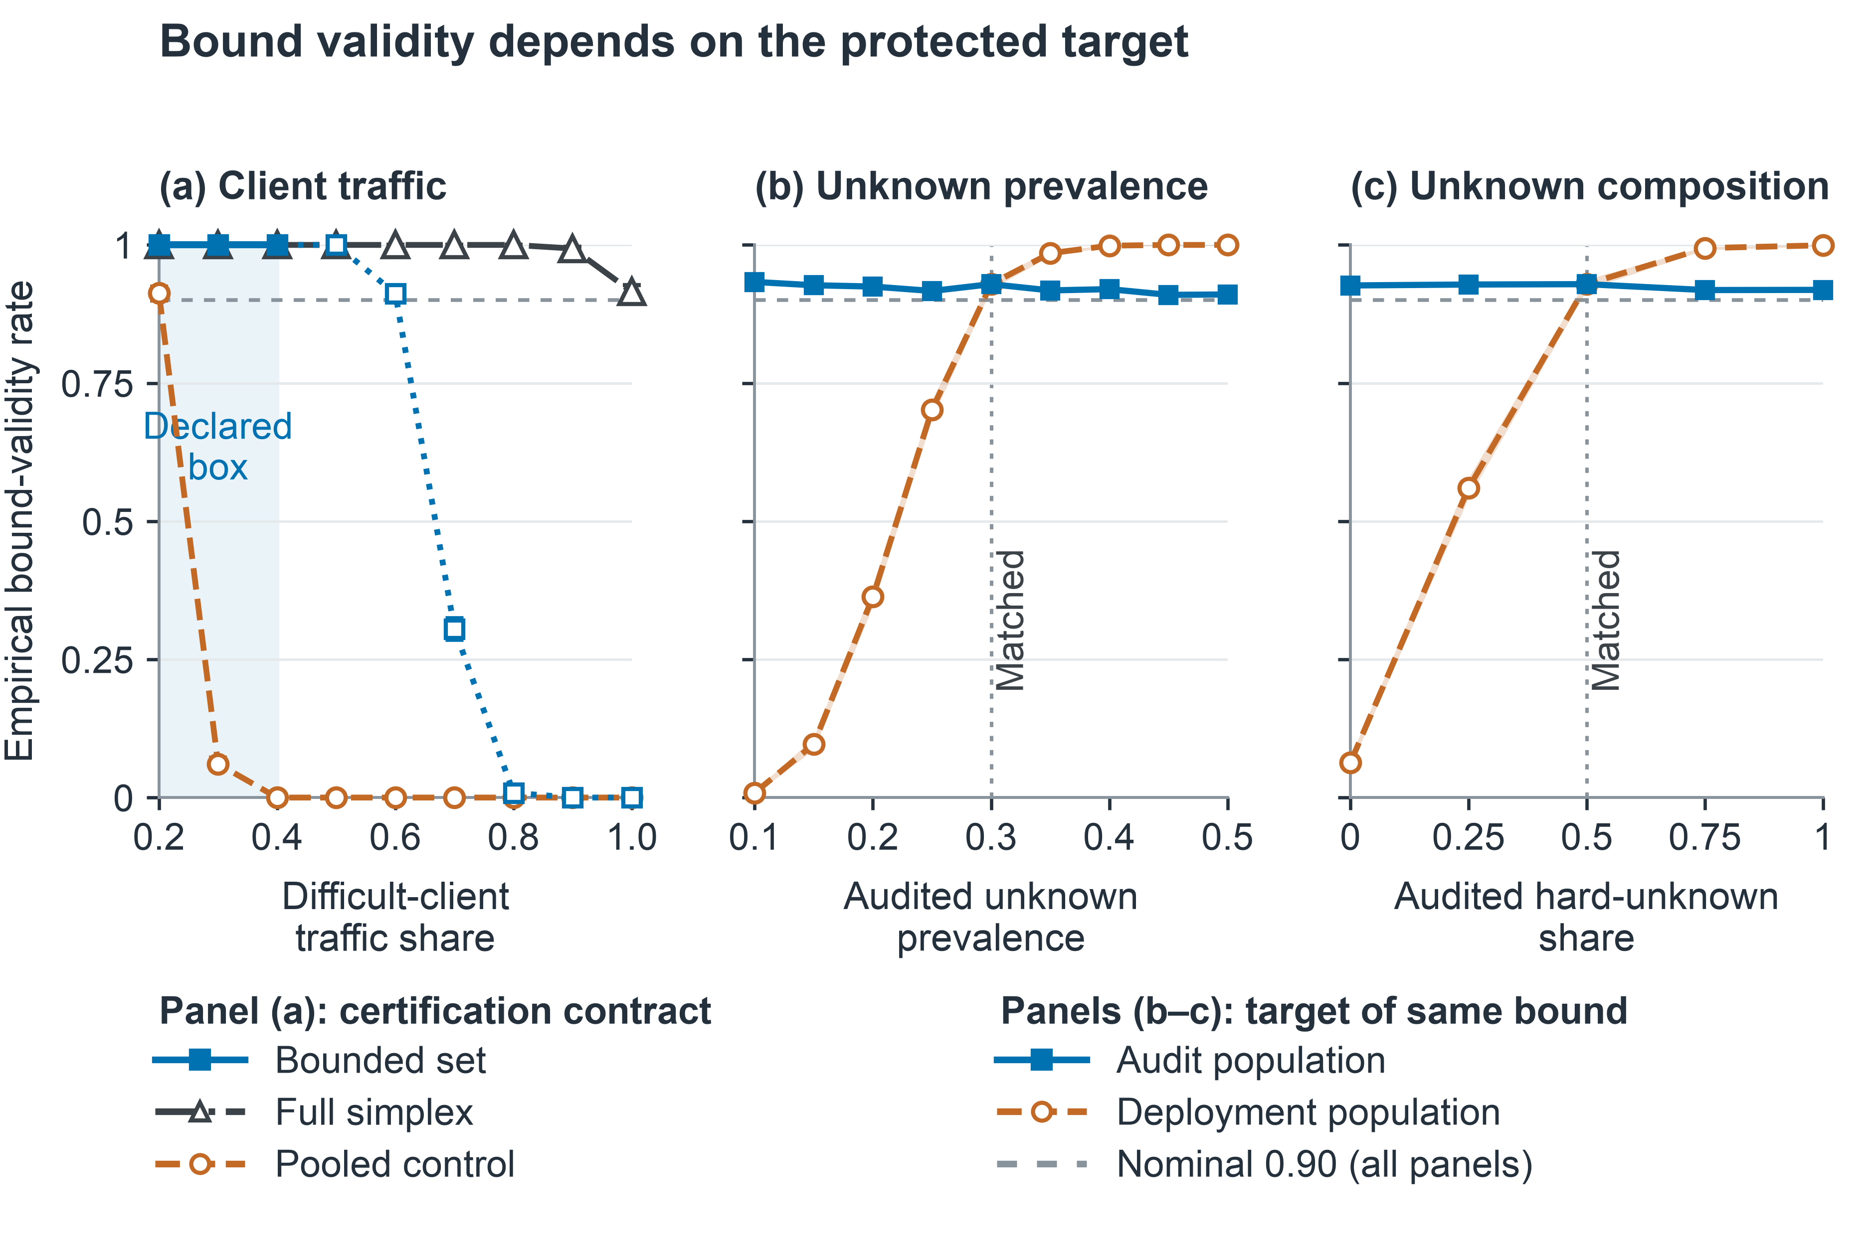
Figure 3. Risk-bound coverage under changes in (a) client traffic, (b) unknown prevalence, and (c) unknown composition. All panels share a 0–1 scale; gray horizontals mark nominal 0.90 coverage, shading in (a) marks the declared traffic box, and vertical lines in (b–c) mark matched targets.
Figure 3(a) separates target protection from favorable observations outside the contract. Pooled validity falls from 0.913 at difficult-client weight 0.20 to 0.061 at 0.30 (−85.2 pp), then zero from 0.40. Full-simplex validity stays ≥0.915. Bounded validity is 1.000 inside its box; its incidental 1.000 at weight 0.50 extends no guarantee and deteriorates thereafter. In (b), auditing unknown prevalence 0.10 gives deployment/audit validity 0.009/0.933, versus 0.929/0.929 at matched prevalence 0.30; auditing excess unknowns is conservative in this simulation. In (c), matching total unknown prevalence 0.30 does not suffice: no audited hard unknowns gives 0.063/0.927, versus 0.929/0.929 at matched hard-unknown share 0.50. The pointwise intervals quantify simulation precision, not simultaneous grid protection. Both the counting law and protected mixture must match. These simulations diagnose a contract failure and do not establish superiority over a valid same-target certificate.

7. Certification Utility under Credal Protection

7.1 Confidence, Risk Target, and Evidence
This matched comparison measures the utility cost of confidence allocation after the target, predictor, candidate family, sampling law, and realized count tensor have been fixed. H is the established LTT-IUT-Holm composition. S uses simple simultaneous family bounds with δᵣ/M and δc/M. B applies the same simple procedure as S but also divides both tails by the number of clients. B is a valid conservative allocation ablation rather than an external state-of-the-art method. At α = 0.20 and joint confidence 0.90, H and S each certified 177 of 450 conditions, whereas B certified 130.
Table 3. Matched full-simplex confidence-allocation sensitivity across all 450 conditions. Entries report certified/450 and mean ECA (%) from one fixed audit. Refusals contribute zero. H, S, and B share the predictor, 12 proposal-frozen candidates, full-simplex target, total confidence budget, and realized count tensor. H uses Holm-IUT, S uses family-only simultaneous allocation, and B additionally divides by client. Confidence rows are sensitivity settings rather than independent replications.
Joint confidence  All 450 conditions | Holm-IUT  (H) | Family-only  (S) | Family + stratum  (B)
0.90 | 177; 8.3 | 177; 8.2 | 130; 6.0
0.95 | 157; 7.4 | 157; 7.3 | 114; 5.1
0.98 | 127; 6.0 | 127; 5.9 | 87; 4.0
0.99 | 113; 5.2 | 113; 5.1 | 70; 3.3
At the primary joint confidence of 0.90, H and S each certified 177 of 450 conditions, whereas B certified 130. Every B-certified condition was also certified by H and S. The 47 additional conditions comprised ten CIFAR-10, six CIFAR-100, 24 Office-Home, and seven PathMNIST conditions. From confidence 0.90 to 0.99, H and S fell from 177 to 113 certifications, while B fell from 130 to 70. The same fixed audits were reused at every confidence level, so these rows are paired sensitivity settings rather than independent evidence.
At the primary setting, mean ECA was 8.3424% for H, 8.1659% for S, and 6.0182% for B. The H-minus-B difference was 2.3242 percentage points. The attribution-preserving decomposition assigned 2.1477 points to S minus B, which isolates removal of client-count division within the same simple procedure, and 0.1765 points to H minus S, which reflects the family decision and selected member. H and S certified the same 177 conditions. A predeclared 20,000-replicate hierarchical bootstrap produced nonnegative H-minus-B point estimates in all ten dataset-condition strata. Descriptive intervals excluded zero in seven strata and touched zero in three. These intervals describe variation within the fixed roster and are neither theorem-confidence intervals nor population-level method tests.
An additional same-target comparator held the predictor, full-simplex protection set, 12-member proposal-frozen family, realized audit counts, risk and acceptance budgets, and Holm family correction fixed. H certified 177 of 450 conditions and obtained mean ECA of 8.3424%, whereas valid fixed-prior betting certified 81 and obtained 3.9676%. H yielded higher ECA in 160 conditions, lower ECA in none, and the same ECA in 290. This fixed-roster result concerns the registered fixed-prior betting construction under the matched contract. It does not imply dominance over every valid betting procedure.

7.1.1 Certified Utility Across Risk Targets and Datasets
Table 4 varies α across columns and d down each CIFAR block; larger d weakens synthetic heterogeneity. Each entry averages ten class splits × five training repetitions under full-simplex Holm-IUT certification, with M = 12 proposal-frozen candidates and risk and acceptance tails of 0.05 each. Models and one shared with-replacement audit per client remain fixed while proposal thresholds and certification are recomputed for each α, so columns are not independent training experiments. Confidence holds per condition and fixed α; split/seed and repeated-audit intervals are not shown.
Table 4. CIFAR risk-target grid: certified/50 and ECA (%). Smaller d means stronger heterogeneity. Each column reuses the same trained models and realized audit counts.
Dataset, heterogeneity | α = 0.05 | 0.10 | 0.15 | 0.20 | 0.25 | 0.30
CIFAR-10, d = 0.1 | 0; 0.0 | 0; 0.0 | 1; 0.3 | 5; 1.5 | 9; 3.4 | 21; 7.5
CIFAR-10, d = 0.5 | 0; 0.0 | 1; 0.5 | 12; 4.9 | 25; 12.1 | 33; 22.8 | 41; 33.1
CIFAR-10, d = 5.0 | 0; 0.0 | 7; 2.8 | 19; 9.1 | 33; 20.3 | 40; 33.9 | 49; 46.2
CIFAR-100, d = 0.1 | 0; 0.0 | 0; 0.0 | 0; 0.0 | 0; 0.0 | 2; 0.2 | 8; 1.2
CIFAR-100, d = 0.5 | 0; 0.0 | 0; 0.0 | 0; 0.0 | 3; 0.3 | 13; 2.6 | 37; 9.4
CIFAR-100, d = 5.0 | 0; 0.0 | 0; 0.0 | 0; 0.0 | 6; 1.0 | 28; 6.7 | 47; 15.5
Table 4 shows CIFAR-10 first certifying at α = 0.10 for d = 0.5/5.0 and at 0.15 for d = 0.1. CIFAR-100 first passes at 0.20 for d = 0.5/5.0 and at 0.25 for d = 0.1; all six rows refuse at 0.05. At 0.20, CIFAR-10 certifies 5/25/33 of 50 as d increases, versus 0/3/6 for CIFAR-100. The newly passing CIFAR-100 d = 0.1 row at 0.25 has only two certifications and ECA of 0.2%; at 0.30 it reaches eight, but ECA remains 1.2%. Certification need not support much automatic use.
At α = 0.30, d = 5.0, CIFAR-100 nearly matches CIFAR-10’s pass frequency (47/50 versus 49/50) but has ECA of 15.5% versus 46.2%, about 30.7 percentage points lower. Weaker heterogeneity and relaxed targets coincide with greater utility here; this is neither a causal heterogeneity effect nor a uniform ordering across models, datasets, or audits.
The purpose of the area under the receiver operating characteristic curve (AUROC) diagnostic is to test whether score ranking alone predicts certifiable utility. Across all 450 conditions, AUROC and Holm-certified ECA have Spearman correlation 0.66 and Pearson correlation 0.57. Nevertheless, 7/45 top-decile conditions refuse, while 13/225 conditions at or below the median certify. Most high-quartile CIFAR-100 conditions still refuse. AUROC is therefore associated with certification but does not determine the accepted-risk decision.

7.1.2 Decision-Gate Decomposition of Refusals
Figure 4 decomposes all 273 Holm refusals among 450 conditions under the full-simplex empirical target, with α = 0.20, δr = δc = 0.05, and 12 proposal-frozen selectors. The ordered post-hoc gates summarize one prespecified audit, so their counts are deterministic and have no sampling error bars.
Among proposal-feasible selectors with positive client acceptance bounds, E denotes observed worst-client risk ≤α. Q denotes those passing a counterfactual that sets every accepted-error count to zero, keeps accepted counts/audit sizes fixed, and recomputes Holm over all 12 members.
After excluding passes, assign proposal infeasibility and zero acceptance first. Of the remainder, only E nonempty means count-only; only Q means empirical-error-only; both empty means joint. Disjoint nonempty E, Q means selector tradeoff. A nonempty intersection means evidence margin: one selector meets both preliminary checks but no actual selector passes.
Evidence margin accounts for 223/273 refusals (81.7%), followed by 26 selector tradeoffs. Empirical-error-only, joint, proposal-infeasible, count-only, and zero-acceptance counts are 9, 7, 7, 1, and 0. The dominant gate combines realized errors and the finite-sample threshold; it establishes neither audit size as the sole cause nor an effective intervention. The gates do not measure the effect of acquiring more labels.
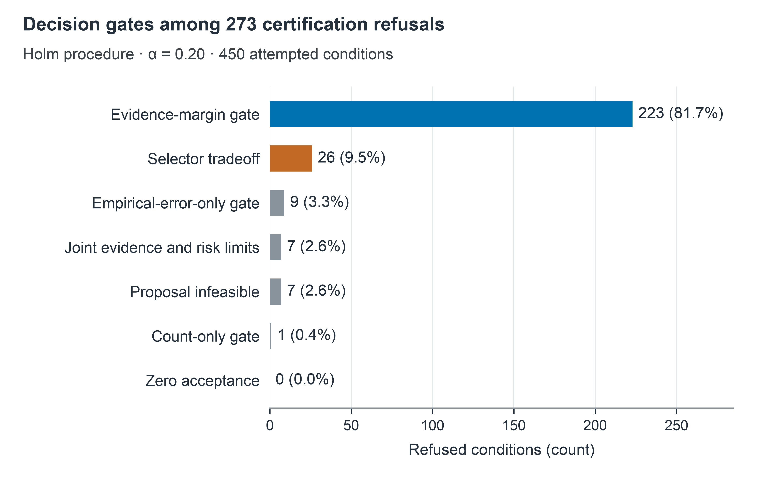
Figure 4. Decision-gate composition of 273 Holm refusals among 450 conditions at α = 0.20. Bars give exact counts and percentages of all refusals, including the zero-acceptance category.
The refusal analysis also supports a retrospective planning calculation. Of the 223 evidence-margin cases, 222 have a finite rate-preserving multiplier with median three and interquartile range two to five. The calculation scales accepted counts, accepted errors, and audit sizes together and recomputes the complete frozen family.
These multipliers are planning diagnostics rather than new certificates. They assume that observed accepted-error rates remain fixed as evidence grows, create no observations, and do not authorize optional stopping with a fixed-sample test.

7.2 Protection-Set and Procedure Sensitivity
The procedure analysis holds the 450 conditions in Section 5 fixed while varying protection and inference. The grid contains 150 CIFAR-10, 150 CIFAR-100, 100 Office-Home, and 50 PathMNIST conditions. Counts and manifests match the archived server sources. The grid was fixed before replay, but earlier inspection makes the comparison exploratory rather than prospective.
Table 5 retains four representative procedures. RATIO is the strict-mixture confidence-set ratio program. CP–IUT–Holm applies the conservative full-simplex conditional test to the narrower target. BETTING–H uses the established fixed-time betting construction followed by Holm correction. SCALE–H uses the frozen half-and-half mixture of that e-value with the registered dyadic-stake mixture. The labels describe evaluation-specific compositions under the same frozen contract.
Table 5. Representative procedure comparison at α = 0.20 and t = 0.50. Entries are ECA mean ± sample SD (%) and certified/N. Refusals contribute zero. Values describe the fixed roster and are not confidence intervals. All procedures reuse the same realized counts within a condition. CP–IUT–Holm is a conservative off-Algorithm comparator for the strict target.
Procedure | CIFAR-10 | CIFAR-100 | Office-Home | PathMNIST
RATIO | 9.63 ± 14.27  52/150 | 0.09 ± 0.81  2/150 | 10.98 ± 8.11  69/100 | 17.27 ± 20.75  23/50
CP–IUT–Holm | 11.49 ± 15.23  63/150 | 0.47 ± 2.06  9/150 | 13.35 ± 7.96  79/100 | 19.38 ± 21.29  26/50
BETTING–H | 16.14 ± 17.97  76/150 | 2.53 ± 4.59  40/150 | 17.34 ± 5.83  95/100 | 28.18 ± 21.52  36/50
SCALE–H | 16.25 ± 18.07  75/150 | 2.61 ± 4.75  40/150 | 17.79 ± 5.96  95/100 | 29.98 ± 20.86  38/50
The designated setting uses α = 0.20 and t = 0.50. Every procedure receives the same 12 proposal-frozen candidates, realized counts, risk budget 0.05, acceptance budget 0.05, and deterministic tie rule. Each confidence statement applies to one fixed cell, risk target, mixture set, and preselected procedure. It is not simultaneous across the full grid.
At the designated setting, BETTING–H increased ECA relative to CP–IUT–Holm on all four datasets. SCALE–H added only 0.11, 0.08, 0.45, and 1.80 percentage points over BETTING–H for CIFAR-10, CIFAR-100, Office-Home, and PathMNIST. The sample standard deviations in Table 5 describe heterogeneity across the fixed roster. They are not uncertainty intervals for a population-level method effect.
The full grid is needed because the designated setting alone can hide reversals as mixture protection broadens or the tolerated accepted-error risk changes.
Figure 5 extends the comparison across all six risk targets and five protection values. Its outline marks the designated setting and does not denote statistical significance.
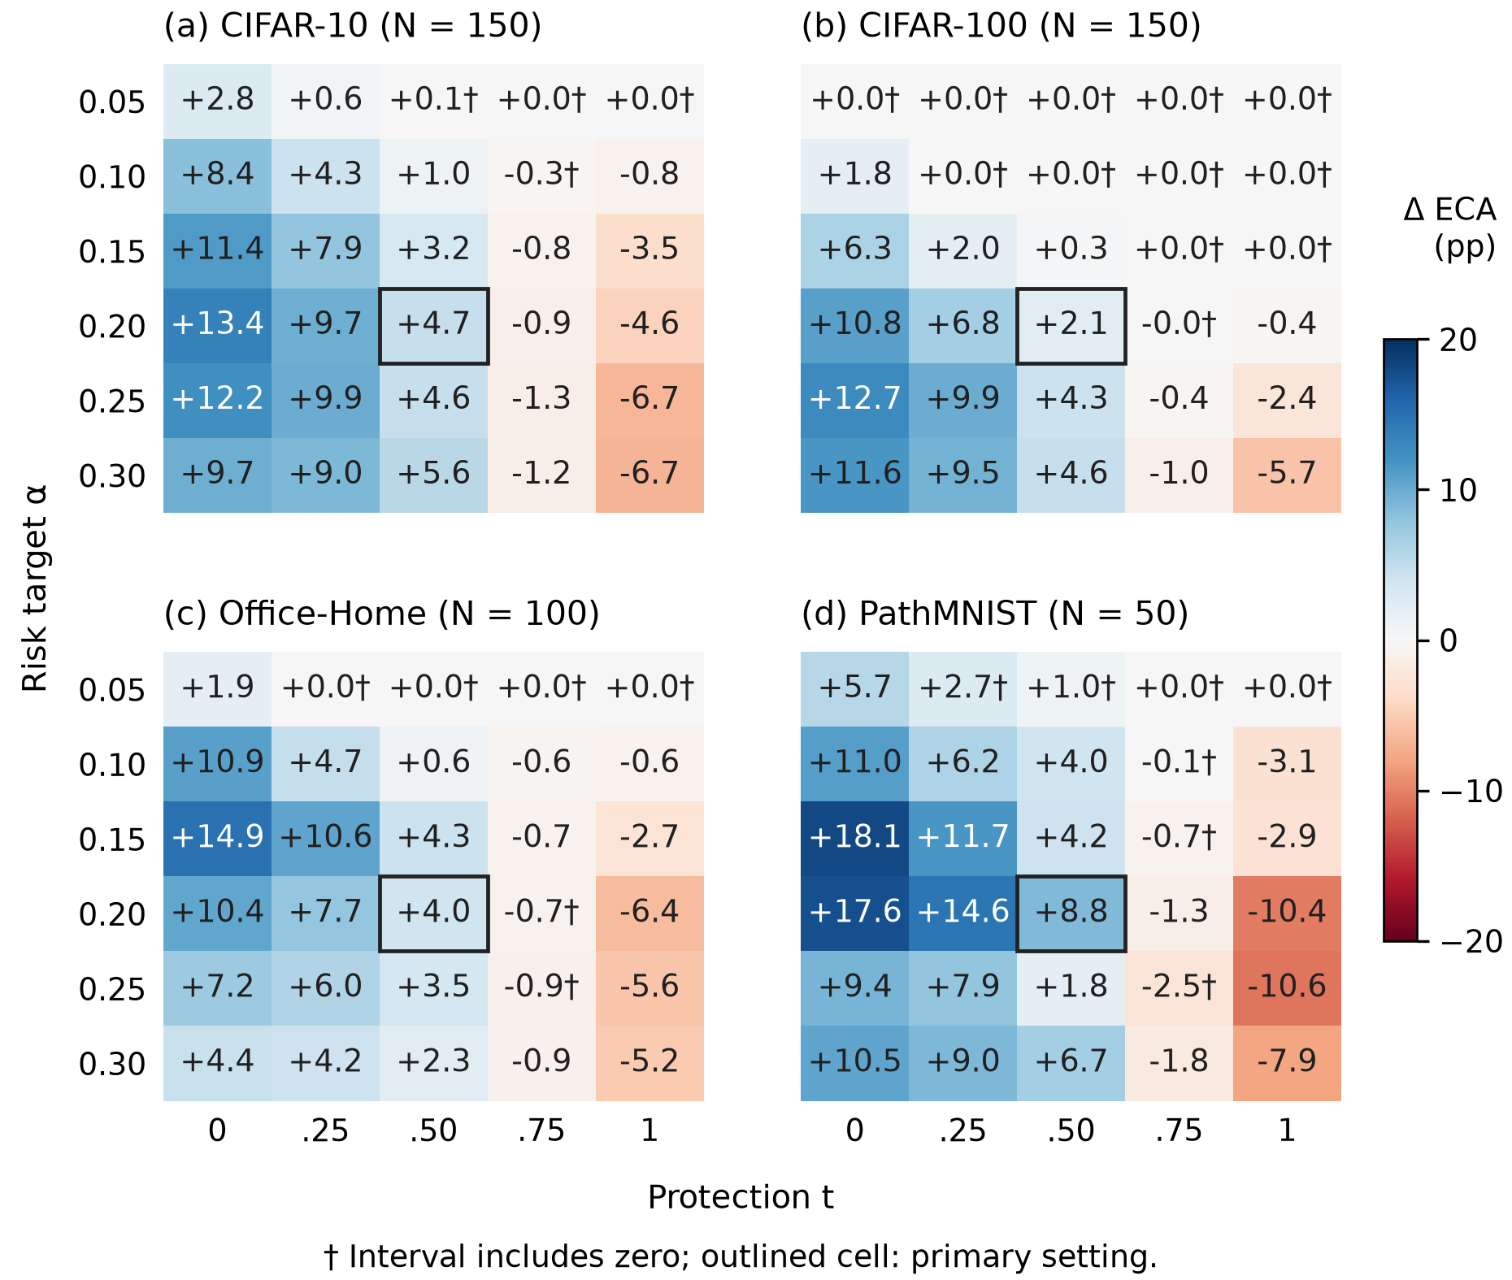
Figure 5. BETTING–H minus CP–IUT–Holm ECA (percentage points) across six risk targets and five protection values. Panels retain 150, 150, 100, and 50 fixed conditions. Signed labels use a common zero-centered scale. Daggers indicate pointwise descriptive 95% intervals containing zero; intervals are unadjusted for repeated targets and are not population-level or familywise tests. Outlines mark the designated setting. Rounded zeros can conceal small differences.
Columns broaden mixture protection; rows relax the tolerated accepted-error risk. Across the 120 dataset–target–protection combinations, BETTING-minus-CP means are positive in 66, negative in 36, and tied in 18. These are repeated comparisons of the same fixed models, not 120 independent replications. Strict targets often erase the intermediate-range gains: CIFAR-100 has no gain anywhere at α = 0.05, and Office-Home ties at all t ≥ 0.25 there. Negative right-hand regions remain visible, and daggers distinguish intervals spanning zero from better-resolved descriptive contrasts. This full grid supports a conditional choice comparison, while ruling out a uniform benefit from either procedure or a target-independent switching rule.

7.2.1 Established Comparators Limit Incremental Claims
The purpose of the closest established-comparator check is to determine whether SCALE improves on betting rather than only on RATIO. On 50 matched Office-Home models at α = 0.20 with 1,000 identity-only traffic draws, BETTING-H exceeds RATIO by 6.570 percentage points, while SCALE-H exceeds RATIO by 6.631 points. Established betting uses the same frozen selectors and evidence [13]. The residual SCALE-H-minus-BETTING-H difference is 0.061 points with a pointwise descriptive interval of [−0.078, 0.201]. Both procedures certify 50/50 models and select the same family member in 49/50. Existing betting therefore explains nearly all of the apparent improvement over RATIO.
Across 20 supporting settings, SCALE–H led BETTING–H in 11, lost in four, and tied in five. The ordering was therefore mixed rather than uniform. These checks reused previously inspected conditions and added no labels, audit draws, or training. They argue against a broad incremental power claim and do not establish equivalence.

7.3 Natural-Domain and Biomedical Certification Utility
The two Office-Home adaptation arms each retain 50 conditions (ten splits × five repetitions) over four natural-domain clients.
At α = 0.20, full adaptation certifies 39/50 with ECA/conditional acceptance of 12.4%/15.9%; frozen-linear certifies 40/50 with 8.2%/10.3%. Thus, full adaptation supports about 4.2 percentage points more ECA but one fewer certification. Across α = 0.05, 0.10, 0.15, 0.20, 0.25, and 0.30, counts are 0, 7, 20, 39, 46, and 50 versus 0, 1, 16, 40, 46, and 50. These single-audit portability profiles, without contrast uncertainty, do not rank training recipes.

7.3.1 Biomedical Modality with Synthetic Client Strata
PathMNIST tests whether certified use varies with the unknown-class task and risk target. Its nine colorectal tissue classes [47], five unknown triples, five repetitions, two heterogeneity levels (d = 0.5/5.0; smaller d means stronger heterogeneity), and five synthetic clients produce 50 conditions. Full-simplex Holm certification uses frozen empirical reservoirs, risk and acceptance tails of 0.05 each, and one prespecified with-replacement audit per client. The archived tissue images in Figure 6(a) provide task context, not clinical transportability.
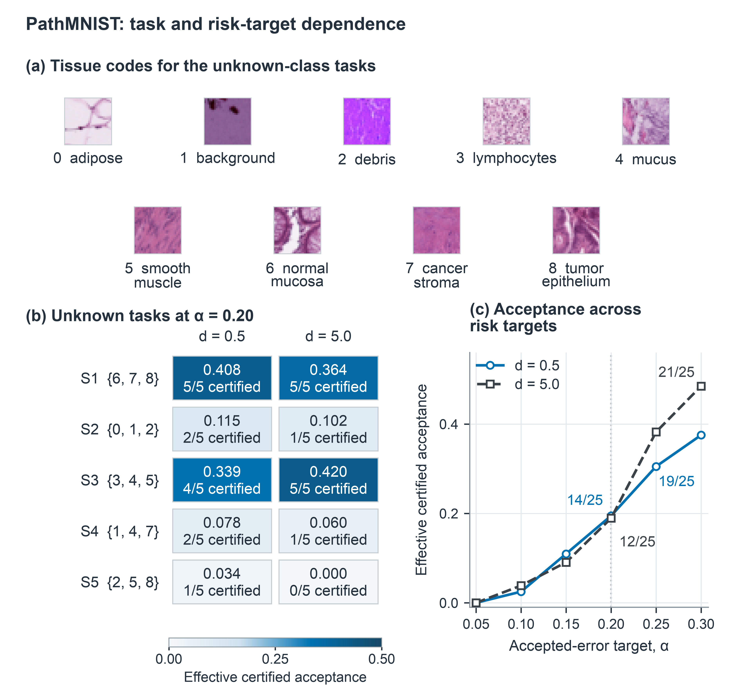
Figure 6. PathMNIST task and risk-target dependence: (a) tissue codes, (b) mean ECA and certified/5 at α = 0.20, and (c) mean ECA across risk targets. Circles/solid lines denote d = 0.5 and squares/dashes d = 5.0; annotations in (c) give certified/25. Panels (b) and (c) use a 0–1 vertical scale; corresponding prose values are percentages.
Each Figure 6(b) tile averages ECA over five training repetitions, assigning refusals zero, and reports certified/5; its unknown triples use the tissue codes in (a). At α = 0.20, PathMNIST certifies 14/25 at d = 0.5 and 12/25 at 5.0; ECA is 19.5%/18.9%, and conditional acceptance is 34.8%/39.4%. Overall, 26/50 certify with ECA of 19.2%. Task dependence is pronounced: S1 holds out normal mucosa, cancer stroma, and tumor epithelium (classes 6–8) and certifies 10/10; S3 certifies nine; S2/S4 three each; S5 one, including 0/5 at d = 5.0. Because each split changes known/unknown classes, these are task contrasts, not causal effects of individual tissues.
Figure 6(c) averages 25 conditions per target and d across all six registered risk targets, with certified/25 annotations at α = 0.20 and 0.30. No condition certifies at α = 0.05. At 0.20, d = 0.5 exceeds 5.0 by only 0.55 percentage points in ECA; at 0.30 the order reverses, 37.5% versus 48.5% (+10.94 percentage points for 5.0). These means have no training/audit variability intervals. Useful acceptance depends on task and target rather than a uniform heterogeneity ordering.

7.4 Registered PACS Rerun: A Risk-Gate-Limited Utility Boundary
The purpose of the PACS rerun was to test whether certified utility persisted under fresh training randomness on the fixed hashed frame, with the full denominator and outcome gates fixed before training. All 30 planned checkpoints reached terminal success and were evaluable. No model failed, no proposal family was infeasible, and independent replay reproduced every registered decision without a mismatch.
At the registered risk target of 0.20, H, S, and B each certified three of 30 models. Mean ECA across the complete denominator was 3.87% for H, 3.87% for S, and 3.56% for B. Among the three certified models, mean selected coverage lower bounds were 38.67%, 38.67%, and 35.57%, respectively. All three procedures certified the same ConvNeXt-Tiny split two models at seeds zero, one, and two. No ResNet18 model and no other class split certified. Proposal construction was not the limiting step because every candidate family was feasible. In addition, 321 of 360 candidates per procedure had positive coverage lower bounds. The risk decision passed for only 11 candidates under H and S and eight under B, all concentrated in the same three models. The risk gate, rather than proposal feasibility or coverage positivity, was therefore the empirical bottleneck.
The rerun produced a complete negative result under the predeclared utility gates. H certified fewer than six models, represented only one architecture and one class split, and achieved mean ECA below 5%. Mean S-minus-B ECA was 0.31 percentage points, below the 1.00-point gain gate; the architecture-specific differences were 0.62 points for ConvNeXt-Tiny and zero for ResNet18. The evidence therefore supports a narrow conclusion. Proposal construction remained feasible, but the risk test supported too few candidates for broad automated use on this same-frame fresh-seed roster. The result does not establish practical PACS utility or procedure superiority.

7.5 Traffic-Informed Credal Sensitivity
This analysis asks whether independently declared traffic information can narrow the credal set and improve utility without treating traffic uncertainty as audit certainty. Table 6 fixes predictors, candidates, and audit counts while changing the traffic contract or confidence allocation. It is a target-sensitivity comparison rather than a same-target method ranking.
The traffic box covers a fixed empirical mixture, not an unseen deployment population. Independent with-replacement draws of m identities from the source-disjoint reservoir give Ns ~ Bin(m, λsres), where λsres is its empirical stratum proportion. Exact CP endpoints use δλ/(2S) for each lower/upper tail and intersect with the S-stratum simplex. A union bound over 2S tails gives simultaneous coverage ≥1−δλ without coordinate independence. The reference uses m = 1,000, δλ = 0.02, and risk/acceptance tails 0.04 each.
Table 6. Office-Home traffic sensitivity: certified/100 and ECA (%). Rows change the protection target or confidence allocation; they are not matched-target rankings.
Protection contract | α = 0.10 | 0.15 | 0.20 | 0.25 | 0.30
Simplex; $δ_{r}$ = $δ_{c}$ = 0.05 | 8; 0.6 | 36; 3.4 | 79; 10.2 | 92; 16.2 | 100; 21.9
Simplex; $δ_{r}$ = $δ_{c}$ = 0.04 | 4; 0.4 | 35; 3.3 | 74; 9.6 | 92; 15.8 | 100; 21.6
Traffic box; m = 250 | 2; 0.3 | 39; 5.9 | 92; 17.9 | 98; 24.9 | 100; 31.3
Traffic box; m = 500 | 2; 0.3 | 43; 6.7 | 92; 18.7 | 99; 25.9 | 100; 32.0
Traffic box; m = 1,000 | 2; 0.3 | 46; 7.3 | 92; 19.3 | 99; 26.6 | 100; 32.7
Traffic box; m = 2,000 | 3; 0.5 | 46; 7.5 | 92; 19.8 | 99; 27.1 | 100; 33.3
At α = 0.20, allocating 0.02 of the confidence budget to traffic estimation reduced full-simplex certification from 79 to 74 of 100. Replacing the full simplex with the independently formed traffic-informed credal set then produced 92 certifications and mean ECA of 19.3%. The comparison therefore changed both the protected deployment set and the confidence allocation. The increase from 74 to 92 certifications and from 9.6% to 19.3% ECA is a target-and-information sensitivity result, not a same-target method effect.
At α = 0.20, all four bounded m values certify 92; ECA rises from 17.9% to 19.8% as m rises from 250 to 2,000, with successive doubling gains of about 0.8, 0.6, and 0.5 percentage points. This single-draw pattern has no split/seed or repeated-traffic-draw intervals and describes diminishing increments rather than stability across traffic draws. Narrowing traffic reduces protected mixtures, but joint endpoint inference can offset that restriction, as at α = 0.10. Table 6 neither isolates each component nor establishes a prospective matched-target study.
Figure 7 summarizes the PACS feasibility boundary at candidate and model levels. Panel (a) uses 360 candidates per procedure, whereas panel (b) uses the 30-model roster. The panels therefore have different denominators and must not be read as one sequential funnel.
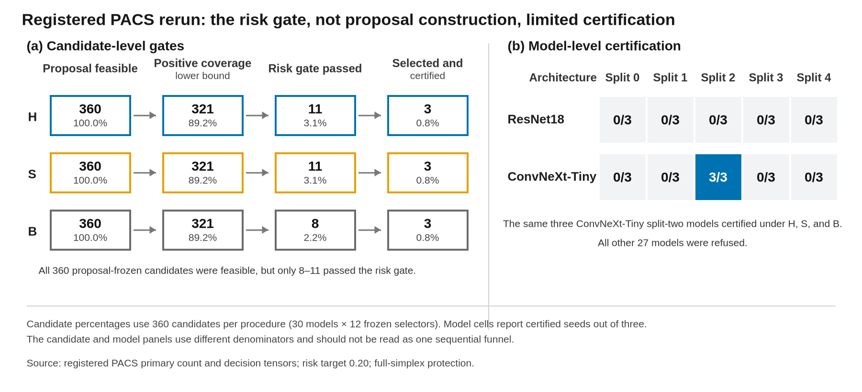
Figure 7. Registered PACS feasibility boundary at α = 0.20 under full-simplex protection. (a) Candidate-level gates for H, S, and B; percentages use 360 proposal-frozen candidates per procedure. (b) Certified models by architecture and class split; each cell reports certified seeds out of three. The same three ConvNeXt-Tiny split-two models certified under all procedures, while the other 27 models were refused.

7.6 External Fixed-Frame Transfer Evaluations
The purpose of these evaluations was to test whether the observed certification utility transferred to source-distinct empirical frames without removing adverse outcomes. They did not estimate performance over an unseen deployment population.
VLCS retained all 30 registered architecture, class-split, and seed cells. Its primary gate failed. ResNet18 produced zero registered utility contrast under both protection settings. For ConvNeXt-Tiny, the full-simplex contrast was 0.164 percentage points, with a descriptive 95% interval from 0.027 to 0.356 percentage points, below the predeclared 1.00-point minimum. Because the protocol was locally pre-specified rather than externally registered, and because near-duplicate and ImageNet-pretraining overlap were not excluded, this is an adverse fixed-frame result rather than an independent population replication.
DomainNet retained all 30 frozen PACS predictors. Under the primary 512-draw contract, no registered ResNet18 condition certified, and the ConvNeXt-Tiny certification rate was at most 1.3%. The predeclared transfer gate therefore failed. A descriptive 1,024-draw analysis produced greater utility, but it was secondary and did not replace the registered primary decision. Together, the VLCS and DomainNet results locate an evidence-budget and transfer boundary. They do not support a positive untouched-dataset utility claim.

8. Discussion
The main result is a separation between two kinds of uncertainty. The credal set describes epistemic uncertainty about future client traffic. The audit bounds sampling uncertainty in accepted errors and acceptance within each client stratum. FedCORE combines them only after clientwise bounds have been formed because acceptance changes the client mixture among automated predictions. Proposition 1 shows why a non-singleton credal envelope cannot generally be replaced by one fixed pooled mixture for every client-risk profile. The empirical argument follows the same separation: target-matched replay evaluates certificate coverage, H/S/B compare utility under one common target and count tensor, and pooled calculations diagnose only contract mismatch.
Under full-simplex protection, the fixed-selector decision uses the true worst client without dividing its risk tail by the number of clients. In the primary paired audit, H and S certified 177 of 450 conditions, whereas B certified 130. S retained every B-certified condition and added 47. Mean ECA increased from 6.02% under B to 8.17% under S and 8.34% under H. Therefore, 2.15 of the 2.32-percentage-point H-minus-B difference was associated with removing client-count division within the same simple procedure, while 0.18 points were associated with the Holm family decision. These are fixed-roster paired results rather than population-level method effects. Strict credal polytopes can improve utility only when their traffic restrictions are justified before certification and any estimation error receives its own confidence budget.
The PACS rerun narrows the utility interpretation. H, S, and B certified the same three models, and the mean S-minus-B ECA difference was only 0.31 percentage points. More importantly, Figure 7 shows where utility was lost. Proposal construction was feasible for all 360 candidates per procedure, and 321 retained a positive coverage lower bound. Only 11 candidates under H and S and eight under B passed the risk decision, yielding three certified models under every procedure. Thus, the observed boundary arose primarily at the risk gate for these trained predictors and this audit budget, not from proposal infeasibility. This same-frame evidence does not establish that the predictor alone, the audit budget alone, or the procedure alone caused the result.
The external evaluations sharpen this boundary. Both primary transfer gates failed despite source-distinct fixed frames and complete denominators. DomainNet further showed why the evidence budget matters. Its descriptive 1,024-draw analysis was more favorable than its registered 512-draw analysis, but it could not retroactively replace the primary result. The evidence therefore supports fail-closed transfer assessment rather than positive cross-dataset utility.
Seven limits define the claims. First, the 450 conditions form a fixed roster rather than independent draws from a model or deployment population. Second, most audits sample with replacement from frozen empirical reservoirs, so their guarantees are conditional on those reservoirs. Third, repeated audit orders quantify conditional sampling variation and do not create new trained models or source-level labels. Fourth, the source-disjoint CIFAR-10.1 analysis reuses three checkpoints and is not a prospective model replication. Fifth, strict-polytope results depend on externally justified traffic sets. Sixth, the PACS rerun was sealed after earlier PACS outcomes were available and reused the same hashed source frame, domain structure, class-split family, and pretrained initialization families. Its checkpoints replicate training randomness conditional on that frame rather than an untouched source population. Seventh, the VLCS and DomainNet analyses use source-distinct fixed empirical frames, but they are not prospective samples from deployment populations and both primary gates failed. VLCS was locally pre-specified and did not exclude near-duplicate or pretraining overlap. DomainNet was sealed before image access but reused frozen PACS predictors and a restricted six-class label space. These evaluations provide adverse transfer-boundary evidence rather than positive evidence of population transport. The public package contains PACS source, an immutable environment, checkpoints, hashes, and execution evidence, but no independent clean-machine rerun is claimed.
Future work should address three substantive questions. Continuing-audit confidence sequences should preserve the same credal selective-risk target as evidence accumulates. Decision-theoretic acquisition policies should optimize labeling cost under the proved endpoint event rather than under a separate surrogate objective. Prospectively constructed traffic sets should combine mixture uncertainty with explicit diagnostics for changes in client conditionals.

9. Conclusion
FedCORE converts distributed audit counts into a finite-sample deployment decision for a fixed federated open-set classifier when future client traffic is imprecisely known. Its central object is the accepted-error ratio after client-dependent acceptance has reweighted the deployment mixture. The framework combines an exact full-simplex decision, a positive-denominator program for strict credal polytopes, and familywise-valid selection among proposal-frozen rules. Target-matched replay supported the stated finite-sample validity contract. Under an identical full-simplex target and identical evidence, the Holm intersection-union procedure certified 177 of 450 conditions, whereas valid fixed-prior betting certified 81. The complete PACS rerun and the external VLCS and DomainNet evaluations retained every adverse outcome and located risk-gate, evidence-budget, and transfer boundaries. These results prevent finite-sample validity from being mistaken for broad deployment utility. The contribution is a target-specific deployment certificate and evidence contract, not a new training method.

CRediT authorship contribution statement
Sanghoon Kim: Conceptualization, methodology, formal analysis, investigation, validation, visualization, and writing - original draft.

Declaration of competing interest
The author declares no known competing financial interests or personal relationships that could have influenced the work reported in this paper.

Acknowledgements
This research was supported by Brain Korea 21 FOUR, the Ministry of Science and ICT (MSIT) in Korea under the ITRC support program supervised by the Institute for Information Communication Technology Planning and Evaluation (IITP-2020-0-01749), and the National Research Foundation of Korea grant funded by the Korea government (RS-2022-00144190).

Data and code availability
Public dataset distributors provide CIFAR-10/100, Office-Home, MedMNIST v2, CIFAR-10.1, PACS, VLCS, and DomainNet. The versioned repository at https://github.com/october25kim/fedcore provides the count-to-decision implementation and the evidence listed in its claim-artifact ledger. Release v0.8.0 contains the complete PACS 30-model denominator, all registered H/S/B decisions, the matched fixed-prior betting comparison, the VLCS and DomainNet protocol and aggregate evidence, and the PACS training-reproduction package. The package includes source commit fa016c199a7c846bbe20b64d54ab34164adf7647, its runtime manifest, an immutable scientific container image, configuration and identity manifests, execution logs, and all 30 checkpoint assets. Licensed source images and pretrained initialization archives are not redistributed. Their acquisition instructions, expected sizes, and hashes are provided instead. The package enables an end-to-end rerun after the user supplies the exact registered PACS archive, but it is not presented as a completed independent clean-machine replication. All theorem-critical definitions and proofs are contained in the manuscript, and no separate supplementary file is required. The release also preserves every adverse external-evaluation cell and the exact file hashes needed to audit the reported denominators.

Declaration of generative AI and AI-assisted technologies in the manuscript preparation process
During manuscript preparation in 2026, the author used OpenAI ChatGPT, OpenAI Codex, and Anthropic Claude to assist with organization, language editing, consistency checks, analysis-code drafting, and data visualization. Exact service versions were not preserved in the working archive. The author executed, inspected, and validated all code against versioned inputs and archived outputs. No AI tool generated or altered the underlying observations or primary research images. The author reviewed and edited all material and takes responsibility for the article.

References
[1] H.B. McMahan, E. Moore, D. Ramage, S. Hampson, B. Agüera y Arcas, Communication-efficient learning of deep networks from decentralized data, in: Proceedings of the 20th International Conference on Artificial Intelligence and Statistics (AISTATS), PMLR 54, 2017, pp. 1273–1282.
[2] W.J. Scheirer, A. de Rezende Rocha, A. Sapkota, T.E. Boult, Toward open set recognition, IEEE Trans. Pattern Anal. Mach. Intell. 35 (7) (2013) 1757–1772. https://doi.org/10.1109/TPAMI.2012.256.
[3] C.K. Chow, On optimum recognition error and reject tradeoff, IEEE Trans. Inf. Theory 16 (1) (1970) 41–46. https://doi.org/10.1109/TIT.1970.1054406.
[4] W. Hoeffding, On the distribution of the number of successes in independent trials, Ann. Math. Statist. 27 (3) (1956) 713–721. https://doi.org/10.1214/aoms/1177728178.
[5] L. Mattner, C. Tasto, Confidence intervals for average success probabilities, Probab. Math. Statist. 35 (2) (2015) 301–312. arXiv:1403.0229.
[6] Y. Geifman, R. El-Yaniv, Selective classification for deep neural networks, Adv. Neural Inf. Process. Syst. 30 (2017) 4878–4887.
[7] S. Bates, A.N. Angelopoulos, L. Lei, J. Malik, M.I. Jordan, Distribution-free, risk-controlling prediction sets, J. ACM 68 (6) (2021) 43:1–43:34. https://doi.org/10.1145/3478535.
[8] A.N. Angelopoulos, S. Bates, A. Fisch, L. Lei, T. Schuster, Conformal risk control, in: The Twelfth International Conference on Learning Representations (ICLR), 2024.
[9] J. Hallberg Szabadváry, T. Löfström, U. Johansson, C. Sönströd, E. Ahlberg, L. Carlsson, Classification with reject option: Distribution-free error guarantees via conformal prediction, Mach. Learn. Appl. 20 (2025) 100664. https://doi.org/10.1016/j.mlwa.2025.100664.
[10] H. Guan, Y. Zhang, H.D. Cheng, M. Xian, X. Tang, BA2Cs: Bounded abstaining with two constraints of reject rates in binary classification, Neurocomputing 357 (2019) 125–134. https://doi.org/10.1016/j.neucom.2019.04.047.
[11] A.N. Angelopoulos, S. Bates, E.J. Candès, M.I. Jordan, L. Lei, Learn then test: Calibrating predictive algorithms to achieve risk control, Ann. Appl. Stat. 19 (2) (2025) 1641–1662. https://doi.org/10.1214/24-AOAS1998.
[12] X. Yu, J. Liu, A joint finite-sample certificate for adaptive selective conformal risk control, arXiv preprint arXiv:2606.08517v1 (2026). https://doi.org/10.48550/arXiv.2606.08517.
[13] I. Waudby-Smith, A. Ramdas, Estimating means of bounded random variables by betting, Journal of the Royal Statistical Society Series B: Statistical Methodology 86 (1) (2024) 1–27. https://doi.org/10.1093/jrsssb/qkad009.
[14] E. Clerico, On the optimality of coin-betting for mean estimation, International Journal of Approximate Reasoning 187 (2025) 109550. https://doi.org/10.1016/j.ijar.2025.109550.
[15] B. Laufer-Goldshtein, A. Fisch, R. Barzilay, T. Jaakkola, Risk-Controlling Model Selection via Guided Bayesian Optimization, arXiv:2312.01692 (2023). https://doi.org/10.48550/arXiv.2312.01692.
[16] Y. Yang, Y. Jin, Multi-distribution robust conformal prediction, in: International Conference on Machine Learning (ICML), 2026. Available as arXiv:2601.02998v2. https://doi.org/10.48550/arXiv.2601.02998.
[17] V. Franc, D. Průša, V. Voráček, Optimal Strategies for Reject Option Classifiers, Journal of Machine Learning Research 24 (11) (2023) 1–49. https://jmlr.org/papers/v24/21-0048.html.
[18] Z. Xu, N. Karampatziakis, P. Mineiro, Active, anytime-valid risk controlling prediction sets, arXiv:2406.10490 (2024). https://doi.org/10.48550/arXiv.2406.10490.
[19] M. Zecchin, S. Park, O. Simeone, Adaptive Learn-then-Test: Statistically Valid and Efficient Hyperparameter Selection, in: Proceedings of the 42nd International Conference on Machine Learning, PMLR 267, 2025, pp. 74018–74036. https://proceedings.mlr.press/v267/zecchin25a.html.
[20] P. B. Stark, ALPHA: Audit that Learns from Previously Hand-Audited Ballots, arXiv:2201.02707 (2022). https://doi.org/10.48550/arXiv.2201.02707.
[21] J. V. Spertus, P. B. Stark, Sweeter than SUITE: Supermartingale Stratified Union-Intersection Tests of Elections, arXiv:2207.03379 (2022). https://doi.org/10.48550/arXiv.2207.03379.
[22] S. Akter, I.F. Shihab, A. Sharma, Private anytime selective-risk certification for federated retrieval-augmented generation: Guarantees and empirical limits, arXiv preprint arXiv:2608.07913 (2026).
[23] C. Lu, Y. Yu, S.P. Karimireddy, M.I. Jordan, R. Raskar, Federated conformal predictors for distributed uncertainty quantification, in: Proceedings of the 40th International Conference on Machine Learning (ICML), PMLR 202, 2023, pp. 22942–22964.
[24] P. Humbert, B. Le Bars, A. Bellet, S. Arlot, One-shot federated conformal prediction, in: Proceedings of the 40th International Conference on Machine Learning (ICML), PMLR 202, 2023, pp. 14153–14177.
[25] V. Plassier, M. Makni, A. Rubashevskii, E. Moulines, M. Panov, Conformal prediction for federated uncertainty quantification under label shift, in: Proceedings of the 40th International Conference on Machine Learning (ICML), PMLR 202, 2023, pp. 27907–27947.
[26] G. Li, Y. Zhang, Y. Wang, C. Wang, FCP-Pro: Federated conformal prediction algorithm based on prototype similarity, Pattern Recognit. 172 (2026) 112514. https://doi.org/10.1016/j.patcog.2025.112514.
[27] H. Wen, O. Simeone, H. Xing, Efficient federated conformal prediction with group-conditional guarantee, in: Proceedings of the 42nd Conference on Uncertainty in Artificial Intelligence (UAI), PMLR 337, 2026, pp. 7290–7313.
[28] Y. Shi, P. Li, X. Cao, Y. Yan, Valid and efficient uncertainty quantification for federated joint shift, in: Proceedings of the 42nd Conference on Uncertainty in Artificial Intelligence (UAI), PMLR 337, 2026, pp. 6232–6260.
[29] N.F. Shahid, When average calibration fails: Site-conditional federated conformal risk control, arXiv preprint arXiv:2606.20115 (2026).
[30] C. Yang, M. Zhu, Y. Liu, Y. Yuan, FedPD: Federated open set recognition with parameter disentanglement, in: Proceedings of the IEEE/CVF International Conference on Computer Vision (ICCV), 2023, pp. 4882–4891. https://doi.org/10.1109/ICCV51070.2023.00450.
[31] M. Zhu, J. Liao, J. Liu, Y. Yuan, FedOSS: Federated open set recognition via inter-client discrepancy and collaboration, IEEE Trans. Med. Imaging 43 (1) (2024) 190–202. https://doi.org/10.1109/TMI.2023.3294014.
[32] X. Liao, W. Liu, P. Zhou, F. Yu, J. Xu, J. Wang, W. Wang, C. Chen, X. Zheng, FOOGD: Federated collaboration for both out-of-distribution generalization and detection, Adv. Neural Inf. Process. Syst. 37 (2024) 132908–132945. https://doi.org/10.52202/079017-4225.
[33] M. Mohri, G. Sivek, A.T. Suresh, Agnostic federated learning, in: Proceedings of the 36th International Conference on Machine Learning (ICML), PMLR 97, 2019, pp. 4615–4625.
[34] H. Zhu, J. Xu, S. Liu, Y. Jin, Federated learning on non-IID data: A survey, Neurocomputing 465 (2021) 371–390. https://doi.org/10.1016/j.neucom.2021.07.098.
[35] A.-A. Papadopoulos, M.R. Rajati, N. Shaikh, J. Wang, Outlier exposure with confidence control for out-of-distribution detection, Neurocomputing 441 (2021) 138–150. https://doi.org/10.1016/j.neucom.2021.02.007.
[36] J. Lust, A.P. Condurache, Efficient detection of adversarial, out-of-distribution and other misclassified samples, Neurocomputing 470 (2022) 335–343. https://doi.org/10.1016/j.neucom.2021.05.102.
[37] R. El-Yaniv, Y. Wiener, On the foundations of noise-free selective classification, J. Mach. Learn. Res. 11 (2010) 1605–1641.
[38] J. De Bock, G. de Cooman, Conditioning, updating and lower probability zero, Int. J. Approx. Reason. 67 (2015) 1–36. https://doi.org/10.1016/j.ijar.2015.08.006.
[39] C.J. Clopper, E.S. Pearson, The use of confidence or fiducial limits illustrated in the case of the binomial, Biometrika 26 (4) (1934) 404–413. https://doi.org/10.1093/biomet/26.4.404.
[40] A. Charnes, W.W. Cooper, Programming with linear fractional functionals, Nav. Res. Logist. Q. 9 (3–4) (1962) 181–186. https://doi.org/10.1002/nav.3800090303.
[41] S. Holm, A simple sequentially rejective multiple test procedure, Scand. J. Stat. 6 (2) (1979) 65–70. https://www.jstor.org/stable/4615733.
[42] V. Vovk, R. Wang, E-values: Calibration, combination, and applications, The Annals of Statistics 49 (3) (2021) 1736–1754. https://doi.org/10.1214/20-AOS2020.
[43] B. Recht, R. Roelofs, L. Schmidt, V. Shankar, Do CIFAR-10 Classifiers Generalize to CIFAR-10?, arXiv:1806.00451 (2018). https://doi.org/10.48550/arXiv.1806.00451.
[44] A. Krizhevsky, Learning multiple layers of features from tiny images, Technical Report, University of Toronto, 2009. https://www.cs.toronto.edu/~kriz/learning-features-2009-TR.pdf.
[45] H. Venkateswara, J. Eusebio, S. Chakraborty, S. Panchanathan, Deep hashing network for unsupervised domain adaptation, in: Proceedings of the IEEE Conference on Computer Vision and Pattern Recognition (CVPR), 2017, pp. 5018–5027. https://doi.org/10.1109/CVPR.2017.572.
[46] Z. Liu, H. Mao, C.-Y. Wu, C. Feichtenhofer, T. Darrell, S. Xie, A ConvNet for the 2020s, in: Proceedings of the IEEE/CVF Conference on Computer Vision and Pattern Recognition (CVPR), 2022, pp. 11976–11986. https://doi.org/10.1109/CVPR52688.2022.01167.
[47] J. Yang, R. Shi, D. Wei, Z. Liu, L. Zhao, B. Ke, H. Pfister, B. Ni, MedMNIST v2: A large-scale lightweight benchmark for 2D and 3D biomedical image classification, Sci. Data 10 (2023) 41. https://doi.org/10.1038/s41597-022-01721-8.
[48] S. Zagoruyko, N. Komodakis, Wide residual networks, in: R.C. Wilson, E.R. Hancock, W.A.P. Smith (Eds.), Proceedings of the British Machine Vision Conference (BMVC), BMVA Press, 2016, pp. 87.1–87.12. https://doi.org/10.5244/C.30.87.
[49] D.-W. Zhou, H.-J. Ye, D.-C. Zhan, Learning placeholders for open-set recognition, in: Proceedings of the IEEE/CVF Conference on Computer Vision and Pattern Recognition (CVPR), 2021, pp. 4399–4408. https://doi.org/10.1109/CVPR46437.2021.00438.
[50] S. Xie, R. Girshick, P. Dollár, Z. Tu, K. He, Aggregated residual transformations for deep neural networks, in: Proceedings of the IEEE Conference on Computer Vision and Pattern Recognition (CVPR), 2017, pp. 5987–5995. https://doi.org/10.1109/CVPR.2017.634.
[51] D. Hendrycks, K. Gimpel, A baseline for detecting misclassified and out-of-distribution examples in neural networks, in: International Conference on Learning Representations (ICLR), 2017. arXiv:1610.02136.
[52] W. Liu, X. Wang, J.D. Owens, Y. Li, Energy-based out-of-distribution detection, Adv. Neural Inf. Process. Syst. 33 (2020) 21464–21475. arXiv:2010.03759.
[53] D. Li, Y. Yang, Y.-Z. Song, T.M. Hospedales, Deeper, broader and artier domain generalization, in: Proceedings of the IEEE International Conference on Computer Vision (ICCV), 2017, pp. 5543–5551. https://doi.org/10.1109/ICCV.2017.591.
[54] A. Torralba, A.A. Efros, Unbiased look at dataset bias, in: 2011 IEEE Conference on Computer Vision and Pattern Recognition, 2011, pp. 1521–1528. https://doi.org/10.1109/CVPR.2011.5995347.
[55] X. Peng, Q. Bai, X. Xia, Z. Huang, K. Saenko, B. Wang, Moment matching for multi-source domain adaptation, in: Proceedings of the IEEE/CVF International Conference on Computer Vision, 2019, pp. 1406–1415. https://doi.org/10.1109/ICCV.2019.00149.

