TABLE_PURCHASES is a table that contains the following three fields: user_id, product, date_purchased.

Here is a sample of records from TABLE_PURCHASES:

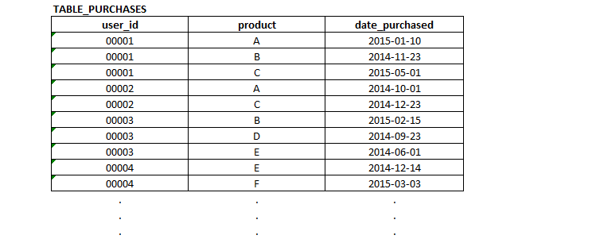

**QUESTION 1:**

Write the SQL to generate the count of unique users who have purchased product B but have never purchased product C.

TABLE_PRICES is a table that contains the following two fields: product, price.

Here is a sample of records from TABLE_PRICES: 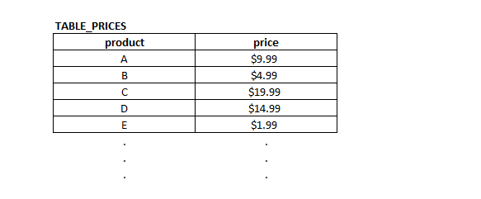

**QUESTION 2:**

Write the SQL to generate the count of unique users who purchased a product priced > $10 during May 2015.

TABLE_WINS contains the numbers of games each Major League Baseball team has won during every season.

TABLE_WINS contains the following three fields: team, season, games_won.

Here is a sample of records from TABLE_WINS:

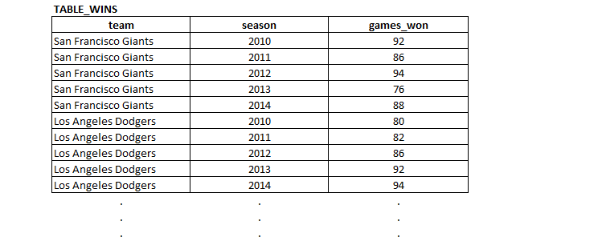

**QUESTION 3:**

Write the SQL to generate the following output, where the second column is the season in which each team had the most wins. The Giants & Dodgers are shown for illustrative purposes below, but the SQL should pull all teams at once:

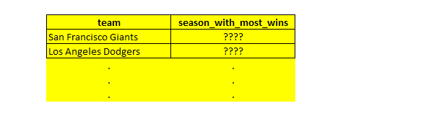

**QUESTION 4:**

Write the SQL to generate the following output, where the fourth column (“season_rank”) is based on numbers of wins and is calculated by team. In other words for a given team the season with the most wins will be ranked 1, season with the next most wins will be ranked 2, and so on.

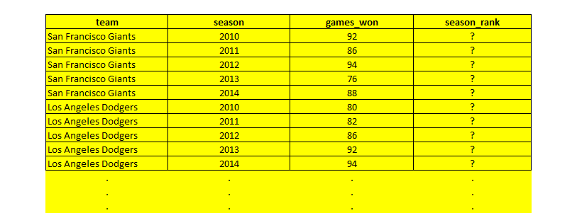

Company W produces and sells exactly three products: Product A, Product B and Product C. The scatter plot below displays all three products. The x-axis displays the percent of Company W’s resources allocated to each product. The y-axis displays the percent of Company W’s revenue generated by each product.

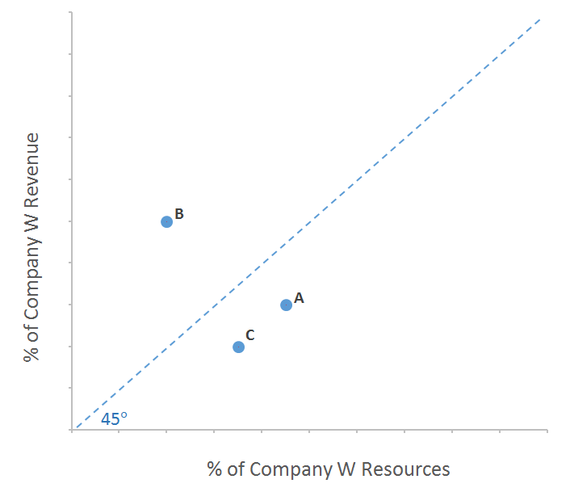

**QUESTION 5:**

1. Assume you are the product manager of one of the products. Would you rather your product be below or above the 45 degree line? Explain.
2. Is it possible for all three products to be below the 45 degree line? Or all three to be above the 45 degree line? Explain.