Katt Kennedy

Thank you for a lovely take-home exercise! I hope this gives a solid sample of the type of work I try to do.

Data Scientist Product Analytics Exercise

January 4, 2022

# Scenario 1

**TABLE_PURCHASES is a table that contains the following three fields: user_id, product, date_purchased.**

**Here is a sample of records from TABLE_PURCHASES:**

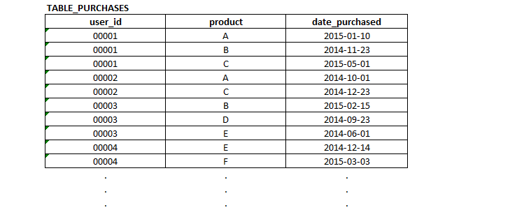

**QUESTION 1:**

Write the SQL to generate the count of unique users who have purchased product B but have never purchased product C.

*My goal here was to create two subqueries to filter out users; this is not the most performant solution, but it will get the job done. An alternative would be to create a CTE with columns totaling the count of each item purchased, which is preferable if this query needs to be repeated on a regular basis.*

SELECT DISTINCT tp.user_id

FROM table_purchases AS tp

WHERE tp.user_id IN ( –sub query of users buying >=1 B

SELECT COUNT(tp.product) AS count

FROM table_purchases as tp

WHERE tp.product = “B”

AND count >= 1)

AND tp.user_id IN ( –sub query to create a user list who have purchased exactly zero C

SELECT COUNT(tp.product) AS count

FROM table_purchases as tp

WHERE tp.product = “C” AND count = 0)

**TABLE_PRICES is a table that contains the following two fields: product, price.**

**Here is a sample of records from TABLE_PRICES:** 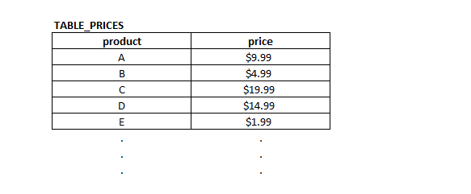

**QUESTION 2:**

Write the SQL to generate the count of unique users who purchased a product priced > $10 during May 2015.

*The goal of this code is to add the price of each product to the base table, then filter out all transactions where the product was not more than $10. This assumes all transactions have only one product associated to the customer, and if a customer purchases multiple items totaling more than $10 than they should still not be included.*

SELECT DISTINCT COUNT(tp.user_id) AS count_of_users

FROM table_purchases AS tpu

LEFT JOIN table_prices AS tpr ON tpu.product = tpr.product

WHERE tpr.price > $10

# Scenario 2

TABLE_WINS contains the numbers of games each Major League Baseball team has won during every season.

TABLE_WINS contains the following three fields: team, season, games_won.

Here is a sample of records from TABLE_WINS:

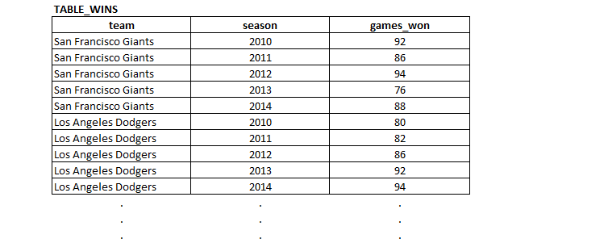

**QUESTION 3:**

Write the SQL to generate the following output, where the second column is the season in which each team had the most wins. The Giants & Dodgers are shown for illustrative purposes below, but the SQL should pull all teams at once:

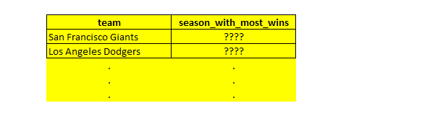

*Here, a subquery finds the season with the most total wins for each team, then returns that season year. This does not take into account win/loss ratios, as this was not an explicit part of the exercise.*

SELECT DISTINCT tw.team

, ws.season AS season_with_most_wins

FROM table_wins tw

LEFT JOIN (SELECT team, season, MAX(games_won)

FROM table_wins AS wins

GROUP BY team, season

–adding season here b/c all terms must be here or in an aggregate)

ON tw.team = ws.team AS ws

**QUESTION 4:**

Write the SQL to generate the following output, where the fourth column (“season_rank”) is based on numbers of wins and is calculated by team. In other words for a given team the season with the most wins will be ranked 1, season with the next most wins will be ranked 2, and so on.

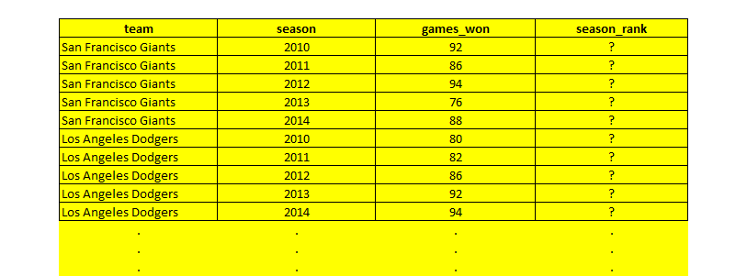

*This is the tricky one! The trick is to use OVER PARTITION and RANK, so that:*

1. *A partition is created by each season*
2. *The partition is ordered by the number of games won, descending*
3. *The rank/order is taken for each partition and returned to the overall query*

SELECT tw.team, tw.season, tw.games_won

,RANK() OVER(PARTITION BY tw.season ORDER BY games_won DESC) AS season_rank

FROM table_wins AS tw

# Scenario 3

Company W produces and sells exactly three products: Product A, Product B and Product C. The scatter plot below displays all three products. The x-axis displays the percent of Company W’s resources allocated to each product. The y-axis displays the percent of Company W’s revenue generated by each product.

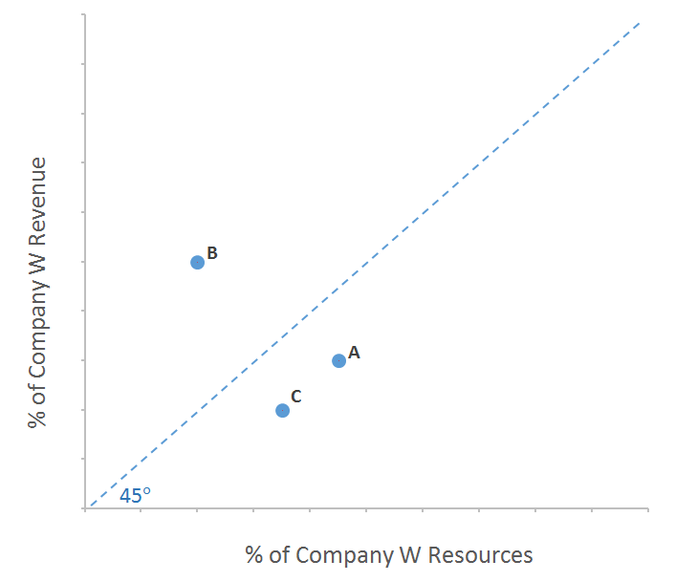

**QUESTION 5:**

1. Assume you are the product manager of one of the products. Would you rather your product be below or above the 45 degree line? Explain.

*Above the 45 degree line; this would mean the product has a larger than average share of company revenue and lower than average share of company resources, instead of the reverse.*

1. Is it possible for all three products to be below the 45 degree line? Or all three to be above the 45 degree line? Explain.

*It is not possible for all three products to be above or below the 45 degree line unless other products exist.*

*The line represents the average ratio of company resources to company revenue for a product line, and how each product relates to this ratio. While it is possible for all products to be profitable (or unprofitable) given different absolute values of Gross Revenue and Gross Resources, it is not possible for all three products to be under or above the line unless other products exist which have different ratios of Revenue: Resources.*