

February 28, 2006

Contestant: Cheryl Jackson |  | Briefcase Chosen: 16
Round 1 | Briefcases 4 ($25,000), 2 ($75), 14 ($10,000), 1 ($400,000), 22 ($300), and 12 ($100) eliminated. Banker offers $10,000; NO DEAL.
Round 2 | Briefcases 15 ($100,000), 13 ($75,000), 18 ($10), 7 ($200,000), and 21 ($25) eliminated. Banker offers $31,000; NO DEAL.
Round 3 | Briefcases 10 ($500,000), 6 ($1,000), 23 ($.01), and 20 ($50) eliminated. Banker offers $48,000; NO DEAL.
Round 4 | Briefcases 3 ($1,000,000), 24 ($50,000), and 17 ($500) eliminated. Banker offers $39,000; NO DEAL.
Round 5 | Briefcases 8 ($400) and 11 ($5,000) eliminated. Banker offers $66,000; NO DEAL.
Round 6 | Briefcase 19 ($750) eliminated. Banker offers $97,000; NO DEAL.
Round 7 | Briefcase 5 ($200) eliminated. Banker offers $172,000; NO DEAL.
Round 8 | Briefcase 25 ($750,000) eliminated. Banker offers $80,000; NO DEAL.
Round 9 | Briefcase 26 ($300,000) eliminated. Banker offers $2; NO DEAL.
Round 10 | Contestant declines to switch briefcases. Contestant’s briefcase opened; briefcase contains $5. FINAL WINNINGS: $5.
UNOPENED BRIEFCASE: 9 ($1).
*Italics represent the portion of the game that took place the previous night

Contestant: Mark Adrian |  | Briefcase Chosen: 13
Round 1 | Briefcases 24 ($400), 20 ($500,000), 4 ($500), 16 ($100), 8 ($75,000), and 15 ($1) eliminated. Banker offers $19,000; NO DEAL.
Round 2 | Briefcases 1 ($200), 10 ($.01), 23 ($1,000,000), 21 ($750), and 18 ($200,000) eliminated. Banker offers $25,000; NO DEAL.
Round 3 | Briefcases 22 ($5,000), 26 ($400,000), 25 ($75), and 19 ($25,000) eliminated. Banker offers $39,000; NO DEAL. ***END OF SHOW***

CHERYL’S MONEY TABLE  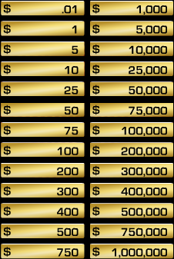 | MARK’S MONEY TABLE  