

March 2, 2006

Contestant: Sherman Mitchell |  | Briefcase Chosen: 14
Round 1 | Briefcases 23 ($10), 7 ($75,000), 1 ($75), 2 ($750), 9 ($1,000), and 26 ($.01) eliminated. Banker offers $23,000; NO DEAL.
Round 2 | Briefcases 6 ($200,000), 5 ($1,000,000), 4 ($100), 10 ($1), and 18 ($25) eliminated. Banker offers $39,000; NO DEAL.
Round 3 | Briefcases 24 ($400,000), 11 ($2,000,000), 8 ($100,000), and 15 ($200) eliminated. Banker offers $31,000; NO DEAL.
Round 4 | Briefcases 21 ($10,000), 17 ($25,000), and 3 ($50,000) eliminated. Banker offers $55,000; NO DEAL.
Round 5 | Briefcases 19 ($500) and 25 ($5,000) eliminated. Banker offers $93,000; NO DEAL.
Round 6 | Briefcase 22 ($5) eliminated. Banker offers $150,000; NO DEAL.
Round 7 | Briefcase 13 ($300,000) eliminated. Banker offers $106,000; NO DEAL.
Round 8 | Briefcase 20 ($50) eliminated. Banker offers $167,000; NO DEAL.
Round 9 | Briefcase 16 ($400) eliminated. Banker offers $250,000; DEAL. FINAL WINNINGS: $250,000.
IF SHERMAN HAD CONTINUED…
Round 10 | Contestant’s briefcase opened; briefcase contains $300.
UNOPENED BRIEFCASE: 12 ($500,000).
*Italics represent the portion of the game that took place the previous night

Contestant: Becky Venable |  | Briefcase Chosen: 7
Round 1 | Briefcases 15 ($25,000), 14 ($75,000), 11 ($1), 26 ($750), 22 ($400,000), and 18 ($5) eliminated. Banker offers $26,000; NO DEAL.
Round 2 | Briefcases 9 ($10), 25 ($300), 2 ($100), 21 ($750,000), and 5 ($.01) eliminated. Banker offers $49,000; NO DEAL.
Round 3 | Briefcases 6 ($400), 19 ($100,000), 24 ($500), and 12 ($1,000) eliminated. Banker offers $101,000; NO DEAL.
Round 4 | Briefcases 16 ($25), 17 ($50), and 13 ($2,500,000) eliminated. Banker offers $74,000; ***END OF SHOW***

SHERMAN’S MONEY TABLE  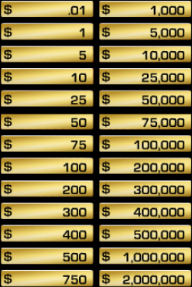 | BECKY’S MONEY TABLE  