

Web: [www.mcdanielnutrition.com](http://www.mcdanielnutrition.com)

Email: www.mcdanielnutrition@gmail.com

**Foods to Boost Your Mood & Rid Winter Woes**

The holidays are over, colds and flu are knocking at your door, and your skin hasn’t seen the sun in days. For some, the combination of these events can set up a bad case of the winter blues. While you might feel the urge to lie in a tanning bed or plow into a bag of chips, there are healthier ways to boost your mood during the winter months. The purpose of January’s “Nutrition Connection” is to summarize the science about "feel good foods" and offer tips on how to maximize these nutrients in your own diet.

**Omega-3’s (EPA & DHA)**  
Research continues to mound regarding omega-3 fat's and their ability to combat depression and optimize mental health. This relationship makes good sense as our brain and nervous system is largely made up of fats. Omega-3's are referred to as "essential" because they cannot be made by our body and must be obtained through the diet. Studies show that omega-3’s can improve different types of depression and also be beneficial at various stages of life, for example, during and after pregnancy.

Eating fish and fatty fish in particular, such as salmon or tuna, is the easiest way to meet your omega-3 requirements. Current recommendations for adults and children is 2-3 servings (4-6 oz.) of fish per week which is equivalent to ~500 mg of omega-3’s per day. For those who don’t enjoy fish or seafood, fish oil supplements can be a good backup plan. 1000 mg of EPA + DHA in supplement form have been shown to be effective. Always consult with your physician about changes to your supplement regimen.  
*Little tip: If you are plagued by the fish pill burp, chill your pills in the freezer before you take them, just make sure you don't forget about them!

**Vitamin D**  
Vitamin D is often referred to as the "sunshine vitamin" because our body can make vitamin D from sunlight. Vitamin D levels often dip during the wintertime due to the less daylight, indoor activity, and challenge in obtaining enough vitamin D through foods such as fatty fish, milk, eggs and fortified foods. Low levels of vitamin D are often associated with mood disorders such as depression and seasonal affective disorder. Statistics show that 75% of adults may be deficient in D. Therefore, as a dietitian, I often recommend that people get their vitamin D levels checked. Optimal levels should fall in the range of 40-60 ng/dl of 25(OH) vitamin D. Supplementation is often warranted and most health professionals would agree that a dose of 600-1000 IU of D3 is appropriate. If your blood levels fall short, your physician may put you on a mega dose of D for several months before returning to the over counter dosage.

**Cold & Flu Foods**

The best line of defense during the winter season is a balanced diet, rich in variety and color. Not only will these foods protect you with a coat of armor, they also might ease any symptoms of a contracted cold or flu bug. Here are three of my top cold and flu protective picks to keep on your grocery list.

**Chicken Noodle Soup**: Mom’s homemade soup might be just what the doctor ordered. Soups typically contain a salty broth, which both hydrates and thins mucus secretions. The warm liquids allow congestion to break up and expedites the removal of germs from the body. Make sure to add in lots of vegetables and lean proteins to boost micronutrients such as vitamin C, A, iron and zinc, all important immunity fighters.

**Garlic**: Vampires and viruses beware! A compound in garlic, called allicin, has both anti-bacterial and anti-fungal properties. Studies have shown that both raw, cooked & garlic pill supplements can help speed up recovery by boosting T-cells in our blood stream. If all else fails, your super garlicky breath will at least keep infectious people at arms reach.

**Tea**: Just like soup, the warm and soothing liquid helps mend sore throats, and certain teas, such as black and green teas contain EGCG a compound which has been shown to keep viruses from reproducing.

**Summing It Up**  
While the cold weather might inspire overeating and inactivity, fight back with immune, mood boosting foods and winter exercise. Your body will thank you.

**Spice-Rubbed Roasted Salmon with Lemon-Garlic Spinach**

Yield: 6 servings (serving size: about 4 1/2 oz salmon and 1/3 cup spinach mixture)

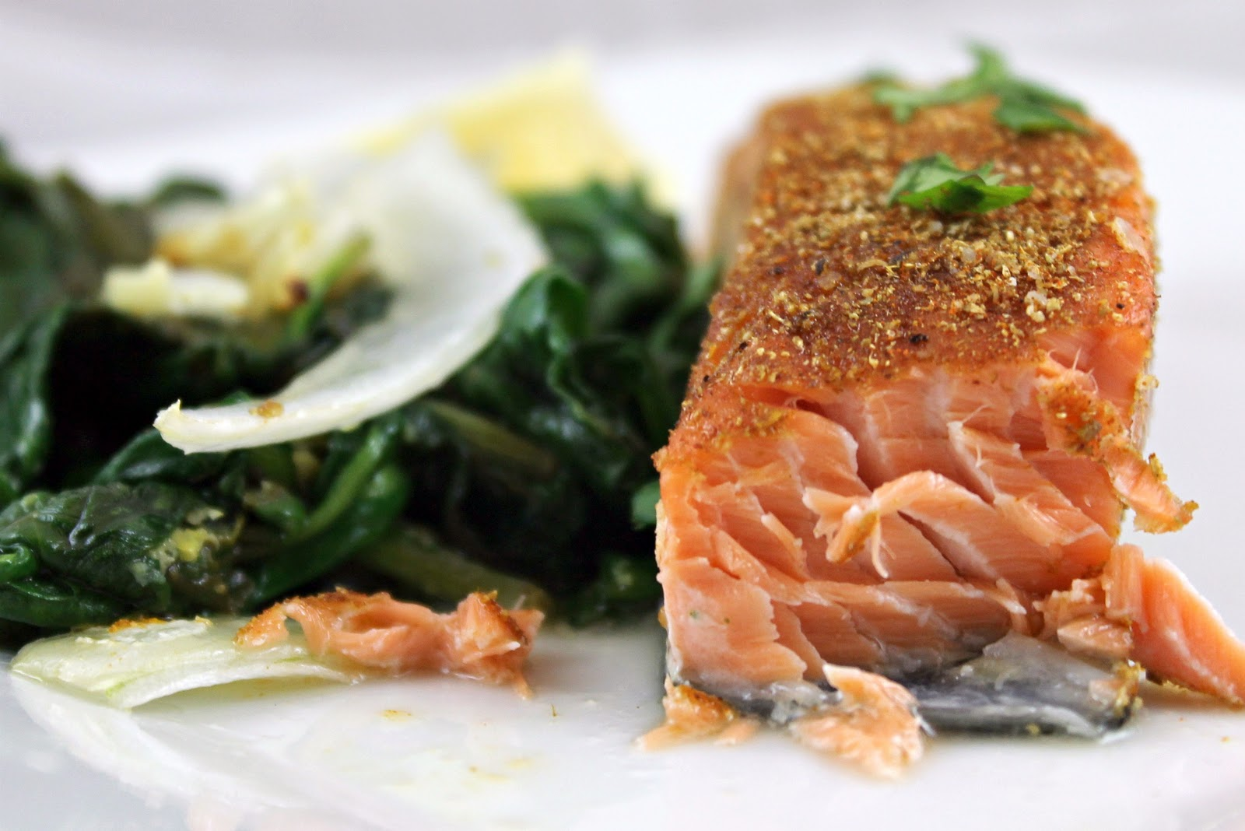**Ingredients:**  
1/2 tsp. salt  
1/2 tsp. cumin  
1/2 tsp. coriander  
1/4 tsp. paprika  
1/8 tsp. cinnamon  
1/8 tsp. black pepper  
1 (2-1/4-pound) skinless salmon  
2 cups thinly sliced onion  
Spinach:  
1 tsp. olive oil  
2 garlic cloves, minced  
2 (6-ounce) packages baby spinach  
1 tsp. grated lemon rind  
1/4 tsp. salt  
1 Tbsp. fresh lemon juice  
Remaining ingredients:  
2 Tbsp. chopped fresh cilantro  
Lemon wedges

**Preparation**  
1. Preheat oven to 400°.  
2. To prepare salmon, combine first 6 ingredients; rub spice mixture evenly over fish. Place onion in an 11 x 7-inch baking dish coated with cooking spray. Place fish on top of onion; bake at 400° for 20 minutes or until fish flakes easily when tested with a fork or until desired degree of doneness.  
3. To prepare spinach, heat oil in a large nonstick skillet over medium heat. Add garlic to pan; cook 1 minute. Add half of spinach; cook for 1 minute, stirring frequently. Add remaining spinach; cook 4 minutes or until wilted, stirring frequently. Sprinkle spinach mixture with rind and 1/4 teaspoon salt. Stir in juice; remove from heat.  
4. Place salmon on a platter. Arrange onions and spinach evenly around salmon. Sprinkle salmon with chopped fresh cilantro. Serve with lemon wedges, if desired.

Calories: 325; Fat: 13g; Sodium: 472 mg; Carb: 11 g; Fiber: 3.4g; Protein: 40 g

*Source: Cooking Light*

**Jennifer McDaniel, MS, RD, CSSD, LD**

[**mcdanielnutrition@gmail.com**](mailto:mcdanielnutrition@gmail.com)

**Web**: [www.mcdanielnutrition.com](http://www.mcdanielnutrition.com)

**Twitter**: @dietdivajen

**Facebook**: McDaniel Nutrition Therapy