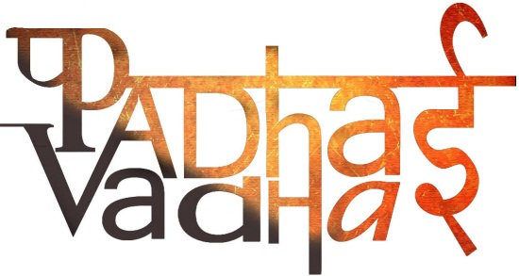

Chapter-4

Tribals, Dikus and the Vision of

a Golden Age

Q. How are Tribal Group ?

Ans. Tribal Group of people in different part of India were involved in a variety of activities for live hood.

Q. what do you mean by jhum cultivators ?

Ans. It is a type of cultivation , farmer cut the treetop of small patch of land and then brut revegetation on the land to clear it for cultivation and after harvested they moved to another land.

Q. Where shifting cultivator’sdown ?

Ans. Found in the hilly and forested tracked of north-east and central India.

Q. What are main source of oil?

Ans. Sal and Mahua are main source of oil.

Q. What are use of Kusam and Palash flower?

Ans. The main use of Kusam and Palash flower to colour their cloths and leather.

Q. who is Baigan ?

Ans. The Baigan are people of the forest who could only live on the produce of the forest. It was

below the dignity of a Baiga to become a labourer.

Q. who is Tribal chiefs ?

Ans. Tribal chiefs are peoples who enjoyed a certain amount economic power and had the right to administer and control their territories they have own land.

Q form where would the forest Department get its labour to cut trees?

Ans. From jhum cultivators the forest department get its labor to cut trees.

Q. When forest satyagraha start and by whom?

Ans. At 1930 forest satyagraha start by SongramSanma.