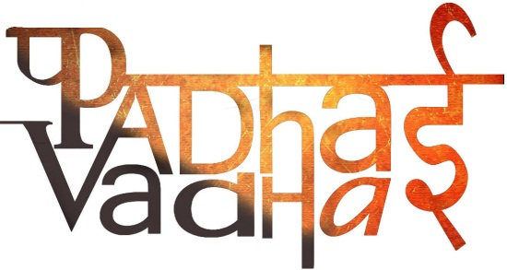

FORCE AND PRESSURE

Q1: Push or pull on an object is known as ______________.

Answer: force

Q2: Force has both the magnitude and the______________.

Answer: direction

Q3: strength of force is usually expressed by its _____________.

Answer: Magnitude

Q4: What can bring a change in the state of motion of an object?

Answer:

Q5: what is the formula of pressure?

Answer: force/area

Q6: What do you mean by contact forces?

Answer: Forces which act only when there is physical contact

Q7: What do you mean by non-contact forces?

Answer: Forces which can act without physical contact

Q8: when the forces are applied on an object in the same direction, what happens?

Answer: Forces applied on an object in the same direction add to one another.

Q9: Force can bring a change in the_____________ and the _____________ of an object.

Answer: State of motion, shape.

Q10: name any contact force.

Answer: friction

Q11: name any non-contact forces.

Answer: Magnetic force and gravitational force

Q12: A batsman hits a cricket ball which then rolls on the level ground, after covering a short distance the ball comes to rest. The ball stops due to which force?

Answer: Frictional force

Q13: When forces, applied on an object, are equal and opposite, then these forces

1) May move the object.

2) May stop a moving object.

3) May move the object and also cause a change in its shape.

4) Do not move the object but may cause a change in its shape.

Answer: 4

Q14: Out of the following which is an example of contact force?

1. Magnetic force

2. Muscular force

3. Electric force

4. Gravitational force

Answer: 2

Q15: An apple falling from tree is an example of which type of force?

Answer: gravitational force

Q16: What is unit of pressure?

Answer: Pascal

Q16: If the area over which the force acts decreases, the pressure increases.(true/false).

Answer: true

Q17: Which force acts from distance and pulls iron objects?

Answer: magnetic force

Q18: What is the SI unit of Force?

Answer: Newton

Q19: define muscular force?

Answer: The force resulting due to the action of muscles

Q20: Water begins to flow towards the ground when we open a tap. This happens due to which force?

Answer: gravitational force

Q21: South pole of a magnet repels south pole of another magnet. Yes/No

Answer: yes

Q22: Why the cutting edge of a knife should be sharp?

Answer: to create great pressure

Q23: Cars and buses are able to run on roads, due to which force?

Answer: friction

Q24: If the area over which the force acts decreases, then the pressure __________.

Answer: Increases

Q25: Which force is used to separate solid pollutant particles from smoke coming out from factories?

Answer: Electrostatic force

Q26: Which force is exerted by the Earth on all the bodies on its surface known as?

Answer: Gravitational force.

Q27: Which instrument is used to measure liquid pressure?

Answer: Monometer

Q28: A liquid exerts pressure in __________ direction. (Upward/downward/sideways/all).

Answer: all

Q29: Which force a person applies while pulling an object?

Answer: Muscular force.