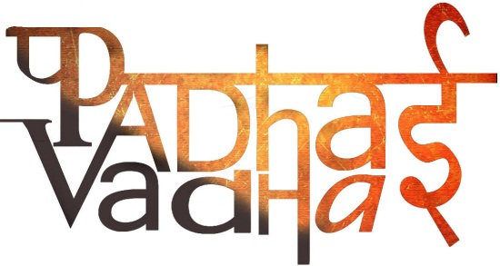

**Chapter 12**

**Buildings, Paintings and Books**

Question1. How high is the iron pillar in Mehrauli and how much it weighs?   
Ans. 7.2 m high, made about 1500 years ago. It weighs over 3 tons.

Question2. Whose inscriptions are inscribed on this pillar?  
Ans. A ruler named Chandra, Gupta dynasty.

Question3. What does Stupa mean?  
Ans. A mound.

Question4. What was kept in the box that was placed at the heart of the stupa?

Ans. Bodily remains of the Buddha or his followers or things they used.

Question5. What name was given to this box?  
Ans. A relic casket.

Question6. What layer was added on that box?  
Ans. A layer of mud brick or baked brick was added on top.

Question7. What was pradakshinapatha?  
Ans. A path that was laid around the stupa.

Question8. Why did Devotees walk around the stupa?  
Ans. They walked in a clockwise direction, as a mark of devotion.

Question9. When was the stone carvings prepared for decorating stupas?  
Ans. 2000 years ago.

Question10. Which Deities were worshipped in Hindu shrines?  
Ans. Vishnu, Shiva and Durga.

Question11. What was garbhagriha?  
Ans. Room where the image of chief deity was placed.

Question12. What was built on top of garbhagriha to mark it sacred place?  
Ans. A tower called Shikhara.

Question13. What was the first step of building a stupa or temple?  
Ans. Good quality stones had to be found, quarried and transported to the place where stupa had to be built. Block of stones had to be shaped and carved into pillars.

Question14. Who paid for to the craft persons who worked in the construction?  
Ans. Kings and queen spent money from their treasury.

Question15. Which place is famous for cave paintings?  
Ans. Ajanta.

Question16. How were the hollow caves painted in the dark?

Ans. With the use of torch light.

Question17. How were the colors made then?  
Ans. From plants and animals.

Question18. Who composed the famous Tamil epic, the Silappadikaram?  
Ans. A poet Ilango, 1800 years ago.

Question19. Another Tamil epic, the Manimekalai was composed by ________.

Ans. Sattanar around 1400 years ago.

Question20. What is the literal meaning of Purana?  
Ans. Old.

Question21. What does Purana contain?

Ans. Stories about gods and goddesses, and how they were to be worshiped.

Question22. In which language were Puranas written?  
Ans. Sanskrit verse.

Question23. Were women and shudras allowed to listen to Puranas?  
Ans. Yes.

Question24. Name two famous Sanskrit epics.

Ans. The Mahabharata and Ramayana.

Question25. Who compiled the Mahabharata?  
Ans. Vyasa.

Question26. Who is the author of Ramayan?  
Ans. Valmiki.

Question27. Stories written by common people are compiled in ______________________.

Ans. The Jatakas and the Panchatantra.

Question28. What was Aryabhatiyam about? Who wrote it?  
Ans. The book Aryabhatiyam was about the science facts. It was written by Aryabhata, a mathematician and astronomer.