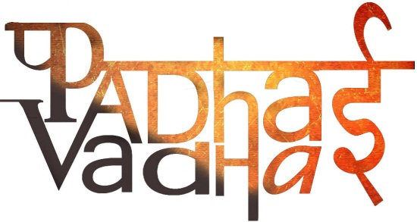

**Chapter 5**

**Separation of Substances**

Question 1. When is handpicking method used for separation of substances?  
Ans. When the large sized impurities are to be separated.

Question 2. Example of situation when handpicking is used?  
Ans. To separate husk from wheat.

Question 3. What is threshing?  
Ans. Process that is used to separate grain seeds from stalks.

Question 4. How does threshing happen?  
Ans. The stalks are beaten to free the grain seeds.

Question 5. What is winnowing?  
Ans. The method of separating components of a mixture.

Question 6. When is winnowing used?  
Ans. To segregate heavier and lighter components.

Question 7. Which process is used to separate pebbles and stones from sand?  
Ans. Sieving.

Question 8. When is sieving done?  
Ans. Sieving is used when components of a mixture have different sizes.

Question 9. When the heavier component in a mixture settles after water is added, the process is called?  
Ans. Sedimentation.

Question 10. What is decantation?  
Ans. When water is removed from sedimentation.

Question 11. Which method is better to use to separate tea leaves from tea?  
Ans. Filtration

Question 12. Give an example of filtration.

Ans. In the making of paneer at home.

Question 13. The process of conversion of water into vapor is ______.

Ans. Evaporation.

Question 14. Give an example of evaporation?  
Ans. To obtain salt from sea water.

Question 15. Explain the process of condensation?  
Ans. Condensation is process of converting water vapour into its liquid form.

Question 16. When salt cannot be dissolved into water anymore, it is called the state of _______?  
Ans. Saturation.

Question 17. How can more of substance be dissolved in a solution?  
Ans. By heating it.