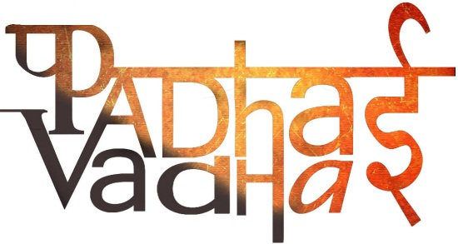

**Chapter 4**

**Key Elements of a Democratic Government**

**Question 1 What is the racial composition of South Africa?**

South Africa has several races people, For Example-

* Black People - Belongs to South Africa.
* White - Came there to settle.
* Indians - Came as labourers and traders.

**Question 2 What does separation on the basis of races called?**

Apartheid.

**Question 3 In how many races South African people were divided?**

They were divided in four categories-

White.

Black.

Indians.

Coloured.

**Question 4 What did the group of people who led the struggle against apartheid called?**

ANC - African National Congress.

**Question 5 When did South Africa become a country?**

In 1994.

**Question 6 How Ambulance of Blacks and White were different in South Africa?**

An ambulance meant for white people would always be well equipped while one meant for black people was not well equipped.

**Question 7 Who were not allowed to vote in South Africa?**

Non Whites.

**Question 8 Why is it important to vote in a democratic government?**

In a democratic government people elect their representatives who take decision on their behalf keeping in mind the voices and interest of the people.

**Question 9 Initially, what laws were imposed on South African people?**

Initially Black, White, Indian and Coloured people were not allowed to mingle with each other or to use common facilities.

**Question 10 What do conflicts in a country lead to?**

Conflicts lead fear and tension among all the people.

**Question 11 How river became a source of conflict in a country?**

River became a source of conflict on the matter of sharing of river water between different places that the river goes through.

**Question 12 The Cauvery Water Dispute was between which States?**

Between Karnataka and Tamil Nadu.

**Question 13 What are the different ways through which people can participate in the process of government?**

People can participate by-

* Showing Interest in the working of the government.
* By providing proper support.
* By criticizing it when required.

**Question 14 What is the major reason behind banning untouchability?**

Because those people who were considered untouchable were denied education, transport, medical and even were not allowed to pray.

**Question 15 Name one leader in India who played an important role to ban untouchability?**

Dr. Bheem Rao Ambedkar

**Question 16 How would Maya's life be different in South Africa today?**Maya's life would be different in South Africa today due to following reasons:

* Practice of apartheid is abolished today.
* She would have enjoyed equal rights before the law.
* No discrimination on the basis of caste, colour, creed and religion.
* She would have the right to choose and participate in the government.

**Question 17 What are the various ways in which people participate in the process of government?**Various ways in which people participate in the process of government:

* By participating in the election.
* By casting their vote.
* By mass protest like rallies, strikes etc.
* By expressing their view and criticizing the
* Keep on track and informed with government works and decisions.
* Supporting the government whenever required.

**Question 18 Why do you think we need the government to find solutions to many disputes or conflicts?**

It is necessary to maintain peace and laws in the nation because It can turn into outrageous or violent movement in future if not solved.

**Question 19 What actions does the government take to ensure that all people are treated equally?**

There should be no discrimination in providing justice on the basis of caste, colour, creed or religion.

Ensuring basic facilities of food, shelter, health and clothes to all..

All should be given equal rights to enjoy their freedom.

**Question 20 What are the key ideas of a democratic government?**

Key ideas of a democratic government should be:

* Rights to participate in the formation of government.
* Justice should be provided to all.
* Government should be accountable to its people.
* No discrimination on the basis of caste, colour, creed or religion.
* Right to organise mass movements, rallies, protests etc.