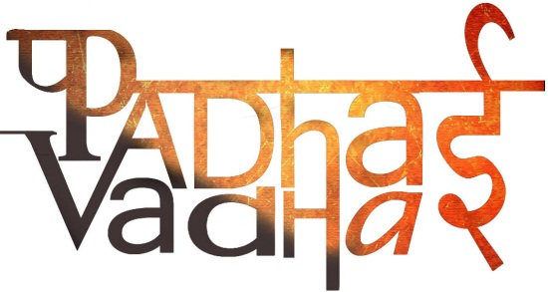

**CHAPTER -1**

**ON EQUALITY**

Qs 1. What are the key elements of a democratic government?

Ans: 1. People’s participation

2. The resolution of conflict

3. Equality and justice.

Qs 2.(Imp) What do you mean by universal adult franchise?

Ans. In a democratic country, all adults irrespective of what religion they belong to, how much education they have had, what caste they are, or whether they are rich or poor are allowed to vote. This is called universal adult franchise.

Qs 3. The idea of universal adult franchise is based on the idea of ____.

Ans. Equality.

Qs 4. Name one most common form of inequality.

Ans. Caste System.

Qs 5. Who is a Dalit?

Ans. Dalit is a term that the so-called lower castes use to address themselves.

Qs 6.(Imp) Why lower caste people call themselves ‘Dalit’?

Ans. Dalit means ‘broken’ and by using this word, lower castes are pointing to how they were, and continue to be, seriously discriminated against.

Qs 7. Name one famous Dalit writer.

Ans. Omprakash Valmiki.

Qs 8. What do you know about Omprakash Valmini’s life?

OR

Why do you think Omprakash Valmiki was being treated unequally by his teacher and his classmates?

Ans. 1. He had to seat away from other students at school and that too on the floor.

2. He was even beaten without any reason.

3. Sometimes, he was asked to sweep the school and the playground.

Qs 9. In what ways was Omprakash Valmiki’s experience similar to that of the Ansaris?

Ans. They both were treated unequally from the other people because of the caste they were born into and the religion they practice.

Qs 10.(Imp) What are the different reasons because of which some people are treated unequally?

Ans. The following reasons determine why some people are treated unequally:

1. The caste they are born into.
2. The religion they practice
3. The class background they come from
4. Whether they are a male or a female.

Qs 11. Why Ansari’s refused to change their name?

Ans. The Ansari’s dignity was hurt when persons refused to lease their apartments to them. Hence, when the property dealer suggested that they change their name, it was their dignity or self-respect that made them refuse the suggestion.

Qs 12.(Imp) Explain Equality in Indian democracy.

OR

How can you say that in a democratic country, the constitution recognizes every person as equal?

Ans. In a democratic country like India, the principle of the equality of all persons is recognized. Every individual in the country, including male and female persons from all castes, religions, tribes, educational and economic backgrounds are recognized as equal by the Constitution.

Qs 13.(Imp) Describe the provisions that are included the recognition of equality.

Ans. 1. Every person is equal before the law: Every person has to follow the same laws.

2. No person can be discriminated against on the basis of their religion, race, caste, place of birth or whether they are female or male.

3. Every person has access to all public places including playgrounds, hotels, shops, markets and also publicly available wells, roads and bathing ghats.

4. Untouchability has been abolished.

Qs 14.(Imp) What are the ways in which the government has tried to implement the equality that is guaranteed in the Constitution?

Ans. 1. Through laws

2. Through government programmes or schemes to help disadvantaged communities.

3. The government has also set up several schemes to improve the lives of communities and individuals who have been treated unequally.

4. Started midday meal scheme. This refers to the programme introduced in all government elementary schools to provide children with cooked lunch.

Qs 15.(Imp) What were the benefits of midday meal scheme?

OR

How do you think that the midday meal scheme might help promote greater equality?

Ans. Effects:

1. More poor children have begun enrolling and regularly attending schools.
2. Teachers reported that earlier children would often go home for lunch and then not return to school but now with the midday meal being provided in the school, their attendance has improved.
3. Their mothers, who earlier had to interrupt their work to feed their children at home during the day, now no longer need to do so.
4. This programme have also helped reduce caste prejudices because both lower and upper caste children in the school eat this meal together.
5. It also helps reduce the hunger of poor students who often come to school and cannot concentrate because their stomachs are empty.

Qs 16. Why do you think that establishing equality in a democratic society is a continuous struggle?

Ans. One of the main reasons behind this is that attitudes change very slowly. Even though people are aware that discrimination is against the law, they continue to treat people unequally on the basis of their caste, religion, disability, economic status and because they are women.

Qs 17. How were treated unequally in the United States of America and why?

Ans. African-Americans were treated unequally in the United States and denied equally through law. This is because their ancestors were slaves who were brought over from Africa.

Qs 18. What do you know about the Civil Rights Movement?

Ans. When travelling by bus, the African-Americans had to sit at the back of the bus or get up from their seat whenever a white person wished to sit. One day, an African-American woman Rosa Parks refused to give up her seat on a bus to a white man. Her refusal that day started a huge agitation against the unequal ways in which African-Americans were treated and which came to be known as the Civil Rights Movement.

Qs 19. Describe the Civil Rights Act of 1964.

Ans. The Civil Rights Act of 1964 prohibited discrimination on the basis of race, religion or natural origin. It also stated that all schools would be open to African-American children and that they would no longer have to attend separate schools specially set up for them.