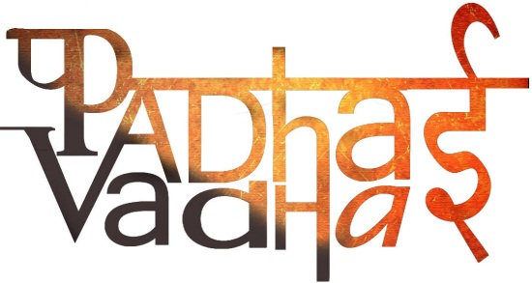

Ch 8

Devotional Paths to the Divine

Question 1. Why was ‘Nayanar movement’ started?

A1. -To check development of Buddhism and Jainism in southern peninsula

-To protect their religion from the incursions of new religions.

Question 2. Who started Langar?

A2. Guru Nanak

Question 3. What was purpose of starting Langar?

A3. To try and preach universal toleration and do away with caste discriminations.

Question 4. What are Hagiographies?

A4. Biographies of the Alvars and Nayanars

Question 5. What are Hagiographies helpful for?

A5. In writing histories of Bhakti tradition.

Question 6. Where were Sikh congregation and religious gatherings of followers of Guru Nanak held?

A6. Dharamsalas.

Question 7. By what name Dharamsalas are known now?

A7. Gurudwara

Question 8. What was the main contribution of Chola and Pandya kings for Bhakti Movement’s growth?

A8. -They built many temples around many shrines between the tenth and twelfth centuries

-The saint poets visited these shrines and sang songs of bhakti

-It strengthened links between Bhakti tradition and temple worship.

Question 9. Who was Shankara?

A9. -One of the most popular religious philosophers of India born in Kerala.

-Expounder of the concept of Advaita which is the doctrine of oneness of the individual soul and the supreme god

-He was a fully developed Yogi, Jnani and Bhakta.

Question 10. Write short note on teachings of Shankara.

A10. -He believed that Brahman alone is real, this world is unreal

-He considered the world as Maya or an illusion

-He preached renunciation of the world and adoption of the path of knowledge.

Question 11. Which two religions helped people to overcome the notion that high caste comes by birth?

A11. Buddhism and Jainisim

Question 12. Who was Ramanuja?

A12. -He was born in Tamil Nadu in the eleventh century

-He was deeply influenced by the Alvars

-He was an exponent of the doctrine of Vishistadavita or qualified non-dualism.

Question 13. State the teachings of Ramanuja.

A13. -He advocated that the best means of attaining salvation was through intense devotion to Vishnu.

-According to Ramanuja's teachings, Lord Narayana or Bhagavan is the Supreme Being

-He believed that Vishnu helped devotees to attain the bliss of union with Him

- Later his teachings inspired the Bhakti cult in North India.

Question 14. Virashaiva movement was started by whom?

A14. Basavanna and his companions like Allama Prabhu and Akkamahadevi

Question 15. Write short note on Sufis.

A15. -Sufis were Muslim mystics

-They rejected outward religiosity and emphasized love and devotion to God and compassion towards all fellow human beings

-They condemned the elaborate rituals and codes of behaviour demanded by Muslim religious scholars

-They also composed poems expressing their feelings

Question 16. Write short note on Khanqahs.

A16. -Khanqahs were like hospices.

-It was a place where the Sufi masters held their assemblies.

-Devotees of all descriptions including members from the royal and noble groups, and ordinary people gathered there.

-They discussed spiritual matters and were blessed by the saints.

Question 17. What were the preachings of Guru Nanak?

A17. -Guru Nanak was born in Talwandi. He preached against caste distinctions ritualism, idol worship and the pseudo-religious beliefs that had no spiritual content.

-He dined and lived with men of the lowest castes and classes which was socially and religiously unheard of in those days of rigid Hindu caste system.

-His followers ate together in the common kitchen called langar which became a nucleus for religious gatherings of his society and of establishing the basic equality of all castes, classes and sexes.

Question 18. Who was Guru Nanak’s successor as was appointed by him before his death?

A18. One of his followers named Lehna

Question 19. Who ordered Guru Arjan’s execution?

A19. Mughal emperor Jahangir

Question 20. Why Jahangir ordered execution of Guru Arjan?

A20. -By the beginning of the seventeenth century, the town of Ramdaspur (Amritsar) developed around the central Gurdwara, also called Harmandar Sahib (Golden Temple).

-It was like a state with self-governing.

-The Mughal emperor saw this development as a potential threat against his rule. So he ordered the execution.

Question 21. Who was Martin Luther?

A21. Martin Luther was one of the most important leaders of the changes that took place within Christianity.

Question 22. What did Luther felt about Roman Catholic Church?

A22. Luther felt that several practices in the Roman Catholic Church went against the teachings of the Bible.

Question 23. When did local myths become a part of the Puranic stories?

A23. -When gods and goddess were identified with Shiva, the local myths and legends became part of the Puranic stories and the methods of worship introduced in the Puranas were followed for the local gods and goddesses.

Question 24. Alvars and Nayanars were devoted to whom?

A24. Alvars were devoted to Vishnu and Nayanars were devoted to Shiva.

Question 25. How did Khalsa Panth emerged?

A25. -The Sikh movement began to get politicized in the seventeenth century.

-Development culminated in the institution of the Khalsa by Guru Gobind Singh in 1699.

-Thus, the community of the Sikhs called the Khalsa Panth came into existence as a political entity.