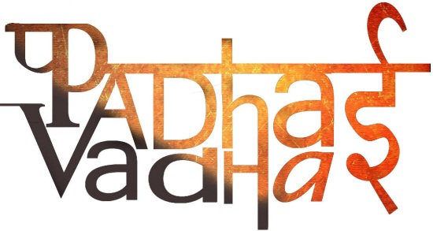

Chapter -1

How, When and Where

Q. Define the word History ?

Ans. History is record of all known past event . History is certainly about changes that occur over time. It is about finding out how things were in the past and how things have changed

Q. Mention a few other event , which if recorded, will make history more interesting to everyone ?

Ans. Historians could write about the cultural changes in society, about how people travelled and exchanged news in the olden days and about the livelihood of people in past.

Q. Who created the First map of India?

Ans. Major jamesRennl an English geographer, historian and pioneer of oceanography prepared the first map of India.

Q. what do we mean by “time – span” in connection with historical events?

Ans. When a specific date cannot be fixed for an event in the past and only an approximate period can be fixed this period of time is called the time-span. When we talk about change that took palce in certain social practice specific dates cannot be fixed only a time -span can be mentioned.

Q. what did British historians in India write about?

Ans. British historians in India wrote about the Governor Generals and Viceroys who ruled India. Their history books contained the activities, policies and achievement of the Governor Generals and nothing more. All the recorded events with specific dates were linked to the lives of these Governor Generals.

Q. Who wrote the book ‘ The History of British India’?

Ans. ‘The History of British India’ was written by James Mill. James Mill was born in 1773 . He was a Scottish historian, ecosnomist, political theorist, and philosopher.

Q. How were records preserved during the British rule?

Ans. Archives and museums were established to preserve important records.

Q. apart from official records what are the other sources of information that is available to historians ?

Ans. The other sources of information that is available to historian are

* Diaries of people
* Accounts of pilgrims and travelers
* Autobiographies of important personalities
* Popular booklets and newspaper.