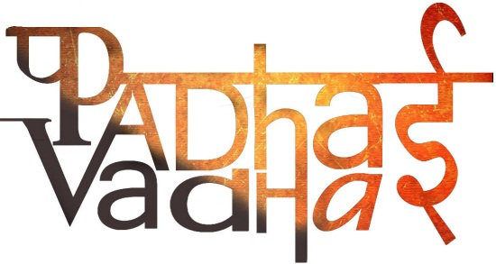

**Chapter 8**

**Ashoka, The Emperor Who Gave Up War**

Question1. Name the book in which Chanakya’s ideas were written.

Ans. Arthashastra.

Question2. Chandragupta was supported by whom?  
Ans. Chanakya or Kautilya.

Question3. Where did merchants, officials and craft persons live?  
Ans. Ujjain.

Question4. How are empires different from kingdoms?  
Ans. Emperors need more resources than kings. So, they need large number of officials to collect taxes.

Question5. Which area was under the direct rule of emperor?  
Ans. Area around Pataliputra.

Question6. What were the designations available under emperor?  
Ans. Officials, messengers, spies and senior ministers.

Question7. Where did the maurayas have their control?  
Ans. Rivers and roads to utilize the resources.

Question8. What were tributes?  
Ans. it was collected as and when it was possible from people who gave a variety of things, more or less willingly.

Question9. Who was the most famous Maurayan ruler?  
Ans. Ashoka.

Question10. Kalinga is the ancient name of which state?  
Ans. Coastal Orissa.

Question11. Why did Ashoka give up the war?  
Ans. He was horrified when he saw the violence and bloodshed.

Question12. What was Ashoka’s dhamma?  
Ans. Ashoka felt that it’s his duty to solve the problems going in his kingdom. So he appointed dhammamahamatta, who went from place to place teaching people dhamma.

Question13. What was inscribed on rocks and pillars?  
Ans. Ashoka’s got his message inscribed.

Question14. In which all areas did he send his messengers to spread the word?  
Ans. Syria, Egypt, Greece and Sri Lanka.

Question15. Most Ashoka’s inscriptions were in ________.

Ans. Prakrit and Brahmi script.