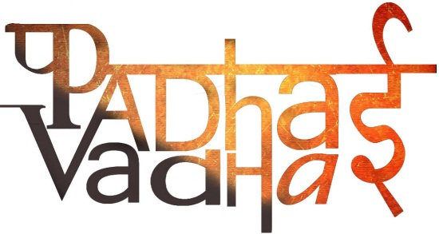

**Chapter-11**

**Light, Shadows and Reflections**

Question -1: What are luminous objects?

Ans. Objects like the sun that give out or emit light of their own are called luminous objects.

Question -2: What are Opaque objects?

Ans. If we cannot see through an object at all, it is an opaque object.

Question -3: What are translucent objects?

Ans. There are some objects through which we can see, but not very clearly. Such objects are known as translucent.

Question -4: What are transparent objects?

Ans. If you are able to see clearly through an object, it is allowing light to pass through it and is transparent.

Question -5: When shadows are formed?

Ans. Shadows are formed when an opaque object comes in the path of light.

Question -6: How pinhole cameras are made? How they can be used?

Ans. Pinhole camera can be made with simple materials and can be used to image the Sun and brightly lit objects.

Question -7: Light travels in a …………………..

Ans. Straight line

Question -8: True/false:

1. Mirror reflection gives us clear images: True
2. Images are same as shadows: False

Question -9: To see an object what do we need?

Ans. To see any non-luminous object we need:

1. Source of light
2. Object
3. Eyes

When a light emitting from luminous body falls on a non-luminous object and is reflected. This reflected light reaches our eyes enables us to see that object.

Question -10: Moon appears bright at night. Is it a luminous or non-luminous body?

Ans. Moon is non-luminous body; it does not emit its own light. It reflects the sun light that falls on it.

Question -11: What is lateral inversion?  
Ans. When an object is placed in front of a plane mirror, the right side of the object appears to be on the left side of the object appears to be on the right side of image. This is called lateral inversion.