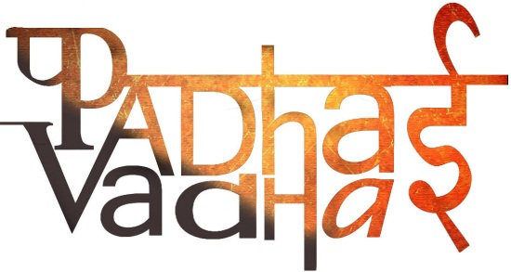

Ch-1

TRACING CHANGES THROUGH A THOUSAND YEARS

Question 1.What did the word 'Rajputra' mean?  
  A1.Son of the Ruler

Question 2.When did the Mughal Empire decline?  
A2.Eighteenth century

Question 3.For what purpose the Persian wheel was used?

A3.Irrigation

Question 4.Which group of Muslims believed that Muhammad Ali was the legitimate heir of Prophet Muhammad?

A4.Shia Muslims

Question 5.Which group regards the Holy Quran as their holy book?

A5.Muslims

Question 6. The political and spiritual leaders of Muslim community were called as?

A6.Khalifas

Question 7. In which century did Babar use the term 'Hindustan' to describe geography?

A7.16th century

Question 8.The Rajputs belonged to which caste?

A8.Kshatriyas

Question 9.In which year poet Amir Khusrau noted different languages?

A9.1318 CE

Question 10.A Sanskrit prashasti praised the ruler for having a vast empire? What was his name?

A10.Ghiyasuddin Balban

Question 11.Which group of people became important during the period between 700 and 1750?

A11.Rajputs

Question 12.Define cartographer?

A12. A person who makes maps.

Question 13.According to poet Amir Khusrau, which was an old language?

A13.Sanskrit

Question 14.A place where manuscripts and documents are stored is known as

A14.Archive

Question 15.Who did the work of copying manuscripts?

 A15.Scribe

Question 18

Question 16. Name the three periods in which Indian history was divided by British historians ,in the 19th century

A16.Hindus, Muslims and British

Question 17.What was the a caste of scribes and secretaries?

A17.Kayasthas

Question 18.Which political and social groups emerged between 700 and 1750?  
A18.-Various social and political groups emerged between 700 and 1750.

-The Rajputs emerged as a powerful group during this period. They belonged to the Kshatriya caste.

The Kayasthas caste was proficient in writing and keeping records and emerged as an important group during the period.

-Marathas, Sikhs, Jats and Ahoms were the other groups who occupied power at the regional level during this time period.   
  
  
Question 19. Who used the term 'Hindustan' for indicating the lands of Punjab, Haryana and the lands between Ganga and Yamuna?

A19.Minhaj-i-Siraj

Question 20.Write a short note on Jatis.

-After society grew and became differentiated, people were grouped into jatis or sub-castes and were ranked on the basis of their backgrounds and occupations.

-Ranks were not fixed permanently   
-Ranks varied according to the power, influence and resources controlled by members of the jati.

-The status of the same jati could vary from area to area.

-Jatis framed their own rules and regulations to manage the conduct of their members.

-These regulations were enforced by an assembly of elders.

-these assembly were described in some areas as the jati panchayat.

-However, jatis were required to follow the rules of their villages.  
  
Question 21.State the various changes which took place in religious activities during the medieval period.  
  
A21.The various changes which took place included :-  
-worship of new deities  
- the construction of temples by royalty   
- growing importance of Brahmanas, the priests, as dominant groups in society.   
-MAJOR CHANGE(in the field of religion) was emergence of the bhakti movement.

-Merchants and travellers first brought the teachings of the holy Quran in India during the seventh century.

-In India, Islam was interpreted by its followers in different ways.

Question 22.Which groups of people were included in the term Rajaputra?  
  
A22.Groups included in the term were not only rulers and chieftains but also soldiers and commanders who served in the armies of different monarchs all over the subcontinent.  
  
Question 23.State any 4 languages noted by the poet Amir Khusrau.  
A23.The various languages noted by the poet Amir Khusrau were

 Sindhi

 Lahori

 Kashmiri

 Dvarsamudri (in southern Karnataka)

 Telangani (in Andhra Pradesh)

 Gujari (in Gujarat)

 Ma’bari (in Tamil Nadu)

 Gauri (in Bengal)

 Awadhi (in eastern Uttar Pradesh)

 Hindawi (in the area around Delhi)  
(any four names can be given)  
  
Question 24.During the medieval period, what was paper used for?

A24. Paper was used for writing holy texts, chronicles of rulers, petitions and judicial records, letters and teachings of saints,  
and for noting accounts and taxes.  
  
  
Question 25.Define patron

A25.A patron is defined as an influential, wealthy individual who supports another person like an artist, craftsperson, learned man or noble.