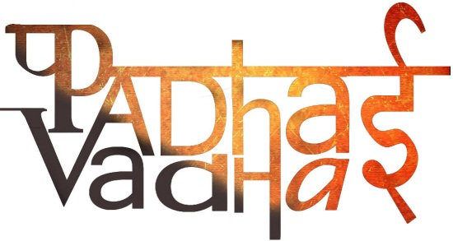

**Chapter 1**

**Understanding Diversity**

**Question 1 What is Diversity?**

It means understanding that each individual is unique,   
and recognizing our individual differences.

**Question 2 How are people diverse from each other?**

People are different in :

Languages.

Religions.

Beliefs.

Cultural Traditions.

Types and houses where we live.

Schools.

Jobs, etc.

**Question 3 What is Caste System?**

For thousands of years, a person's social class was determined by birth. Historians later called this the caste system.

**Question 4 What is Inequality?**

Inequality means people have unequal access to scarce and valued resources in society. These resources might be economic or political, such as health care, education, jobs, property and land ownership, housing, and ability to influence government policy.

**Question 5 What does living in India adds to your life?**

Things which rich heritage of diversity adds to our life:  
• Conversation with people with different languages.  
• Large variety in foods.  
• Celebrate different festivals and respect their cultures.  
• Huge no. of dance and music forms.  
• Variety of clothes of different regions, etc.

**Question 6 What does “Unity in Diversity” means?**

The diversity in India has always been recognised as a source of its strength. Even during freedom movements, women and men from different cultural, religious and regional backgrounds came together to decide joint actions and opposes the British rule. This strength of unity made it very hard for Britishers to continue the rule and Indians won the battle of independence.

**Question 7 What does the book “Discovery of India” States?**

The Discovery of India is written by Jawaharlal Nehru.

It says that Indian unity is not something imposed from the outside but rather it  was something deeper and within its fold. This suggests that despite of having geographical, language and cultural differences, people of India are living with peace with respect for each others traditions and with unity.

**Question 8 Compare the Characteristics of Ladakh and Kerala.**

|  |  |  |
| --- | --- | --- |
| **Basis** | **Ladakh** | **Kerala** |
| **Location** | East Part of Jammu and Kashmir | Southwest Corner of India. |
| **Component** | Desert | Land |
| **Climate** | Less rain and Snow | humid tropical wet climate |
| **Vegetation** | Very few trees. | A number of spices are grown here. |
| **Religion** | Buddhism and Islam. | Judaism, Islam, Christianity, Hinduism and Buddhism. |
| **Occupation** | Keep sheep to produce Pashima wools. | Agriculture and animal husbandry |
| **Food** | Meat and milk products. Ex-Cheese and Butter. | Rice fish and vegetables. |
| **Trade** | Considered a good trade route as it has many passes. | Spices attracts traders. |
| **Other Name** | Little Tibet. | [Kollam](https://en.wikipedia.org/wiki/Kollam) |