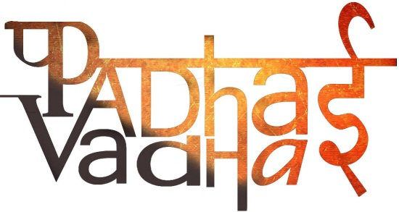

Ch 3

The Delhi Sultans

Question 1. Who established capital at Delhi at first?

A1. Tomara Rajputs

Question 2. Who was the famous king of Tomar Dynasty?

A2. Angpal

Question 3. Who was the king of Chauhan Dynasty?

A3. Prithviraj Chauhan

Question 4. When delhi became commercial hub, who were the rulers?

A4. Tomar Rajputs and later Chauhan Dynasty.

Question 5. Coinage was called by what name?

A5. Dehliwal

Question 6. Were there any more cities developed during Delhi Sultanate period?

A6. Yes.

Question 7. Who established rule in Delhi after defeating Chauhan rulers?

A7. Qutb-ud-din-aibak marked the beginning of Mamaluk Rule.

Question 8. Who founded Turkish Dominion?

A8. Qutb-ud-din-aibak

Question 9. What is meant by ‘Tawarikh’?

A9. ‘Tawarikh’ means ‘histories’.

Question 10. Who constructed Qutab Minar in Delhi?

A10. Qutb-ud-din-aibak started it and Iltumish and Firuz Shah completed it.

Question 11. Under Delhi Sultans, which was the language of administration?

A11. Persian Language.

Question 12. Who was ‘Lakh Baksh’?

A12. Qutb-ud-din-aibak

Question 13. Which phrase defined the kings and his justice’s relationship?

A13. Circle of Justice

Question 14. Name the country from which Ibn Batuta travelled to India?

A14. Morroco

Question 15. What is the Persian word for slave?

A15. Bandagon

Question 16. What type of taxes were collected by Delhi Sultans?

A16. 1. On cultivation called kharaj

2. On cattle

3. On houses

Question 17. Who died after falling from house in a polo match?

A17. Qutb-ud-din-aibak

Question 18. Under whose regime Delhi was attacked twice in 1299-1300 and 1302-03?

A18. Alauddin Khalji

Question 19. Which garrison town was built by Alauddin Khalji?

A19. Siri

Question 20. Under whose reign Begumpuri Mosque was built?

A20. Muhammad Tughluq.

Question 21. Which Mongol ruler attacked Delhi during sultanate regime?

A21. Genghis Khan

Question 22. Mention some duties of mosque.

A22. 1. To lead military campaigns

2. maintain law and order

3. collection of revenue

4. to pay to the soldiers

Question 23. Which was the reason due to which Ala-ud-din built Siri Fort?

A23. To defend city from Mongol invasions