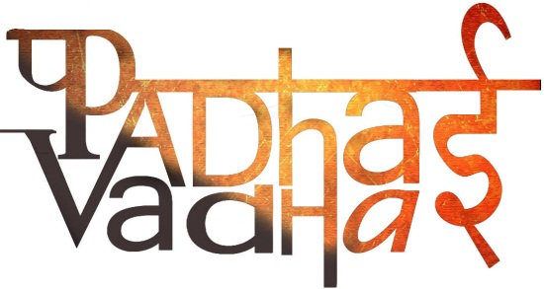

**Chapter 5**

**What Books and Burials Tell Us**

Question 1. How many Vedas are present? Name them.  
Ans. Four. Rigveda, Samveda, Yajurveda and Atharvaveda.

Question 2. Name the oldest Veda.

Ans. Rigveda, 3500 years old.

Question 3. How many hymns are there in Rigveda?  
Ans. More than a thousand times, called sukta.

Question 4. How many Gods have been mentioned in the hymns?  
Ans. Three.

Question 5. Which Gods have been mentioned?  
Ans. Agni – the god of fire, Indra – a warrior god and Soma – a plant from which a special drink is prepared.

Question 6. Rigveda contains the prayers mostly for ______________.

Ans. Cattle, children and horses.

Question 7. How was the wealth utilized?  
Ans. Some was kept by leaders; some was given to priest and the rest was distributed among people.

Question 8. What were the offerings made by the people as a part of yajnas?  
Ans. Ghee, grain and in some cases, animals.

Question 9. Name two groups who are described in terms of their work?

Ans. 1. Priests called Brahmins.

2. who performed rituals called rajas.

Question 10. Name two words which were used to describe the community.

Ans. Jana and vish.

Question 11. People who composed the hymns called themselves ________.

Ans. Aryans.

Question 12. What did Aryans call their opposition?  
Ans. Dasas or Dasyus.

Question 13. What does Dasa mean?

Ans. Slave.

Question 14. Who were slaves?  
Ans. Slaves were the men and women captured in the war. Rulers could make them do anything that they wanted.

Question 15. What was Megaliths?  
Ans. Stone boulders.

Question 16. Which color of distinctive pots were kept during burials?

Ans. Black and Red ware.

Question 17. What were used other than pots?  
Ans. Weapons of iron, skeleton of horses, horse equipment or ornaments of gold and silver.

Question 18. Things that were kept with skeleton belong to the _________.

Ans. Dead person.

Question 19. Were some burial spots meant for certain families?  
Ans. Sometimes megaliths contain more than one skeleton. These indicate that people, perhaps belonging to the same family.

Question 20. Where were, people buried in Inamgaon?  
Ans. They were generally buried in the ground with the head towards the north. Sometimes they were buried within their homes.

Question 21. What was filled in the vessels that were placed with the dead?  
Ans. Food and water.