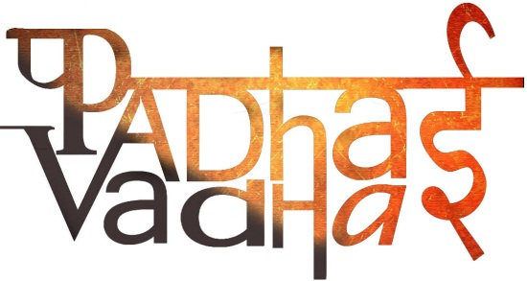

**Chapter 10**

**Traders, Kings and Pilgrims**

Question1. What was South India famous for?  
Ans. Gold, spices, and precious stones.

Question2. Where did the South Indians trade most?

Ans. Roman.

Question3. If traders wanted to reach western coast, which route would they opt?  
Ans. South-west monsoon.

Question4. Which is the most fertile river amongst the river valleys?  
Ans. Kaveri.

Question5. What does “mwendar” mean?  
Ans. Three chiefs.

Question6. What did chiefs receive?  
Ans. Instead of tax, they demanded gifts.

Question7. To whom did chiefs usually distribute their wealth?  
Ans. Supporters, family, soldiers, and poets.

Question8. Who was the most important ruler of Satvahanas?  
Ans. Gautamiputra Shri Satakarni.

Question9. How many years later, they won the rule over western India?  
Ans. 200 years.

Question10. Satvahana rulers were known as _____.

Ans. Lords of dakshinapatha.

Question11. Where was the technique of making silk, first developed?

Ans. China around 7000 years ago.

Question12. Why is the route called silk route?  
Ans. Because that route was usually followed by the traders who carried silk with them.

Question13. Why was Silk expensive?  
Ans. Because silk came all the way from China.

Question14. What was so attractive about the silk route that most of the rulers wanted the control?  
Ans. It was a good way to benefit from taxes and gifts.

Question15. Who controlled the silk route best?  
Ans. Kushanas.

Question16. Major centres of power of the Kushanas?  
Ans. Peshawar and Mathura.

Question17. Which coins were used by the traders along the silk route?  
Ans. Gold coin.

Question18. Who was the most famous ruler of the Kushanas?  
Ans. Kanishka.

Question19. Who composed the biograohy of the Buddha, Buddhacharita?  
Ans. Ashvaghosha.

Question20. What was the new form of Buddhism developed?  
Ans. Mahayana Buddhism.

Question21. What were the two major changes in new Buddhism?  
Ans. 1. Statues of the Buddha were made.

2. Belief in Bodhisattvas.

Question22. What was the old form of Buddhism?  
Ans. Theravada Buddhism.

Question23. Who are pilgrim?  
Ans. Men and women who undertake journeys to holy places.

Question24. How many manuscripts did Xuan Zing carry with him on the way back to china?  
Ans. 50 manuscripts loaded on the backs of 20 horses.

Question25. What does bhakti mean?  
Ans. Devotion to chosen deity.

Question26. What would happen if devotee worships with a pure heart?

Ans. Then the deity will appear in front of him in whatever form he wants.