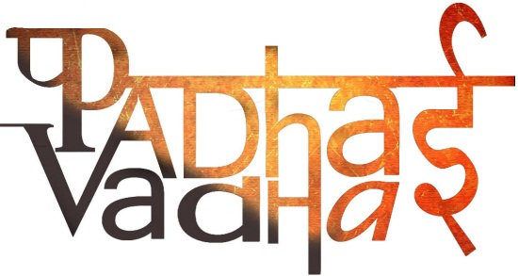

**CHAPTER-5 “WATER”**

1. **What is the name of the process by which water continually changes its form and circulates between oceans, atmosphere and land?**

Water cycle.

1. **What is precipitation?**

Precipitation means anything falling from the sky which include rain, snow, hail etc. on the surface of the earth when they become too heavy and unable to float in the air.

1. **What is a terrarium?**

A terrarium is a closed environment that has a collection of small plants growing in a transparent, sealed container and can actually be used to illustrate how an ecosystem works.

1. **What are the major sources of fresh water?**

Rivers.

Ponds.

Springs.

Glaciers.

1. **What are the sources of salty water?**

Ocean bodies.

Seas.

1. **Why the water of the ocean is saline?**

Because it contains large amount of dissolved salts. Most of the salt is sodium chloride or the common table salt that we eat.

1. **What is Salinity?**

It is the amount of salt in grams present in 1000grams of water.

1. **What is the average salinity of the ocean?**

35 parts per 1000.

1. **How much of the earth surface is covered by water?**

Three-fourth of the earth surface.

1. **What is the percentage of saline water among all the water on earth?**

97.3%.

1. **What is the percentage of fresh water among all the water on earth?**

2.7%.

1. **When is world water day celebrated?**

March 22.

1. **What are the different types of movements in oceans?**

Waves.

Tides.

Currents

1. **What is the name of movement of ocean in which water on the surface of the ocean rises and falls alternately?**

Waves.

1. **What are the factors affecting the height of the waves?**

Following are the factors-

A. Speed of wind.

B. duration of wind.

C. Distance the wind blows over water.

1. **How waves are formed?**

Waves are formed when gentle winds scrape across the ocean surface.

1. **Relationship between winds and waves?**

They have a direct relationship. The stronger the wind blows, the bigger the wave become.

1. **What does tsunami means?**

It is a Japanese word that means “Harbour Waves”. It means a long, high sea wave caused by an earthquake or other disturbance

1. **What is the height of largest Tsunami ever measured?**

150M high.

1. **What was the aftermath of 2004 Tsunami that affected India?**

It caused wide spread damaged in the coastal areas of India.

Indira point in the Andaman and Nicobar got submerged.

1. **What are Tides?**

The rhythmic rise and fall of ocean water twice in a day is called a tide.

1. **How tides are caused?**

Tides are caused by strong gravitational pull exerted by the sun and the moon.

1. **Which factors affect the movement of ocean water?**

Temperature.

Earthquake or volcanic eruption.

Gravitational pull of the sun and the moon.

Underwater landslides.

1. **When are the tides highest?**

During the full moon and new moon.

1. **What does the highest tides are called?**

Spring Tides.

1. **When is the tides lowest?**

When the moon is in its 1st and last quarter.

1. **What does Lowest tides are called?**

Neap Tides.

1. **Which tides help in navigation and fishing?**

High tides,

1. **What are Ocean Currents?**

Ocean Currents are Streams of water flowing constantly on the ocean surface in definite directions.

1. **What are the types of Ocean Currents?**

A. Warm. B. Cold.

1. **Which ocean currents originate near the equator and move towards the poles?**

Warm ocean currents.

1. **Which ocean currents carries water from higher latitudes(polar) to lower latitudes(tropical)?**

Cold water ways.

1. **Which area provides the best fishing grounds?**

The areas where the warm and cold currents meet.

Time- 1 hour. Somya Sharma

8130450511

sssharmasomya@gmail.com