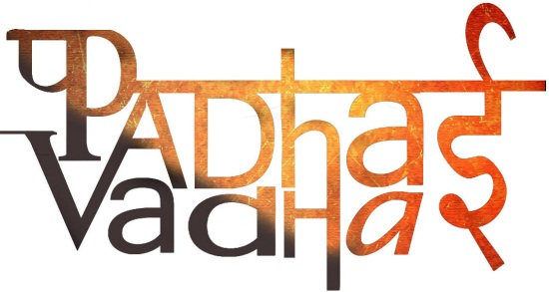

**CHAPTER-3**

**HOW THE STATE GOVERNMENT WORKS**

Qs 1.(Imp) Who is an MLA?

Ans. MLA (Member of the Legislative Assembly) are elected by the people. Then they become the members of the legislative assembly and also form the government.

Qs 2. MLAs are elected by the ______.

Ans. People.

Qs 3. From each ________, the people elect one representative who then become an MLA.

Ans. Constituency

Qs 4. People stand for elections in the name of different _____.

Ans. Political Parties.

Qs 5.(Imp) When does a party is called a majority?

Ans. A political party whose MLAs have won more than half the number of constituencies in a state can be said to be a majority.

Qs 6.(Imp) The political party that has the majority is called the _______ and all the other members are called _________.

Ans. Ruling party, opposition.

Qs 7. Who is the head of the State?

Ans. Governor.

Qs 8. A Governor is appointed by the _______.

Ans. State government.

Qs 9. What is the role of a Governor?

Ans. He/she ensure that the State Government works within the rules and regulations of the Constitution.

Qs 10. What is a coalition?

Ans. At times, the ruling party may not be a single party but a group of parties working together. This is called a coalition.

Qs 11.(Imp) How do people who are MLAs become ministers or chief minister?

Ans. When a party wins an election, the MLAs belonging to the ruling party elects their leader who then become the chief minister. The chief minister then selects other people as ministers. After the elections, it is the Governor of the State who appoints the chief minister and other ministers.

Qs 12. Who appoints the chief minister of a State?

Ans. Governor of the State.

Qs 13. A ________ is a place where all the MLAs whether from the ruling party or from the opposition meet to discuss various things.

Ans. Legislative Assembly.

Qs 14. Some MLAs have dual responsibilities. What are they?

Ans. One as an MLA and the other as a minister.

Qs 15. The decisions taken by the Chief minister and other ministers have to be approved by ____________.

Ans. The members of the Legislative assembly.

Qs 16. All the MLAs who gather together in the legislative assembly are called the ________.

Ans. Legislature.

Qs 17. Name some government departments.

Ans. 1. Public Works Department

2. The Agriculture Department

3. The Health Department

4. The Education Department.

Qs 18. Whatever work is done by the departments has to be approved by the __________.

Ans. Members of legislative assembly.

Qs 19. In a democracy, people organize ________ to raise their opinions and protest against the government.

Ans. Meetings.

Qs 20. How is the government of the State forms?

Ans. In a democracy, it is the people who elect their representatives as Members of the Legislative Assembly (MLAs) and thus, it is the people who have the main authority. The ruling party then form the government.

Qs 21. What is the rule of the ministers?

Ans. The ministers in charge of the various departments of the government.

Qs 22.(Imp) What is a press conference?

Ans. A gathering of journalists from the media who are invited to hear about and ask questions on a particular issue and are then expected to report on this to the larger public is a press conference.