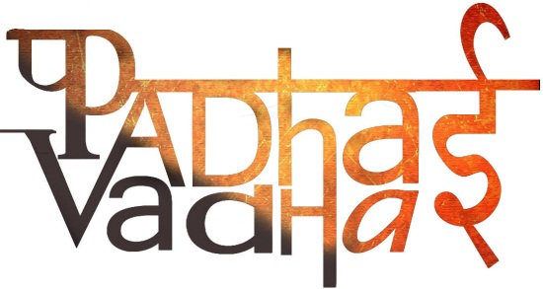

**Chapter-7**

**Urban Administration**

Question-1: Who is responsible for replacing the street lights?

Ans. Municipal Corporation of the city

Question-2: What other activities are performed by Municipal Corporation?

Ans. Few activities that are performed by Municipal Corporation are:

1. Proper Water Supply
2. To keep markets and streets clean
3. To run schools, hospitals and dispensaries.

Question-3: What is the other name of Municipal Corporation?

Ans. Municipal Council

Question-4: Who decides where the park should go?

Ans. Ward Councilors

Question-5: Which two authorities are not elected but appointed?

Ans. Commissioners and administrative staffs

Question-6: Which authority are elected and not appointed?

Ans. Councilors

Question-7: What is Tax?

Ans. Sum of money that people pay to the government for the services that government provides.

Question-8: How much property tax is paid by public?

Ans. 25%-30%

Question-9: Why children stopped playing in the streets?

Ans. Children stopped playing in the streets because they were afraid of falling sick.

Question-10: In case of dirty streets and poor sanitation conditions in your surroundings, to whom you should complain?

Ans. Commissioner

Question-11: What idea can help in reducing garbage on roads?

Ans. To keep dustbins at home