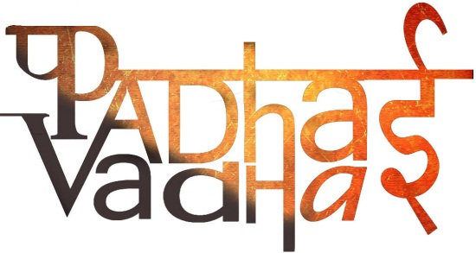

**Chapter-16**

**Garbage in, Garbage out**

Question -1: What do you mean by landfills?

Ans. Landfill is an area where the garbage collected from a city or town is dumped. The area is later converted into a park.

Question -2: What do you mean by Composting?

Ans. Converting plant and animal waste including that from kitchen, into manure, is called composting.

Question -3: What do you mean by Vermicomposting?

Ans. The method of making compost from kitchen garbage using red worms is called vermicomposting.

Question -4: How manures are formed?

Ans. There are some things present in garbage that rots,they form manure which is useful for plant’s growth.

Question -5: How many types of bins there are?

Ans. There are two types of bin green colored bins are for recyclable materials like food items, papers etc, and blue colored bin is for non recyclable materials like plastics, metals and glass.

Question -6:Can plastics be converted into less harmful substances by the process of composting?

Ans. Plastics cannot be converted into less harmful substances by the process of composting.

Question -7: Is it possible to recycle paper and plastic?

Ans. Paper can be recycled but in the case of plastic, some kind of plastics can be recycled.

Question -8: List some ways to minimize overuse of plastic.

Ans. These are the some ways by which we can minimize the use of plastic:

* Re-use the jars and containers.
* Use paper, jute or cloth bags instead of plastic bags.
* Don’t put garbage in plastic bag and throw it away.
* Recycle plastic waste as much as possible.

Question -9: How red worms are useful?

Ans. Red worms help in saving money which is spent on buying expensive chemical fertilizer and manures from the market.

Question -10: Why is use of composting better than that of chemical fertilizers?

Ans. These are the following reasons by which we can say that using composting is better than using chemical fertilizers:

Chemical fertilizers are expensive as compared to compost.

Chemical fertilizers are harmful for soil whereas compost is good for soil.

Question -11: Who collect the garbage from the bins to the landfill?

Ans. Safai karamcharis

Question -12: What type of waste materials rot completely when buried in the soil?

Ans. kitchen ,plants and animals waste.

Question -13: Where Red worms grow?

Ans. In Moist surroundings.

Question -14:  Describe steps involved in recycling a paper.

Ans. Steps involved in recycling paper

* Tear paper into small pieces.
* Soak these pieces in water for a day.
* Make a thick paste and spread it on a net or sieve.
* Let water drain off completely.
* Use an old cloth or newspaper to remove the extra water from the paste and dry it.
* Use this paste to get beautiful patterns