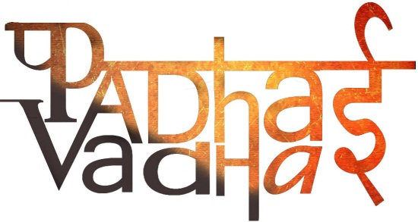

**Chapter 6**

**Changes Around Us**

Question 1. Are all changes reversible?

Ans. Some changes are reversible.

Question 2. What happens when iron is heated?  
Ans. It expands.

Question 3. What happens when cold water is poured on heated iron?  
Ans. It shrinks.

Question 4. What happens when ice is heated?  
Ans. It gets melted into water.

Question 5. Can following cases be reversed:

1. Balloon inflated by a person – Yes
2. Aeroplane cut out of paper – No
3. A ball of dough and a rolled out roti – Yes