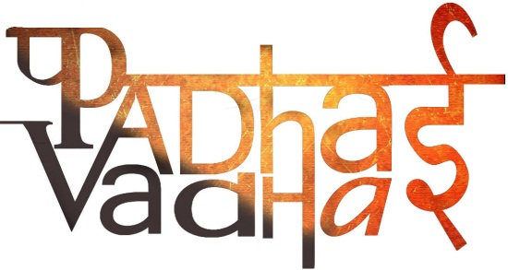

**Chapter-13**

**Fun with Magnets**

QUESTION 1 What is magnetite?

A Magnetite is a natural magnet It contains iron.

QUESTION 2 What are magnets?

A Magnets are substances having property of attracting iron or iron like materials. \

QUESTION 3 Name some different shapes of magnets.

A 1. Bar magnet

2. horse shoe magnet

3. cylindrical magnet

4. ball ended magnet

5. needle magnet

QUESTION 4 What are magnetic and non magnetic materials?

A The materials which get attracted to magnets are known as magnetic materials example: iron nickel cobalt. The materials which do not get attracted to magnets are known as non magnetic materials example plastic rubber wood.

QUESTION 5 How many poles exist in a magnet?

A Every magnet has two poles north pole and a south pole. North Pole is denoted by N and South Pole is denoted by S

QUESTION 6 What is the property of magnet which is used by travelers to find directions?

A When we freely suspend a magnet it always points in N-S direction This property is used by travelers to find directions

QUESTION 7 What is a magnetic compass?

A A device which was developed based on the property of magnets of finding directions is known as magnetic compass.

QUESTION 8 what happens when we bring like poles of a magnets close to one another?

A Like poles repel.

QUESTION 9 what happens when we bring unlike poles of a magnets close to one another?

A Unlike poles attract.

QUESTION 10 How do magnets lose their properties?

A Magnets loose their property if they are heated, hammered or dropped from some height.

QUESTION 11 How can we keep our magnets safe?

A To keep magnets safe Bar magnets should be kept in pairs with unlike poles on same side They must be separated by a piece of wood while two pieces of soft iron should be placed across their ends For horse shoe magnet one should keep a piece of iron across the poles.

QUESTION 12 what precautions should be taken in handling magnets?

A We should keep magnets away from cassettes, mobiles, TV music systems compact disks and computers.