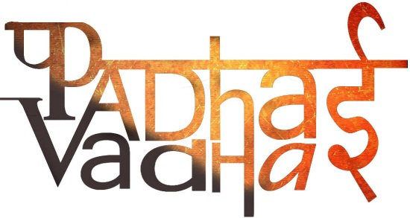

**Chapter-1**

**Crop Production and Management**

Q1: The process of loosening and turning the soil is called ______

(a) broadcasting

(b) irrigation

(c) tilling

(d) leveling

Q2: The organic substance obtained from dead plants an animal wastes is _________

(a) Manure

(b) Fertilizer

(c) Irrigation

(d) Agriculture

Q3: Which of the following is not a rabi crop?

(a) Rice

(b) Mustard

(c) Wheat

(d) Barley

Q4: Which of the following is not a kharif crop?

(a) Paddy

(b) Soyabean

(c) Groundnut

(d) Pea

Q5: In which of the following method of irrigation rotating nozzles are used?

(a) Moat

(b) Drip System

(c) Chain pump

(d) Sprinkler System

Q6: Which of the following nutrient replenish the soil after growing leguminous plants?

(a) Nitrogen

(b) Oxygen

(c) Phosphorus

(d) Potassium

Q7: The management of rearing animals for food and other products is known as _______

(a) Granaries

(b) Animal husbandry

(c) Poultry

(d) Warehouse

Q8: The process of separating the grain from the chaff is?

(a) Threshing

(b) Weeding

(c) Sowing

(d) Tilling

Q9: Weeds can be removed by using?

(a) Pesticides

(b) Fungicides

(c) Weedicides

(d) Bactericides

Q10: Which leaves are used by farmers to protect their crops from weeds and insects?

(a) Peepal leaves

(b) Basil leaves

(c) Neem leaves

(d) Mango leaves

Answers:

1: (c) tilling

2: (b) Manure

3: (a) Rice

4: (d) Pea

5: (d) Sprinkler System

6: (a) Nitrogen

7: (b) Animal husbandry

8: (a) Threshing

9: (c) Weedicides

10: (c) Neem leaves

Very Short Question/Answers

Q1:We get our food from?

Ans: Plants and animals

Q2: The same kind of plants grown and cultivated at one place on large scale is called_________.

Ans: Crop

Q3: Define crop.

Ans: Plants of same kind that are grown and cultivated at one place on large scale is called a crop

Q4: Name some crop plants.

Ans: Some of the crop plants are wheat, rice, maize, sugarcane, cotton, vegetables, fruits etc.

Q5: Classify crops on the basis of seasons in which they are grown.

Ans: On the basis of season in which crops are grown they are classified into: Rabi crops and Kharif crops

Q6: Define kharif crops with examples.

The crops which are sown in rainy season that is generally from june to September in India are called kharif crops. e.g: cotton, maize, paddy, groundnut etc.

Q7: Define rabi crops with examples.

Ans: The crops which are sown in winter season that is generally from October to march in India are called rabi crops. e.g: wheat, mustard, gram, pea etc.

Q8: Ploughing is done by ___________________.

Ans: Plough

Q9: Hoe is a simple tool which is used for removing ________________.

Ans: Weeds

Q10: Continuous growing of crops makes the soil poorer in certain______________________.

Ans: Nutrients

Q11: Name the bacteria which fix atmospheric nitrogen.

Ans: Rhizobium bacteria

Q12: Which one is better organic manure or fertilisers?

Ans: Organic manure is better than firrigation

Q13: Name different sources of irrigation.

Ans: Source of irrigation: ponds, lakes, rivers, dams, canals, wells, and tubewells.

Q14: Give few examples of weedicides.

Ans: 2,4-D

Q15: Weedicides sprayer should cover their _________________ and _______________ with a piece of cloth during spraying of these chemicals.

Ans. nose and mouth