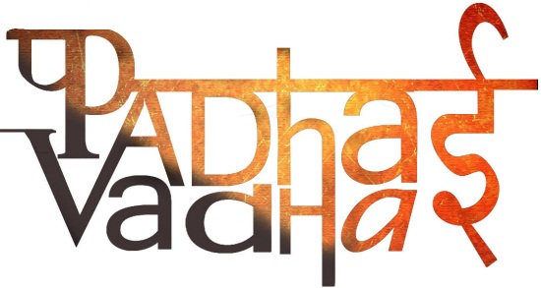

Understanding Marginalisation

Q.1: Explain at least three different reasons why groups may be marginalised ?

Ans: There are numerous reasons of marginalisation. The three reasons because of which a group may be marginalised are:

a. Speaking a different language,

b. Following different customs or belong to a different religious group other than the majority,

c. Being considered of low status and poor by the majority etc.

Q.2: Why do we need safeguards for minorities ?

Ans: Safeguards for minorities are needed mainly to protect such communities against the possibility of being culturally dominated by the majority as well as to guard them against any discrimination and disadvantage that they may face. These safeguards are in order to ensure that the people of the minority communities can maintain their cultural distinctiveness while having access to rights, development and other opportunities.

Q.3: Name the states of India where Tribal people have been living.

Ans: Tribal people have been living mostly in the sates like - Chhattisgarh, Jharkhand, Madhya Pradesh, Orissa, Gujarat, Maharashtra, Rajasthan, Andhra Pradesh, and West Bengal and in the North Eastern states of Arunachal Pradesh, Asam, Manipur, Meghalaya, Mizoram and Nagaland and Tripura.

Q.4: What is Ghettoisation ?

Ans: Ghetto is a locality which is populated largely by members of a particular community. Ghettoisation is the process that leads to such a situation. This may happen due to many social, cultural and economic reasons including a sense of fear and hostility. Such a ghettoized community is often seen as a socially isolated community from the rest of the society.

Q.5: In your opinion, why is it important that Adivasis should have a say in how the forest and forest lands are used ?

Ans: Adivasis should have a say in how the forest and forest lands are used because they are the people who have been associated with forest for centuries and so, are directly affected by the decisions taken by our government regarding forest matters.

Q.6: Who are Adivasis ? Why are they called exotic or backward ?

Ans: ‘Adivasi’ literally means an ‘Original Inhabitant’. Th4y are the communities who lived, and often like to live in close association with forests.   Often Adivasis are wrongly called exotic or backward because some people think that Adivasis are immune to modern advancements, economic developments etc. and also resist to change or new ideas.