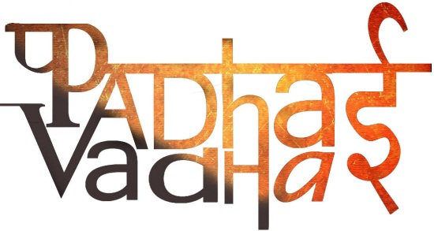

**Chapter 7**

**Getting To Know Plants**

Question 1. Are all the plants same?

Ans. No.

Question 2. What are weeds?

Ans. The unwanted plant that grows in the gardens or crop fields.

Question 3. What are the major categories of plants?  
Ans. Herbs, shrubs or trees.

Question 4. How herbs look?  
Ans. Plants with green and tender stems, and they are usually short.

Question 5. Mention some properties of shrubs.

Ans. Plants that have their stems branching out in the base. The stem is hard but not very thick.

Question 6. How trees distinguish from herbs and shrubs?  
Ans. Plants that are very tall and have thick and brown stems.

Question 7. Mention a property of the stem.

Ans. Stem conducts water.

Question 8. How do stems conduct water?

Ans. Through narrow tubes inside the stem.

Que9. How are leaves attached to the stem?  
Ans. Leaves are attached through the part called petiole.

Question 10. What is the broad, green part of the leaf is called?  
Ans. Lamina.

Question 11. What are lines on the leaf are called?  
Ans. Veins.

Question 12. What is the thick vein in the middle is called?  
Ans. Midrib.

Question 13. The design made by veins in a leaf is called?  
Ans. Leaf venation.

Question 14. If the design is net like on both sides of midrib, the venation is called?  
Ans. Reticulate.

Question 15. What is transpiration?  
Ans. When water comes out of leaves in the form of vapour.

Question 16. Explain the process of photosynthesis.

Ans. Leaves prepare their food in present of sunlight, with the help of water and carbon dioxide.

Question 17. What is the result of photosynthesis?  
Ans. Plants exhale oxygen.

Question 18. How do the leaves and stem get the water?  
Ans. Through the roots.

Question 19. What does anchor mean?  
Ans. Anchor means roots help in holding the plant firmly.

Question 20. The main root is called ____ .  
Ans. Tap root.

Question 21. Smaller roots are called ______ .

Ans. Lateral roots.

Question 22. Rest of the roots, are called _____.

Ans. Fibrous roots.

Question 23. What is the functioning of the roots?

Ans. Roots absorb water and minerals from the soil.

Question 24. We eat some of the roots, name them.

Ans. Carrot, radish, sweet potato and turnip.

Question 25. What are the prominent parts of the open flower called?  
Ans. Petals.

Question 26. What is that part which holds the petals of the flower together and is made of leaf-like structures?  
Ans. Sepals.

Question 27. What are the 2 main parts of the plant?  
Ans. Stamen and pistil.

Question 28. Name the parts of the stamen.  
Ans. Anther and filament.

Question 29. Name the parts of the pistil.

Ans. Style, stigma and ovary.

Question 30. What is the innermost part of the flower is called?  
Ans. Pistil.

Question 31. How does ovary look like?  
Ans. It is the lowermost and swollen part of the pistil.

Question 32. What are the bead like structure in ovary, called?

Ans. Ovules.