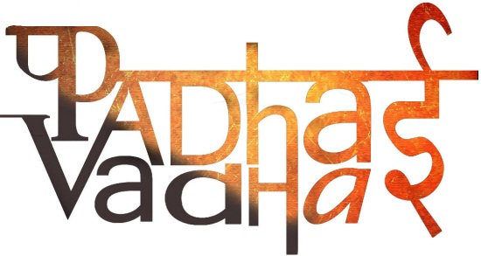

**Chapter 11**

**New Empires and Kingdoms**

Question1. What Prashasti means?

Ans. Inscription of a special kind.

Question2. What glorious words were used for Samudragupta’sprashasti?

Ans. As a warrior, as a king who won victories in battles, who was learned and the best of poets.

Question3. Who was the first ruler of Gupta dynasty to adopt the title of maharaj-adhiraja?  
Ans. Chandrgupta.

Question4. What is Genealogies?

Ans. List of ancestors.

Question5. How do we know about Samudragupta?

Ans. Through inscriptions and coins.

Question6. Samudragupta’s court included which two famous persons of that time?  
Ans. Kalidasa, the poet and Aryabhata, the astronomer.

Question7. Who wrote Harshacharita?  
Ans. Banabhatta, the court poet of Harshavardhana.

Question8. Harshavardhana became king of _______.

Ans. Thanesar.

Question9. In which areas was Harshavardhana successful?  
Ans. East, he captured Magadha and Bengal.

Question10. What happened when he tried to cross the Narmada?  
Ans. He was stopped by Pulakshin II.

Question11. Where was the kingdom of Pallavas spread?  
Ans. Kanchipuram to the Kaveri delta.

Question12. What about the kingdom of Chalukyas?  
Ans. They were centered around the Raichur Doab, between Krishna and Tungabhadra.

Question13. What was the capital of Chalukyas?  
Ans. Aihole.

Question14. Aihole was developed as a _________.

Ans. Religious centre.

Question15. Who was the best-known Chalukya ruler?  
Ans. Pulakeshin II.

Question16. Who wrote the prashasti of Pulakeshin II?  
Ans. Ravikriti, his court poet.

Question17. To whom did Chalukyas and Pallavas give away their kingdoms?  
Ans. Rashtrakuta and Chola dynasties.

Question18. How were the kingdoms administered?  
Ans. Some important administrative posts were now hereditary.

One person held many offices.

Important men had a say in local administration.

Question19. Who were samantas?  
Ans. Military leaders who provided the king with troops when needed.

Question20. Were troops paid regular salaries?  
Ans. No, instead some of them received grants of land.

Question21. Assembly of Brahmin land owners is known as ________.

Ans. Sabha.

Question22. What were the major areas look after by this assembly?  
Ans. Irrigation, agricultural operations, making roads, local temples etc.

Question23. What was the name of the assemblies where the land owners were not brahmins?  
Ans. The ur.

Question24. The ________ was an organization of merchants.

Ans. Nagaram.

Question25. What was the name of Kalidasa’s famous play?  
Ans. AbhijnanaShakuntalam.