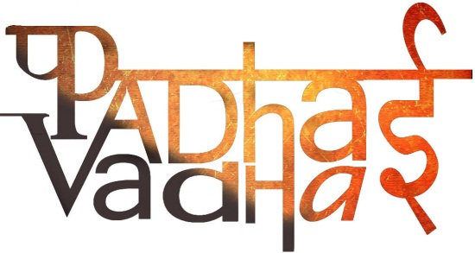

**Chapter-4**

**Metals and Non-Metals**

Q1: Whose reactivity is highest among the following metals?

(a) Copper

(b) Potassium

(c) Iron

(d) Zinc

Q2: The metal stored in kerosene due to its high reactivity with air and water is ...

(a) Magnesium

(b) Zinc

(c) Sodium

(d) Calcium

Q3: Materials having the properties of both metals and non metals are called _____.

(a) Metalloids

(b) Noble metals

(c) Alloys

(d) Mixtures

Q4: Metals are generally__________

(a) soft and ductile

(b) hard and brittle

(c) non-reactive and malleable.

(d) hard, ductile and malleable

Q5: Which non-metal is a good conductor of electricity?

(a) Phosphorus

(b) Sulphur

(c) Graphite

(d) Coal

Q6: Non metals are generally _____________.

(a) hard and ductile

(b) soft and brittle

(c) hard and brittle

(d) soft and ductile

Q7: A metal which is found in liquid state at room temperature is ...

(a) Sodium

(b) Mercury

(c) Potassium

(d) Aluminium

Q8: Iron can displace _______ from its salt solution.

(a) Zinc

(b) Sodium

(c) Potassium

(d) Copper

Answers:

1: (b) Potassium

2: (c) Sodium

3: (a) Metalloids

4: (d) hard, ductile and malleable

5: (c) Graphite

6: (b) soft and brittle

7: (b) Mercury

8: (d) Copper

Q1: All metals are good conductor of __________ and ___________________.

Ans: Heat and electricity.

Q2: When we beat the aluminium wire its shape changed which property of metals is shown by this?

Ans: Property of malleability of metals

Q3: When we beat a coal it breaks down into small pieces, why ?

Ans: Because coal is non-metal and it is not malleable

Q4: Name some metals and non-metals.

Ans: Examples of metals: iron, magnesium, copper, calcium etc.

Examples of non-metals: sulphur, carbon, phosphorus, oxygen etc

Q5: Segregate good conductor of electricity and which one is bad conductor?

An iron pan, an aluminium utensil, wood, plastic handle of a pan, nail

Ans: Good conductor: An iron pan, an aluminium utensil and nail

Bad Conductor: wood and plastic handle of a pan

Q6: Why bells in temples are made up of metal?

Ans: because metals are sonorous.

Q7: metallic box or a wooden box -Which of the two will produce ringing sound ?

Ans: a metallic box

Q8: Sulphur is ductile yes or no?

Ans: No.

Q9: Which one of the two is malleable

1)oxygen or 2)calcium?

Ans: Calcium

Q10: which metal is found in liquid state at room temperature?

Ans: Mercury.

Q11: which metal is soft and can be cut easily with a knife.

Ans: sodium and potassium.

Q12: Which is malleable, phosphorus or iron?

Ans: iron.

Q13: Metals like gold, silver, platinum etc. retain their lustre because they do not react with air, water or _________

Ans: Acids

Q14: Metals react with oxygen to form__________________

Ans: Metallic oxides.

Q15: Tick the right answer.

Metal reacts with water to form

Oxide

Chloride

Hydroxide

None of these

Ans: Hydroxides.

Q16: Complete the reaction of magnesium and oxygen

2 Mg + O2 ---> __________________

MgO+ H2O ---> ____________________

Ans: 2 Mg + O2? 2 MgO

MgO+ H2O-> Mg(OH) 2

Q17: Complete the equation:

Zinc reacts with dilute hydrochloric acid to form zinc chloride and hydrogen.

Zn + 2 HCl ---> ______ + H2

Ans: Zn + 2 HCl ----> ZnCl2+ H2

Q18: Complete the following displacement reaction:

Copper sulphate + ______ -----> Zinc sulphate + ______

Ans: Copper sulphate + zinc -----> Zinc sulphate + copper

Q19: true of false?

A less reactive metal can replace a more reactive metal, but a more reactive metal cannot replace a less reactive metal.

Ans: False

Q20: which non-metal is used in fertilizer to enhance the growth of plants.

Ans: Nitrogen.

Q21: which is the most essential non metal for breathing?

Ans: Oxygen.

Q22: Complete the following reaction:

Rusting of iron is an oxidation reaction, which is takes place as.

3Fe + O2 + _______ 3 FeO + H2

Ans: 3Fe + O2 + H2O 3 FeO + H2

Q23: Non-metals generally do not react with acids but metals react with acids and produce hydrogen gas that burns with a _____________ sound .

Ans: Pop

Q24: Which one of these is more reactive iron or copper?

Ans: Iron

Q25: Which one of these is less reactive sodium or gold?

Ans: sodium

Q26: most reactive metal is sodium, yes or no?

Ans: yes

Q27: can we prevent Rusting of iron by coating its surface with new iron metal?

Ans: no