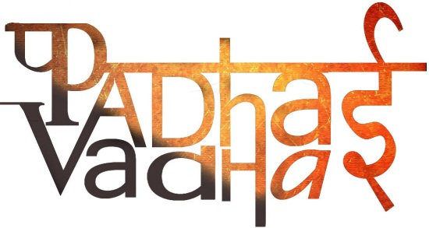

**Ch-4(geography)  
 MAPS**   
  
1.What is a Map?  
 a1. A map is a representation or a drawing of the earth’s surface or a part of it drawn on a flat surface according to a scale.  
  
2. Collection of maps is known as?  
a2. Atlas  
  
3. Maps showing natural features of the earth such as

Mountains, plateaus, plains, rivers, oceans etc. are known as?  
a3. Physical or Relief maps  
  
4.Define political maps.  
a4. Maps showing cities, towns and villages, and different

countries and states of the world with their boundaries

are called **political maps**.  
  
5. Maps focusing on specific information; such as road maps, rainfall maps, etc are known as?  
a5. Thematic maps  
  
6. What are the components of maps?  
a6. distance, direction and symbol.  
  
7. What do you mean by scale?  
a7.Scaleis the ratio between the actual distance on the ground and the distance shown on the map.  
  
8. When large areas like continents or countries are to be shown on a paper, then we use a small scale known as?

A8. Small scale map  
  
9. What is a Large-Scale map?   
a9.When a small area like your village or town is to be shown on paper, then we use a large scale that is 5 cm. on the map shows 500 meters only on the ground. It is called a Large Scale map.  
  
10. What does an arrow with ‘N’ at the upper right hand corner of map denotes?  
a10. This arrow shows the northern direction. It is called the north line. When we know the north, we can find out other directions.  
  
11. Name the cardinal points.   
a11. There are four major directions, North, South, East and West. They are called cardinal points.  
  
12. Name four intermediate directions.  
a12. North-east (NE)

South-east(SE)

South-west (SW)

North-west (NW).  
  
13. What is compass?  
a13. It is an instrument used to find out main directions. Its magnetic needle always points towards north-south direction.  
  
14. What is the use of symbols?  
a14. With the use of these symbols, maps can be drawn easily and are simple to read.  
  
15. There is an international agreement regarding the use of symbols. These symbols are known as?  
a15.Conventional symbols  
  
16. What is a sketch?  
a16. A sketch is a drawing mainly based on memory and spot observation and not to scale. Such a rough drawing is drawn without scale, and is called a **sketch map.**  
17. A drawing of a small area on a large scale is called?  
a17. Plan