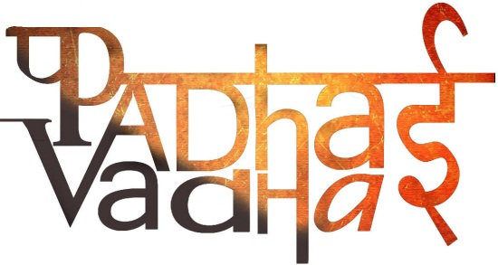

**Chapter 5**

Question 1. What is the minimum age of a person who has the right to vote?

Ans. 18 years

Question 2. What is the other name of panchayat president?

Ans. Sarpanch

Question 3. What are the members of the panchayat called?  
Ans. Panchs

Question 4. The Gram Panchayat is elected for how many years?  
Ans. 5

Question 5. Who appoints the secretory of Gram Sabha?

Ans. Government

Question 6. What is the problem the villagers are facing?  
Ans. Problems of water

Question 7. What is the process of conserving the water for refilling it in villages called?

Ans. Watershed Development

Question 8. List all the problems of Gram Sabha.

Ans.

1. Water conservation
2. Women has to go 3Km away to get water

Question 9. After how long Gram Panchayat meets ? What is their main task ?

Ans. The Gram Panchayat meets regularly and their main task is to implement development programs that comes under it.

Question 10. Whom did the Gram Panchayat approach to get the problem solved ?

Ans. Block development officer

Question 11. What are the three levels of Panchayats ?

Ans.

1. Panchayati Raj system
2. District Panchayats / Zila Parishads
3. Block Level

Question 12. What is the Panchayati raj system ?

Ans. Panchayati raj system is the process through which people participate in their own government. It is the first tier or level of democratic government.

Question 13. What is the other name for block level of Panchayati Raj system ?

Ans. Janpad Panchayat or Panchayat Samiti

Question 14. What is the role of Zila Parishad ?

Ans.

1. It makes Development plans at the district level
2. With the help of Panchayat samitis, It also regulates the money distribution among Gram panchayats.