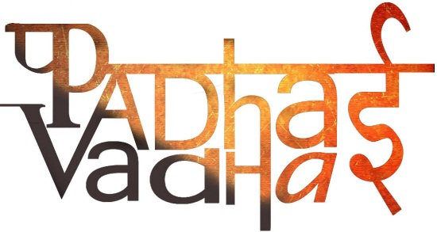

Ch 9

The Making Of Regional Cultures

Question 1. In which century was the Chera Kingdom established?

A1. Ninth century

Question 2. Where was Chera Kingdom established?

A2. South-Western part of peninsula.

Question 3. Name the languages spoken in Chera?

A3. Malayalam and Sanskrit

Question 4. Which literature work is based upon Malayalam and Sanskrit?

A4. Lilatilakam

Question 5.Where was Lilatilakam composed?

A5. Manipravalam

Question 6. Where is Jagannath Temple located?

A6. Orissa

Question 7. Who constructed Jagannath Temple?

A7. Rulers of Ganga Dynasty, Anantavarman

Question 8.Which king dedicated his kingdom to Lord Vishnu?

A8. King Anangabhima III.

Question 9. Which was the Rajputana region as called by the British?

A9. The region that constituted most of the present day Rajasthan.

Question 10. Who were kathaks originally?

A10. A caste of story tellers in the temples of North India.

Question 11. From which Sanskrit word was the word kathak derived?

A11. Katha.

Question 12. Which were the two gharans of kathak?

A12. One was in the courts of Rajasthan (Jaipur) and the other in Lucknow.

Question 13. Define miniature paintings.

A13. Small sized paintings, generally done in water colour on cloth or paper.

Question 14. Which emperors patronized miniature paintings?

A14. Akbar, Jahangir and Shah Jahan.

Question 15. Define Basohli.

A15. A bold and intense style of miniature painting is called Basohli.

Question 16. Bengali derived from which language?

A16. Sanskrit.

Question 17. How many categories can the early Bengali be divided into?

A17. Two categories.

Question 18. Who is a Pir?

A18. It is a Persian word meaning a spiritual guide.

Question 19. Why were temples and other religious structures were built by powerful individuals and groups?

A19. To both-demonstrate their power and proclaim their piety.

Question 20. Terracotta temples in Bengal were built with whose support?

A20. With the support of several ‘low’ social groups such as Kolu (oil pressers) and the Kansari (bell metal workers).

Question 21. What is double-roofed structure of thatched huts called?

A21. Dochala

Question 22. What is four-roofed structure of thatched huts called?

A22. Chauchala

Question 23. What is the meaning of Brihaddharma Purana?

A23. Brihaddharma Purana, a thirteenth-century Sanskrit text from Bengal, permitted the local Brahmanas to eat certain varieties of fish.